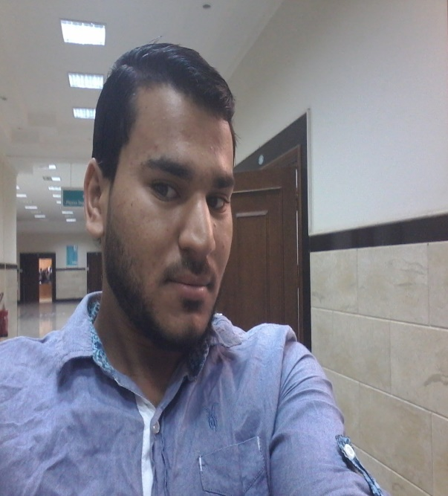
Name: Mohamed Abo Elwafa Abd Elmonien Khalifa
- Address:- Egypt_kafr elshiekh.
- Age :-22years old.
- Education:- student of science faculty _KFS university.
- specialization:- physics
- Social state :- single.
- Phone:- 01067586587
- Email :- mohamedkhalifa692@yahoo.com
- Email :- mohamedkhalifa692@hotmail.com
- Date of birth 1/7/1994
- Total degree :very good.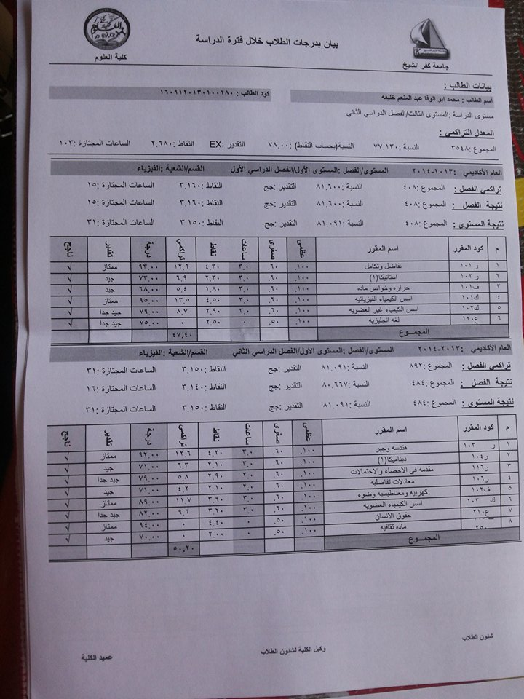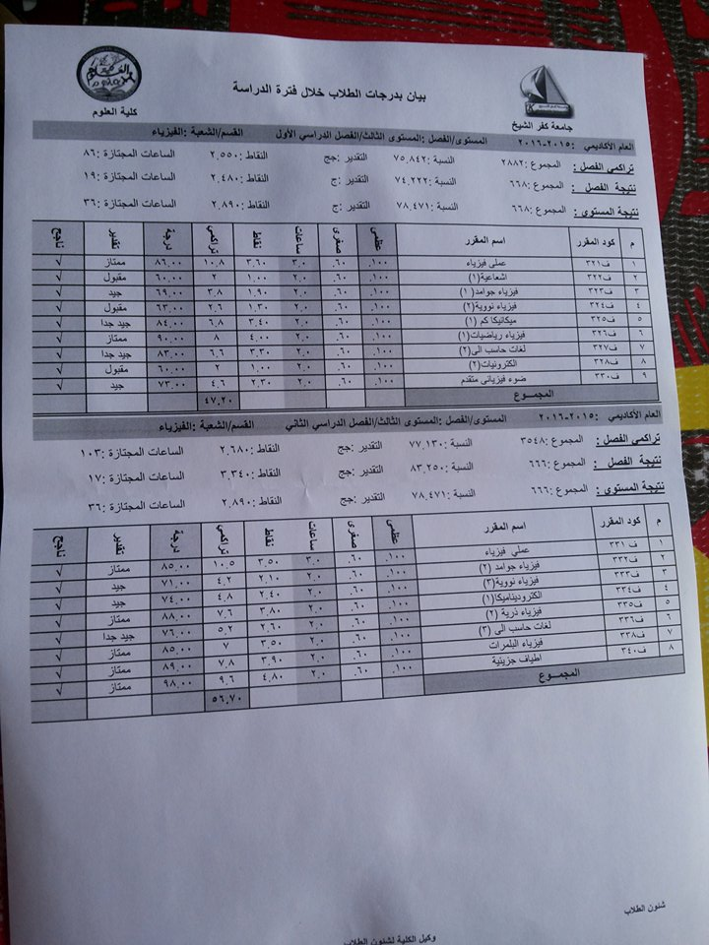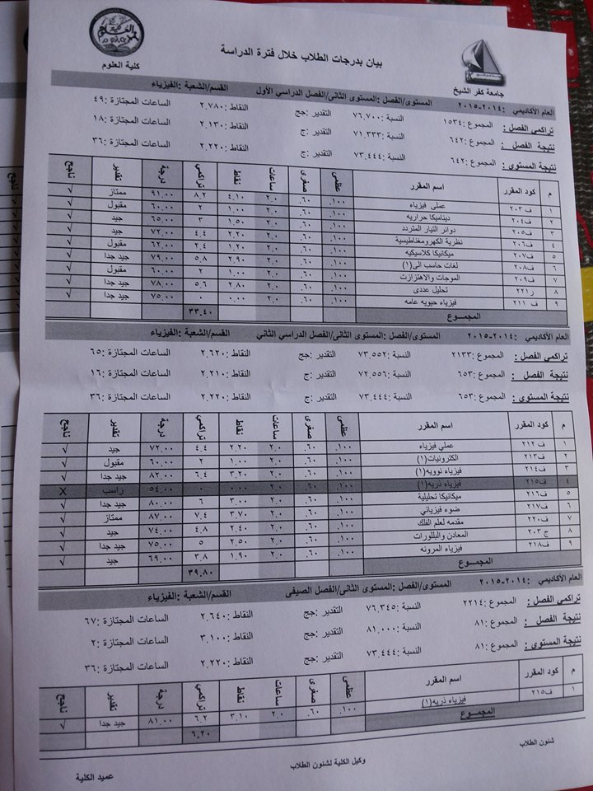
- Skills :- ICDL , english , lab skills , communication skills , HR.
- Work experience:-

- Member of the Society of Friends of Zewail City
- I have training in solar cell and their application tewnty hours 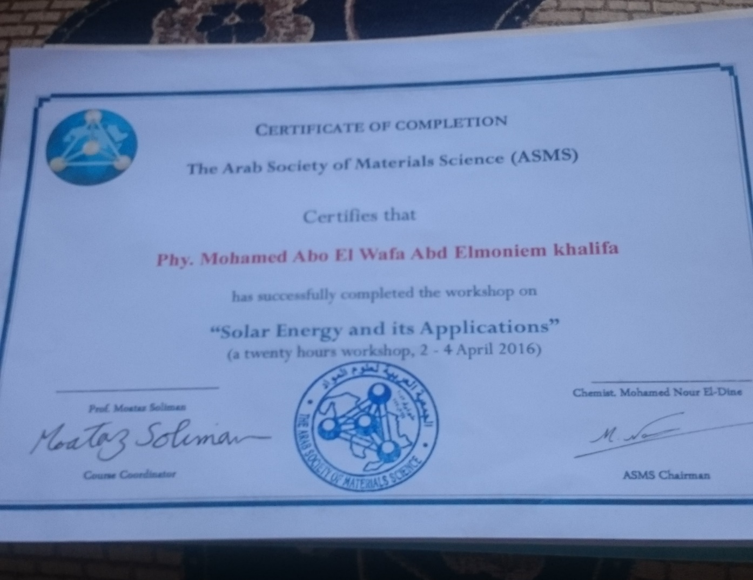

- I have training in Robbotics for five days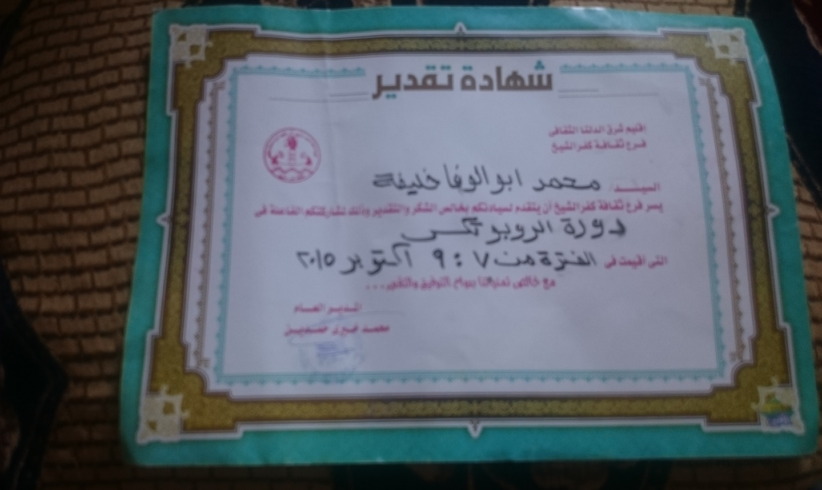

- Member of the Science Club Kafr El-Sheikh

- I worked in the renewable energy laboratory at the Faculty of Science Kafr El-Sheikh for a year

- Occupational Safety and Health Administration (OSHA) course for 18 hours with degree (excellent). 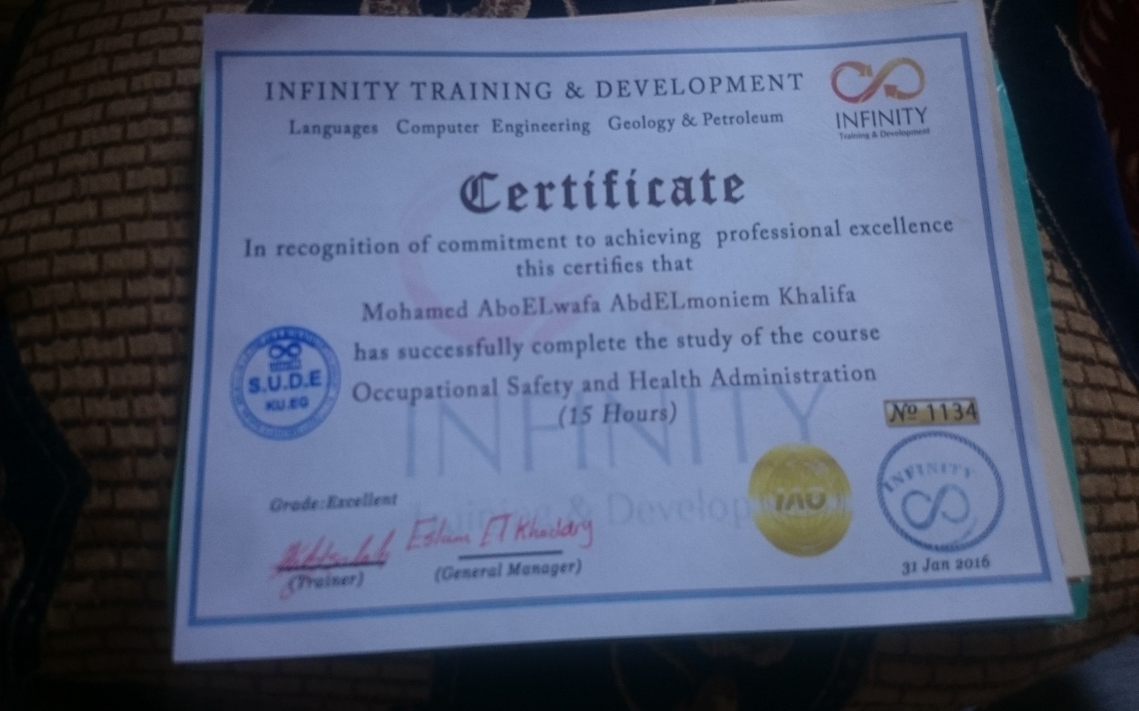

- Member of the Institute promising The Leader in Helwan Youth Leadership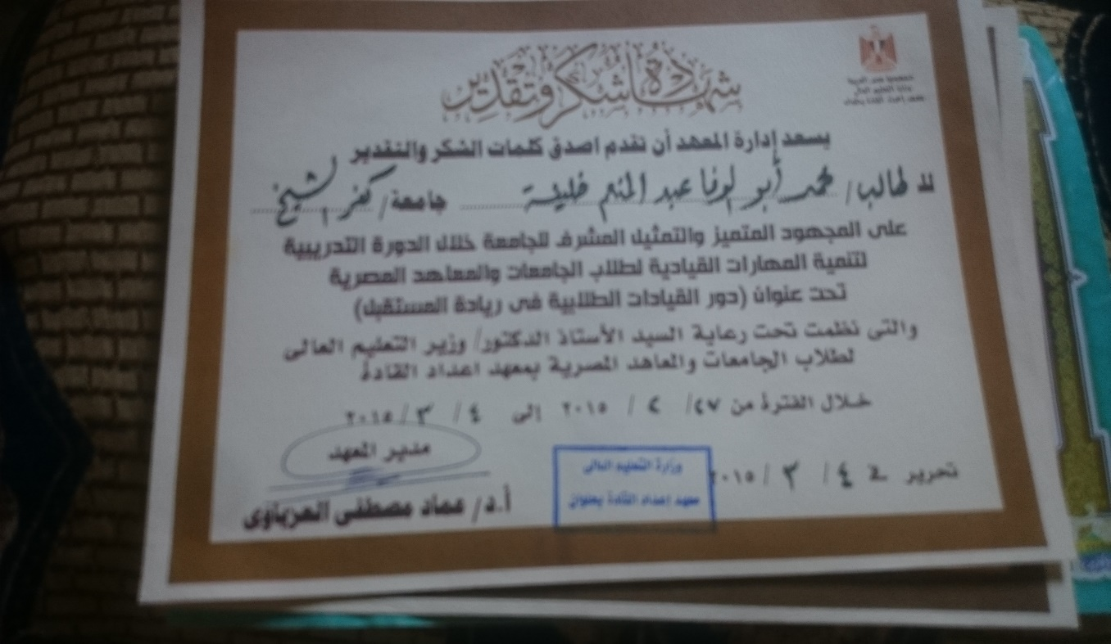
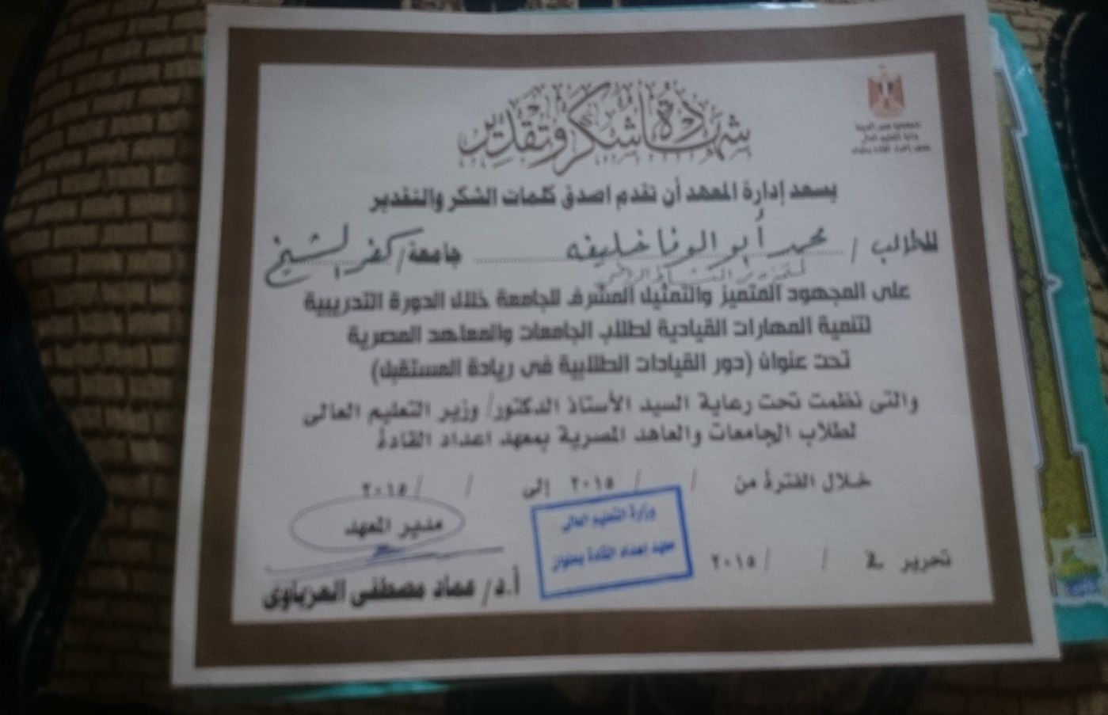
- I have the Human Development titled Be a leader and changed the world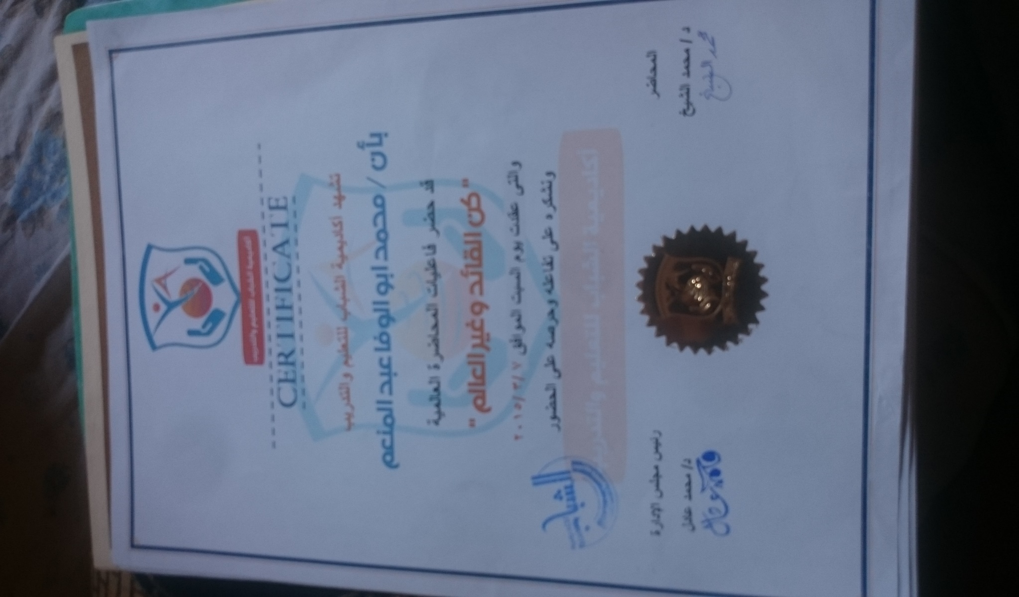

- Characteristics:-
- Works in group and also active when works alone.
- Patient and ambitious and work hard
- Faithful and seek to raise the place where works.
- Cooperative , flexible and social
- Activities & skills :-
- Trained and passed all exams of ICDL.
- Fluent in Arabic, English and basic French.
- communication skills and manage, speak efficiently in the formal meetings.
- Student Union adviser in the College of Science

- Member in Wise family in the College of Science

