Title: Breaking the Stigma of Opioid Addiction: One Family’s Story
Ingrid E Blair, Mother, Chemical Engineer and Business Executive, 3M

Abstract (300 word limit)
Statement of the Problem: The social stigma associated with opioid addiction is limiting the public engagement to drive government institutions to swiftly, fully and effectively address this epidemic.
Embedded in the stigma is the belief of middle-class families that opioid addiction only happens to ‘bad kids’ with ‘bad parents’ which inherently limits their active participation in pushing for funding for public intervention.
This presentation is a mother’s story of how the disease of addiction impacted her family and what we as individuals can do to break the stigma and take steps to change the trajectory of this epidemic.

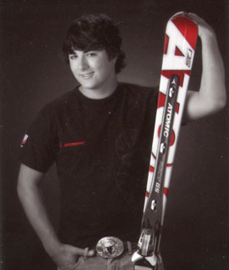
Image

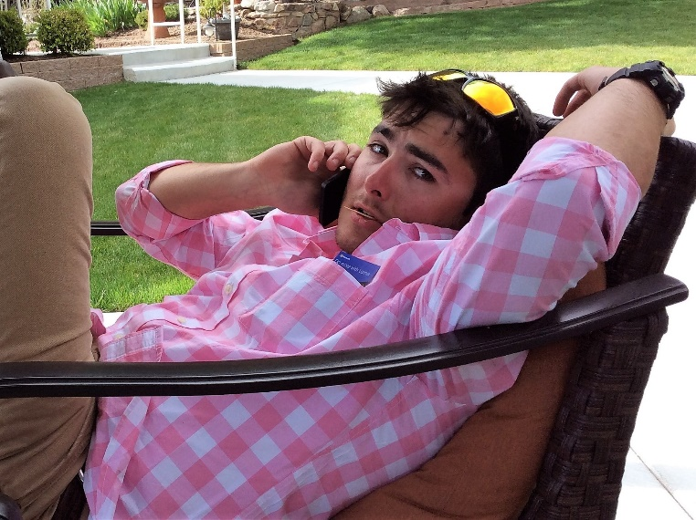
Hunter Thomas Blair March 7, 1992 – Dec 4, 2016

Recent Articles / Presentation (minimum 5)
- Speaker, IBEW International Womens Conference, June 2018, St. Paul, MN as part of National Safety Council (NSC) workshop on addressing the opioid epidemic.
- https://www.hudsonstarobserver.com/lifestyle/health/4341442-education-key-facing-drug-abuse

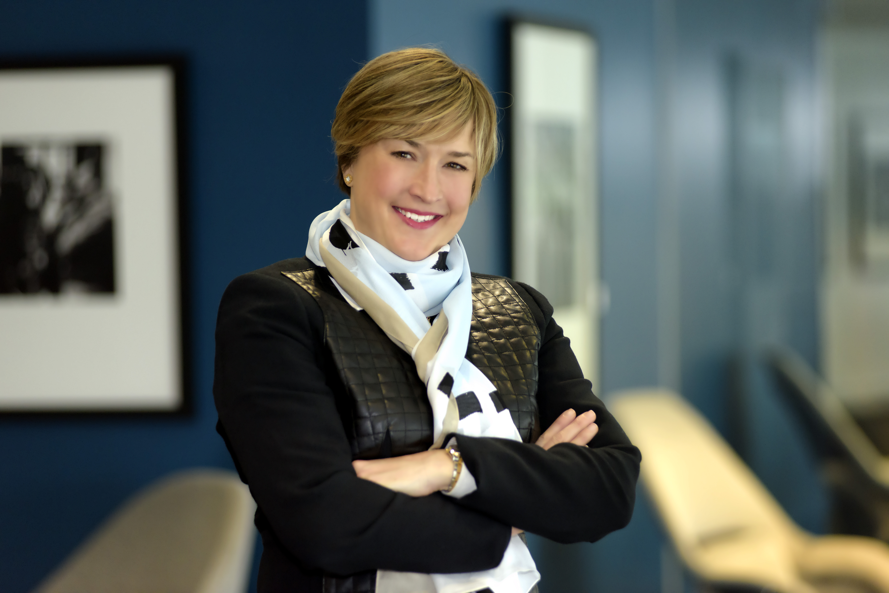Biography (150 word limit)
We called him our beautiful boy because he was that; strikingly handsome, charismatic, wicked smart with a dry sense of humor and appealing laugh. Our son, Hunter, died on December 4, 2016, at the age of 24 from a heroin overdose.

Ingrid lives in Hudson, WI with her husband, Tom, and their sons, Jake & Cooper. She is Vice President, Business & Marketing, 3M Drug Delivery Systems Division, a current advisory board member with Rise Together (weallrisetogether.com), a former board member of the Hamline University School of Business, and of Solumed, a medical supplies company. Ingrid has a bachelor’s degree in Chemical Engineering from the University of Minnesota. She is a casual runner, a recent yoga convert, and an avid downhill skier. Ingrid is presently on leave from her position at 3M to honor and mourn the loss of her son and support her husband and living children.
Email:ingrid.e.blair@gmail.com
- Full Name: Ingrid Evelyn Blair
- Personal Email: ingrid.e.blair@gmail.com
- Mobile Number: 715-497-9748
- Linked In: https://www.linkedin.com/in/ingridblair/
- Facebook: https://www.facebook.com/ingrid.benzblair
- Session Name/ number:
- Category: Oral presentation
- Date of Birth: 03/30/1964
- Postal Address: 1417 Boulder Pt. Dr., Hudson, WI, 54016

