Terahertz-based reflectometry: potential clinical applications in corneal hydration sensing and tear film stability assessment
Ilya Ozheredovª, PhD; Mikhail Mischenkoª; Mikhail Prokopchukª; Yulia Listopadskayaª; Tatyana Safonova^{b}; Ekaterina Sikach^{b}
ªLomonosov Moscow State University Moscow, Russia
^{b}Research Institute of Eye Diseases, Moscow, Russia

Abstract
Statement of the Problem: The tear film stability assessment represents one of the most important diagnostic criteria in DES. The limitations of current methods of its assessment may be overcome by the development and implementation of improved automated diagnostics methods. As one of these methods the device prototype based on frequency-domain THz reflectometry is proposed. It allows to analyze the rate of dehydration of the corneal surface and, as a result, to calculate the time of tear film rupture. The purpose of this study is to analyze its applicability of the developed prototype device in ophthalmology clinical practice. Methodology & Theoretical Orientation: The benefit of the developed device is that it has options to vary the frequency of the probe radiation, which allows us to assess the exact selected corneal region and, at the same time, to separate the contribution from the tear film and corneal epithelium in the overall THz “response” signal while maintaining maximum spectral sensitivity. The experimental study was conducted on overall 29 (58 eyes) healthy volunteers and patients. Findings: A graphical representation of the corneal hydration dynamics was obtained. It is apparent from the graph that there is a clear trend of decreasing reflection coefficient over time in relation to the physiological blinking cycle and the associated changes in the tear film stability and corneal epithelium hydration. Typical behavior of the amplitude of reflected THz signal over time is presented on Figure for patients with DES (a) and healthy volunteers (b) (Dots: experimental data; line: linear approximation). Conclusion & Significance: The proposed diagnostic method based on THz radiation is fundamentally different from the ones that are already used in ophthalmology clinical practice and allows us to in vivo analyze the corneal outer layers' hydration level and tear film stability.

Image
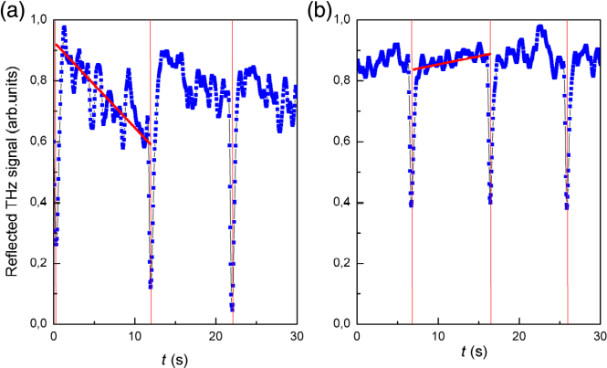
Recent Publications
- D. B. Bennett et al., “Terahertz sensing in corneal tissues,” J. Biomed. Opt. 16, 057003 (2011).
- Z. D. Taylor et al., “THz and mm-wave sensing of corneal tissue water content: electromagnetic modeling and analysis,” IEEE Trans. Terahertz Sci. Technol. 5, 170–183 (2015).
- Z. D. Taylor et al., “THz and mm-wave sensing of corneal tissue water content: in vivo sensing and imaging results,” IEEE Trans. Terahertz Sci. Technol. 5, 184–196 (2015).
- E. N. Iomdina et al., “Study of transmittance and reflectance spectra of the cornea and the sclera in the THz frequency range,” J. Biomed. Opt. 21(9), 097002 (2016).
- I. Ozheredov et al., “In vivo THz sensing of the cornea of the eye,” Laser Phys. Lett. 15, 55601 (2018).
- E A Kekkonen, A A Konovko, Yu S Lee, I M Lee, A P Shkurinov, I A Ozherdov, K H Park, T N Safonova, E I Sikach, "Assessment of the degree of hydration of ocular surface tissues using THz reflectometry", QUANTUM ELECTRON, 2020, 50 (1), 61–68

Biography (150 word limit)
Ekaterina Sikach is a post-graduate student at (Moscow, Russia). Her research interest is centered around development of treatment of dry eye syndrome.
Email: e.sikach@niigb.ru

Notes/Comments:

