Berlin Global Ophthalmology Summit February 2018 Abstract

Diagnostic Dilemma?
Shaz Rehan (FP Doctor, Cardiff, Wales, UK), Zartash Rehan (FP Doctor, Cardiff, Wales, UK) Daniel Athavale (SpR, Sydney Eye Hospital, Sydney, Australia)

Abstract (Word Count = 299)
We write to report a diagnostic dilemma. An 85-year-old white Australian gentleman was referred to Sydney Eye Hospital for investigation of visual loss. His ocular history included bilateral pseudophakia and he was not a known diabetic. He described a 1 day hx of non-traumatic visual blur effecting his RE. At presentation, on examination, in the RE the VA was CF, and a large spontaneous hyphaemia was seen. IOP was normal. There was no evidence of UGH syndrome, he was not taking aspirin or anticoagulants and a B scan of the retina was NAD. The LE was NAD. He was commenced on atropine 1% BD, and Maxidex QID, given an eye shield and advised strict bed rest. Day 3, hyphaema present and unchanged, IOP 35mmHg and thus commenced on Combigan BD. Interestingly in the LE, KP’s were seen, and a deep AC with cells and flare. An iris nodule not previously there 2 days earlier was noted. IOP was 18mmHg. Vitreous cells and a hazy retinal view were present but there was no retinitis or vasculitis. The patient was commenced on atropine 1% BD, and Maxidex QID for the LE. The patient underwent many investigations which revealed: normal FBC and U&E’s, HLA-B27 negative, syphilis serology –ve, ACE levels normal, CXR ? scarring at the right apex. Day 6, ongoing hyphaema with a worse view of the AC, and an IOP of 23mmHg in the RE. LE – KP’s, AC cells and vitreous cells present, with a normal retinal appearance. The iris nodule is now smaller in size. A diagnostic/therapeutic AC washout was performed: histopathology showed blood cells and no evidence of malignant cells. Further investigations: QuantiFeron test was +ve and a HRCT of the chest showed no active tuberculoma. Diagnosis: RE hyphaema query cause. LE iris nodule and AAU ? Cause.

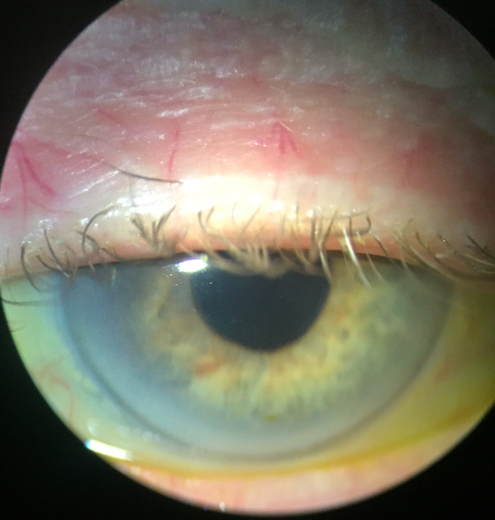
Image(s)
Figure 2 – Iris Nodule.
Figure 1 – Large Hyphaema of the Right Eye.
Recent Publications (minimum 5)
Not applicable =

Biography
All 3 authors are passionate about Ophthalmology and medical education. They want to raise awareness of this interesting and challenging case and share it with the international ophthalmology community.
Email: shazmrehan@gmail.com

