The Expression of Programmed Cell Death 4 in Uveal Melanoma

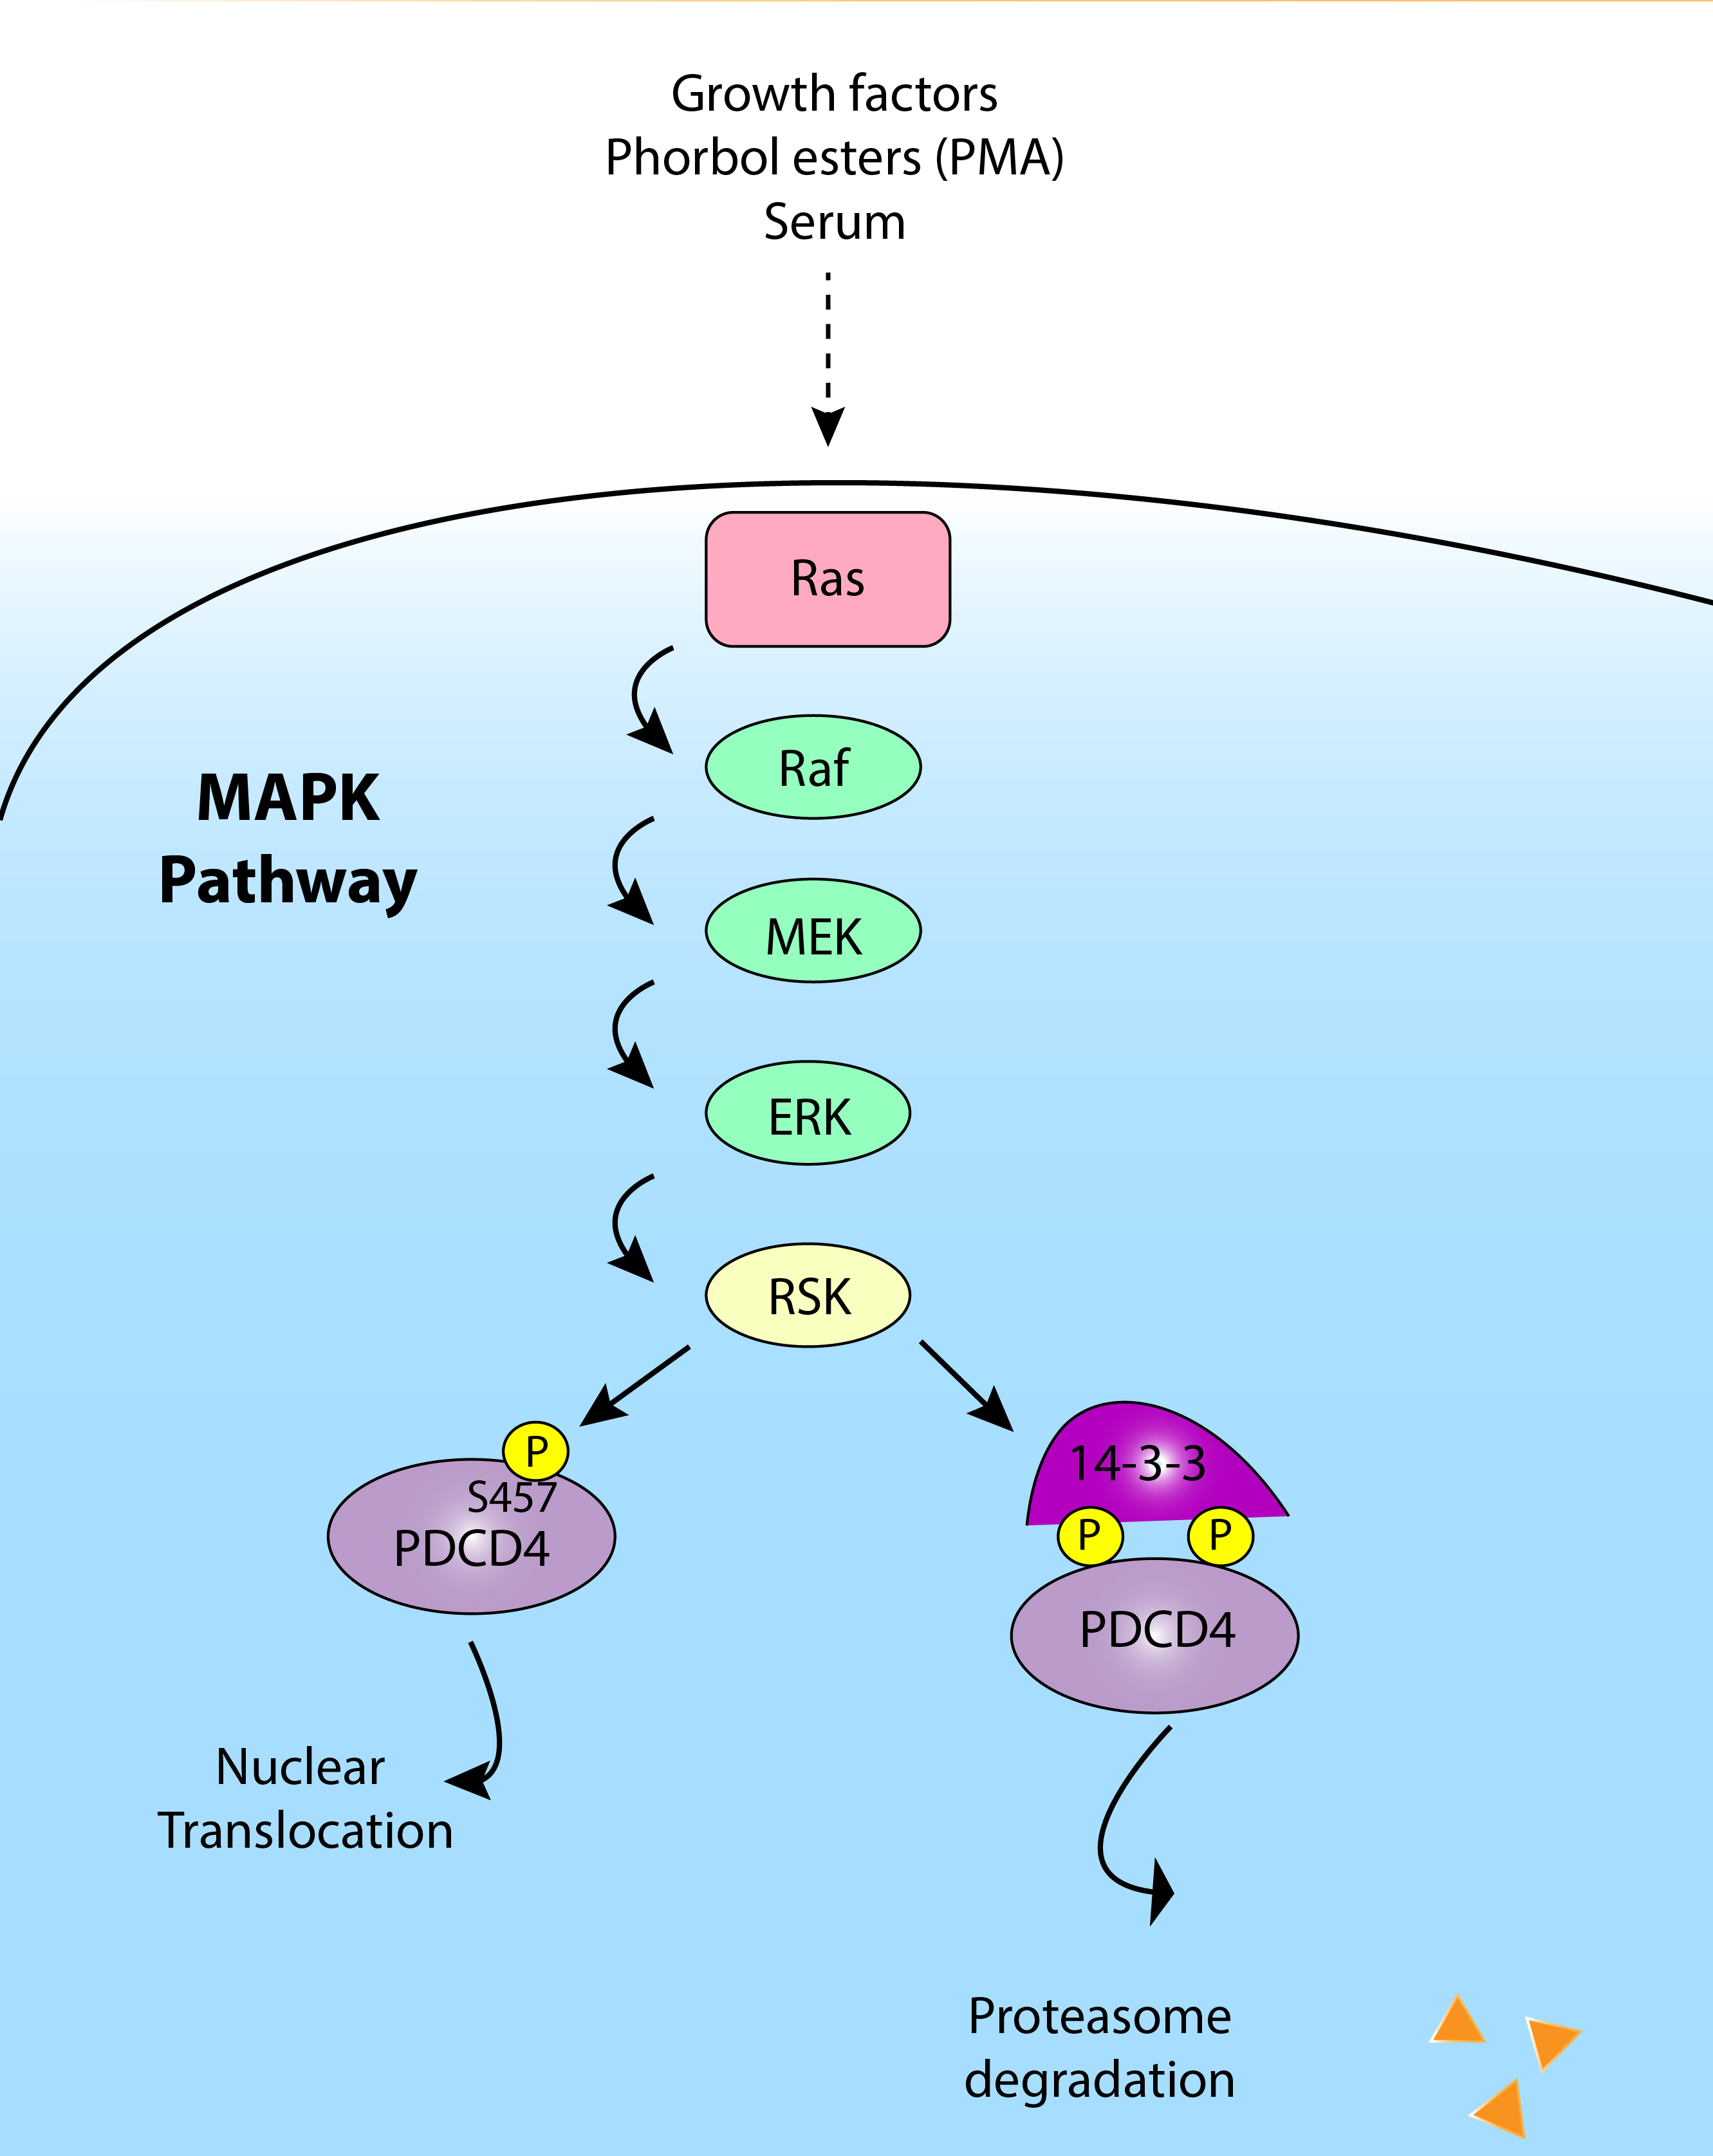
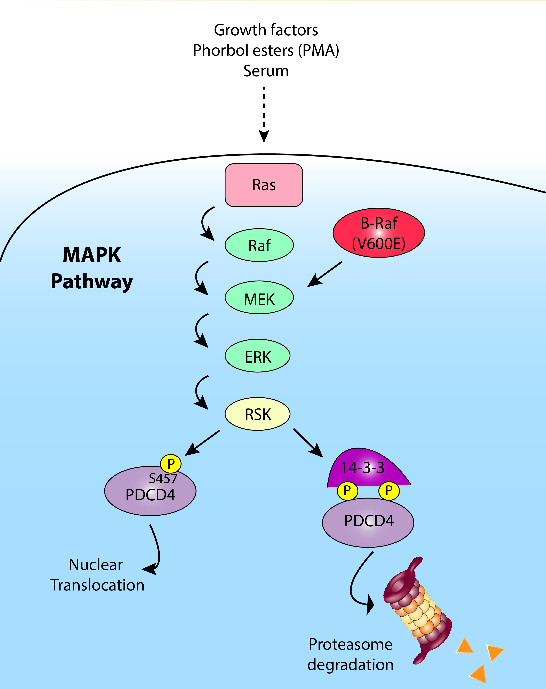
Ibrar Ahmed, Liverpool Ocular Oncology Research Group, Department of Molecular and Clinical Cancer Medicine

Abstract (300 word limit)

Uveal melanoma (UM) is the most frequently occurring intraocular malignancy in adults. Arising from the uncontrolled proliferation of melanocytes in the choroid, ciliary body and iris, UMs have a strong propensity to metastasise to the liver, where they are fatal. In a previous study, proteomic examination of UMs at either a high or low risk of developing metastasis identified the down regulation of PDCD4 protein levels with increasing metastatic risk. This study examined Programmed Cell Death 4 (PDCD4) protein expression and subcellular localisation in UM cell lines by western blotting and immunohistochemistry. The expression of PDCD4 and the specificity of the anti-PDCD4 antibody were determined by western blot using whole cell lysates of five uveal melanoma cell lines. Using the same cell lines, immunohistochemical staining was also undertaken to further assess PDCD4 protein levels and subcellular localisation. PDCD4 was identified as a single band between 48 and 63kDa by Western blot in all five UM cell lines. Immunohistochemistry demonstrated PDCD4 protein in the nucleus and cytoplasm of the UM cell lines. PDCD4 levels were similar in all UM cell lines examined irrespective of whether they were derived from a primary tumour or metastatic lesion. The proportion of PDCD4 localised to either the nucleus or cytoplasm differed between the cell lines, which may influence its function. Further research is now necessary to examine its expression in patient samples and determine its functional relevance to disease progression.

Fig 1 – shows the Ras/MAPK pathway, a signaling cascade resulting in the phosphorylation of PDCD4 at two sites, by serine residues, causing proteasomal degradation. This pathway has shown to be frequently dysregulated in various other cancers also, most notably, in cutaneous melanoma by the BRAF mutation.
Recent Publications
1. Damato BE, Coupland SE. Differences in uveal melanomas between men and women from the British Isles. Eye. 2012 Feb;26(2):292–9.
2. Damato EM, Damato BE. Detection and Time to Treatment of Uveal Melanoma in the United Kingdom: An Evaluation of 2384 Patients. Ophthalmology. 2012 Aug 1;119(8):1582–9.
3. Carvajal RD, Schwartz GK, Tezel T, Marr B, Francis JH, Nathan PD. Metastatic disease from uveal melanoma: treatment options and future prospects. Br J Ophthalmol. 2016 Aug 29;bjophthalmol-2016-309034.
4. Valpione S, Moser JC, Parrozzani R, Bazzi M, Mansfield AS, Mocellin S, et al. Development and External Validation of a Prognostic Nomogram for Metastatic Uveal Melanoma. PLOS ONE. 2015 Mar 17;10(3):e0120181.
5. Griewank KG, Yu X, Khalili J, Sozen MM, Stempke-Hale K, Bernatchez C, et al. Genetic and Molecular Characterization of Uveal Melanoma Cell Lines. Pigment Cell Melanoma Res. 2012 Mar;25(2):182–7.



Biography
Ibrar Ahmed, an intercalating medical student with a long-standing passion for ophthalmology with the aim of becoming a professional, highly motivated ophthalmologist to provide the best possible care and service to patients. Ibrar is currently undertaking a Masters of Research with the Liverpool Ocular Oncology Research Group specializing in the field of ocular oncology, studying uveal melanomas more specifically.

Email: hliahme2@liverpool.ac.uk

