Is Anisometropia a real indication for LASIK in pediatric age group?
Prof. Dr. Akmal Rizk Research Institute of Ophthalmology Cairo

Aniseikonia is one of the most important factors to affect binocular vision and induce diplopia. It occurs due to different optical power of both eyes. Unilateral aphakia was the most common cause of aniseikonia before the era of intraocular lenses. That happened due to different refractive ametropia. Most of ophthalmologists put the assumption that anisometropia induces aniseikonia and consider Lasik is only indicated in children when they have anisometropia.
Eighty-five patients suffering anisometropia were collected between 2007 & 2010.
The aniseikonia was measured by a new aniseikoinia test using polarized filters.
The age group was between 6-15 years old. 72 had anisomyopia while 13 had anisohyperopia. 14 had suppression while 76 had no aniseikonia.

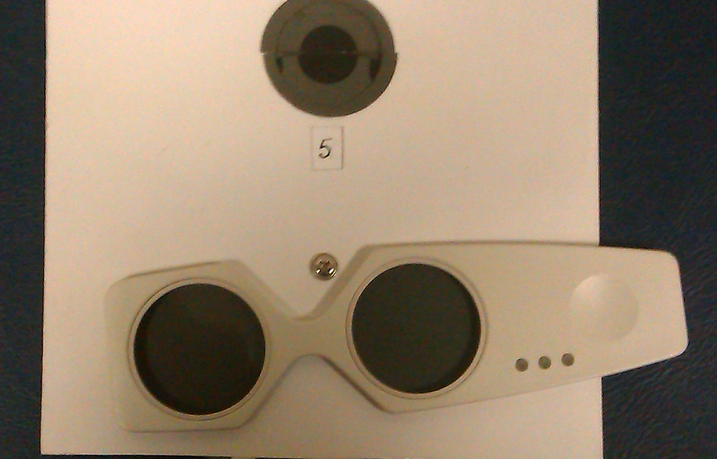

It was written in the literature that ametropia more than 3D would be axial and less than 3D might be refractive and the power of the ametropic globe will be the power of emmotropia. Optically, there is no aniseikonia when the correcting lens is put at the anterior focal plane of the globe.
The purpose of this study is that correction of anisometropia is safe and perfect solution of aniseikonia occurred due to uncorrected anisometropia and LASIK is not required to correct anisometropia
References
Benegas, N M.h, Egbert J, Engel WK and Kushner BJ, : Diplopia secondary to aniseikonia associated with macular disease. Arch Ophthalmol 117(7): 896-899, 1999
Lubkin V, Covin R, Pavlica M, and Kramer P: Aniseikonia in unilateral and bilateral pseudophakia. Invest Ophthalmol Vis Sci 3 (suppl): 94, 1992
Awaya, S Suggawara M Horibi, Fand ToriiF: New aniseikonia test and its clinical application. Acta Soc Ophthalmol. Jpn. 86: 217-222, 1987

