A case report of eye trauma from firework.

Krasniqi Marsida¹
¹Department of Medicine Sciences, University Aleksander Moisiu, Durres, Albania; Our Lady of Good Counsel, Tirana Albania
Abstract:
A 52 years old man was presented to the ophthalmic emergency room with a firework facial and eye trauma, on 31 December 2018. He presented multiple, small facial cutaneous abrasions and burn (Fig 1). His visus on the left eye was light perception and in the right eye was finger counting in 5cm. The clinical presentation of both eyes was lid and conjunctival burns, chemosis and conjuctival hemorrhage, corneal punctiform perforation, multiple corneal foreign bodies, hyphema of 3mm, traumatic cataract (Fig 2). USG (A+B scan) revealed extended vitreous hemorrhage and a single foreign body. No iridodialysis was seen. The patient had no retinal detachment or optic nerve injury.
After suturing and debriding the cornea, washing of the anterior chamber he underwent cataract surgery with scleral fixation intraocular lens, vitrectomy and silicone oil tamponade on both eyes (Fig 3). After 3 months' follow-up, his visual acuity on his right eye was 20/200 and his left eye was 20/400. The causes of poor vision were corneal scar, astigmatism after corneal repair, vitreous hemorrhage, and macular edema.
Fireworks-related eye injuries constitute an important cause of preventable blindness worldwide. As ocular firecracker injuries result in significant morbidity, public education regarding proper use of fireworks may help in reducing the incidence of ocular injuries.

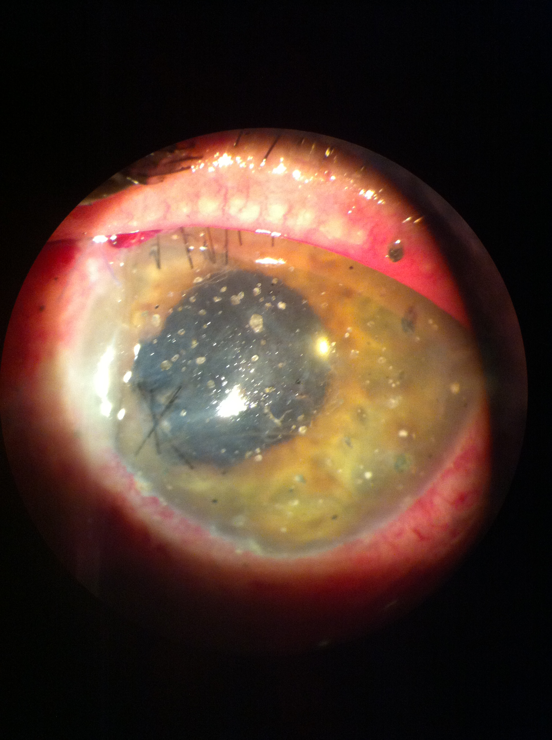
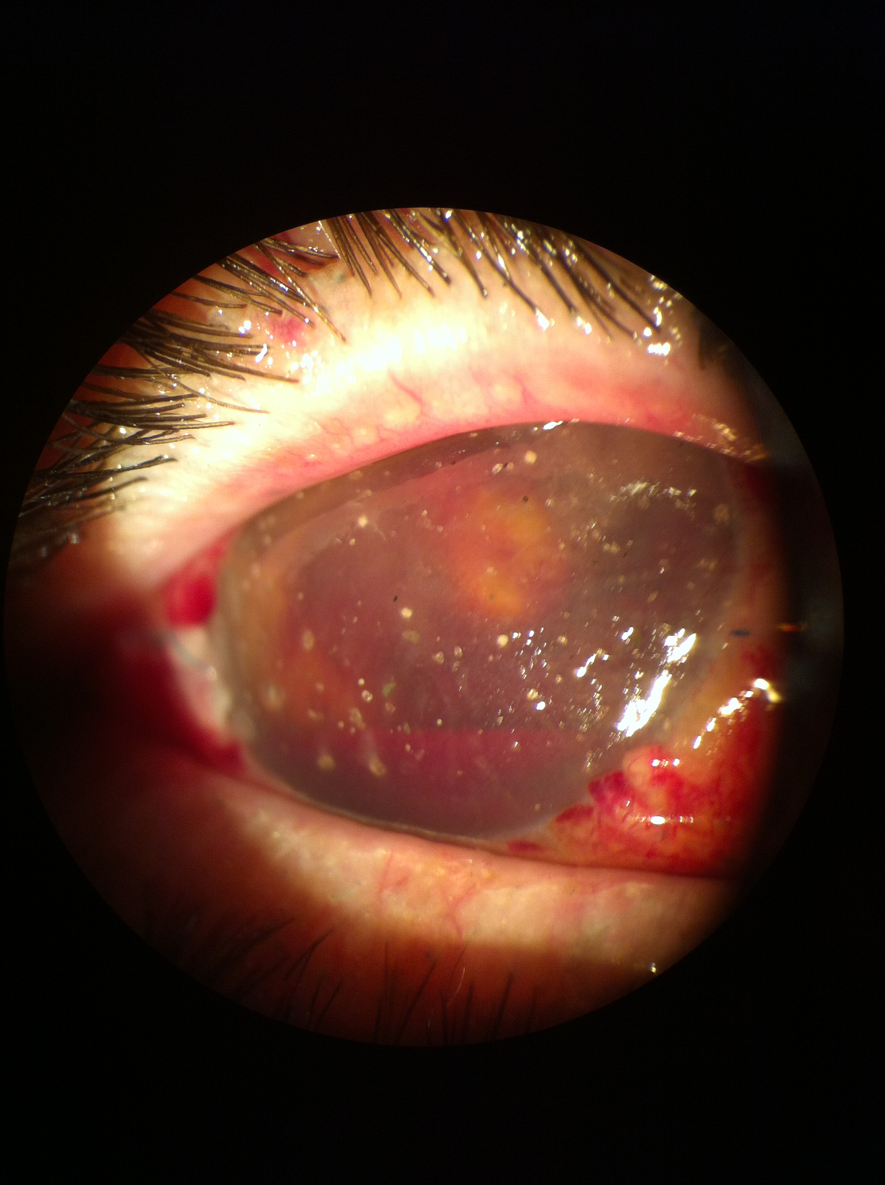

Fig 1. Fig.2 Fig.3
Keyword: eye trauma, fireworks, vitreous haemorrage, traumatic cataract

