Migration of an Ozurdex® implant into the anterior chamber: a case report
Dr Devangna Bhatia, Dr Muhammad Cheema, Dr Shweta Singh, Mr Saju Thomas, Darlington Memorial Hospital, UK

Abstract:
Ozurdex® is a small sustained-release, biodegradable intravitreal steroid implant, measuring approximately 0.46mm in diameter and 6mm in length. These implants are increasingly being used by Ophthalmologists for several ocular conditions when cystoid macular oedema (CMO) is present. Corneal oedema is one of the most serious complications of implant migration. Despite prompt removal of anterior chamber implants, recent case reports have shown that the corneal oedema does not resolve spontaneously and can require further operative management including keratoplasty. Recent case series have demonstrated potentially permanent vision threatening corneal endothelial decompensation and oedema despite urgent removal of implant from anterior chamber.
Methodology: We describe an uncommon case of migration of an Ozurdex® implant into the anterior chamber in a patient with iris defects, following complicated vitreoretinal (VR) surgery also requiring a pupilloplasty and a surgical iridectomy.
Findings: Due to the small diameter of the Ozurdex® implant, it can migrate through any sized iris defect. In our patient, the implant migrated within 1 month of being implanted. Even though, the patient underwent urgent removal of the implant, complications of corneal oedema persisted and his vision has been compromised (counting fingers in the affected eye).
Conclusion & Significance: Even though iris defects may be small, the slight diameter of an Ozurdex® implant, can allow it to migrate anteriorly leading to corneal complications. Steroid induced complications such as cataract formation and raised IOP are well recognised common side effects, especially with the use of Ozurdex® implants. However, there is now growing evidence of the risk of intravitreal implants migrating to the anterior chamber and this risk should be discussed with the patient pre-operatively.

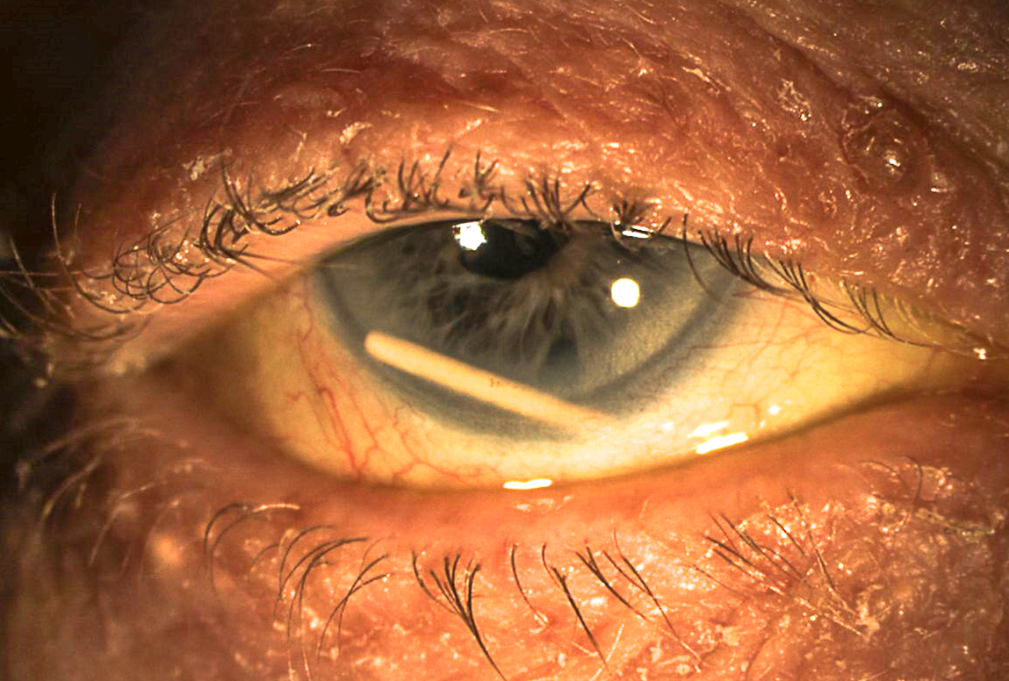
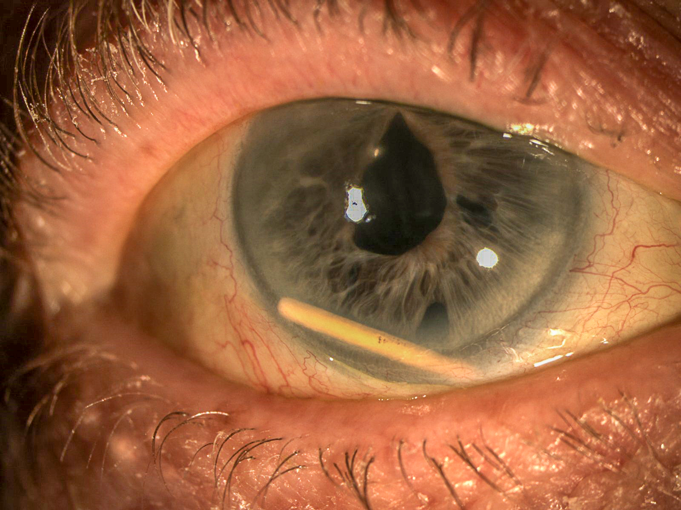
Figure 2 – Following removal of the implant

Figure 1 – Ozurdex® implant in AC. Inferior peripheral iridectomy visible

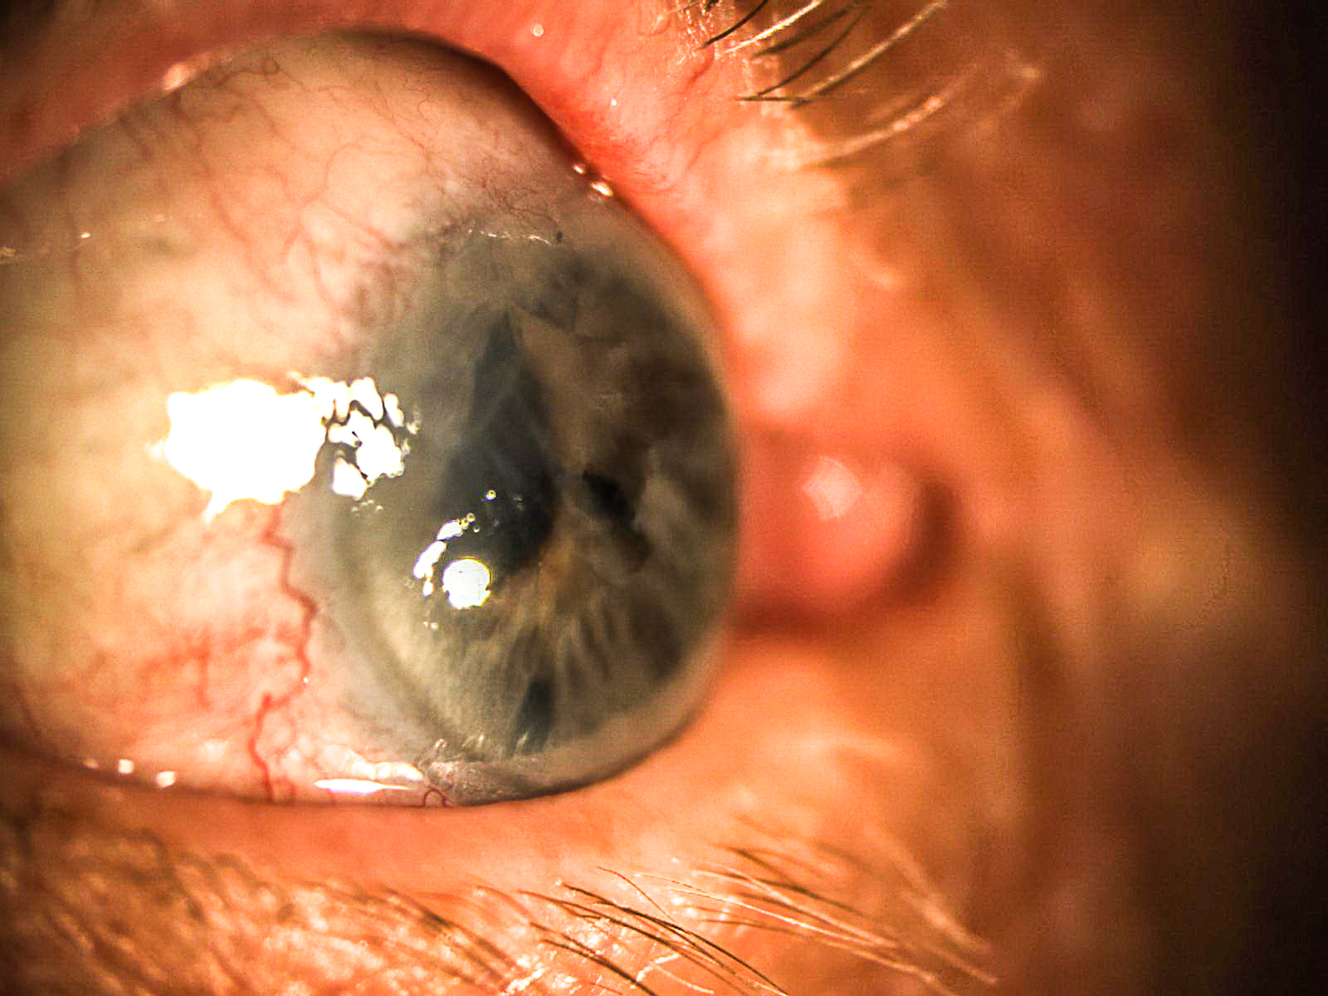

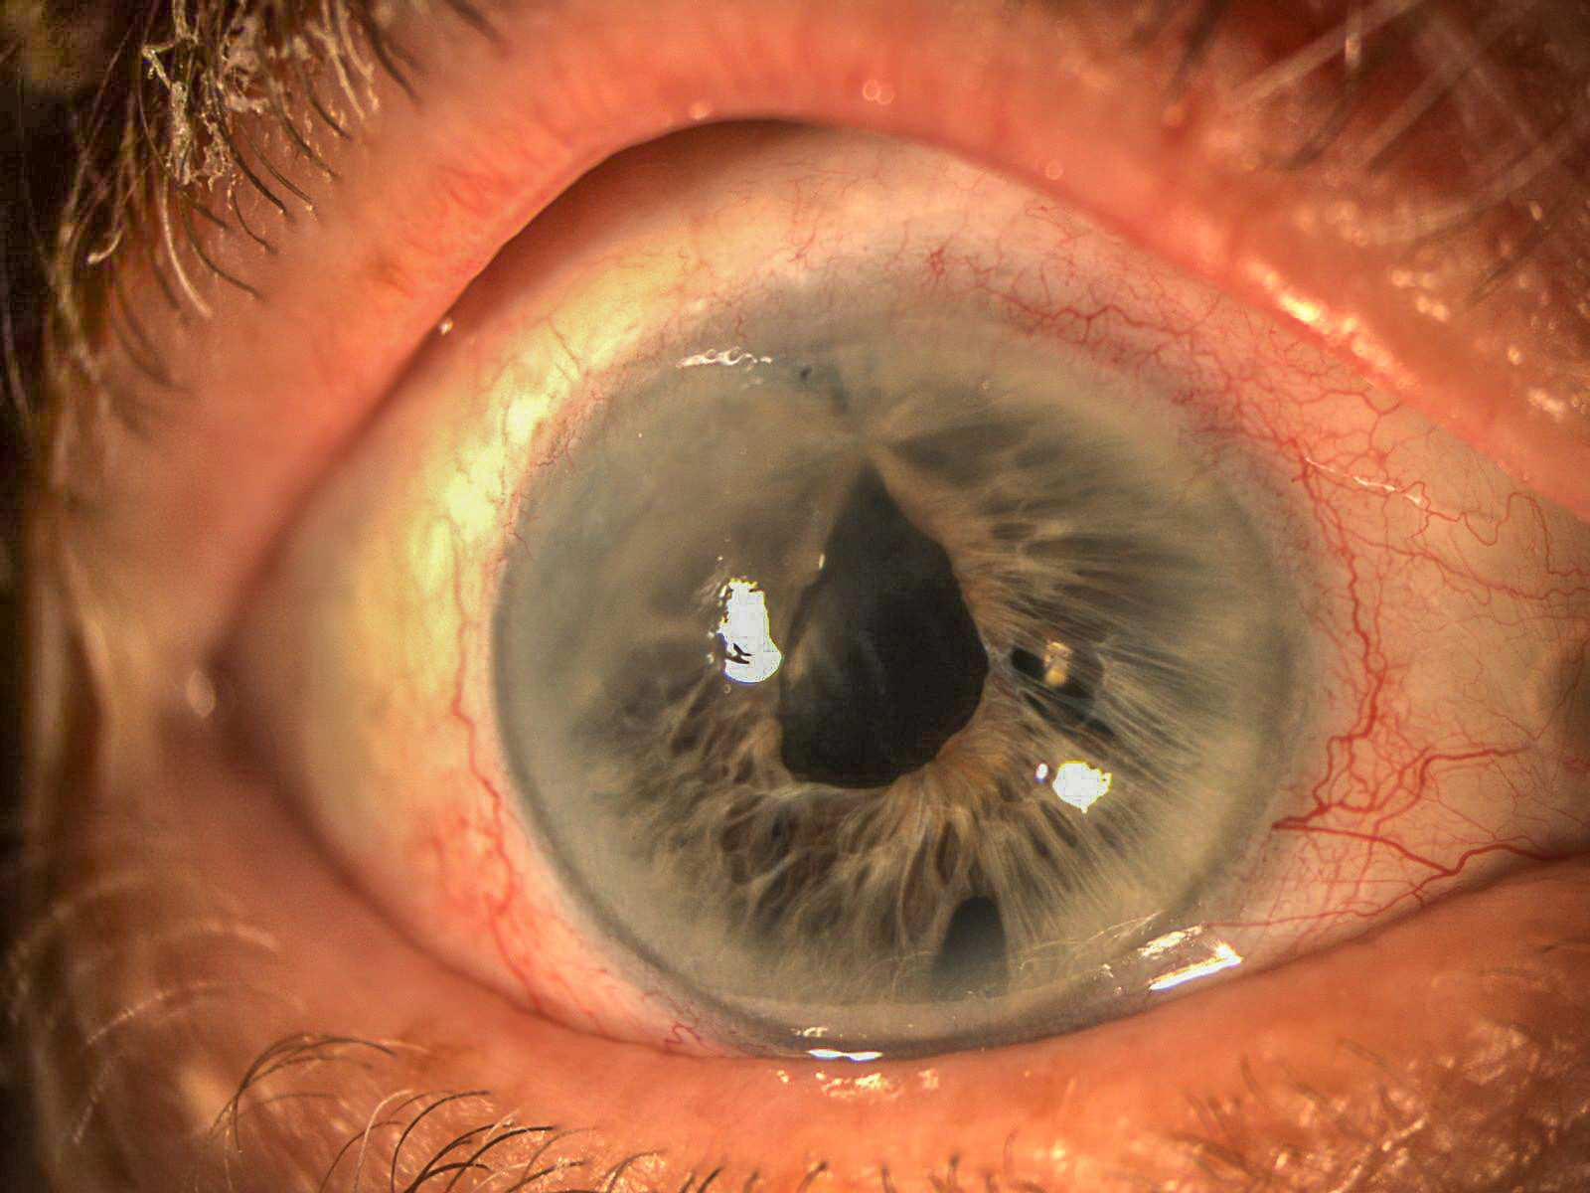

Recent Publications:

- Bansal, R. et al. (2012) ‘Wandering Ozurdex implant’, Journal of Ophthalmic Inflammation and Infection, 2(1), pp. 1–5.
- Kishore, S. A. and Schaal, S. (2013) ‘Management of Anterior Chamber Dislocation of Dexamethasone Implant’, Ocular Immunology and Inflammation, 21(1), pp. 90–91.
- Ozurdex - Summary of Product Characteristics (SPC) - (eMC) (2015) 30th March. Available at: https://www.medicines.org.uk/emc/medicine/23422
- Pacella, F. et al. (2016) ‘Management of anterior chamber dislocation of a dexamethasone intravitreal implant: a case report.’, Journal of medical case reports. Journal of Medical Case Reports, 10(1), p. 282.
- Rahimy, E. and Khurana, R. N. (2014) ‘Anterior segment migration of dexamethasone implant: risk factors, complications, and management’, Current Opinion in Ophthalmology. Current Opinion in Ophthalmology
- Rahimy, E. and Khurana, R. N. (2017) ‘Anterior segment migration of dexamethasone implant’, Current Opinion in Ophthalmology, 28(3), pp. 246–251.

Biography:
Dr Devangna Bhatia, Dr Muhammad Cheema, Dr Shweta Singh and Mr Saju Thomas all work in the Department of Ophthalmology in Darlington Memorial Hospital.

Email: drshwetadogra@yahoo.com

