Basic Principles of the Orbital Surgery and the Orbital Surgical Approaches
Hossam E. Elbarbary. Alexandria University, Faculty of Medicine, Ophthalmology Department, Alexandria, Egypt.

Abstract

This presentation will highlight and review the basic principles and important concepts for any orbital surgeon. Before undertaking any surgery in the orbit, a thorough knowledge of the normal eye lid and orbital anatomy is essential. Thorough understanding of CT and MRI is a must. One should also understand the instrumentation needed for any orbital surgery. The key to safe surgery is good surgical exposure. Adequate hemostasis needs to be ensured during orbital surgery. Many approaches can be used to gain access to the orbit. The different types of incisions and approaches will be demonstrated. The approaches can be anterior orbitotomy, lateral orbitotomy, transnasal endoscopic approach, transantral approach, and transfrontal orbitotomy.

Image
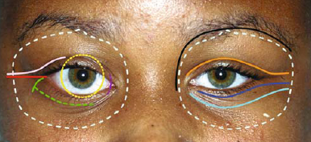

Figure:1 Skin and conjunctival incisions for orbit surgery

Recent Publications

- Tse D. Lateral orbitotomy. In: Tse D, Kenneth W, eds. Color atlas of opthalmic surgery: Oculoplastic surgery. Philadelphia: JB Lippincott 1992; 445-62.
- Zeynel A. Surgical Treatment. In: Zeynel A, eds. Orbital tumors:Diagnosis and treatment. Newyork: Springer 2005; 359-90.
- Henderson JW, Farrow GM. Orbital Tumors. 2nd ed. New York: BC Decker; 1980:580–4.
- Kaptanoğlu E, Solaroğlu I, Okutan O. Lateral orbital approach to intraorbital lesions. Journal of Ankara Medical School 2002; 24:177-82.
- Malaty et al. Lateral Orbitotomy for Management of Intraorbiyal lesions in Alexandria University Hospital: two years of surgical experience. Delta Journal of Ophthalmology 2011;12: 174-84.

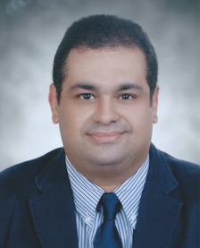
Biography
Dr. Hossam E. Elbarbary was graduated in 2001 from Faculty of medicine, Alexandria University, Egypt. He has completed the Master degree of Ophthalmology in 2006 and his M.D. and PhD in 2011 from Faculty of Medicine, Alexandria University, Egypt. He is a Lecturer and Staff university member of Ophthalmology Department of Alexandria Medical School. He is a consultant of Orbit, Lid, and Lacrimal Surgery in the Alexandria University Hospitals.
Email
hossameldin.elbarbary@alexmed.edu.eg
elbarbary_h@yahoo.com
Phone: +201220877008

Notes/Comments:

