Randomised controlled trial evidence questions the assumption that pulmonary metastasectomy benefits patients with colorectal cancer
Tom Treasure, MD, University College London, UK
Abstract (299 words)
Statement of the Problem: Over 40 years there has been an increasing number of operations to remove lung metastases from colorectal cancer (CRC) in the belief that otherwise the selected patients would have near zero five-year survival (5YS). Claims for benefit are as high as 60% 5YS. Methodology & Theoretical Orientation: Pulmonary Metastasectomy in Colorectal Cancer (PulMiCC) recruited patients who were potential candidates for metastasectomy and with informed consent collected baseline data on factors known to influence survival. Where there was equipoise patients were offered randomisation into a nested randomised controlled trial.Findings: 512 patients were recruited in 25 centres in Europe and China of whom 263 had elective metastasectomy, 128 did not, 93 were randomised and 28 were excluded. In elective patients 5YS with metastasectomy was 47% versus 22% without. The difference could all be accounted for by differences in the number of metastases, liver involvement andelevation of the tumour marker carcinoembryonic antigen. In the RCT where the arms were very well balanced for all seven known risk factors, there was no statistical difference at any time point and median survival was in fact longer for controls at 3.8 versus 3.5 years.Conclusion & Significance: The zero-survival assumption was refuted. The true survival without metastasectomy in patients who could have been candidates for operation was highly significantly better than the more plausible 5% estimate (P<0.001). The claimed benefit of 60% is also refuted although some very much smaller difference in the long term cannot be excluded. The claimed relief from chemotherapy was not seen. Lung metastases are very rarely isolated disease but a clear signal of systemic blood borne spread. Lung metastases rarely contribute to terminal decline or symptoms. By removing them all that is achieved is loss of the most easily monitored component of the disease.
Biography
Tom Treasure is a cardiothoracic surgeon with a research base as Honorary Professor in the Clinical Operational Research unit at University College London.
https://www.ctsnet.org/home/ttreasure

Image
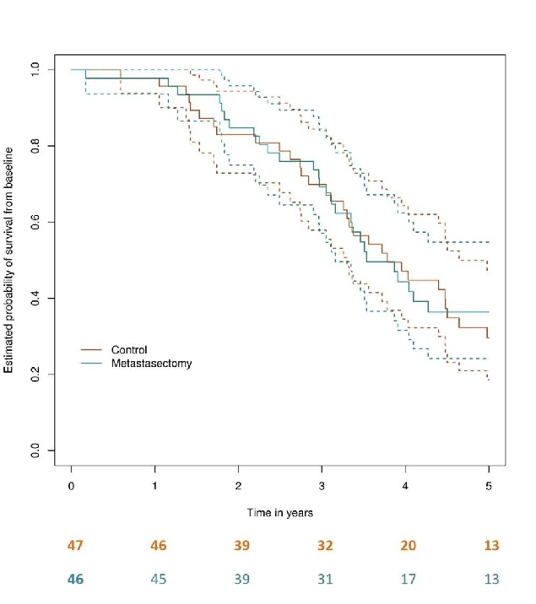
Figure: Kaplan Meier analysis of the PulMiCC randomised controlled trial.

Recent Publications
- Macbeth F, Fallowfield L. The myth of pulmonary metastasectomy. Br J Cancer. 2020;123(4):499-500.
- Milosevic M, Edwards J, Tsang D, Dunning J, Shackcloth M, Batchelor T, et al. Pulmonary Metastasectomy in Colorectal Cancer: updated analysis of 93 randomized patients - control survival is much better than previously assumed. Colorectal Dis. 2020;22(10):1314-24.
- Brew-Graves C, Farewell V, Monson K, Milosevic M, Williams NR, Morris E, et al. Pulmonary metastasectomy in colorectal cancer: health utility scores by EQ-5D-3L in a randomized controlled trial show no benefit from lung metastasectomy. Colorectal Dis. 2021;23(1):200-5.
- Treasure T, Farewell V, Macbeth F, Batchelor T, Milosevic M, King J, et al. Pulmonary Metastasectomy in Colorectal Cancer (PulMiCC) Cohort Study: analysis of case selection, risk factors and survival in a prospective observational study of 512 patients. Colorectal Dis. 2021.



