Modelling of Marine Oil Spill: A Case Study
Zheng Li¹, Hanzhang Qiao², Noori Saady^{3,} *

¹ Wood Environment & Infrastructure Solutions, St. John’s, NL
² EnviroRisk International Inc., St. John’s, NL
^{3, *} Faculty of Engineering and Applied Science, Memorial University of Newfoundland, St. John’s, NL, Canada, A1B 3X5
- Corresponding author: nsaady@mun.ca

Abstract
The early stage of oil spill in marine environment is critical because we need to predict the behaviour of the spill in terms of its spread and fate. To this end several software packages are available to handle this problem. GNOME, a modeling software, generated simulated scenarios for an oil spill in the Galveston Bay, US, under different water current intensity, wind intensity, and types of crude.
GNOME-predicted impacts of different types oil spill under various weather and oceanic conditions. Under all conditions, the spilled oil reached the shoreline after 12h. However, strong current caused significantly larger quantity (69 bbl) of oil to accumulate ashore compared to that accumulated due to medium currents (45 bbl). Moreover, wind affected spilled oil diffusion by wave movement. The beached amount under light wind and strong wind were 255 and 575 barrels, respectively, at the end of the simulation (72 hours). This means that strong wind caused 2.25 times more oil to reach the beach compared to light wind. The changing wind resulted in completely different diffusion when compared to constant wind. The latter presented the prominent influence of wind on oil surface dispreading. The effect of crude-type has been simulated through the evaporation rate. A round 9600 barrels of gasoline evaporated in 24 hours after spilling compared to 3730 and 6390 barrels for medium crude and diesel, respectively.

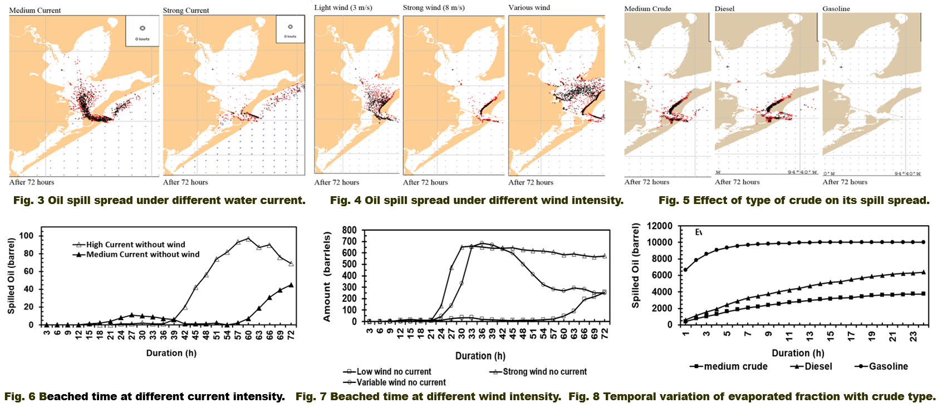

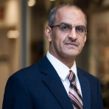
Biography
Noori Saady is an assistant professor at the Memorial University of Newfoundland. He is specialized in bioprocesses and biotechnologies treating and converting organic waste into biofuel and bioenergy and value-added by-products using wet and dry anaerobic digestion and microbial fuel cell. He published 30 research articles, two book’s chapters, and presented in many international conferences.
Email: nsaady@mun.ca

Notes/Comments:

