Oil shale combustion under oxyfuel conditions
Al-Makhadmeh L, Dr., Al-Hussein Bin Talal University, Jordan University of Science and Technology, Jordan
Maier J, Dipl. Ing., University of Stuttgart, Germany
Scheffknecht G, Univ.-Prof. Dr. techn., University of Stuttgart, Germany

Abstract (300 word limit)
Direct combustion of Jordanian oil shale under oxyfuel conditions was investigated. Unstaged and staged air-firing as well as combustion at 27% O2/73% CO2 (OF27) was conducted successfully. A 20 kW vertical reactor was used at a combustion temperature of 1200◦C. Oil shale- N conversion rate to NO is higher during unstaged air-firing than oxyfuel combustion; they are 27% and 15% for air-firing and OF27 combustion, respectively. NOx emission reduced efficiently by adopting staged combustion technology under oxy-fuel conditions as well as air-firing. In addition, the reduction of simulated recycled NO has been investigated. The actual situation has been simulated by injecting NO in the reactor through the burner during OF27 combustion. The reduction of the injected NO is more efficient with staging compared to unstaged combustion mode; 100% reduction of the injected NO during staged OF27 combustion is registered while for unstaged OF27 combustion it ranges from 57% to 65%. The high sulphur content in Jordanian oil shale is considered one of the biggest challenges for its utilization. The oil shale- S conversion rates to SO2 is lower during unstaged OF27 combustion compared to air-firing; they are 69% and 49% for air-firing and OF27 combustion, respectively. For both unstaged combustion modes, direct limestone injection at different molar Ca/S ratios has been investigated; SO2 emissions are reduced significantly by direct limestone injection. At Ca/S molar ratio of 3, the desulphurization efficiencies are 100% and 95% for OF27 combustion and air-firing, respectively.

Image
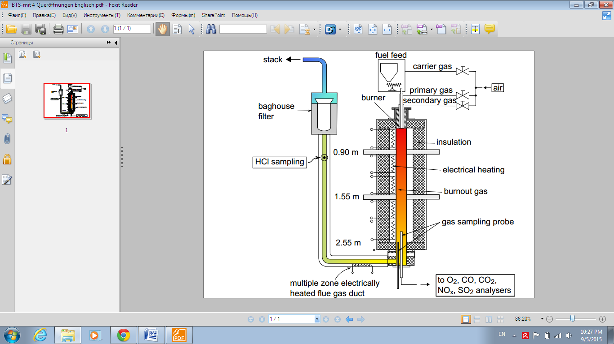
Fig. 20 kW vertical Reactor
Recent Publications (minimum 5)
- Al-Makhadmeh L., J. Maier, MA Batiha and G. Scheffknecht (2017) Oxy-fuel technology: Oil shale desulphurisation behaviour during staged combustion. Fuel, 190, 229–236. Online on 26/11/2016.
- Al-Makhadmeh L., MA Batiha (2015) Removal of Iron and Copper from Aqueous Solutions Using Jordanian Kaolin and Zeolitic Tuff. Desalination and Water Treatment, 2015. 1-14.
- Al-Makhadmeh L., J. Maier, M. Al-Harahsheh and G. Scheffknecht (2015) Oxy-fuel technology: Oil shale desulphurisation behaviour during unstaged combustion. Fuel, 158, 460–470.
- Mohammad Al-Harahsheh, Awni Al-Otoom, Leema Al-Makhadmah, Ian E Hamilton, Sam Kingman, and Sameer Al-Asheh (2015) Pyrolysis of Poly(vinyl chloride) and –Electric Arc Furnace Dust Mixtures. HAZMAT, Jun 25; 299: 425-436.
- Al-Makhadmeh L., J. Maier and G. Scheffknecht (2014) Oxy-fuel technology: NO Reduction During Oxy-Oilshale combustion. Fuel, 128, 155–161.

Biography (150 word limit)
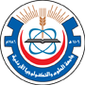
Leema Almakhadmeh, Associate Professor, Department of Environmental Engineering/Al-Hussein Bin Talal University and Department of Chemical Engineering/Jordan University of Science and Technology- Jordan. B.Sc. and M.S degrees from Jordan University of Science and Technology, Ph.D degree from Stuttgart University/Germany. Research areas are: oxyfuel combustion, pyrolysis and char combustion, emission control technologies (NOx, SOx, PM), and others.

Email:
l.a;-makhadmeh@ahu.edu.jo, lamakhadmeh@just.edu.jo

Notes/Comments:

Presenting author details
Full name: Leema Abd Al-Rahman Al-Makhadmeh
Contact number:+962798345597
Mail id:
Category: (Oral presentation/ Poster presentation): Oral presentation

