Simulating Drilling Fluid Induced Emulsions for Fluids Separation Testing

Scarborough, J.; Franca, L.; Ledesma, T.; †Fritz, S.; †Legan, R.

Baker Hughes, Upstream Chemicals, Sugar Land, Texas
† Baker Hughes, Upstream Chemicals, Bakersfield, California
Abstract
Drilling new wells is a conventional method for companies to maintain standard oil production decline. Many of these new wells are drilled in existing fields to produce from zones that are considered economical. Companies initially produce fluids into a frac tank to prevent production fluids contaminated with drilling mud from flowing to the production facilities. However, most wells still contain enough contaminants that cause drilling fluid induced emulsions during initial production to the plant. Several types of drilling fluids were identified as potential candidates for drilling the new wells, consisting of water-based, brine-based, oil-based, and synthetic-based drilling muds. Multiple tests were completed to simulate the effects of the drilling mud on the production system. These fluids were added in iterations of less than one percent based on total production. Each drilling fluid iteration was treated with varying fluid separation chemicals, applying different dosages and strategies. The fluids separation test identifies the least impactful drilling fluid on the production fluids. The test also highlights the optimal fluids separation chemistry to treat the new wells.
Introduction
In this case study, a customer was planning to expand their field by drilling several hundred new horizontal wells. Upon completion of the new wells, the customer planned to flow all production fluids straight to the production facility. As mentioned before, flow back to frac tanks is a typical procedure to prevent system upsets in the fluid separation process. The customer needed help identifying the potential flowback issues from various drilling mud candidates.
The drilling fluid candidates included one water-based mud (WBM), one oil-based mud (OBM), one low-solids non-dispersed mud (LSND), and two synthetic based muds (SBM). To begin the study, samples of crude oil mixed with different drilling fluids were tested at different temperatures and fluid mixture ratios to observe the emulsion tendency. The different temperatures highlighted the effect of how heat-driven resolution of the drilling fluid induced emulsion. Unsure of the oil/water ratio of new wells, various water cuts were tested with temperature to capture a range of possibilities.
After the drilling muds were tested for emulsion tendency, various demulsifiers were used on the worst case drilling fluid induced emulsion. Different chemistries were screened at various dosages to establish an operating window for use during the flow back period. Once an operating range was established, more products were tested to find the most effective and economical treatment solution. The treatment solutions were analyzed further to find trends in chemistries that effectively break the drilling fluid induced emulsion.
Statement of Theory and Definitions
The oilfield emulsion is a fluid containing oil, water, and a stabilizing agent. Without a stabilizing agent, oil and water will not emulsify. No amount of agitation will create an oilfield emulsion without these stabilizing agents. Stabilizing agents are surface-active materials that are soluble in both oil and water¹. The stabilizing agent in this case study is the residual drilling mud flowing back to the production facility.
Drilling mud A is a LSND mud. LSND muds are various molecular weight long chain polymers that provide viscosity for control of fluid loss. These polymer fluids have clays incorporated through dilution, encapsulation, and/or flocculation. Various types of polymers used include guar gum, xanthan gum, starch, polyacrylates, cellulosics, polyacrylamides, and maleic anhydride derivitives³. Figure 1 illustrates the structure of a polyacrylamide molecule.
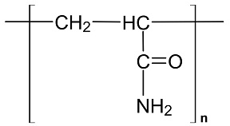
Figure 1: Structure of a Polyacrylamide (PAM) Molecule

The WBM is labeled as drilling fluid B. WBMs are frequently used due to their low cost compared to other drilling muds. This type of drilling fluid has water as the continuous phase and may be fresh, hard, or salty depending on the application and costs involved. Natural clays are added to increase the density, viscosity, gel strength, and yield point while decreasing the amount of fluid loss to the formation². These clays create a filter cake on the formation wall to help with the fluid loss. Drilling fluid lost to formation and parts of the filter cake not cleaned from drilling operations will flow back to the production facility in this case study.
The SBM drilling fluids are labeled as C and E in the testing. A SBM is an emulsified mud with synthetic oil as the external (continuous) phase, water as the internal (non-continuous) phase, and a surfactant. The synthetic oils typically consist of fatty acid ester-based oils and branched chain synthetic hydrocarbons like polyalphaolefins (PAOs). Like OBMs, SBMs also have emulsifiers and wettability agents added. Figure 2 illustrates the structure of a polycarboxylic acid ester.
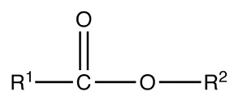
Figure 2: Structure of a Polycarboxylic Acid Ester

Drilling mud D is classified as an OBM. OBMs have a continuous liquid hydrocarbon phase. Diesel is generally used due to its viscosity characteristics, low flammability, and low solvency for rubber. Water is present in OBMs in the form of an emulsion. Chemical emulsifiers must be added to OBMs to prevent water droplets from coalescing and settling out of the emulsion. Wettability agents are also added to make the solids preferentially oil wet rather than water wet⁴.
It is important to establish the best demulsifier to be used after determining the severity of the induced emulsion created from the various drilling muds. Demulsifiers are mostly oil-soluble products with both hydrophilic and hydrophobic tendencies that disperse into the oil external emulsion and break the emulsifying agent surrounding the water phase⁵. Once the emulsifying agent is broken, water coalesces to form larger drops⁶. The crude in this case has a low API requiring longer retention times, high heat input, and higher dosage rates.
Demulsifier selection for an oil production facility uses a procedure called “The Bottle Test”. This test uses a chemical free sample of emulsion from the system. The goal is to simulate the system fluid movement (agitation), retention time, temperature, and vessel performance. One must observe the vessel mechanics to choose an effective procedure. Demulsifiers are tested and compared based on the ability to separate water, lower oil in water (OIW), dehydrate the oil, and minimize the salt content in the oil^{7, 8}.
Testing Methodology
Emulsions are very sensitive and prone to change their characteristics over time and location. To mitigate these types of variables, testing should be performed onsite. However, this may be difficult depending on the resources available. In this case, testing should be performed as soon as possible. The following procedure describes the steps involved to simulate the drilling fluid induced emulsions with the different types of drilling mud.
Create the drilling mud induced emulsion by: (1) Collect emulsion/oil and brine samples from targeted wells specified by the customer. (2) Centrifuge a sample of the emulsion/oil fluid to determine the free brine and emulsified brine in the system. (3) Fill prescription bottles with the calculated oil/emulsion and brine to achieve the final water cuts of 20%, 30%, 50%, 90%. (4) Dose each bottle with 0.5% (~5000 ppm) of the desired drilling fluid. (5) Shake the bottles fifty times and place bottles in three different water baths at 120˚F, 75˚F, and 40˚F. (6) Once the internal fluid temperature equilibrates to the desired temperature, shake the bottles at a high speed in the mechanical shaker for five minutes, stop one minute, and shake again for one minute. (7) Place the bottles back in the water bath and begin to record solids precipitation, water separation, and interface quality at various time intervals. (8) Perform a composite grindout by thieving the free water from the bottle until only oil remains. (9) Shake the bottle and pour into a centrifuge tube. (10) Perform the grindout according to API standards. (11) Record the results using the measurements and descriptions as seen in Figure 3.

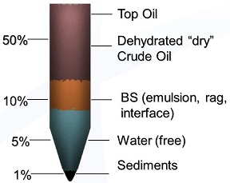

Figure 3: Characterization of Grindout

To set up the demulsifier test, start by: (1) Collect representative demulsifier free produced fluid samples. (2) Drain free water from sample containers; keep the free water in a separated container. (3) Centrifuge produced fluid sample to obtain the baseline BS&W. (4) Perform initial ratio test with incumbent demulsifier to determine the range of dosage rates in the bottle. (5) Fill prescription bottles with 50mL of oil, 49.5mL of brine, and 0.5mL of drilling mud. (6) Shake the bottles fifty times and place bottles the water bath at 70˚F. (7) Once the internal fluid temperature equilibrates to the desired temperature, dose each bottle with demulsifier at the specific concentration in the test. Each test should include a blank sample and incumbent sample as baseline. (8) Shake the bottles on high speed for five minutes. (9) Place the bottles back in the water bath and begin to record solids precipitation, water separation, and interface quality at various time intervals un. (10) Take the bottles out of the bath at 90 minutes. Observe final water and interface quality.
Observations and Results
Production fluids from various wells were used in this study. The wells were scattered across the field and completed within different parts of the reservoir. Collecting a variety of production fluids in different locations assists the customer in developing certain drilling mud packages for each. The data in this section focuses on only one of the wells used.
The first series of tests focused on the impact of drilling mud to the production system. Water separation in this test is the primary focus. Upon arrival to a production facility, the fluids enter the Free Water Knockout (FWKO). The purpose of the FWKO is to separate the free flowing brine from the emulsion. In Charts 1-3, the least problematic drilling fluids should have close to 100% water separation.

Chart 1: 60 Minute Fluid Separation Results at 120˚F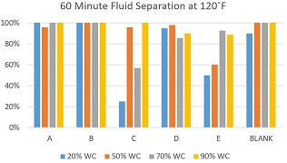
Chart 2: 60 Minute Fluid Separation Results at 70˚F
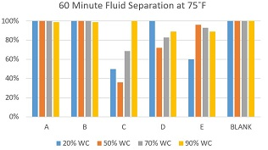

Chart 3: 60 Minute Fluid Separation Results at 40˚F
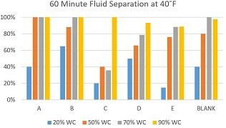
Drilling fluid A, B, and the blank drop almost all of the water within the 60 minute period at 120˚F and 75˚F. These all have some issues with fluid separation at 40˚F. Many factors could influence this behavior that are out of the scope of this research. Drilling fluids C, D, and E all show potential of emulsion issues due to their poor water separation at various watercuts and temperatures. Drilling fluid D shows better ability to coalesce water compared to C and E. Figure 4 provides a visual fluid separation, water quality, and interface quality for the 50% watercut test at 120˚F.
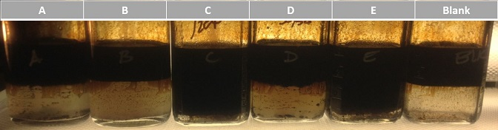
Figure 4: Emulsion Tendency of each Drilling Fluid
Fluid separation is a qualitative test and is performed with little equipment required. However, fluid separation is only part of the puzzle. Oil must meet the pipeline specification for water content. Without proper oil dehydration and analysis, this is unattainable. Oil dehydration is analyzed via the composite grindout. Charts 4-6 analyze the volume of water and unresolved emulsion suspended in the oil phase for the 70% water fluids. Water separation and oil dehydration do not always correlate and is important to analyze both parameters.
Chart 4: Grindout Results for 70% WC at 120˚F
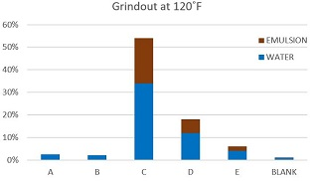
Chart 5: Grindout Results for 70% WC at 75˚F
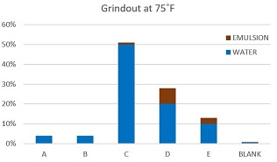
Chart 6: Grindout Results for 70% WC at 40˚F
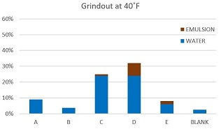
Drilling fluids A, B, and Blank have very low unresolved emulsion and small volumes of water suspended in the oil phase. Drilling fluid E shows both unresolved emulsion and water in the oil. However, fluid E averages to less than 10% BS&W at the end of each test. Drilling fluid C and D show signs of being problematic in a production system. These fluids have emulsifiers that create strong films preventing the water to coalesce in the oil phase. To break these emulsions, large amounts of demulsifier are needed.
Sediments are measured in the composite grindout as seen in the example in Figure 3. Sediments can be formation fines, scales, paraffin, asphaltenes, drilling mud particulates, and other solids or gels from various oilfield operations. After close analysis, these sediments are identified as drilling mud particles and formation fines. Charts 7-9 provide the volume of sediments suspended in the oil phase and interface. Sediments have the potential to build an interface in a vessel and cause separation issues. However, some vessels do not have the ability to mud wash the bottoms to clean solids that precipitate in the water phase. In these scenarios it is best to have vessels with an interface draw system to send the interface to slop tanks for special separation treatment.

Chart 7: Sediment Results for 70% WC at 120˚F
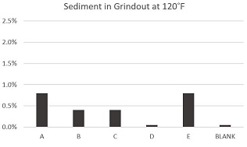
Chart 8: Sediment Results for 70% WC at 75˚F
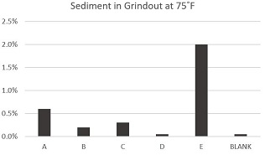
Chart 9: Sediment Results for 70% WC at 40˚F
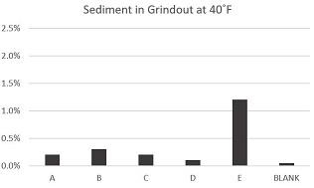
Figure 5 shows how fluid A precipitates many of the solids to the bottom of the bottle in the water phase. This fluid is a LSND mud having clays suspended in a polymer phase. After agitation, the LSND mud appears mixed with the produced fluids and begins to settle while entraining other formation fines along the way. This can be detrimental to systems that do not have mud wash capabilities on the bottom of the vessels.
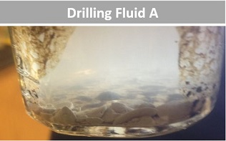
Figure 5: Sediment Precipitation in Drilling Fluid A
In all the tests, similar trends were observed between all of the drilling muds. Drilling mud A allows good fluid separation at various temperatures and water cuts. Solids precipitate at the bottom of the bottle and some remain at the interface creating an uneven (i.e. raggy) interface. Drilling fluid B has the least impact on fluid separation and dehydration. These results are expected since fluid B is a WBM. This is the preferred drilling mud to be used when wells will flowback directly to the production facility. Drilling fluid D created oil dehydration and water quality difficulties. Oil covered fines were noticed at the interface, creating an emulsion pad. Drilling fluids C and E are the most problematic for fluid separation and water quality. Fluid C is worse than E because of the amount of BS&W within the oil phase seen in Figures 4-6. The emulsifiers and wettability agents in the SBMs have the tendency to create drilling fluid induced emulsions upon flowback to the production facility.
Drilling fluid C was used for the demulsifier test as it provided the worst case scenario during flowback to a production facility. The demulsifier test used a similar procedure as before. Only fluid separation, water quality, and interface quality were noted in this test. Various demulsifiers were tested to find the best solution. Figures 6-8 provide a visual comparison of a few demulsifiers.
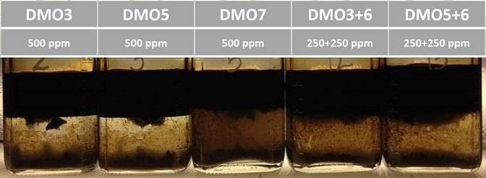
Figure 6: Demulsifier Test at 500 ppm
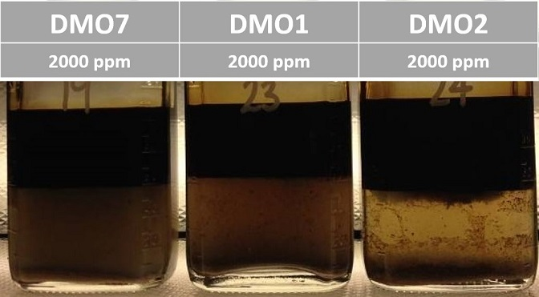
Figure 7: Demulsifier Test at 2000 ppm
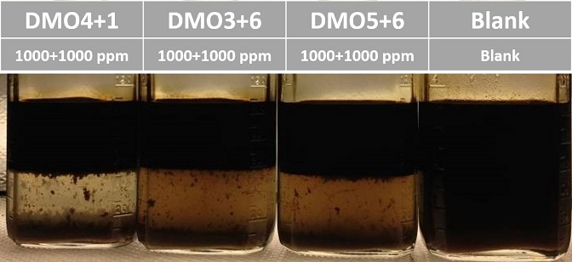
Figure 8: Demulsifier Combination Test at 2000 ppm
The speed of separation is important within a production system, as most of the field brine must be separated from the bulk fluid. The water is then sent into the water treatment system. The most effective treatment for this type of system must have good water and interface quality along with fast water separation. Charts 10-12 provide trend the speed of fluid separation with the tests.
Chart 10: 90 Minute Fluid Separation for 500 ppm Demulsifier Test
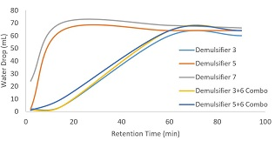

Chart 11: 90 Minute Fluid Separation for 2000 ppm Demulsifier Test
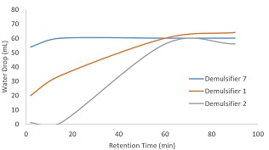
Chart 12: 90 Minute Fluid Separation for 2000 ppm Demulsifier Combination Test
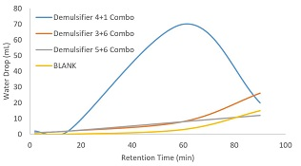
Demulsifier 5 and 7 show fast separation at 500 ppm in Chart 10. In this type of system, water quality is very important as the water is processed and used for other industries. Demulsifier 5 provides better water quality compared to Demulsifier 7 as seen in Figure 6. Demulsifier 5 has a heavy pad interface and oil-wet solids at the bottom of the bottle. This is not easily visible in the picture but can create issues in a production system. A heavy pad interface can create solids build-up in the pad creating wet-oil issues within the rest of the production system. Although the water quality in Demulsifier 7 is worse, the interface is loose allowing effective fluid separation. Many of the solids are suspended in the water phase. Both deposit solids at the bottom which will require routine clean outs during the drilling campaign.
Combination products were attempted to achieve good water and interface quality along with fluid separation, however, these products needed high dosage rates. Chart 12 shows the Demulsifier 4+1 combo separating the fluids but then decreasing towards the end of the test. This phenomenon is due to pad growth at the interface. The result is the water beginning to re-emulsify into the oil.
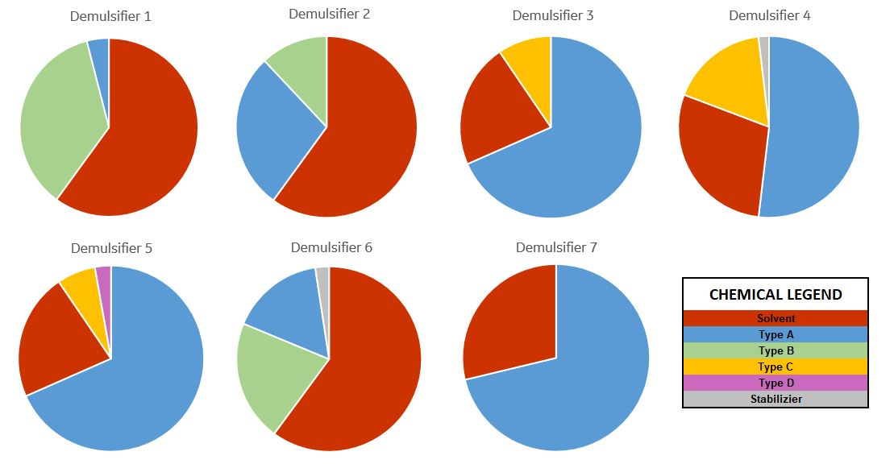
Figure 9: Base Chemistry Breakdown of each Demulsifier
Figure 9 breaks down the generalized chemistry families found in each of the demulsifiers. All of the demulsifiers are primarily made with a solvent and the Type A chemistry. Demulsifier 5 and Demulsifier 7 showed fast fluid separation. Type C assisted with water clarity in Demulsifier 5. It is believed that the Type D chemistry has a negative impact on the interface. Due to the poor interface quality, Demulsifier 5 is not ideal for this system.
Demulsifier 7 has a loose interface. The loose interface will ensure that fluid separation will not be an issue. The poor water quality due to the suspended oil wet sediments is a negative with this demulsifier, but can be fixed mechanically using an air flotation/flocculation system with a water clarification chemistry. The combination of these two will use chemical and mechanical flocculation technologies to lift the oil wet solids to be skimmed and sent for slop oil treatment.
Conclusions
WBMs are the best drilling muds to use when given the option. WBMs will be the least problematic when flowing wells directly to the production facility instead of frac tanks. They also tend to be cheaper than most other muds. LSND muds are another good option if planning to flow wells directly to a production facility. In this scenario, it is important to prepare for solid precipitation within the vessel of the production facility. Slop tanks and routine vessel mud washing programs should be in place for optimal facility performance. OBMs and SBMs require additional planning. These drilling fluids will create many issues upon entering the production facility. Chemical testing should be performance prior to the drilling campaign.
Chemical testing may take time to gather enough data to characterize how the fluids will respond to drilling mud with various watercuts and temperatures. When testing demulsifiers, look for chemistries like Type A that provide rapid fluids separation. If the chemistry leaves oil-wet solids dispersed in the water phase, other chemistries that provide synergies to effectively flocculate the oil particles in the water phase may need to be blended. This scenario using SBM represents the worst case for residual drilling mud returns to the production system. Drilling mud may flow back in traces or in slugs up to six months after a well begins to produce.

ACKNOWLEDGEMENTS
We would like to thank everyone who spent long hours in the field to sample wells and perform the tests through the evening. We would like to thank Baker Hughes, a GE Company for allowing us to publish these results. We would also like to thank Petrophase 2019 for the invitation to present our research.

References
- Sjoblom,J. 1996. Emulsions and Emulsion Stability,Vol.61. New York, New York : Dekker
- Chilingarian, G.V.; Vorabutr, P., 1983. Drilling and Drilling Fluids, Updated Textbook Edition. New York, New York: Elsevier.
- Carico, R.D.; Bagshaw, F.R., 1978. Description and Use of Polymers Used in Drilling, Workovers, and Completions. AIME Prod. Tech. Symp., Hobbs, N.M., SPE Pap. 7747: 6pp.
- Bourgoyne Jr. A.T.; Chenevert, M.E.; Millheim, K.K.; Young Jr., F.S. 1986. Applied Drilling Engineering, Volume 2. Richardson, Texas. Society of Petroleum Engineers.
- Petroleum Extension Service. 1990. Treating Oilfield Emulsions, Fourth edition. Austin , Texas: Petex.
- Lossant,K.1974. Emulsions and Emulsion Technology,Vol.6. New York, New York : Dekker
- Arnold, K.; Stewart, M. 2009. Emulsion and Oil Treating Equipment, First edition. Burlington, Massachusetts: Gulf Professional Publishing.
- Scarborough, J.; Mega-Franca, L.; Ibrahim, M. 2019. Minimise System Upsets in High Oil Production Facility throughout Demulsifier Chemical Trial. Presented at the International Petroleum Technology Conference, Beijing, China, 26-28 March 2019.

