“DEVELOPMENT OF ACTIVATED NANO PARTICLE FLY-ASH DRILLING FLUID ADDITIVES” AN ALTERNATIVE FOR BENTONITE.
Ajay Kumar Sahu, Lovely Professional University, Jalandar,(144411), India.

Abstract
Colloidal properties of drilling fluids are exhibited by bentonite clay particles where montmorillonite is the principle constituent. Due to crystal defect in montmorillonite, bentonite possesses swelling property and is used to maintain gel strength and viscosity of drilling fluid. Bentonite is a naturally occurring material and the price of bentonite is increasing day by day, therefore a viable alternative to bentonite needs to be developed that should be mechanically strong, physically small, thermally stable, environmentally benign chemical.
Fly ash has a similar chemical composition as that of bentonite, which makes it appropriate for evaluation as replacement of bentonite. Fly-ash is a pozzolanic material, a mixture of several mineral oxides, and considered as a major environmental pollutant. Major components of fly ash are Silicon dioxide (SiO₂), Ferric oxide (Fe₂O₃), Aluminum oxide (Al₂O₃) and Calcium oxide (CaO). Mineralogical properties of fly ash are almost identical with bentonite. The major problem with fly-ash is that it is chemically inert.
In this study appropriate functionalization has been carried out on fly ash to generate active sites on fly-ash surface, which may have similar or even better surface properties as compared to the bentonite. Aqueous drilling fluid suspensions were prepared using different solid content of activated fly ash and API bentonite. Rheological studies were performed for both bentonite and activated fly ash mixture with varying solid loading.
Finally, after comparing all the test results it could be concluded that activated fly ash can replace bentonite for preparing colloidal suspensions. It is an economic replacement and also it helps in reduction of solid waste through recycling of fly ash for oil well drilling operations.
In this study, we have proposed the efficient utilization of waste fly-ash as a drilling fluid for oil well drilling through processing and estimating rheological properties.

Keywords: bentonite, fly-ash, functionalization, rheological studies, reduced solid waste, economical.

Image

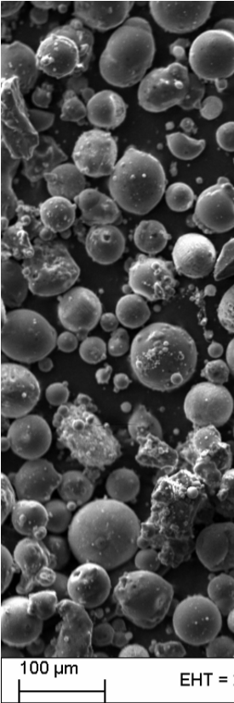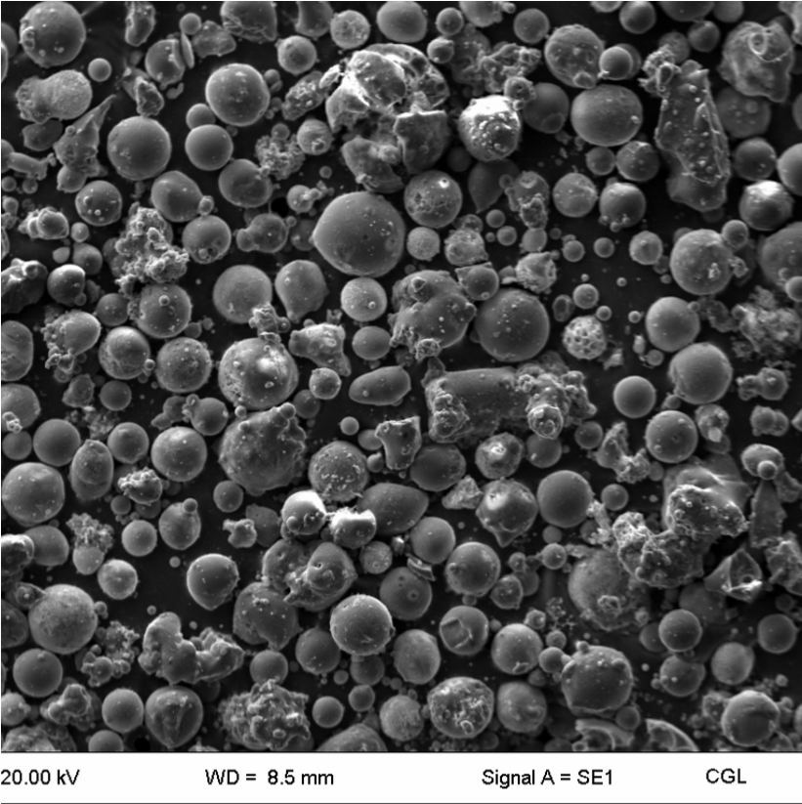

SEM- microphotograph of virgin fly ash
Recent Publications (minimum 5) (If not leave as blank)


Biography
I have post graduated from the renowned university of Indian School of Mines and had done the above study as an academic project. Recently I joined Lovely Professional University as an Assistant Professor in the Petroleum Engineering Department.
Email:sahuajay91@gmail.com
Contact no: 7280993339
DOB (Date of Birth): 22/12/1990
LinkedIn account: sahuajay91@gmail.com
Track:
Category - Oral (or) Poster: Oral
Notes/Comments:

