Ajay Kumar Sahu*
Asst. Professor (Chemical and Petroleum Engineering Department)
Lovely Professional University, Punjab-144411, (India)

ABSTRACT:
Colloidal properties of drilling fluids are exhibited by bentonite clay particles where montmorillonite is the principle constituent. Due to crystal defect in montmorillonite, bentonite possesses swelling property and is used to maintain gel strength and viscosity of drilling fluid. Bentonite is a naturally occurring material and the price of bentonite is increasing day by day, therefore a viable alternative to bentonite needs to be developed that should be mechanically strong, physically small, thermally stable, environmentally benign chemical.
Fly ash has a similar chemical composition as that of bentonite, which makes it appropriate for evaluation as replacement of bentonite. Fly-ash is a pozzolanic material, a mixture of several mineral oxides, and considered as a major environmental pollutant. Major components of fly ash are Silicon dioxide (SiO₂), Ferric oxide (Fe₂O₃), Aluminum oxide (Al₂O₃) and Calcium oxide (CaO). Mineralogical properties of fly ash are almost identical with bentonite. The major problem with fly-ash is that it is chemically inert.
In this study appropriate functionalization has been carried out on fly ash to generate active sites on fly-ash surface, which may have similar or even better surface properties as compared to the bentonite. Aqueous drilling fluid suspensions were prepared using different solid content of activated fly ash and API bentonite. Rheological studies were performed for both bentonite and activated fly ash mixture with varying solid loading.
Finally, after comparing all the test results it could be concluded that activated fly ash can replace bentonite for preparing colloidal suspensions. It is an economic replacement and also it helps in reduction of solid waste through recycling of fly ash for oil well drilling operations.
In this study, we have proposed the efficient utilization of waste fly-ash as a drilling fluid for oil well drilling through processing and estimating rheological properties.

Keywords: bentonite, fly-ash, functionalization, rheological studies, reduced solid waste, economical.

INTRODUCTION:
Fly-ash is a pozzolanic material comprising of several mineral oxides. It is considered as a major environmental pollutant all over the world. Thermal power plants produces huge amount of fly ash and now it becomes world largest quantity of solid waste leading to severe disposal problem.
In oil well drilling application, fly ash was mainly used for the stabilization of drilling fluid wastes to avoid ground water contamination (Deeley & Laguros, 1987 and Thompsom, 1984). It was also used as a formable drilling fluid for deep water offshore well operations (Totten, J.E. Griffth, 1997). Water based drilling mud typically contains clays, barite, lime, caustic soda and other chemicals. If the cuttings contain too much liquid, land disposal of these wastes raises groundwater pollution and difficult to reuse for construction purposes. Fly ash was usually used to reduce free water and toxic contaminants by solidification (which is also referred to as encapsulation, briquetting, fixation, and stabilization). Usually, hydration of the fly ash forms a crystalline structure, consisting of calcium-alumina-silicate which results a rock-like, monolithic and hardened mass (Conner). High-calcium (Class-C) fly ash has the property of cementation and is very useful in stabilizing the drilling fluid. Mahlaba-et-al studied the slurry behavior of fly ash and brine suspension as backfill materials to conserve fresh water. Recently, Yang and Tang studied the effectiveness of fly ash and poly-acryl-amide composite as a sand fixing agent for wind erosion control.
About 53.0% of India’s energy supply is based on coal and shall be so for few the next few decades. There are about 82 coal fired thermal power stations producing approximately 130 million tons of fly ash per year in the Country. Till date, nearly 38.0 % of fly ash has been successfully utilized in the Country at preset (reported by National Thermal Power Corporation, India) in various fields including land filling, cement making, concrete products making particularly bricks, blocks and tiles, road making, and mines backfilling. For efficient utilization of fly ash in different areas, it is essential to know the flow behavior of fly ash slurry suspension with varying particle size, particle size distribution and particle loading.

EXPERIMENTAL WORK
Rheological analysis of aqueous solution of Bentonite and Activated Fly are done separately at room temperature.

MATERIAL USED
Virgin fly ash was collected from thermal power plant (Rihand, Noida, India) with the following specifications: Specific gravity between 2-2.5 and particle size in the range of 10-100 μm. Chemical assay of virgin fly ash was determined using X-Ray Fluorescence (Model: PW-1710; Make: Philip) with the following composition (wt %): SiO₂ =59.23, Al₂O₃ =32.16, Fe₂O₃ =5.03, CaO =0.9 and TiO₂ =2.59. Morphological analysis of virgin fly ash using Scanning Electron Microscope (Model S-440, LEO) was carried out and the microphotograph is shown in Fig. 1. It reveals that fly ash particles are spherical and smooth. Zinc chloride (SD Fine-Chem Ltd., Mumbai, India) with specific gravity: 2.91. On the other hand Bentonite powder is provided by Central drug house (P) ltd. Delhi having a molecular formula H₂Al₂O₆Si. Atomic or molecular weight =180.
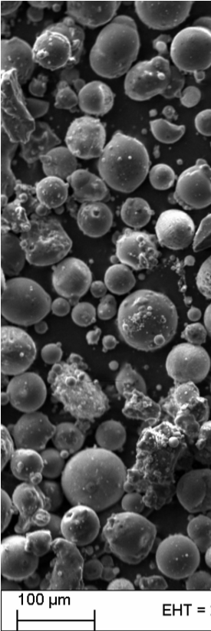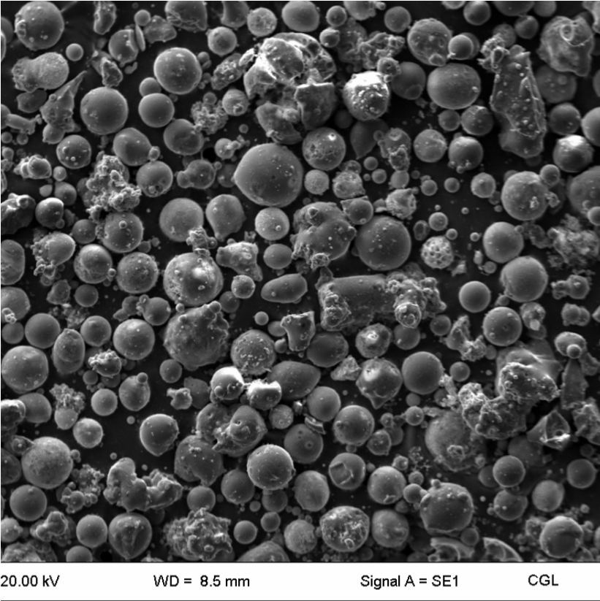
Figure 1: Scanning Electron microscope microphotograph of virgin fly ash

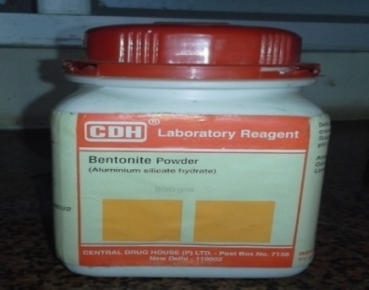
Figure 2: API Bentonite

FUNCTIONALIZATION OF FLY ASH
Fly ash is inert in nature and without functionalization it does not react with any other material. A method of forming functionalized fly ash particles includes contacting a plurality of fly ash particles with a hydroxide compound under conditions to directly bond oxygen onto a surface portion of the plurality of fly ash particles. The plurality of fly ash particles having oxygen directly bound to their surface portion are reacted with an organic alcohol or an organic acid to covalently bond hydrophobic groups in the form of condensation residue from the organic alcohol or organic acid to the oxygen(O) to form the plurality of functionalized fly ash particles.
Fly ash sample is first screened through an 80-mesh size to eliminate the larger particles. The un-burnt carbon along with the volatile materials is removed through calcination process where fly ash is kept at 800° Celsius for 2 hour. After that fly ash sample is treated with Hydrochloric acid to improve its reactivity. Then again it is kept in a vacuum dryer for 24 hour. After talking out the sample it is reacted with a monomer in the presence of Calcium catalyst. Epoxide functional group is added and hydrolysis of the sample is performed which breaks the epoxide group and formed a di-ol group. The simplified flow chat of the entire process is given below.
.
Figure 3: Flow chat for fly ash preparation
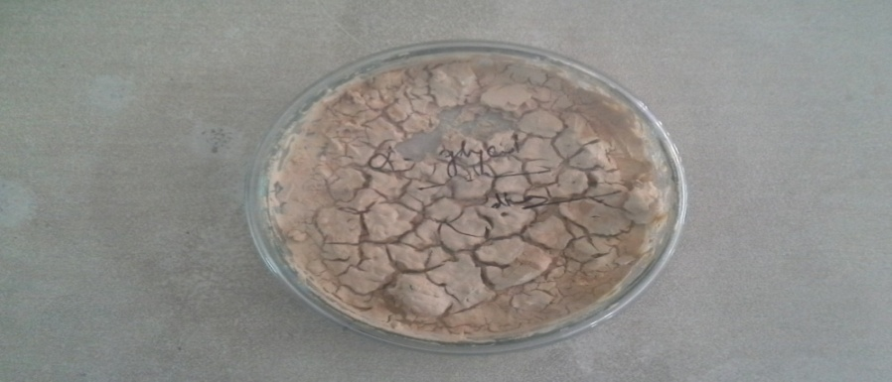
Figure 4: Activated Fly ash sample

PREPARATION OF MUD SAMPLE
Base mud sample, containing only water and bentonite clay, was prepared by adding 3g, 6g, 9g, 12g and 15 g of bentonite to 300 liters of water to obtain a bentonite mass fraction of 1%, 2%, 3%, 4% and 5%. This mud sample was named “mud A, mud B, mud C, mud D and mud E”. Again, mud sample containing Activated Fly ash and tap water, was prepared by adding 3g, 6g, 9g, 12g and 15g of activated fly ash to 300 liters of water to obtain a fly ash mass fraction of 1%, 2%, 3%, 4% and 5%. This mud sample was named mud F, mud G, mud H, mud I and mud J. The rheological properties of this mud’s were measured and recorded. Other mud samples with varying additive concentrations were prepared and their rheological properties were measured and recorded. All rheological properties were measured at ambient conditions (at 75ºF).
Mud sample | Bentonite weight (g) | Water
Mud A | 3 | 300
Mud B | 6 | 300
Mud C | 9 | 300
Mud D | 12 | 300
Mud E | 15 | 300
Table 1: Composition of Bentonite mud samples

Same procedure was repeated using fly ash. Composition of fly ash is listed below:
Percentage | Activated Fly ash weight (g) | Water
Mud F | 3 | 300
Mud G | 6 | 300
Mud H | 9 | 300
Mud I | 12 | 300
Mud J | 15 | 300
Table 2: Composition of activated fly ash mud samples

RESULTS AND DISCUSSION
Several rheological tests were performed with the help of FANN viscometer on the prepared mud samples with different solid loading. Then test results were compared.

PLASTIC VISCOSTY, YIELD POINT AND APPARENT VISCOSITY MEASUREMENT
% | ᶿ600 | ᶿ300 | ᶿ200 | ᶿ100 | ᶿ6 | ᶿ3 | PV  (cP) | YP  (lb/100ft²) | AV  (cP)
1 | 6 | 4.5 | 3 | 2.5 | 2 | 1 | 1.5 | 3 | 0.75
2 | 9 | 7 | 5 | 4.5 | 3 | 2 | 2 | 5 | 1
3 | 15 | 13 | 10.5 | 8 | 6 | 4 | 2 | 11 | 1
4 | 17 | 15 | 13.5 | 11 | 8 | 6 | 2 | 13 | 1
5 | 22 | 19 | 16 | 14 | 11 | 7 | 3 | 16 | 1.5
Table 3: Viscometer dial reading for Bentonite sample

% | ᶿ600 | ᶿ300 | ᶿ200 | ᶿ100 | ᶿ6 | ᶿ3 | PV  (cP) | YP  (lb/100ft²) | AV  (cP)
1 | 7 | 5 | 3.5 | 3 | 2.5 | 1 | 2 | 3 | 1
2 | 11 | 8 | 6 | 4 | 3.5 | 2 | 3 | 5 | 1.5
3 | 16 | 14 | 12 | 9 | 7 | 4 | 2 | 12 | 1
4 | 20 | 17 | 15 | 12.5 | 9 | 6 | 3 | 14 | 1.5
5 | 24 | 21 | 18 | 14 | 12 | 10.5 | 3 | 18 | 1.5
Table 4: Viscometer dial reading for activate fly ash sample.
Comparison between dial reading of both Bentonite and Activated mud samples i.e; dial reading vs rotational speed (in RPM) are show in the figure 5, figure 6, figure 7, figure 8, figure9 with varying solid loading. It is observed that with the increment of rotational speed, dial reading also increases for both aqueous bentonite and activated fly ash solution.
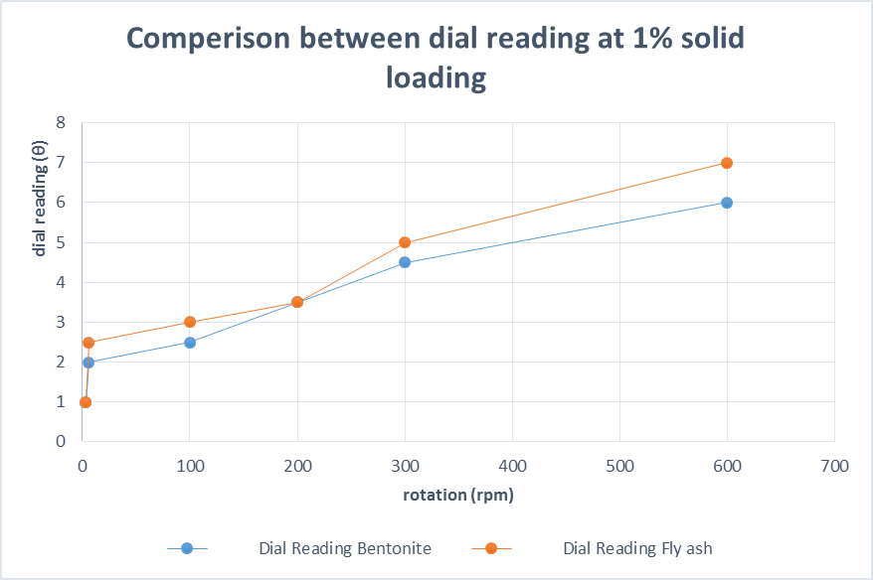
Figure 5: Comparison of dial reading between Bentonite and Activated fly ash with 1% solid loading
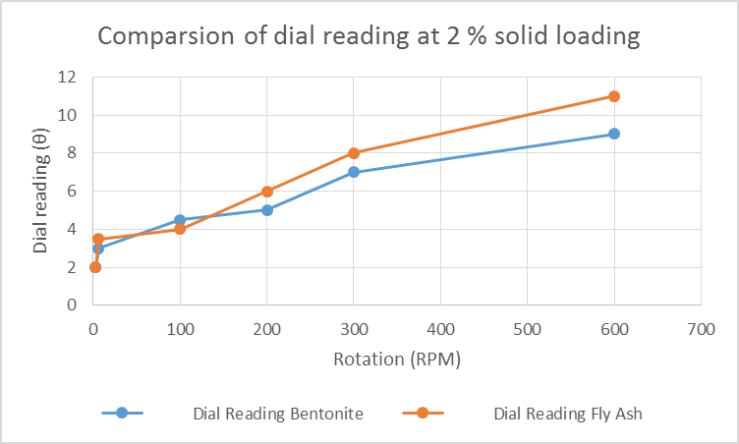
Figure 6: Comparison of dial reading between bentonite and activated fly ash with 2% solid loading
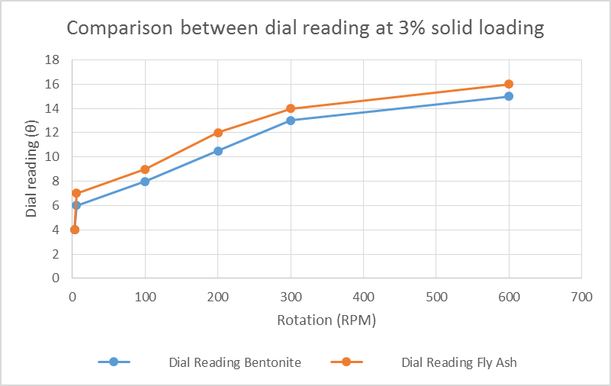
Figure 7: Comparison of dial reading between bentonite and activated fly ash with 3% solid loading
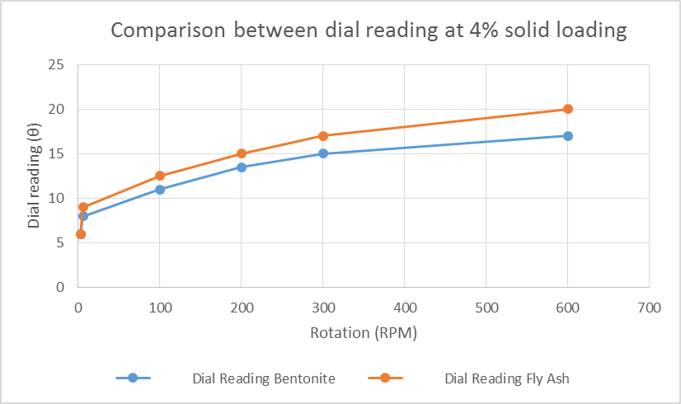
Figure 8: Comparison of dial reading between bentonite and activated fly ash with 4% solid loading
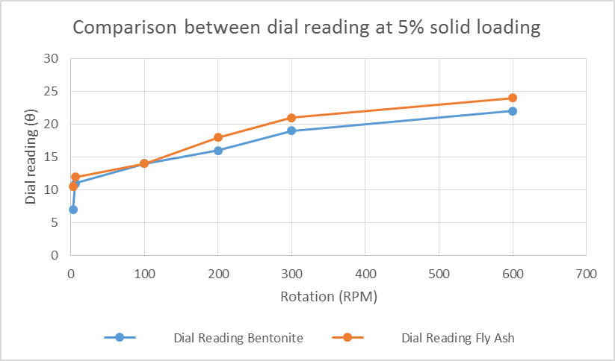
Figure 9: Comparison of dial reading between bentonite and activated fly ash with 5% solid loading
Plastic viscosity, Yield Point also calculated with viscometer dial readings and plotted (fig 10 & fig 11) against different solid loading for both bentonite and activated fly ash samples. It is observed that Plastic viscosity and Yield point values of fly ash solution are almost equal or better than conventional aqueous bentonite suspension.
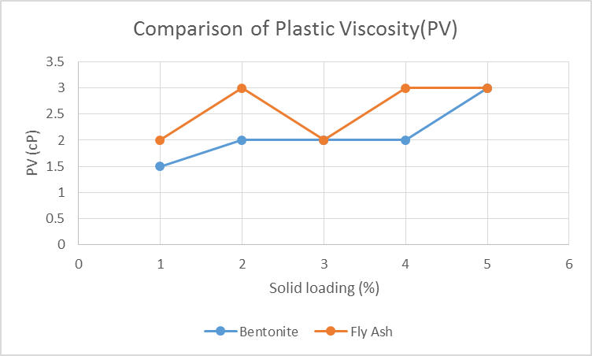
Figure10: Comparison of Plastic viscosity for Bentonite and activated fly ash

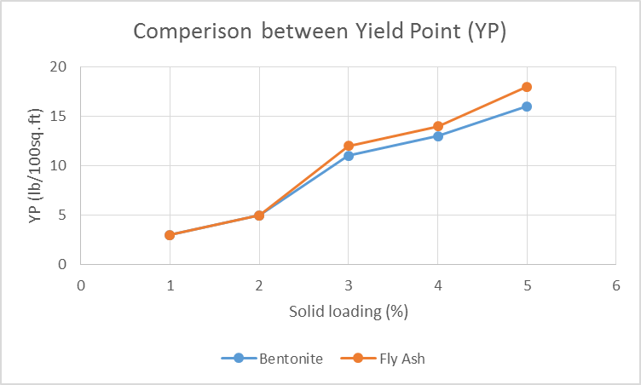
Figure 11: Comparison of Yield strength for Bentonite and fly ash
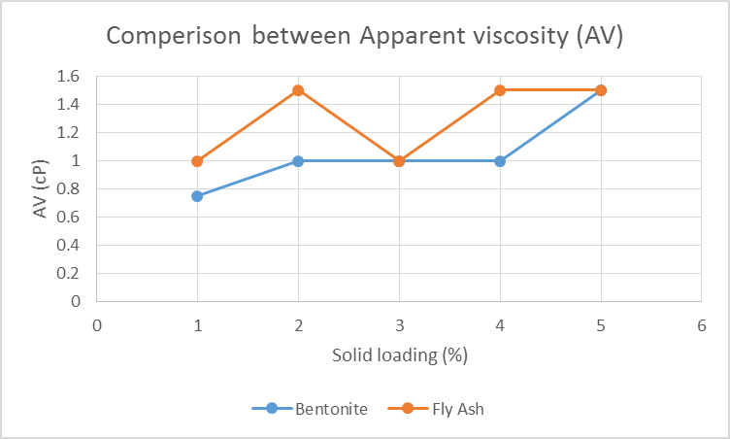
Figure 12: Comparison of Apparent viscosity between Bentonite and fly ash
Now, we calculate the shear rate value at bob wall using rotational speed (N) and viscometer dial reading (θ). First flow behavior index (ή) is calculated, and obtained from the slope of wall shear stress at the bob vs angular velocity (ω) plots. The best fit equation is obtained from logarithmic plots of shear stress vs angular velocity from table 4, which is lnτ=a₀+a₁lnω+a₂(lnω)².
After subsequent differentiation, we obtain the flow behavior index. It can be said that flow behavior index consequently increases with the increase in rotational speed.

SHEAR STRESS MEASUREMENT
Rotor rotation | Bob radius (mm) | Spring constant (Nm/scale reading) | Bob height (mm) | 2п | Shear stress(τ) Pa | Angular velocity (ω)
600 | 17.245 | 0.0000387 | 38 | 6.283 | 3.27028E-07 | 62.83
300 | 17.245 | 0.0000387 | 38 | 6.283 | 1.63514E-07 | 31.415
200 | 17.245 | 0.0000387 | 38 | 6.283 | 1.09009E-07 | 20.94333333
100 | 17.245 | 0.0000387 | 38 | 6.283 | 5.45047E-08 | 10.47166667
6 | 17.245 | 0.0000387 | 38 | 6.283 | 3.27028E-09 | 0.6283
3 | 17.245 | 0.0000387 | 38 | 6.283 | 1.63514E-09 | 0.31415
Table 5: Calculation of shear stress

Now wall shear rates for bentonite and activated fly ash are calculated and shear rate vs solid loading graphs are plotted (fig 13 & fig 14). It is interesting to observe that shear rate value of bentonite solution for a given particle size distribution increases with the increase in solid loading. The same cannot be said to fly ash solution as the shear rate value is independent of solid loading at a particular rotational speed. Shear rate value for both bentonite and activated fly ash are compared for different solid loadings and it can be observe that in most of the cases shear rate of bentonite solution is more than shear rate values of fly ash. This results in sufficient reduction of in viscosity of bentonite suspension at higher shear stress as compared to the fly ash suspension. Therefore shear thinning behaviour of bentonite suspension predominated over activated fly ash solution. This is mainly due to the crystalline charged surface of bentonite particles (Darly and Gray).

SHEAR RATE MEASUREMENT
% | Rotation | a1 | a2 | ln600 | ή | ω | ϔ (cm⁻¹) | Τ(Pa)
1 | 600 | 0.125 | 0.0469 | 6.397 | 0.725039 | 62.8 | 218.7646 | 3.27E-07
2 | 600 | 0.1081 | 0.0342 | 6.397 | 0.545655 | 62.8 | 264.4493 | 3.27E-07
3 | 600 | 0.033 | 0.032 | 6.397 | 0.442408 | 62.8 | 311.6841 | 3.27E-07
4 | 600 | 0.0551 | 0.0223 | 6.397 | 0.340406 | 62.8 | 390.3485 | 3.27E-07
5 | 600 | 0.0819 | 0.0162 | 6.397 | 0.289163 | 62.8 | 452.5168 | 3.27E-07
For 300 RPM
% | Rotation | a1 | a2 | ln300 | ή | ω | ϔ(cm⁻¹) | τ(Pa)
1 | 300 | 0.125 | 0.0469 | 5.7 | 0.65966 | 31.4 | 115.9139 | 1.64E-07
2 | 300 | 0.1081 | 0.0342 | 5.7 | 0.49798 | 31.4 | 141.7461 | 1.64E-07
3 | 300 | 0.033 | 0.032 | 5.7 | 0.3978 | 31.4 | 170.3592 | 1.64E-07
4 | 300 | 0.0551 | 0.0223 | 5.7 | 0.30932 | 31.4 | 212.7386 | 1.64E-07
5 | 300 | 0.0819 | 0.0162 | 5.7 | 0.26658 | 31.4 | 243.9472 | 1.64E-07
For 200 RPM
% | Rotation | a1 | a2 | ln200 | ή | ω | ϔ(cm⁻¹) | τ(Pa)
1 | 200 | 0.125 | 0.0469 | 5.29 | 0.621202 | 20.93 | 80.38725 | 1.09E-07
2 | 200 | 0.1081 | 0.0342 | 5.29 | 0.469936 | 20.93 | 98.91172 | 1.09E-07
3 | 200 | 0.033 | 0.032 | 5.29 | 0.37156 | 20.93 | 120.4369 | 1.09E-07
4 | 200 | 0.0551 | 0.0223 | 5.29 | 0.291034 | 20.93 | 149.9233 | 1.09E-07
5 | 200 | 0.0819 | 0.0162 | 5.29 | 0.253296 | 20.93 | 170.5627 | 1.09E-07
For 100 RPM
% | Rotation | a1 | a2 | ln100 | ή | ω | ϔ(cm⁻¹) | τ(Pa)
1 | 100 | 0.125 | 0.0469 | 4.61 | 0.557418 | 10.47 | 43.40223 | 5.45E-08
2 | 100 | 0.1081 | 0.0342 | 4.61 | 0.423424 | 10.47 | 53.88722 | 5.45E-08
3 | 100 | 0.033 | 0.032 | 4.61 | 0.32804 | 10.47 | 67.26826 | 5.45E-08
4 | 100 | 0.0551 | 0.0223 | 4.61 | 0.260706 | 10.47 | 83.04995 | 5.45E-08
5 | 100 | 0.0819 | 0.0162 | 4.61 | 0.231264 | 10.47 | 92.9672 | 5.45E-08
For 6RPM
% | Rotation | a1 | a2 | ln6 | ή | ω | ϔ(cm⁻¹) | τ(Pa)
1 | 6 | 0.125 | 0.0469 | 1.79 | 0.292902 | 0.628 | 4.472066 | 3.27E-09
2 | 6 | 0.1081 | 0.0342 | 1.79 | 0.230536 | 0.628 | 5.59295 | 3.27E-09
3 | 6 | 0.033 | 0.032 | 1.79 | 0.14756 | 0.628 | 8.604459 | 3.27E-09
4 | 6 | 0.0551 | 0.0223 | 1.79 | 0.134934 | 0.628 | 9.392993 | 3.27E-09
5 | 6 | 0.0819 | 0.0162 | 1.79 | 0.139896 | 0.628 | 9.065953 | 3.27E-09
For 3 RPM
% | Rotation | a1 | a2 | ln3 | ή | ω | ϔ(cm⁻¹) | τ(Pa)
1 | 3 | 0.125 | 0.0469 | 1.09 | 0.227242 | 0.314 | 2.834928 | 1.64E-09
2 | 3 | 0.1081 | 0.0342 | 1.09 | 0.182656 | 0.314 | 3.495511 | 1.64E-09
3 | 3 | 0.033 | 0.032 | 1.09 | 0.10276 | 0.314 | 6.143594 | 1.64E-09
4 | 3 | 0.0551 | 0.0223 | 1.09 | 0.103714 | 0.314 | 6.087679 | 1.64E-09
5 | 3 | 0.0819 | 0.0162 | 1.09 | 0.117216 | 0.314 | 5.394436 | 1.64E-09
Table 6: Calculation of Shear rate for API Bentonite:

Figure 13: Shear rate vs solid loading for aqueous bentonite solution.
% | Rotation | a1 | a2 | ln600 | ή | ω | ϔ(s⁻¹) | τ(Pa)
1 | 600 | 0.7254 | 0.0146 | 6.397 | 0.912192 | 62.8 | 194.9759 | 3.27E-07
2 | 600 | 0.0417 | 0.0279 | 6.397 | 0.398653 | 62.8 | 340.0967 | 3.27E-07
3 | 600 | 0.039 | 0.0396 | 6.397 | 0.545642 | 62.8 | 264.4537 | 3.27E-07
4 | 600 | 0.0252 | 0.0389 | 6.397 | 0.522887 | 62.8 | 273.0423 | 3.27E-07
5 | 600 | 0.0168 | 0.0414 | 6.397 | 0.546472 | 62.8 | 264.1565 | 3.27E-07
300RPM
% | Rotation | a1 | a2 | ln300 | ή | ω | ϔ(s⁻¹) | τ(Pa)
1 | 300 | 0.7254 | 0.0146 | 5.7 | 0.89184 | 31.4 | 98.41999 | 1.64E-07
2 | 300 | 0.0417 | 0.0279 | 5.7 | 0.35976 | 31.4 | 185.8573 | 1.64E-07
3 | 300 | 0.039 | 0.0396 | 5.7 | 0.49044 | 31.4 | 143.4481 | 1.64E-07
4 | 300 | 0.0252 | 0.0389 | 5.7 | 0.46866 | 31.4 | 148.715 | 1.64E-07
5 | 300 | 0.0168 | 0.0414 | 5.7 | 0.48876 | 31.4 | 143.8355 | 1.64E-07
200RPM
% | Rotation | a1 | a2 | ln200 | ή | ω | ϔ(s⁻¹) | τ(Pa)
1 | 200 | 0.7254 | 0.0146 | 5.29 | 0.879868 | 20.93333 | 66.00147 | 1.09E-07
2 | 200 | 0.0417 | 0.0279 | 5.29 | 0.336882 | 20.93333 | 131.329 | 1.09E-07
3 | 200 | 0.039 | 0.0396 | 5.29 | 0.457968 | 20.93333 | 101.0051 | 1.09E-07
4 | 200 | 0.0252 | 0.0389 | 5.29 | 0.436762 | 20.93333 | 104.9998 | 1.09E-07
5 | 200 | 0.0168 | 0.0414 | 5.29 | 0.454812 | 20.93333 | 101.5734 | 1.09E-07
100RPM
% | Rotation | a1 | a2 | ln100 | ή | ω | ϔ(s⁻¹) | τ(Pa)
1 | 100 | 0.7254 | 0.0146 | 4.6 | 0.85972 | 10.46667 | 33.34742 | 5.45E-08
2 | 100 | 0.0417 | 0.0279 | 4.6 | 0.29838 | 10.46667 | 73.27967 | 5.45E-08
3 | 100 | 0.039 | 0.0396 | 4.6 | 0.40332 | 10.46667 | 56.12396 | 5.45E-08
4 | 100 | 0.0252 | 0.0389 | 4.6 | 0.38308 | 10.46667 | 58.65438 | 5.45E-08
5 | 100 | 0.0168 | 0.0414 | 4.6 | 0.39768 | 10.46667 | 56.80102 | 5.45E-08
6RPM
% | Rotation | a1 | a2 | ln6 | ή | ω | ϔ(s⁻¹) | τ(Pa)
1 | 6 | 0.7254 | 0.0146 | 1.79 | 0.777668 | 0.628 | 2.103461 | 3.27E-09
2 | 6 | 0.0417 | 0.0279 | 1.79 | 0.141582 | 0.628 | 8.960098 | 3.27E-09
3 | 6 | 0.039 | 0.0396 | 1.79 | 0.180768 | 0.628 | 7.061655 | 3.27E-09
4 | 6 | 0.0252 | 0.0389 | 1.79 | 0.164462 | 0.628 | 7.740305 | 3.27E-09
5 | 6 | 0.0168 | 0.0414 | 1.79 | 0.165012 | 0.628 | 7.715195 | 3.27E-09
3RPM
% | Rotation | a1 | a2 | ln3 | ή | ω | ϔ(s⁻¹) | τ(Pa)
1 | 3 | 0.7254 | 0.0146 | 1.09 | 0.757228 | 0.314 | 1.06711 | 1.64E-09
2 | 3 | 0.0417 | 0.0279 | 1.09 | 0.102522 | 0.314 | 6.157706 | 1.64E-09
3 | 3 | 0.039 | 0.0396 | 1.09 | 0.125328 | 0.314 | 5.050205 | 1.64E-09
4 | 3 | 0.0252 | 0.0389 | 1.09 | 0.110002 | 0.314 | 5.743528 | 1.64E-09
5 | 3 | 0.0168 | 0.0414 | 1.09 | 0.107052 | 0.314 | 5.899922 | 1.64E-09
Table 7: Calculation of Shear rate for Activated fly ash:

Figure 14: Shear rate vs Solid loading for activated fly ash

Figure 15: Comparison of shear rate at 1% solid loading

Figure 16: Comparison of shear rate % solid loading

Figure 17: Comparison of shear rate at 3% solid loading

Figure 18: Comparison of shear rate% solid loading

Figure 19: Comparison of shear rate 5% solid loading
Shear stress values are calculated for both bentonite and activated fly ash suspensions. It is observed that wall shear stress values are increases with increase in solid loading. Similar thing is observed in case of activated fly ash samples.

CALCULATION OF SHEAR STRESS FOR API BENTONITE
% | a0 | a1 | a2 | rpm | ω | lnω | sq(lnω) | lnτ | τ(Pa)
1 | 0.046 | 0.125 | 0.0469 | 600 | 62.8 | 4.14 | 17.14 | 1.367366 | 3.923
2 | 0.1114 | 0.1081 | 0.0342 | 600 | 62.8 | 4.14 | 17.14 | 1.145122 | 3.1428
3 | 0.8064 | 0.033 | 0.032 | 600 | 62.8 | 4.14 | 17.14 | 1.4915 | 4.4437
4 | 1.3912 | 0.0551 | 0.0223 | 600 | 62.8 | 4.14 | 17.14 | 2.001536 | 7.4004
5 | 1.5696 | 0.0819 | 0.0162 | 600 | 62.8 | 4.14 | 17.14 | 2.186334 | 8.9025
300 RPM
% | a0 | a1 | a2 | rpm | ω | lnω | sq(lnω) | lnτ | τ(Pa)
1 | 0.046 | 0.125 | 0.0469 | 300 | 31.4 | 3.45 | 11.88 | 1.034422 | 2.814
2 | 0.1114 | 0.1081 | 0.0342 | 300 | 31.4 | 3.45 | 11.88 | 0.890641 | 2.43669
3 | 0.8064 | 0.033 | 0.032 | 300 | 31.4 | 3.45 | 11.88 | 1.30041 | 3.6708
4 | 1.3912 | 0.0551 | 0.0223 | 300 | 31.4 | 3.45 | 11.88 | 1.846219 | 6.3358
5 | 1.5696 | 0.0819 | 0.0162 | 300 | 31.4 | 3.45 | 11.88 | 2.044611 | 7.726
2000 RPM
% | a0 | a1 | a2 | rpm | ω | lnω | sq(lnω) | lnτ | τ(Pa)
1 | 0.046 | 0.125 | 0.0469 | 200 | 20.93 | 3.04 | 9.25 | 0.859825 | 2.3627
2 | 0.1114 | 0.1081 | 0.0342 | 200 | 20.93 | 3.04 | 9.25 | 0.756374 | 2.1305
3 | 0.8064 | 0.033 | 0.032 | 200 | 20.93 | 3.04 | 9.25 | 1.20272 | 3.3291
4 | 1.3912 | 0.0551 | 0.0223 | 200 | 20.93 | 3.04 | 9.25 | 1.764979 | 5.8414
5 | 1.5696 | 0.0819 | 0.0162 | 200 | 20.93 | 3.04 | 9.25 | 1.968426 | 7.15921
100 RPM
% | a0 | a1 | a2 | rpm | ω | lnω | sq(lnω) | lnτ | τ(Pa)
1 | 0.046 | 0.125 | 0.0469 | 100 | 10.47 | 2.35 | 5.52 | 0.598638 | 1.8196
2 | 0.1114 | 0.1081 | 0.0342 | 100 | 10.47 | 2.35 | 5.52 | 0.554219 | 1.7405
3 | 0.8064 | 0.033 | 0.032 | 100 | 10.47 | 2.35 | 5.52 | 1.06059 | 2.888
4 | 1.3912 | 0.0551 | 0.0223 | 100 | 10.47 | 2.35 | 5.52 | 1.643781 | 5.1747
5 | 1.5696 | 0.0819 | 0.0162 | 100 | 10.47 | 2.35 | 5.52 | 1.851489 | 6.3692
6 RPM
% | a0 | a1 | a2 | rpm | ω | lnω | sq(lnω) | lnτ | τ(Pa)
1 | 0.046 | 0.125 | 0.0469 | 6 | 0.63 | -0.46 | 0.213 | -0.00151 | 0.99849
2 | 0.1114 | 0.1081 | 0.0342 | 6 | 0.63 | -0.46 | 0.213 | 0.068959 | 1.071
3 | 0.8064 | 0.033 | 0.032 | 6 | 0.63 | -0.46 | 0.213 | 0.798036 | 2.22117
4 | 1.3912 | 0.0551 | 0.0223 | 6 | 0.63 | -0.46 | 0.213 | 1.370604 | 3.937728
5 | 1.5696 | 0.0819 | 0.0162 | 6 | 0.63 | -0.46 | 0.213 | 1.535377 | 4.64307
2 RPM
% | a0 | a1 | a2 | rpm | ω | lnω | sq(lnω) | lnτ | τ(Pa)
1 | 0.046 | 0.125 | 0.0469 | 3 | 0.21 | -1.16 | 1.34 | -0.03615 | 2.7141
2 | 0.1114 | 0.1081 | 0.0342 | 3 | 0.21 | -1.16 | 1.34 | 0.031832 | 1.0323
3 | 0.8064 | 0.033 | 0.032 | 3 | 0.21 | -1.16 | 1.34 | 0.811 | 2.2501
4 | 1.3912 | 0.0551 | 0.0223 | 3 | 0.21 | -1.16 | 1.34 | 1.357166 | 3.88516
5 | 1.5696 | 0.0819 | 0.0162 | 3 | 0.21 | -1.16 | 1.34 | 1.496304 | 4.46515
Table 8: Calculation of shear stress for API bentonite:

CALCULATION OF SHEAR STRESS FOR ACTIVATED FLY ASH
Fly ash | a0 | a1 | a2 | rpm | ω | lnω | sq(lnω) | lnτ | τ(Pa)
1 | -3.23 | 0.7254 | 0.0146 | 600 | 62.8 | 4.14 | 17.14 | 0.0234 | 1.024
2 | -0.6098 | 0.0417 | 0.0279 | 600 | 62.8 | 4.14 | 17.14 | 0.041044 | 1.0418
3 | -0.4556 | 0.039 | 0.0396 | 600 | 62.8 | 4.14 | 17.14 | 0.384604 | 1.469
4 | -0.1782 | 0.0252 | 0.0389 | 600 | 62.8 | 4.14 | 17.14 | 0.592874 | 1.8029
5 | 0.0278 | 0.0168 | 0.0414 | 600 | 62.8 | 4.14 | 17.14 | 0.806948 | 2.241
300RPM
Fly ash | a0 | a1 | a2 | rpm | ω | lnω | sq(lnω) | lnτ | τ(Pa)
1 | -3.23 | 0.7254 | 0.0146 | 300 | 31.4 | 3.45 | 11.88 | -0.55392 | 0.57469
2 | -0.6098 | 0.0417 | 0.0279 | 300 | 31.4 | 3.45 | 11.88 | -0.13448 | 0.8741
3 | -0.4556 | 0.039 | 0.0396 | 300 | 31.4 | 3.45 | 11.88 | 0.149398 | 1.1611
4 | -0.1782 | 0.0252 | 0.0389 | 300 | 31.4 | 3.45 | 11.88 | 0.370872 | 1.449
5 | 0.0278 | 0.0168 | 0.0414 | 300 | 31.4 | 3.45 | 11.88 | 0.577592 | 1.7818
200RPM
Fly ash | a0 | a1 | a2 | rpm | ω | lnω | sq(lnω) | lnτ | τ(Pa)
1 | -3.23 | 0.7254 | 0.0146 | 200 | 20.93 | 3.04 | 9.25 | -0.88973 | 0.41106
2 | -0.6098 | 0.0417 | 0.0279 | 200 | 20.93 | 3.04 | 9.25 | -0.22496 | 0.7985
3 | -0.4556 | 0.039 | 0.0396 | 200 | 20.93 | 3.04 | 9.25 | 0.02926 | 1.029
4 | -0.1782 | 0.0252 | 0.0389 | 200 | 20.93 | 3.04 | 9.25 | 0.258233 | 1.2946
5 | 0.0278 | 0.0168 | 0.0414 | 200 | 20.93 | 3.04 | 9.25 | 0.461822 | 1.5869
100RPM
Fly ash | a0 | a1 | a2 | rpm | ω | lnω | sq(lnω) | lnτ | τ(Pa)
1 | -3.23 | 0.7254 | 0.0146 | 100 | 10.47 | 2.35 | 5.52 | -1.44472 | 0.8652
2 | -0.6098 | 0.0417 | 0.0279 | 100 | 10.47 | 2.35 | 5.52 | -0.3578 | 0.6992
3 | -0.4556 | 0.039 | 0.0396 | 100 | 10.47 | 2.35 | 5.52 | -0.14536 | 0.8647
4 | -0.1782 | 0.0252 | 0.0389 | 100 | 10.47 | 2.35 | 5.52 | 0.095748 | 1.10048
5 | 0.0278 | 0.0168 | 0.0414 | 100 | 10.47 | 2.35 | 5.52 | 0.295808 | 1.3442
6RPM
Fly ash | a0 | a1 | a2 | rpm | ω | lnω | sq(lnω) | lnτ | τ(Pa)
1 | -3.23 | 0.7254 | 0.0146 | 6 | 0.63 | -0.46 | 0.213 | -3.56057 | 0.0284
2 | -0.6098 | 0.0417 | 0.0279 | 6 | 0.63 | -0.46 | 0.213 | -0.62304 | 0.5363
3 | -0.4556 | 0.039 | 0.0396 | 6 | 0.63 | -0.46 | 0.213 | -0.46511 | 0.62806
4 | -0.1782 | 0.0252 | 0.0389 | 6 | 0.63 | -0.46 | 0.213 | -0.18151 | 0.834
5 | 0.0278 | 0.0168 | 0.0414 | 6 | 0.63 | -0.46 | 0.213 | 0.02889 | 1.029
3RPM
Fly ash | a0 | a1 | a2 | rpm | ω | lnω | sq(lnω) | lnτ | τ(Pa)
1 | -3.23 | 0.7254 | 0.0146 | 3 | 0.21 | -1.16 | 1.34 | -4.0519 | 0.00174
2 | -0.6098 | 0.0417 | 0.0279 | 3 | 0.21 | -1.16 | 1.34 | -0.62079 | 0.5375
3 | -0.4556 | 0.039 | 0.0396 | 3 | 0.21 | -1.16 | 1.34 | -0.44778 | 0.63904
4 | -0.1782 | 0.0252 | 0.0389 | 3 | 0.21 | -1.16 | 1.34 | -0.15531 | 0.8561
5 | 0.0278 | 0.0168 | 0.0414 | 3 | 0.21 | -1.16 | 1.34 | 0.063788 | 1.065
Table 9: Calculation of shear stress for activated fly ash:

Figure 20: Comparison of shear stress for Bentonite and activated fly ash

API FILTRATION LOSS
With the help of API filtrate press equipment fluid loss value for both Bentonite and Activated fly ash is measured. Test results are tabulated below
Solid loading (%) | Bentonite (ml) | Activated Fly ash(ml)
1 | 17.5 | 16
2 | 17 | 15
3 | 16 | 13
4 | 12 | 12
5 | 15.5 | 14
Table 4:8Filtrate loss for Bentonite and Activated fly ash

MUD CAKE THICKNESS
Mud cake thickness is measured using Vernier caliper the results are tabulated below
Mud sample  % | Bentonite mud cake thickness (mm) | Fly ash mud cake thickness(mm)
1 | 1.23 | 0.98
2 | 0.88 | 0.98
3 | 0.9 | 0.86
4 | 0.75 | 0.76
5 | 2 | 0.96
Table 10: Mud cake thickness

CONCLUSION
A method of transformation of waste to resource i.e.; utilization of fly ash as an alternative to bentonite for oil well drilling operation have been proposed.
Based on the results, Fly ash can be used only after proper functionalization and modification of its surface chemistry. It was observed that Plastic viscosity and Yield point values are almost similar or more than conventionally used Bentonite suspension. This may be an indication that activated fly ash can provide the same lifting capacity as bentonite suspension.
Wall shear rates for bentonite and activated fly ash are calculated and shear rate vs. solid loading graphs are plotted. It is interesting to observe that shear rate value of bentonite solution for a given particle size distribution increases with the increase in solid loading. The same cannot be said to fly ash solution as the shear rate value is independent of solid loading at a particular rotational speed. Shear rate value for both bentonite and activated fly ash are compared for different solid loadings and it can be observe that in most of the cases shear rate of bentonite solution is more than shear rate values of fly ash.
Fluid loss is less for activated fly ash suspension as compared to the bentonite suspension. Mud cake thickness is also evaluated for both bentonite and fly ash suspension and it was found that mud cake thickness is less in case of fly ash sample, which is a desired parameter for any drilling fluid.
Thus, fly ash has several future prospective for enthusiastic researchers. With surface modification and enhancing its reactivity we can use it in high pressure high temperature wells or may be in some formation which has a severe shale swelling issues.
REFERENCES
- Alderman, N. J., Gavignet, A., Guillot, D., & Maitland, G. C. (1988). High-Temperature, HighPressure Rheology of Water-Based Muds. Society of Petroleum Engineers, 187-195.
- Ali, M., & Al-Marhoun, M. (1990). The Effect of High Temperature, High Pressure, and Aging on Water-Based Drilling Fluids. Society of Petroleum Engineers, Unsolicited.
- Annis, M. R., & ESSO, P. R. (1967). High-Temperature Flow Properties of Water-Base Drilling Fluids. Journal of Petroleum Technology [Volume 19, Number 8], 1074-1080.
- API Recommented Practice 13B-1, I. 1.-1. (2003, December). Recommended Practice for Field Testing water-based Drilling Fluids. American Petroleum Institute.
- Azar, J., & Samuel, G. R. (2007). Drilling Engineering. PennWellCorporation.
- Bayat B. Comparative study of adsorption properties of Turkish fly ashes. II.The case of chromium (VI) and cadmium (II). J Hazard Mater 2002; 3898:1–16.
- Bingham, C. E. (1922). Fluidity and Plasticity. New York: McGraw-Hill.
- Bourgoyne Jr., A. T., Millheim, K. K., Chenevert, M. E., & Young Jr., F. (1986). Applied Drilling Engineering. Richardson, TX: Society of Petroleum Engineering.
- Brodkey, S. R., & Hershey, C. H. (1988). Transport Phenomena: A Unified Approach. McGrawHill Books Co.
- Caenn, R., Darley, H. C., & Gray, G. R. (2011). Composition and Properties of Drilling and Completion Fluids. Gulf Professional Pub.
- Clark, E. P. (1995). Drilling Mud Rheology and the API recommended Measurements. Society of Petroleum Engineers, Inc.
- J.R. Conner, S.L.A. Hoeffner, Critical review of stabilization/solidification technology, Critical Reviews in Environmental Science and Technology, 28 (1998) 397 -462.
- Darley, H. C., & Gray, G. R. (1988). Composition and Properties of Drilling and Completion Fluids. Gulf Professional Pub.
- Deeley G.M. and L.W. Laguros, Stabilization of drilling fluid waste with fly ash Materials Research Society Symposium Proceedings, 86 (1987) 77-85.
- Dyke, K. V. (2000). Drilling Fluids: Rotary Drilling Series (Unit II). Austin, TX: The University of Texas.
- Fink, J. (2003). Oil Field Chemicals. Gulf Professional Pub.
- Gangoli N, Markey DC, Thodos G. Removal of heavy metal ions from aqueous solutions with fly ash. In: Proceedings of the national conference on complete wateruse, May 4–8, 1975. p. 270–275.
- Gray CA, Schwab AP. Phosphorus-fixing ability of high pH, high calcium, coalcombustion,waste materials. Water Air Soil Pollut 1993;69:309–2
- Growcock, F., & Harvey, T. (2005). Drilling Fluids. In ASME Shale Shaker Committe, Drilling Fluids Processing Handbook. Elsevier.
- Gupta VK, Mittal A, Gajbe V, Mittal J. Removal and recovery of the hazardousazo dye acid orange 7 through adsorption over waste materials: bottom ashand de-oiled soya. Ind Eng Chem Res 2006; 45(4):1446–53.
- Matheswaran M, Karunanithi T. Adsorption of chrysoidine R by using fly ashin batch process. J Hazard Mater 2007; 145:154–61.
- Hanson, P., Trigg Jr., T., Rachal, G., & Zamora, M. (1990). Investigation of Barite "Sag" in Weighted Drilling Fluids in Highly Deviated Wells. Society of Petroleum Engineers, Inc., 223230.3
- Hower J.C., Maroto-Valer MM, Taulbee DN, Sakulpitakphon T. Mercury captureby distinct fly ash carbon forms. Energy Fuel 2000;14:224–6
- Hower J.C., Robl TL, Anderson C, Thomas GA, Sakulpitakpton T, Mardon S.Characteristics of coal combustion products (CCP’s) from Kentucky powerplants, with emphasis on mercury content. Fuel 2005; 84:1338–50.
- Kikuchi R. Application of coal ash to environmental improvement – transformation into zeolite, potassium fertilizer, and FGD absorbent. ResourConserv Recycl 1999; 27:333–46.
- Kok, M.V., and Iscan, G., 2009. Effect of Carboxy Methyl Cellulose and Determination of Pore Throat Criteria for Water-based Drilling Fluids, Energy Sources, Part A: Recovery, Utilization, and Environmental Effects, 31:5, pp.396-405.
- Lo´ pez-Anto´n MA, Dı´az-Somoano M, Martı´nez-Tarazona MR. Mercury retentionby fly ashes from coal combustion: influence of the unburned coal content. Ind Eng Chem Res 2007; 46:927–31.
- Lyons, W. C., & Plisga, G. J. (2005). Standard Handbook of Petroleum & Natural Gas Engineering. Elsevier Inc.
- Lu GQ, Do DD. Adsorption properties of fly ash particles for NOx removal from flue gases. Fuel Process Technol 1991; 27:95–107.
- L. F. Thompson, Drilling fluid waste minimization and stabilization using polymer technology, Paper No. SPE 29196, SPE Estern Regional meeting, Charleston, West Virginia, 1994
- Mahto, V., Pathak, A.K., and Sharma, V.P., 2010. Study the effect of polymers on the rheological properties and filtration properties of water based drilling fluids. Advances in Drilling Technology-proceedings of First international conference on drilling technology (ICDT-2010) and NationalWorkshop on Manpower in Petroleum Engineering (NWMDPE-2010) 18-21, IIT Madras.
- Maglione, R., Robotti, G., & Romagnoli, R. (2000). In-Situ Rheological Characterization of Drilling Mud. SPE Journal 5 (4), 377-386.
- Majidi, R., Miska, S. Z., Yu, M., Thompson, L. G., & Zhang, J. (2008). Modelling of Drilling Fluid Losses in Naturally Fractured Formations. Society of Petroleum Engineers.
- Mall ID, Srivastava VC, Agarwal NK, Mishra IM. Removal of congo red fromaqueous solution by bagasse fly ash and activated carbon: kinetic study andequilibrium isotherm analyses. Chemosphere 2005;61:492–501.
- McNerlin, B., & Oakey, N. (2011). Barite Sag Occurrence and Resolution during Angolan Completion Operations. Society of Petroleum Engineers.
- Menzel, D. (1973). A New Weighting Material for Drilling Fluids Based on Synthetic Iron Oxide. American Institute of Mining, Metallurgical, and Petroleum Engineers, Inc., 4517-MS.
- Moore, P. L. (1974). Drilling Practice Manual. PennWell Pub. Co.
- Ahmaruzzaman,M., A review on the utilization of fly ash, Progress in Energy and combustion Science, 36 (2010) 327-363
- Oxford Jr., W., & Foss, R. (1958). Corrosion of Oil and Gas Well Equipment. American Petroleum Institute.
- Patton, C. C. (1974). Corrosion Control in Drilling Operations. In P. L. Moore, Drilling Practice Manual (pp. 381-399). The Petroleum Publishing Co.
- Ranney, M. W. (1979). Crude Oil Drilling Fluids. Park Ridge, N.J.: Noyes Data Corp.
34. R. Giere, L.E. Carleton, G.R. Lumpkin, Micro- and nano-chemistry of fly ash from a coal-fired power plant, American Mineralogist, 88 (2003) 1853 - 1865.

- Sakulpitaphon T, Hower JC, Trimble AS, Schram WH, Thomas GA. Arsenic and mercury partitioning in fly ash at a Kentucky power plant. Energy Fuel 2003; 17:1028–33.
- Thompsom L.F., Drilling fluid waste minimization and stabilization using polymer technology, Paper No. SPE 29196, SPE Eastern Regional Meeting, Charleston, West Virginia, 1994.
- Pavlish JH, Sondreal EA, Mann MD, Olson ES, Galbreath KICK, Laudal DL. Status review of mercury control options for coal-fired power plants. Fuel Process Technol 2003;82:89–165
- P.L. Totten, J.E. Griffth, B.L. King, Foamable drilling fluid, EP0761798, 1997. (http://www. freepatents-online.com/EP0761798.pdf).
- Sharma, M & Guria C. (2012), recycle of waste Fly ash: A rheological investigation, International Journal of Science, Environment and Technology, Vol. 1, No 4, 2012, 285-301
- Ugurlu A, Salman B. Phosphorus removal by fly ash. Environ Int 1998; 24:911–8.
- Wenwu, H., & Stephens, M. (2011). Bridging Particle Size Distribution in Drilling Fluid and Formation Damage. Society of Petroleum Engineers.

