Does dissolution play an important role in the enhancement of

porosity in tight oil sandstone reservoirs ?
Yang Li,PhD,Beijing Normal University , China
Jinliang Zhang,PhD,Beijing Normal University , China

Abstract

Some scholars believe that when acidic fluids exist in the reservoir, there will be increased feldspar, rock fragment, and laumontite dissolution, which improves reservoir quality.The dissolution products such as kaolinite and illte precipitated near the second pores can be an evidence of dissolution. However, the precipitation of dissolution products occupied the space of primary pores. Then, how to determine the impacts of dissolution on reservoir quality quantitatively?
This study, fully considers whether the dissolution and precipitation systems are open or closed based on the reaction equations of feldspar and laumontite under acidic conditions,
and the locations of products of dissolution are analysed.Quantitative analysis shows that Feldspar dissolution in a closed system can only result in a <1% net increase of porosity in the tight oil reservoirs, which produced
little improvement in reservoir quality. It is likely that some of the secondary pores produced by dissolution reactions were occupied by the products of dissolution.The total content of products of dissolution such as kaolinite, illite and quartz overgrowth does not have a linear correlation with porosity but has a negative correlation when permeability is less than 1 mD , indicating that dissolution in a closed system may not result in a significant net increase of porosity in tight oil sandstones reservoirs. Instead, due to the precipitation of the products of dissolution, the primary intergranular pores and pore throats were filled, leading to the significant deterioration of permeability.

Images
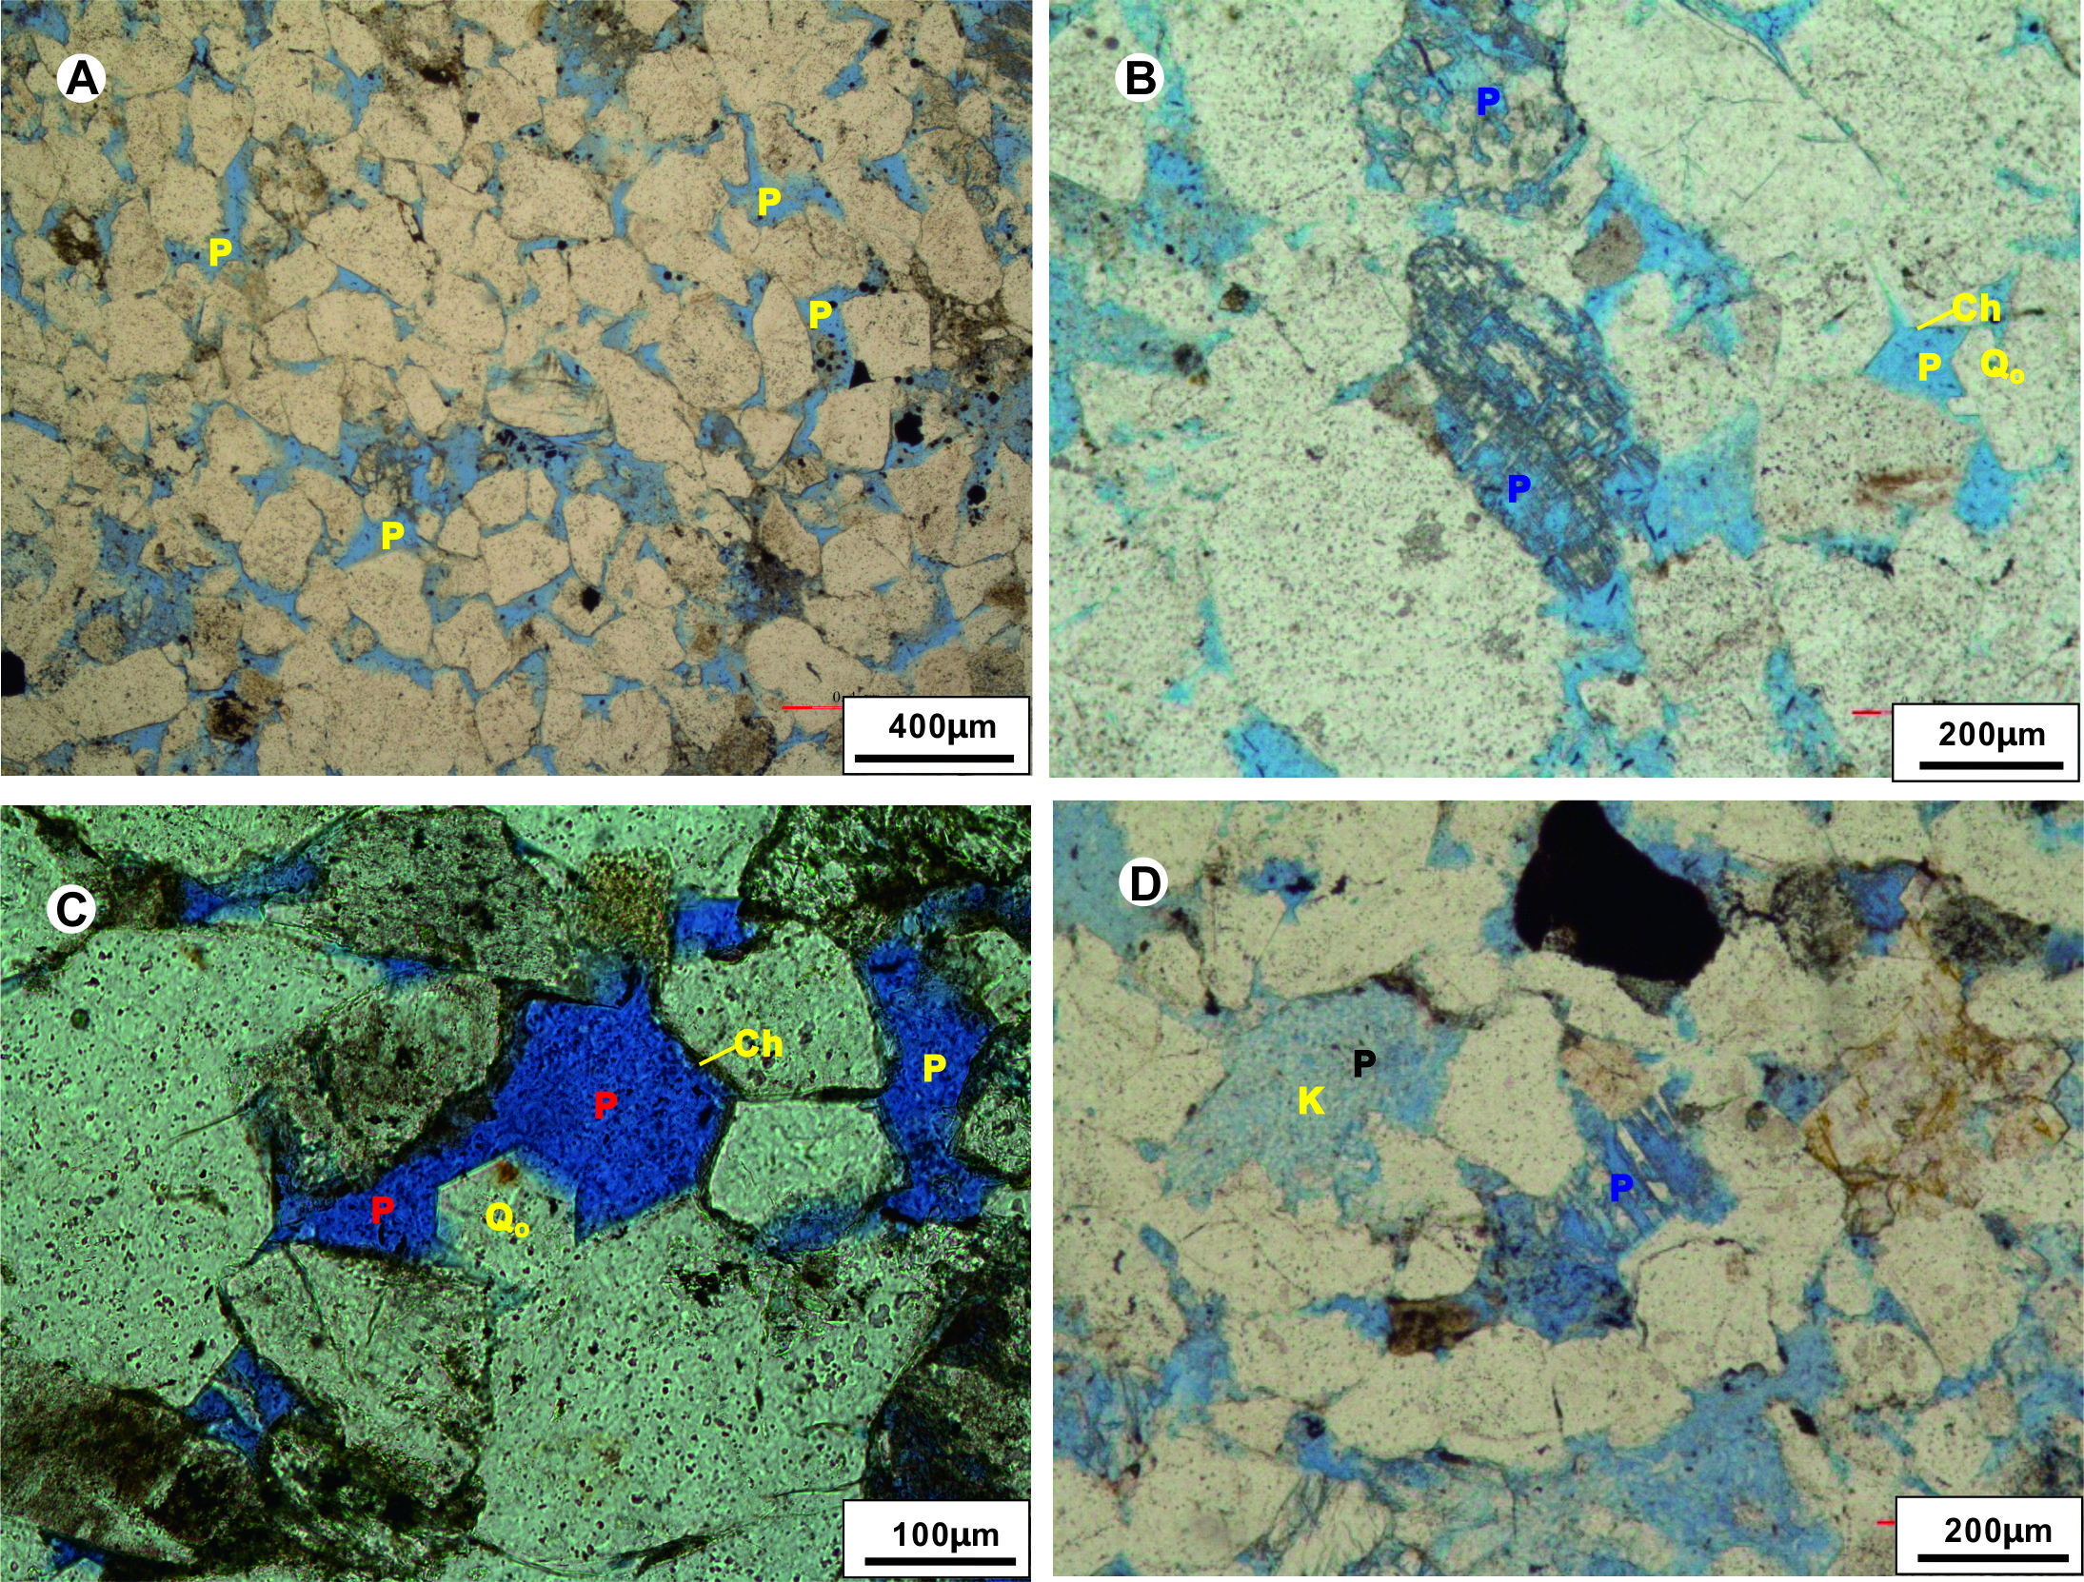
Figure 1. Optical microscopy images showing features of dissolution in tight oil sandstones(A)intergranular pores (P in yellow), plane-polarized light; (B)intragranular pores (P in blue) by dissolution, plane-polarized light; (C) quartz overgrowths located near the moldic pore (P in red) by dissolution, plane-polarized light; (D) intragranular pores (P in blue) by dissolution of feldspar and kaolinite with intercrystalline pores (P in black)filling the intergranular pore, plane-polarized light.
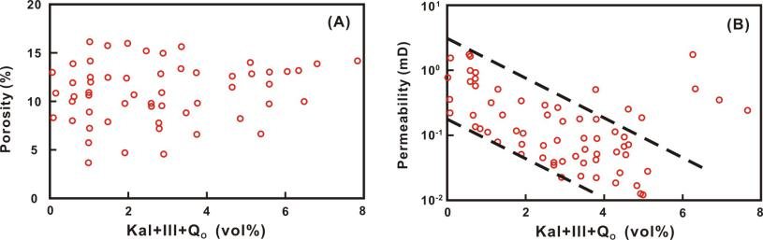
Figure 2. Variations in porosity (A) and permeability (B) with contents of clay minerals cements in tight oil sandstones.Kal+ill+Q_{O}= the total content of kaolinite, illite and quartz overgrowth.
Biography


Yang Li has his expertise in quantitative impact of diagenesis on reservoir quality and sandstone petrology.

