Job strain, overweight and diabetes: a 13-year prospective study among 12,896 men and women in Ontario
Mahée Gilbert-Ouimet, PhD, Université du Québec à Rimouski (UQAR), Canada
Rick H. Glazier, MD, MPH, CCFP, University of Toronto, Canada
Chantal Brisson, PhD, Laval University, Canada
Cameron Mustard, ScD, University of Toronto, Canada
Peter M. Smith, PhD, University of Toronto, Canada

Abstract
Statement of the Problem: Diabetes is one of the primary cause of death worldwide. More than 450 million adults worldwide (7.7%) are now living with this chronic disease and a 50% increase between 2010 and 2030 is expected. The American Diabetes Association recently called for research on social and environmental determinants of diabetes to intensify primary prevention. Recent epidemiological evidence suggests that frequent and modifiable psychosocial stressors at work might contribute to the development of diabetes, but more prospective studies are needed. The purpose of this study is to evaluate the relationship between job strain and the incidence of diabetes among 12,896 men and women over a 13-year period in Ontario, Canada, and also to examine the modifying effect of body mass index in this relationship. Methodology & Theoretical Orientation: Data from Ontario respondents (35-74 years of age) to the 2000-01, 2002 and 2003 cycles of the Canadian Community Health Survey were prospectively linked to the Ontario Health Insurance Plan database for physician services and the Canadian Institute for Health Information Discharge Abstract Database for hospital admissions. Our sample consisted of actively employed participants with no previous diagnose for diabetes. Cox-proportional hazard regression models were performed to evaluate the relationship between job strain, obesity and the incidence of diabetes. Findings: Overall, job strain was not associated with the incidence of diabetes. Among women, job strain was associated with an elevated risk of diabetes, although this finding did not reach statistical significance. Among men, no association was observed. Also, job strain increased the risk of diabetes among women with obesity, while these stressors reduced the risk among men with obesity. Conclusion & Significance: The current study suggests that lowering job strain might be an effective strategy for preventing diabetes among women, especially the high-risk group that are women with obesity.

Images
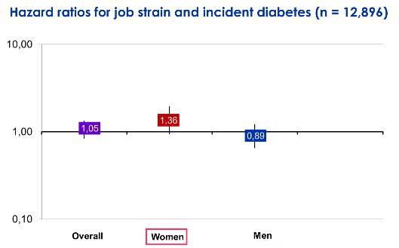
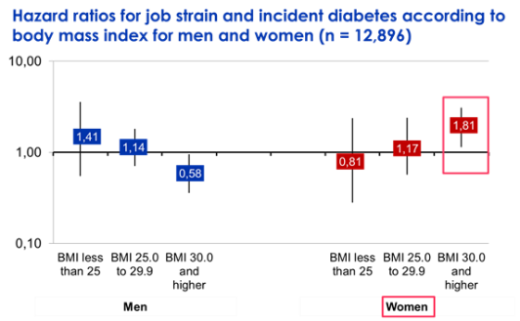
Recent Publications
- Shaw JE, Sicree RA, Zimmet PZ. Global estimates of the prevalence of diabetes for 2010 and 2030. Diabetes Res Clin Pract. 2010;87(1):4-14.
- American Diabetes Association. Economic costs of diabetes in the U.S. in 2017. Diabetes care. 2018;41:917–28.
- Gilbert-Ouimet M, Smith P, Brisson C, Duchaine C, Mustard C. Psychosocial work factors and diabetes: what is known and what is left to know? J Diabetes Metab Disord Control. 2018;5(4):138-9.
- Pan KY, Xu W, Mangialasche F, Fratiglioni L, Wang HX. Work-related psychosocial stress and the risk of type 2 diabetes in later life. J Intern Med. 2017;281(6):601-10.
- Gilbert-Ouimet M, Ma H, Glazier R, Brisson C, Mustard C, Smith PM. Adverse effect of long work hours on incident diabetes in 7065 Ontario workers followed for 12 years. BMJ Open Diabetes Res Care. 2018;6(1):e000496.



Dr. Mahée Gilbert-Ouimet is an associate professor of population health in the Department of Health Sciences at the Université du Québec à Rimouski. She holds a Canada Research Chair in Sex and Gender in Occupational Health. Gilbert-Ouimet's research mainly focuses on the effects of adverse psychosocial working conditions on the incidence of chronic health conditions, and on intervention studies aimed at reducing these working conditions. She is also interested in developing methods and recommendations that improve sex and gender considerations in health research.
Email: mahee_gilbert-ouimet@uqar.ca

