Long working hours associated with elevated ambulatory blood pressure among female and male white-collar workers over a 2.5-year follow-up
Mahée Gilbert-Ouimet, PhD, Université du Québec à Rimouski (UQAR), Canada
Xavier Trudel, PhD, Laval University, Canada
Denis Talbot, PhD, Laval University, Canada
Michel Vézina, PhD, Laval University, Canada
Alain Milot, PhD, Laval University, Canada
Chantal Brisson, PhD, Laval University, Canada

Abstract
Statement of the Problem: Hypertension accounts for 54% of all strokes and 47% of all ischemic heart disease events globally. Population-based strategies targeting modifiable risk factors are needed to improve the prevention of hypertension. Long working hours have been linked to high blood pressure (BP). Women and men differences, along with the potential effect modification of family responsibilities, also need to be further studied. The purpose of this study is to examine the effect of long working hours (≥41 h/week) on BP, over a 2.5-year follow-up in a large sample of white-collar women and men in Quebec City, Canada. The effect modification of family responsibilities was also investigated. Methodology & Theoretical Orientation: A repeated longitudinal design was used. Data collection was performed at three-time points over follow-up among over 2000 white-collar workers. Working hours were self-reported assessed by questionnaire. BP was measured using Spacelabs 90207. The outcomes were systolic and diastolic BP mean. Cross-lagged GEE linear regressions were used to examine whether working hours were associated with BP means at the next measurement time. Findings: Women working long hours had a higher diastolic BP mean at follow-up compared to women working regular hours (+1.8 mm Hg (95% CI: 0.5–3.1)). In men, those working long hours had both higher systolic and diastolic BP means increases (systolic: +2.5 mm Hg (95% CI: 0.5–4.4)) and diastolic: +2.3 mm Hg (95% CI: 1.0–3.7)). This association was greater among workers having high family responsibilities. This longitudinal study showed that women and men working long hours had higher BP means when compared those working 35–40 h per week. Conclusion & Significance: These findings suggest that strategies that promote work weeks not exceeding 40 h might contribute to the primary prevention of hypertension, especially for workers with high family responsibilities.

Images
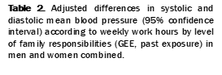
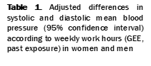

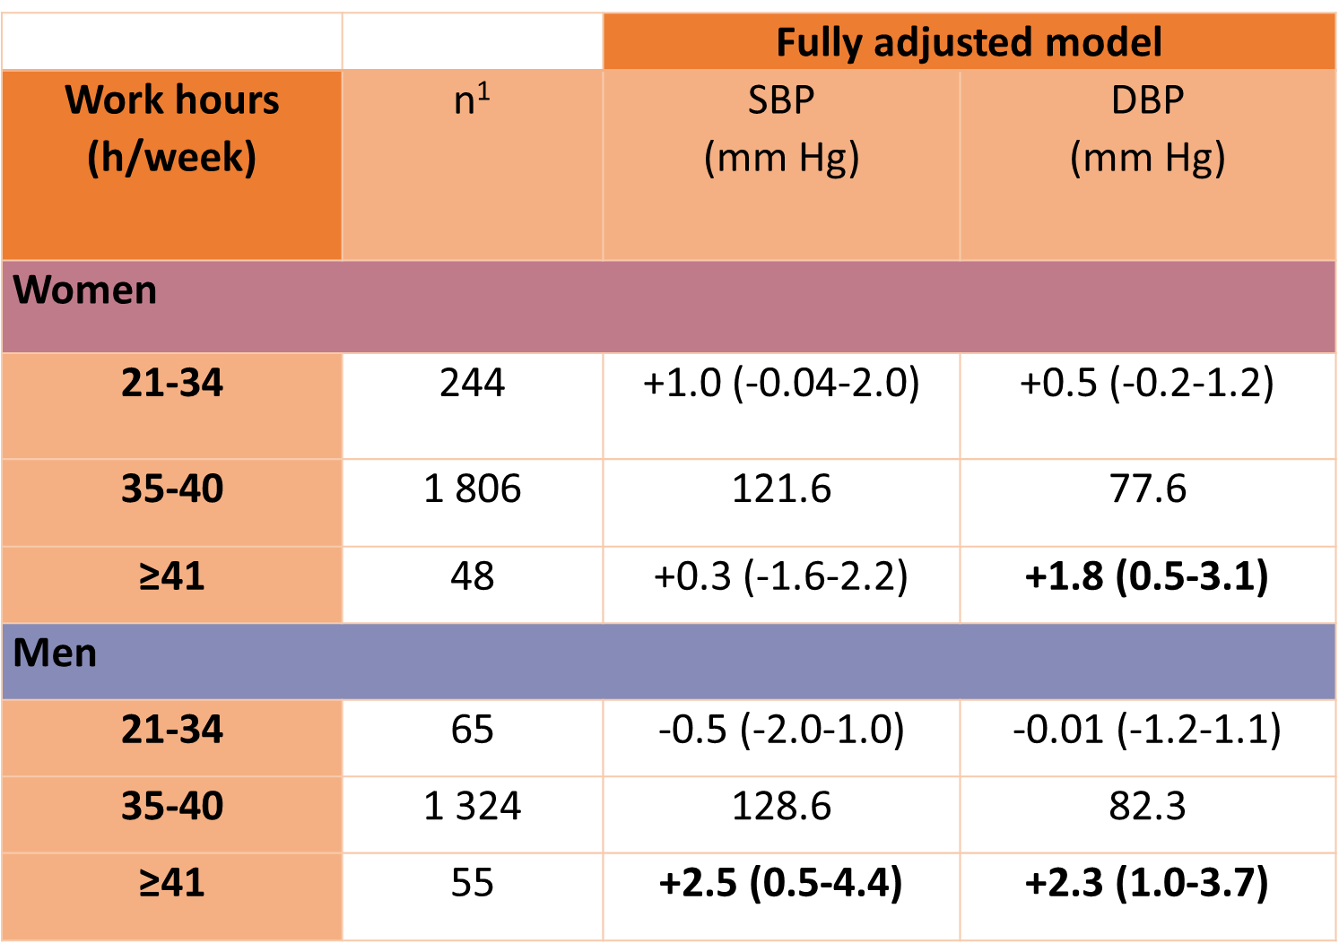
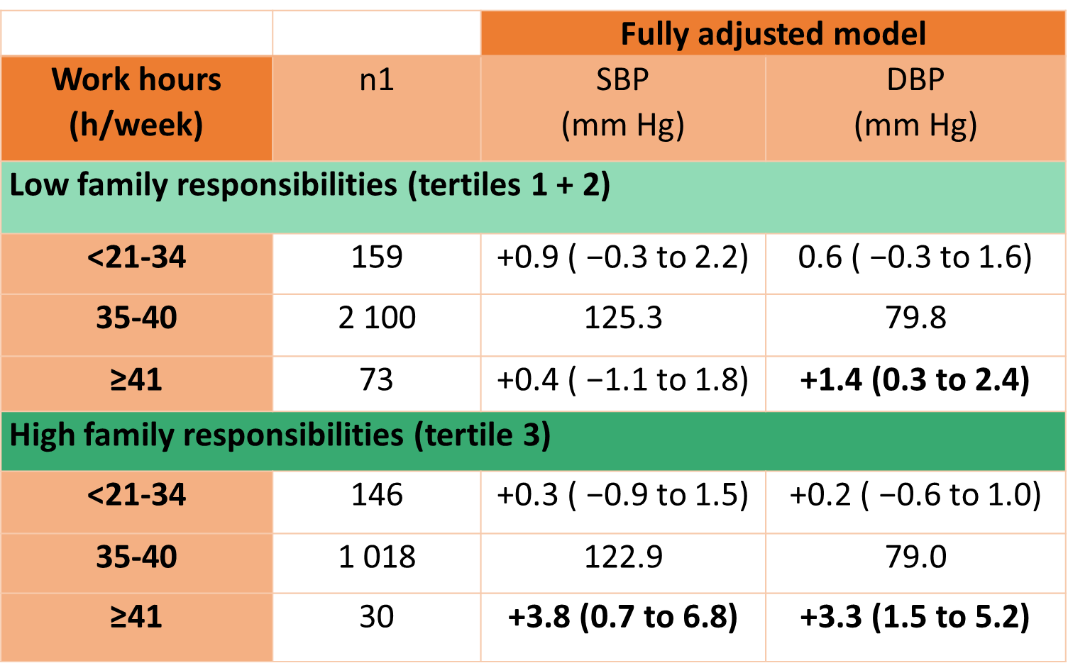

Recent Publications
- Virtanen M, Kivimaki M. Long working hours and risk of cardiovascular disease. Curr Cardiol Rep. 2018;20:123.
- Kivimaki M, Jokela M, Nyberg ST, Singh-Manoux A, Fransson EI, Alfredsson L, et al. Long working hours and risk of coronary heart disease and stroke: a systematic review and meta-analysis of published and unpublished data for 603,838 individuals. Lancet 2015;386:1739–46.
- Munakata M. Clinical significance of stress-related increase in blood pressure: current evidence in office and out-of-office settings. Hypertens Res. 2018;41:553–69.
- Dembe AE, Yao X. Chronic disease risks from exposure to longhour work schedules over a 32-year period. J Occup Environ Med. 2016;58:861–7.
- Li J, Pega F, Ujita Y, Brisson C, Clays E, Descatha A, et al. The effect of exposure to long working hours on ischaemic heart disease: a systematic review and meta-analysis from the WHO/ ILO Joint Estimates of the Work-related Burden of Disease and Injury. Environ Int. 2020;142:105739..



Dr. Mahée Gilbert-Ouimet is an associate professor of population health in the Department of Health Sciences at the Université du Québec à Rimouski. She holds a Canada Research Chair in Sex and Gender in Occupational Health. Gilbert-Ouimet's research mainly focuses on the effects of adverse psychosocial working conditions on the incidence of chronic health conditions, and on intervention studies aimed at reducing these working conditions. She is also interested in developing methods and recommendations that improve sex and gender considerations in health research.
Email: mahee_gilbert-ouimet@uqar.ca

