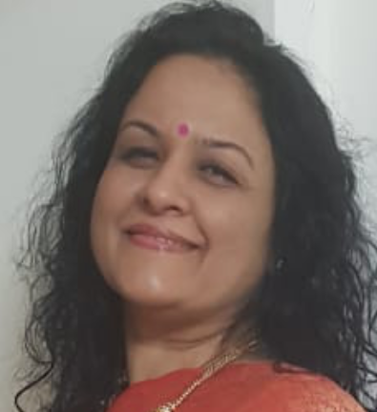

Tackling the weight plateau in weight loss journey.
Consultant Dietitian, Mumbai Diet and Health Centre, Bandra, Mumbai, India

There is a rising prevalence of obesity globally and it is associated with many comorbidities. India, a developing nation is also facing a similar burden, with complications arsing because of over weight at much lower BMI. Weight loss is the only way to manage rising non communicable diseases. While weight loss although difficult, begins with a lot of zest and zeal. After a period of six months weight plateau sets in. Weight plateau is most difficult time as despite of all interventions weight loss does not continue leading to lot of emotional distress. This is the time when individuals give up life style intervention and succumb to there emotional needs of more intake and less physical activity. There are very few established modalities to over come this plateau. There are a few cases where weight loss plateaus were managed and after a stagnant period of a month or two weight loss restarted. There are various dietary modification and change in physical activity which can be done for this problem and will be discussed.

Biography:
Shilpa Joshi is currently the Consultant Dietician and Educator at Mumbai. She is National Vice President of Indian Dietetic Association. She is also Honorary Secretary of All India Association for Advancing Research in Obesity. She has about 12 publications in peer reviewed journals and has presented nationally and internationally in meetings. She has authored several Textbook chapters. She is also master trainer “Diabetes Conversation Maps”, International Diabetes Federations’ initiative for diabetes education. She has presented at various international meetings including at the American Diabetes Association, International Diabetes Federation and International Confederation of Dietitians. She is runners up recipient of Wimpfheimer Guggenheim's International Essay award (2017) of the Academy of Nutrition and Dietetic Foundation on ‘Malnutrition’. She is also the recipient of ‘we for Stree’ award by Federation of Obstetrics and Gynecologist of India (2019).

Presenting Author Details:
Name: Shilpa Shashank Joshi
Contact No: 9820602701
Email ID : shilpajoshi.s11@gmail.com
Website: www.shilpajoshird.com
Category: Oral
Session name: Obesity and Nutrition

