Using planning powers to implement healthy weight environments in UK local government
Michael Chang MRTPI, MRes, Leeds Beckett University, UK

Abstract (300 word limit)
Statement of the Problem: The obesogenic environment refers to physical environmental factors that promote gaining weight and one that is not conducive to weight loss within the home or workplace. The Foresight obesity project found difficulties in pinning down a definition, but suggests how the environment is designed through urban planning can impact on physical activity and access to nutrition. There is no one consistent or commonly agreed policy framework for urban planning for healthy weight environments (PHW). Current research is disparately isolated to single interventions rather than take a place-based approach, and is not based on practical realities in real life local government contexts.
Methodology & Theoretical Orientation: The research takes an unorthodox approach to close the divergence of academic evidence and policy realities. The research builds on the UK Foresight obesity report of whole systems-approach to population level health improvement. The first phase will be a literature review to determine the relevance of evidence for a framework of place-based PHW elements. It will also undertake a review of current policy levers to implement PHW by local government. The second phase involves structured conversations with local government in workshop settings to understand practical barriers.
Findings: The research takes place between October 2017 and September 2019. The first phase findings of the literature review are expected to determine the lack of coherent academic evidence on place-based interventions on planning healthy weight environments but will suggest a cumulative academic consensus for PHW actions. It will also be expected to suggest the existence of sufficient policy levers to implement PHW actions by local government policy makers but that significant practical barriers exist preventing effective action.
Conclusion & Significance: This research will help with the implementation of a whole systems approach to tackling obesity with urban planning playing a critical role in shaping environmental determinants. It will help policy makers identify practical barriers by utilizing existing arsenal of policy levers to fully implement national and local priorities to reduce obesity rates through urban planning interventions.
Image
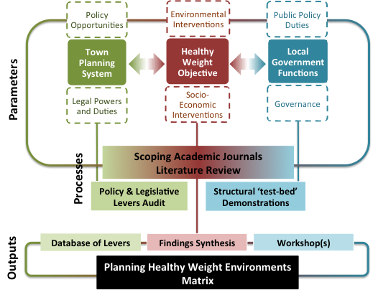
Recent Publications (minimum 5)
- Chang, M. (2017) Taking stock – and future challenges, Town & Country Planning , 85 (11), pp 455-457
- Chang, M. (2017) Edging closer to an effective reunion between town planners and public health professionals, Journal of Public Health (Oxford). 39 (1): pp 6-7.
- Chang, M., (2016), Building the Foundations. Tackling obesity through planning and development, LGA and PHE
- Chang, M, and Ross, A. (2015), Reuniting health and planning - reflections from the frontline, Urban Design and Planning (ICE), 168 (2), pp. 69-74
- Chang, M, and Ross, A. (2014), Planning healthy weight environments. Report from the TCPA Reuniting health with planning initiative, TCPA

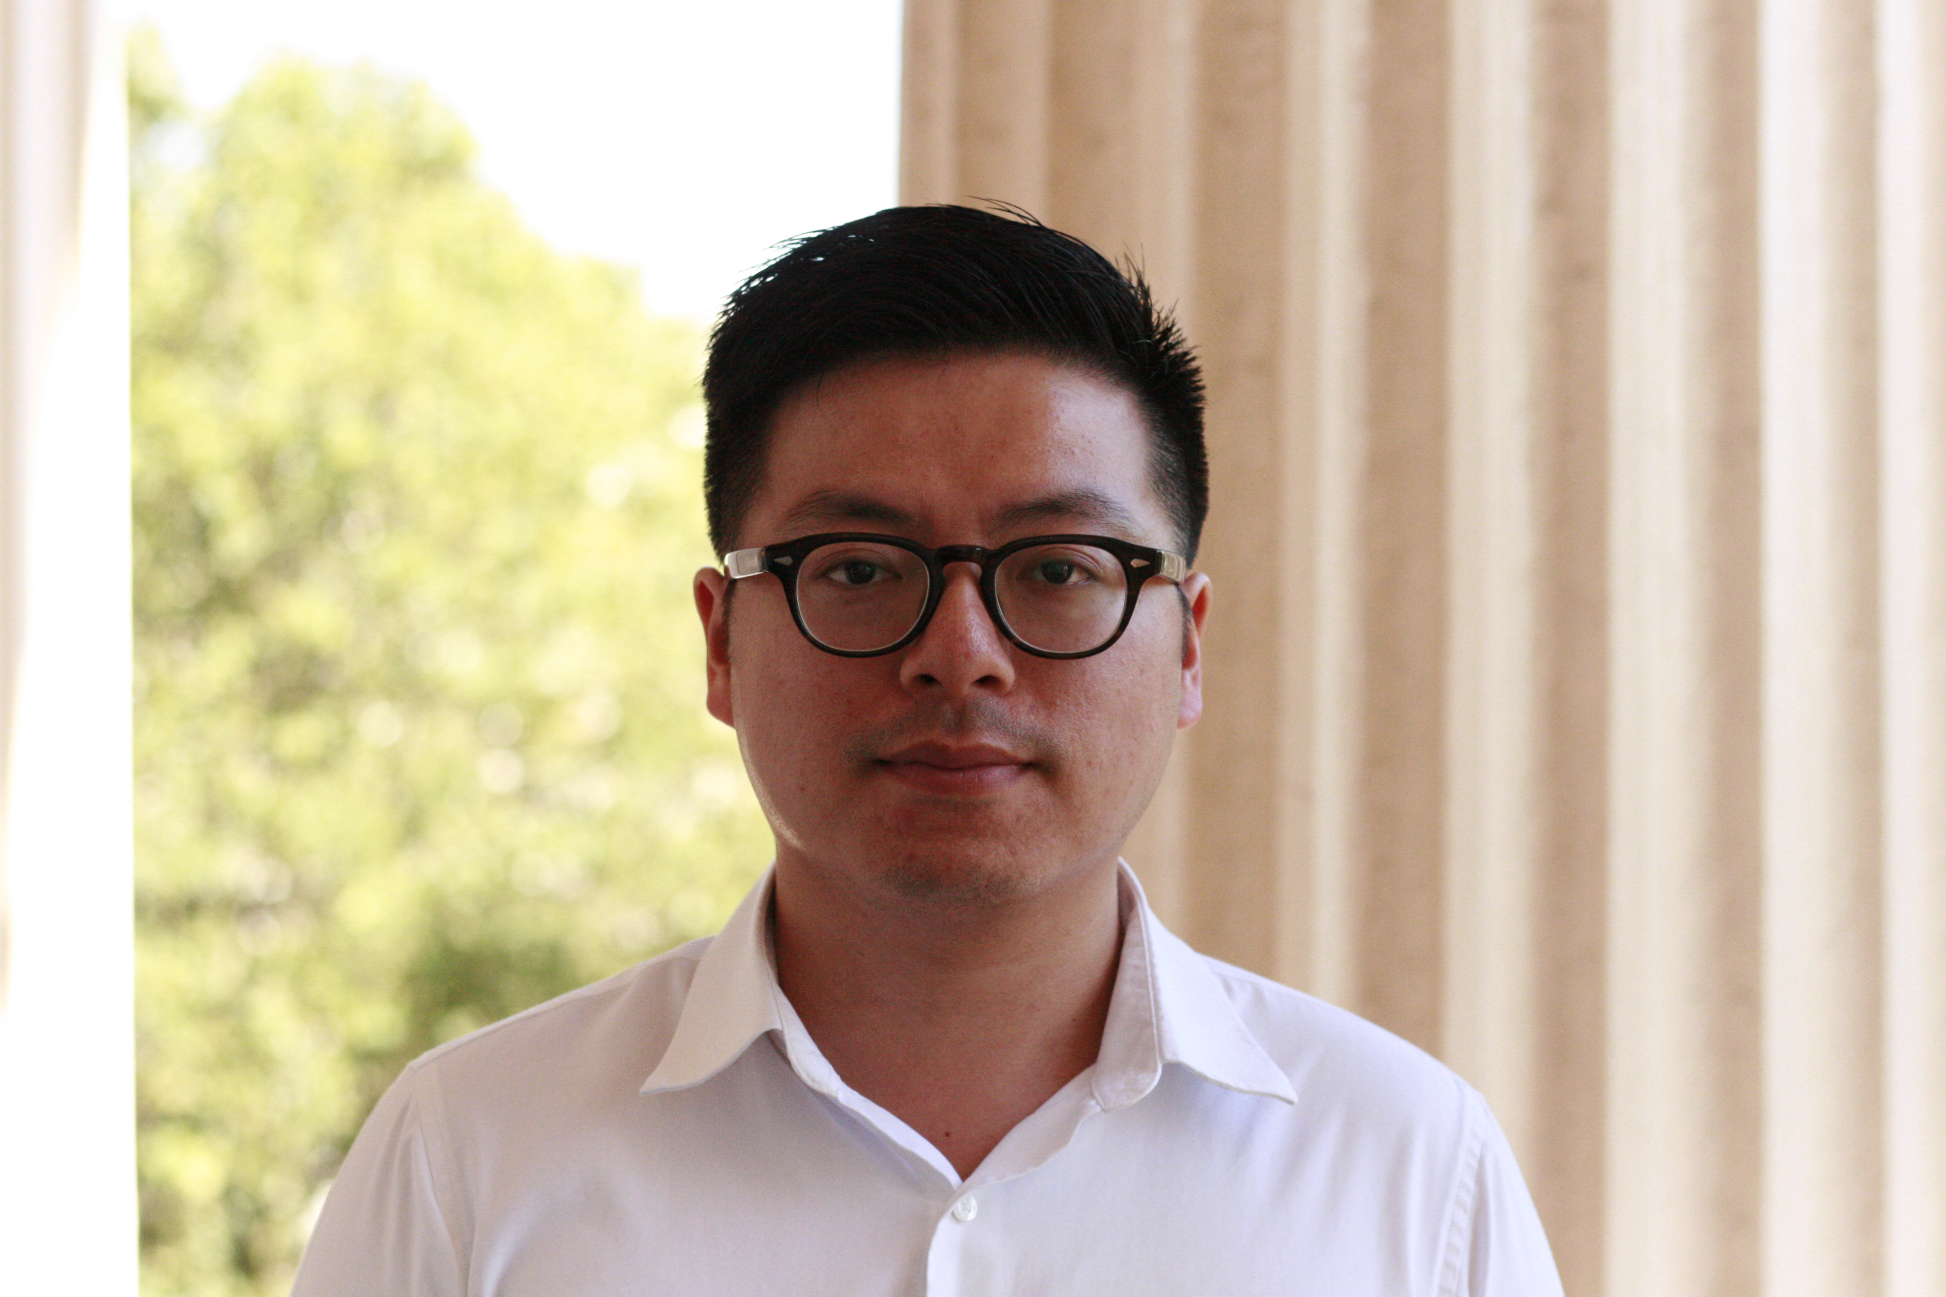Biography (150 word limit)
Michael Chang is a UK Chartered Town Planner with over 10 years of practical experience. This research is undertaken as a Master by Research at Leeds Beckett University’ School of Sport while working as a Project and Policy Manager at Town and Country Planning Association. This unique combination of a researching practitioner aims to ensure a practical relevance of academic findings to ultimately influence policy makers in central and local government agencies. Michael has a Master of Science in Urban Regeneration from University College London and Bachelor of Planning (First Class Honours) from University of Auckland. He worked on secondment to Public Health England in 2016 to help implement its Healthy Places programme including advising on health policy. He is a member of the Strategic Obesity Network and has contributed to conferences and events organised by institutions such as the Association for the Study of Obesity and Public Health England.
Email: M.Chang6692@student.leedsbeckett.ac.uk

Notes/Comments:

