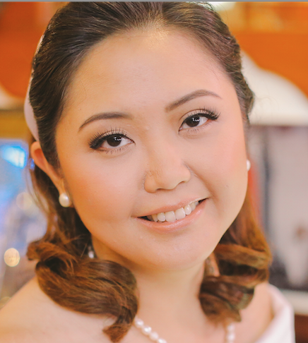

Title of the Paper: The Validation of an Instrument to Assess Parental Feeding Styles of Children in Filipino Language

Carmina Niña R. Salac, M.D.
University of Santo Tomas Hospital, Manila, Philippines

Overweight and obesity are emerging major problems among children today worldwide. Research on parent feeding styles and practices has begun to provide some clues about the role parents play in the etiology of childhood obesity. Only recently has attention been directed toward the parental feeding styles. Experts have suggested that gestation to early infancy is a critical period in which physiologic changes occur that greatly influence a child's later risk for obesity. The objective of the study is to examine validity and reliability of an instrument translated to Filipino language for characterizing parental feeding practices. Subjects were the parents with toddlers from the University of Santo Tomas Hospital. A Focus Group Discussion was done. The Toddler Feeding Questionnaire was translated to Filipino language. A final questionnaire underwent pretesting and Cronbach’s alpha test. Data analysis was done using Strata SE version 13. Quantitative variables were summarized while qualitative variables were tabulated. Test-retest and Cronbach’s apha tests were done. A total of eighteen (18) parents participated in the study. About 89% of the toddlers had normal weight according to the WHO growth standards (weight for length). All but two (2) items (Q18 and Q33) in the final questionnaire reached significant differences (p <0.05). The overall internal reliability of the questionnaire was acceptable (alpha = 0.82). This instrument was found to be valid with acceptable reliability and internal consistency.

Biography

Carmina Niña R. Salac, M.D. has completed her degree in Doctor of Medicine in the University of Santo Tomas, Manila, Philippines, in 2011. She completed her residency in Pediatrics in University of Santo Tomas Hospital, Manila in 2015. She is currently a pediatric junior consultant in various hospitals in the country.

Presenting author details
Full name: Carmina Niña R. Salac
Contact number: +63 9175668613
Twitter account: carmininamd
Category: Poster presentation

