Individualized exercise therapy is a key factor of obesity management
Márton Dvorák, Department of Health Sciences and Sport Medicine, University of Physical Education, Hungary
Miklós Tóth, Prof, Department of Health Sciences and Sport Medicine, University of Physical Education, Hungary

Abstract (300 word limit)
Introduction: Obesity and Adiposity-Based Chronic Disease (ABCD) are one of the most common health risk factors nowadays but regular exercise – part of complex lifestyle medicine program – is effective treatment for obesity if it is individualized and followed by an exercise professional. For better results the accurate dose-effect is needed to be defined. Materials and Methods: The 30 weeks lifestyle change program of a 65-year-old male patient (Body Mass Index (BMI) 43.8 kg/m²) was followed by medical doctor, exercise physiologist and nutritionist. Over regular controls and blood tests every training was measured with a heart rate monitor watch and diet diary was written. Results: Bodyweight decreased by 24.1 kg (18,4%) and BMI to 35.8 kg/m². Decreased resting heart rate (from 72 bpm to 63 bpm), diastolic blood pressure (from 72 mmHg to 67 mmHg) and increased systolic blood pressure (from 126 mmHg to 135 mmHg) were reported beside the reduce of antihypertensive and antidiabetic medicines. Blood test results and fitness level improved, daily steps and time spent with trainings increased. Conclusions: Lifestyle medicine with professional support is an effective and long-term treatment for ABCD. Individualized exercise and nutritional therapy are essential and the wearable technology with telemedicine consultation has also important role.

Image
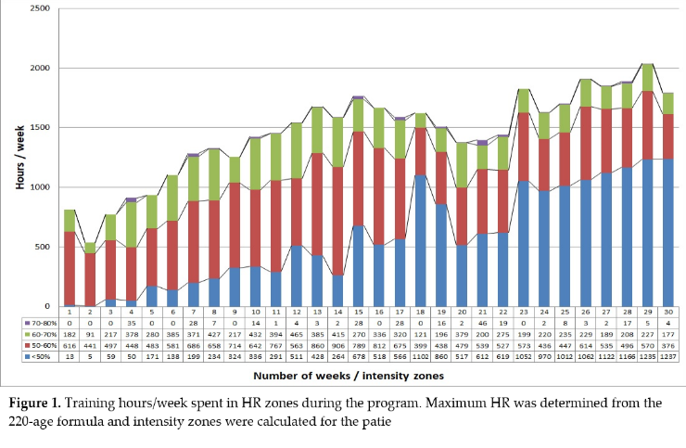
Recent Publications (minimum 5)
- Mechanick, J. I., Hurley, D. L., & Garvey, W. T. Adiposity-Based Chronic Disease as a new diagnostic term: The American Association of Clinical Endocrinologists and American Colleague of Endocrinology position statement. Endocrine practice: official journal of the American College of Endocrinology and the American Association of Clinical Endocrinologists, 2017, 23(3), 372–378.
- Pescatello LS. Exercise measures up to medication as antihypertensive therapy: its value has long been underestimated. Br J Sports Med. 2019, 53(14), 849-852.
- Emery MS. Long Term Strenuous Exercise: Is There a Dose Effect?. J S C Med Assoc. 2016, 112(2), 197-199.
- Miyauchi M, Toyoda M, Kaneyama N et al. Exercise therapy for management of type 2 diabetes mellitus: superior efficacy of activity monitors over pedometers. J Diabetes Res. 2016, 2016, 5043964.
- DiFrancisco-Donoghue J, Jung MK, Stangle A et al. Utilizing wearable technology to increase physical activity in future physicians: A randomized trial. Prev Med Rep. 2018, 12, 122-127.


Biography (150 word limit)
Márton Dvorák has his expertise in exercise therapy for elderly and patients with chronic diseases. He is working in University of Physical Education in Hungary as PhD student and also in Yourpower Health Center as exercise physiologist. Part of a lifestyle medicine team with doctors and nutritionists he is leading exercise therapy department for patients with diabetes, obesity, cardiovascular diseases.
Email: dvorak.marton@yourpowermed.hu

Notes/Comments:

Presenting author details
Full name: Márton Dvorák
Contact number: +36 30 519 2381
Twitter account:
Linked In account: linkedin.com/in/márton-dvorák-60417a13b
Session name/ number: Obesity
Category: (Oral presentation/ Poster presentation)

