Assessment of energy and macronutrients intake of children attending kindergartens in Kosovo (full day program-8 hours)
Rysha A. PhD, Department of Food Technology, Faculty of Agribusiness, University of Pejë Kosovo,
Gjergji T. PhD, University of Prishtina Kosovo,
Ploeger A. PhD, Kassel University Germany

Abstract (300 word limit)
Statement of the Problem: A balanced diet and knowledge of children’s intake of energy and macronutrients is important for normal growth as well as for nutritional interventions to prevent childhood malnutrition. Understanding preschool children’s food consumption in kindergartens of Kosovo may be one possibility to find out whether Kosovo preschool children’s energy is adequate. This work aimed to observe the menu designs and to evaluate for the first times the macronutrient intake by children attending public and private kindergartens of Kosovo (full day programme – 8 hours).
Methodology: Preschool children (n = 469) aged 4<7 years from kindergartens in Kosovo have participated in a dietary intake assessment through weighted dietary record method. The program PRODI and SPSS version 17 were used for calculation and comparison of nutrient values with dietary reference values. The one - way analyses of variance (ANOVA) was used for determination of differences between the mean intake values according to age and gender and according to public and private kindergartens.
Findings: The total energy intake derived from carbohydrates, fat and protein was approximately the same for 1<4 and 4<7 years old children: carbohydrates 58%; fat 27% and proteins 15%. The mean energy intake values covered between 36% and 79% of the Recommended Daily Intake. The consumption of amino acids is higher than that required for preschool aged children and the mean percentage of energy derived from MUFA and PUFA was not more than 35% of RDI. The total fiber intake covered between 30% and 46% of RDI.
Conclusion & Significance: Meals that are served in kindergartens are not nutrient balanced and children, when at kindergartens in Kosovo, consume more foods with high energy density and less high-fiber foods

Image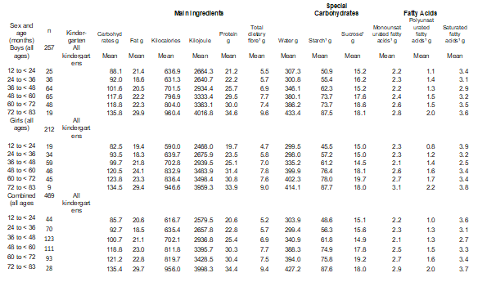
Table 1: Mean values of main nutrients, special carbohydrates and fatty acids
consumed by children from all kindergartens according to gender and age
Recent Publications (minimum 5)
- Mendez R, Grissom M. Disorders of childhood growth and development childhood obesity. FP Essent 2013; 410: 20–24.
- Hebestreit A, Bornhorst C, Pala V, Barba G, Eiben G, Veidebaum T, Hadjigergiou C, Molnár D, Claessens M, Fernández-Alvira JM, et al. Dietary energy density in young children across Europe. Int. J. Obes. (Lond.) 2014; 38 (Suppl. 2): S124–S134
- 19. Deutsche Gesellschaft für Ernährung, Österreichische Gesellschaft für Ernährung, Schweizerische Gesellschaft für Ernährung (eds): Referenzwerte für die Nährstoffzufuhr, ed 2. Bonn, 2015.
- Rysha A, Gjergji TM, Ploeger A. Dietary habits and food intake frequency of preschool children. Nutrition & Food Science 2017; 47 (4): 534-542.
- Johnson L, Mander AP, Jones LR, Emmett PM, Jebb SA. Energy-dense, low-fiber, high-fat dietary pattern is associated with increased fatness in childhood. Am J ClinNutr 2008; 87: 836-54.

Biography

Agim Rysha has completed his PhD at Kassel University in Germany. Currently he works as a Ass.Prof., at the Department of Food Technology, Peja University, Kosovo.
Agim does research in Food Technology and Nutrition Sciences. Their most recent publication is 'Dietary habits and food frequency intake of preschool children'

Photo

