Identification and differentiation among chicken’s, duck’s, quail’s, rabbit’s and turkey's meat using Cytb-PCR-RFLP technique

Salah M Abdel-Rahman, PhD, SRTA-City, Egypt

Abstract

PCR–RFLP technique was developed for identification and differentiation among chicken’s, duck’s, quail’s, rabbit’s and turkey's meat. DNA from small amount of muscles (0.05 g) was extracted and a region of mitochondrial DNA (cytochrome-b gene) in chicken, duck, quail, rabbit and turkey was amplified by PCR. Fragment length of the PCR product was 371 bp in chicken, 374 bp in duck and rabbit and 377 bp in both quail and turkey. Six nucleotides different makes it difficult to differentiate among these five species-specific meat. For differentiation, three different restriction enzymes (DdeI, MspI and TaqI) were used to digest the PCR products. Restriction analysis showed difference among chicken’s, duck’s, quail’s, rabbit’s and turkey's meat. Where, DdeI yielded two fragments (291 and 83 bp) only in rabbit’s meat. MspI yielded three fragments (221, 85 and 65 bp) in chicken’s meat and two fragments (290 and 87 bp) in both quail’s and turkey's meat. TaqI yielded three fragments (146, 134 and 94 bp) in duck’s meat and two fragments (226 and 151 bp) in quail’s meat. The use of Cytb-PCR-RFLP assay allowed a direct and fast authentication and differentiation among chicken’s, duck’s, quail’s, rabbit’s and turkey's meat (Fig. 1).

Image

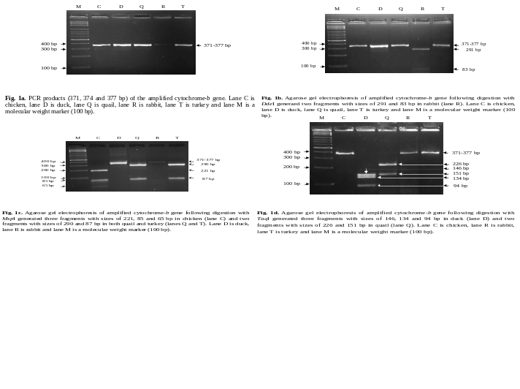

Recent Publications

1. Abdel-Rahman S, Mustafa Y, Abd Errasool H, Heikal H, Elmaghraby A (2019) FSHR (exon 10) gene polymorphisms and its association with fertility trait in Egyptian Ossimi sheep. Biotechnology in Animal Husbandry 35: 127-140.
2. Ahmed SS, Abdel-Rahman SM, Grobler PJ, Kotzé A (2018) Allelic diversity of DQA2 exon 2 gene in Egyptian goat populations. Indian Journal of Animal Research 52: 1101-1106.
3. Makhlouf A, Abd El-hady AM, Abdel-Rahman SM, El-Raffa AM (2018) Single-strand conformation polymorphism of myostatin gene linked to slaughter traits and some blood constituents in rabbits. Egypt. J. Genet. Cytol. 47: 123-137.
4. Makhlouf A, Abd El-Hady AM, Abdel-Rahman SM, El-Raffa AM (2017) Analysis of rabbit growth hormone gene polymorphisms to evaluate its impact on live body weight, hemato and biochemical parameters. Arab J. Biotech. 20: 77-90.
5. Abdel-Rahman SM, Elmaghraby AM, Haggag AS (2015) Fast and sensitive determination of camel’s and goat's meat and milk using species-specific genetic markers. Biotechnology in Animal Husbandry 31: 415-423.


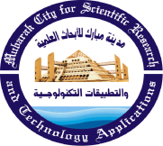

Biography
Dr. Salah Abdel-Rahman is a Professor of Molecular Genetics and works at Nucleic Acid Research Department, Genetic Engineering and Biotechnology Research Institute, City of Scientific Research and Technological Applications, Alexandria, Egypt. Dr. Salah has an expertise in detection of adulteration and identification of meat and milk species using molecular genetic techniques. In addition to poultry’s meat identification, Dr. Salah could also identified the farm animals meat and milk, such as: goat, dog, cat, buffalo, cattle, sheep, camel, donkey, horse and pig. However, the proposed PCR and PCR–RFLP assays represent a rapid and sensitive method applicable to the detection and authentication of meat and milk species-specific.
Email: salahmaa@gmail.com

Notes/Comments:

Presenting author details
Full name: Salah M. Abdel-Rahman
Contact number: 00201112727468
Twitter account:
Linked In account:
Session name/ number:
Category: (Oral presentation)

