TYPE 3 DIABETES
Nurhayat Atasoy
Department of Chemistry, Faculty of Science, Van Yüzüncü Yıl University,
Türkiye
Abstract
Type 3 Diabetes, called "Diabetes in the Brain", is seen together with Type 2 Diabetes and Alzheimer's/Dementia/Dementia. Long-term uncontrolled high blood sugar can cause damage to the vessels. Brain vessels are also affected by this situation. Diabetes can also disrupt the balance of certain chemicals in the brain, causing inammation in the brain along with high blood sugar, and can damage brain cells. It is stated that there is a hereditary link between Alzheimer's disease, which is dened by low insulin levels in the blood, as well as insulin resistance in the brain, and type 3 diabetes. type 3 diabetes; It occurs due to pancreatic damage, some diseases and trauma. One study stated that people with type 2 diabetes have a 60% higher risk of Alzheimer's. The 3 main risk factors for Type 3 Diabetes are: high blood pressure, being overweight or obese, depression and polycystic ovary syndrome (PCOS). Scientists have found that people with Alzheimer's have problems processing glucose in certain areas of the brain. Therefore, people diagnosed with insulin resistance should accept that they have come to a crossroads. The global diabetes community states that Alzheimer's disease develops as a result of the development of insulin resistance in the brain tissue. A substance called amyloid, which is seen in the pancreas of diabetic patients, has also been found in the brain cells of type 3 diabetes patients. In addition, we all know that today's nutrition system and sedentary lifestyle increase cell-killing substances in the body, which we call free radicals. In this way, the risk of
Alzheimer's increases. Correction of insulin deciency and resistance is shown in Alzheimer's disease will help develop new treatment approaches. Insulin and its sub-pathways will continue to maintain their current importance in restoring and preserving memory functions in the future. Determining the type of diabetes is extremely important for the treatment process. For example,
gliclazide is used for type-2 treatment, but may not be as effective for type 3c. For such reasons, making the diagnosis correctly will be benecial both for the health of the patient and economically during the treatment. In this way, the waste of time and money due to misdiagnosis will be eliminated. For these reasons, both healthcare professionals and the public should be adequately informed about type 3c, and an important disease such as diabetes should never be ignored.
Keywords: Alzheimer, İnsulin resistance, Pancreatic damage
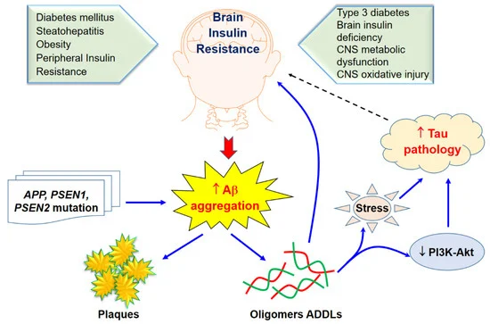
Figure1: Type 3 Diabetes and Its Role in Alzheimer’s Disease (Nguyen et al., 2020).

References
1.Pasquier F, Boulogne A, Leys D, Fontaine P. diabetes mellitus and dementia. diabetes metab 2006;32:403-14.
2. Hoyer S. Brain glucose and energy metabolism abnormalities in sporadic Alzheimer disease.
Causes and consequences: an update. Exp Gerontol 2000;35:1363-72.
3. Frölich L, Blum-Degen D, Bernstein HG, Engelsberger S, Humrich J, Laufer S, et al. Brain insulin and insülin receptors in aging and sporadic Alzheimer’s disease. J
Neural Transm 1998;105:423-38.
4. Messier C, Teutenberg K. The role of insulin, insulin growth factor, and insulin-degrading enzyme in
brain aging and Alzheimer’s disease. Neural Plast
2005;12:311-28.
5. Chen GJ, Xu J, Lahousse SA, Caggiano NL, de la Monte SM. Transient hypoxia causes Alzheimer-type molecular and biochemical abnormalities in cortical neurons: potential strategies for neuroprotection. J Alzheimers Dis 2003;5:209-28.
6.Zhu T, Meng Q, Ji J, Lou X, Zhang L. Toll-like receptor 4 and tumor necrosis factor-alpha as diagnostic biomarkers for diabetic peripheral neuropathy. Neurosci Lett 2015;585:28-32.
7.Lester-Coll N, Rivera EJ, Soscia SJ, Doiron K, Wands JR, de la Monte SM. Intracerebral streptozotocin model of type 3 diabetes: relevance to sporadic Alzheimer's disease. J Alzheimers Dis 2006;9:13-33
8. Nguyen TT, Ta QTH, Nguyen TKO, Nguyen TTD, Van Giau V. Type 3 Diabetes and Its Role Implications in Alzheimer’s Disease. International Journal of Molecular Sciences. 2020; 21(9):3165.

Biography: Nurhayat Atasoy was born in Turkey. She completed her undergraduate education in the Department of Chemistry at Van Yüzüncü Yıl University. She completed her master’s and doctoral studies in the field of biochemistry at the same university. She trained many undergraduate, graduate and doctoral students in this field. She is still working as an associate professor at the same university. She has studies on vitamins, hormones, antioxidants, heavy metals and food chemistry, and these studies continue.



