The content of antioxidants – phenolic compounds, in red wines of Georgia “Kindzmarauli” and “Saperavi”
N. Kekelidze, T. Kekelidze, L. Akhalbedashvili, G.Maisuradze, B. Kvirkvelia, G. Tsotadze, A.Mskhiladze, V.Lipartiani
Ivane Javakhishvili Tbilisi State University, 1/3, Chavchavadze av. Tbilisi, 0179, Georgia

Abstract
Statement of the Problem: The special attention of researchers is attracted by grape wines - sources of a unique natural composition of antioxidants and other biologically active substances, superior in their activity to individual antioxidants. About 50 components of the phenolic complex exhibit radioprotective, anti-radiation, bactericidal, antioxidant, antisclerotic, and other functional properties. Chemical analyzes of Georgian wines also showed a high content of phenolic compounds in in red wines obtained by the Georgian traditional method - aging in Qvevri. Earlier were determined the mineral content and heavy metals in wines Kindzamarauli and Saperavi and the corresponding raw materials, kindly provided by the wine enterprise Khareba. Methodology & Theoretical Orientation: One of the main aim of study was to determine phenol compounds in Qvevri wines over wine, made without it. Identification of phenolic compounds was performed using HPLC (Agilent 1260). Division was carried out on the reversed phase Agilent- Zorbax Eclipse XDB-C18-01 column at the room temperature according to modified method of Jordao et.al. Findings: According to obtained data some following phenolic compounds were detected in wines: gallic acid; protocatechuic acid; (+) catechin; vannilic acid; caffeic acid; syringic acid;(-) epicatechin; ferulic acid; dihydroquercetin; rutin; o-coumaric acid; resveratrol; quercetin; p-hyroxybenzoic acid. Content of them changes during processing according chain: stem→skin→pulp→juce→wine. Total content of phenolic compounds is greatest in Saperavi wine (1120 mg / l), sustained in Qvevri over wort, compared to Saperavi wines (700-750 mg/l), and obtained from grape juice by European method.
Conclusion & Significance: According to the content of resveratrol, all the wines studied belong to class of very good (content of resveratrol is more than 7 mg / l), and "Saperavi" of 2012 year with the content of resveratrol of 18 mg / l - to selected wines. Identified phenolic compounds can act as antioxidants and increase the nutrition and medical properties of wine.

Recent Publications
- Heli Sirén, Kimmo Sirén , Juhani Sirén (2015) Evaluation of organic and inorganic compounds levels of red wines processed from Pinot Noir grapes Analytical Chemistry Research 3: 26-36.
- Glonti T., Glonti Z. (2013) The remarkable Ovevri wine Tbilisi, Qvevri foundation.
- Glonti T., Glonti Z. (2010) The antioxidant ability of wines,made of the white sort of grapes Kakhuri Mtsvane, “Vinigradarsnvj I Vinodelie”, Magarach.
- Kekelidze N., Kekelidze T., Akhalbedashvili L., Mirskhulava M., Maisuradze G., Kvirkvelia B., Tsotadze G., Liparteliani V. (2017) Some mineral components in Georgian red wines. Science of Europe 12: 4-8.
- Kekelidze N., Kekelidze T., Akhalbedashvili L., Mirskhulava M., Maisuradze G., Kvirkvelia B., Tsotadze G., Liparteliani V. (2017) Heavy metals in Georgia red wines Kindzmarauli and Saperavi. 13 Intern. Conf. in Natural Medicines, Nutraceuticals and Neurocognition, Rome, Italy.
- Jordao A.M. Ricardo-da-Silva J.M., Laureano O. (2001) Evolution of proanthocyanidins in bunch stems during berry development.Vitis 40, 1:17-22.

Biography
Lali Akhalbedashvili is a Doctor of Sciences in physical chemistry. She has completed with honors Ivane Javakhishvili Tbilisi State University, and defended PhD thesis in Lomonosov Moscow State University. She works in Ivane Javakhishvili Tbilisi State University and in Caucasian Institute of Mineral Resources as senior researcher. Fields of specialization: heterogeneous catalysis, adsorption, ionexchange and catalytic properties of synthetic and natural zeolites; their investigation for purification of radioactive waste water from ¹³⁷Cs, ⁹⁰Sr, ⁶⁰Co and other nuclides; gas chromatography and gas-liquid chromatography; synthesis, analysis and study of catalytic activity of high temperature superconductors. She is an author of 95 scientific papers.

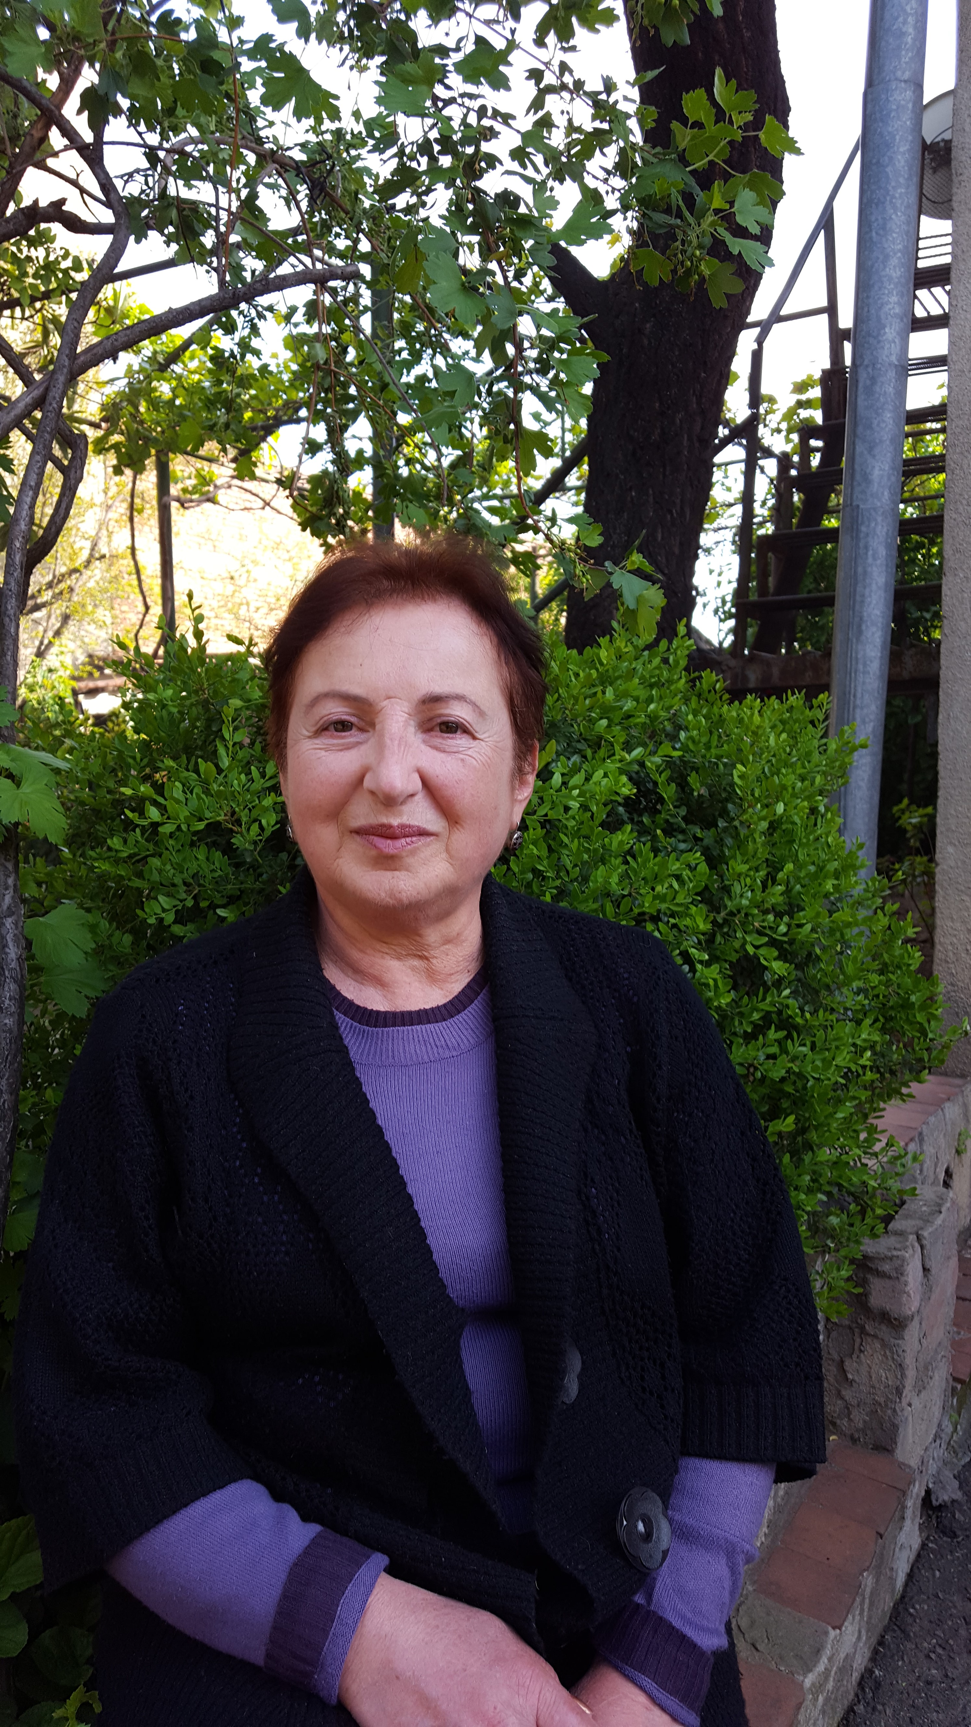

Photo

