Phenolic Antioxidants in Plant Foods and their Roles in Human Health

Yuegang Zuo , Department of Chemistry and Biochemistry, University of Massachusetts Dartmouth, 285 Old Westport Road, North Dartmouth, MA 02747, USA

Abstract
Polyphenols are constituents of many fruits, vegetables and other plant-derived foods, and they have attracted a great deal of public and scientific interest because of their potential anticarcinogenic, antibacterial, antiinflammatory and other health-promoting effects as antioxidants and free radical scavengers. A number of epidemiological studies have given evidence that consumption of fruits and vegetables is correlated with reduced incidence of and mortality from cancer, and cardiovascular and neurological diseases. The protection that fruits and vegetables provide against these diseases has been attributed to the polyphenolic and other antioxidant phytonutrients contained in these foods. Therefore, it is important to isolate, identify and quantify polyphenolic compounds and their bioavailability in order to understand their critical roles in human health. In this presentation, the speaker will first report on the progress on the separation, identification and measurement of polyphenols in various fruits, vegetables, traditional Chinese medicines, tea and other plant-derived foods in the past decade [Chen et al., J. Chromatogr. 913 (2001) 387; Zuo et al., Talanta 57 (2002) 307; J. Agric & Food Chem. 50 (2002) 3789; Jiao & Zuo, Phytochem. Anal. 20 (2009) 272; Ahmad et al., Food Chem. 190 (2015) 80], mainly by GC, GC-MS, HPLC, HPLC-MS, CE, and CE-MS [Y. Zuo (2014) (Eds.), High-Performance Liquid Chromatography (HPLC): Principles, Procedures and Practices. Nova Science Publishers, Inc., New York]; then further discuss the antioxidant, free-radical scavenger and anticancer capacity of polyphenols, and finally focus on the bioavailability including absorption, subsequent distribution, metabolism and excretion of polyphenols in human fluids [Zhang & Zuo, J. Agric & Food Chem. 52 (2004) 222; Wang et al. Food Chem. 132 (2012) 1420].

Recent Publications
- Ahmad N, Zuo Y, Lu X, Anwar F, Hameed S (2015) Characterization of free and conjugated phenolic compound in fruits of selected wild plants. Food Chemistry 190, 80-89.

- Zuo R, Zhou S, Zuo Y, Deng Y (2015) Determination of creatinine, uric and ascorbic acid in bovine milk and orange juice by hydrophilic interaction HPLC. Food Chemistry 182, 242-245.

- Zuo Y (2014) (Eds.), High-Performance Liquid Chromatography (HPLC): Principles, Procedures and Practices. Nova Science Publishers, Inc., New York, USA.

- Wang C, Zuo Y, Vinson JA, Deng Y (2012) Absorption and excretion of cranberry-derived phenolics in humans. Food Chemistry 132, 1420-1428.

- Wang C, Zuo Y (2011) Ultrasound-assisted hydrolysis and gas chromatography-mass spectrometric determination of phenolic compounds in cranberry products. Food Chemistry 128, 562-568.

- Jiao Y, Zuo Y (2009) Ultrasonic extraction and HPLC determination of anthraquinones, aloe-emodine, emodine, rheine, chrysophanol, and physcione, in Radix Polygoni multiflori. Phytochem. Anal. 20, 272-278.

- Zuo Y, Wang C, Lin Y, Guo J, Deng Y (2008) Simultaneous determination of anthraquinones in radix Polygoni multiflori by capillary gas chromatogr coupled with flame ionization and mass spectrometric detection. J. Chromatogr. A 1200, 43-48.

- Chen H, Zuo Y (2007) Identification of flavonol glycosides in American cranberry fruit. Food Chemistry 101, 1357-1364.

- Zhang K, Zuo Y (2004) GC-MS Determination of Flavonoids and Phenolic and Benzoic Acids in Human Plasma after Consumption of Cranberry Juice. J. Agriculture and Food Chemistry 52, 222-227.

- Zuo Y, Wang C, Zhan J (2002) Separation, characterization and quantitation of benzoate and phenolic antioxidants in American cranberry fruit. J. Agric & Food Chem 50, 3789-3794.

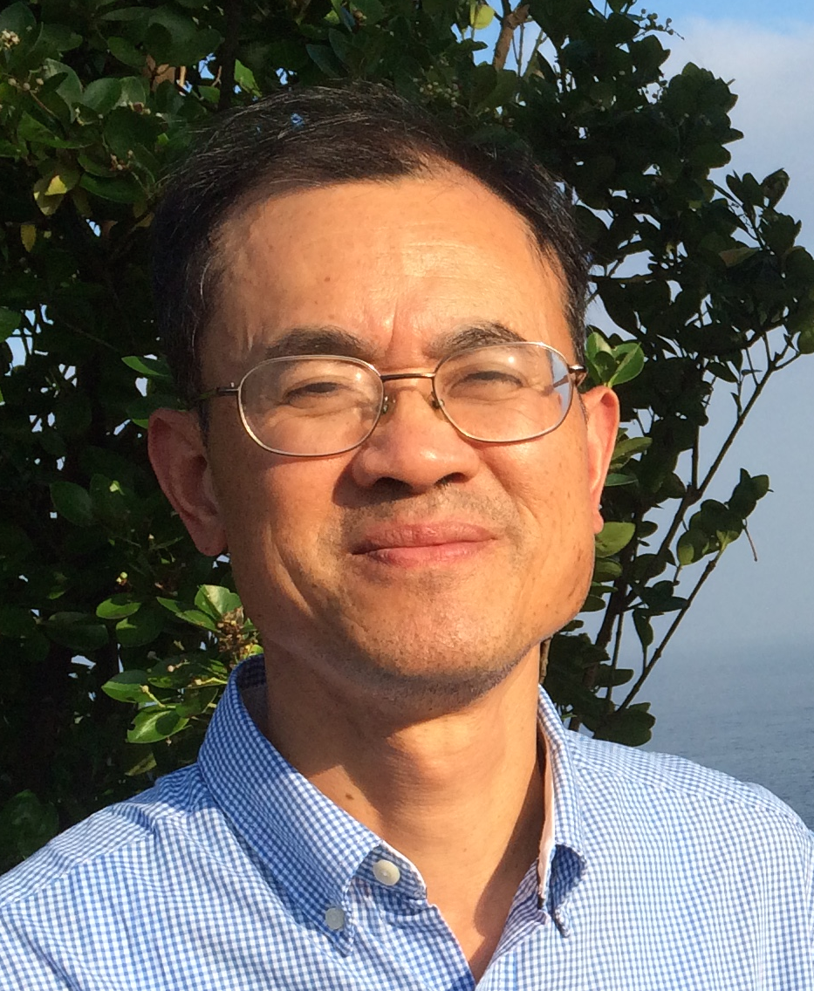Biography
Yuegang Zuo is currently a Full Professor in analytical and environmental chemistry and Director of Graduate Programs at Department of Chemistry and Biochemistry, University of Massachusetts Dartmouth. He received his B.S. degree in chemistry from Wuhan University in 1982, his M.S. degree in environmental chemistry from the Research Center for Eco-Environmental Sciences, Chinese Academy of Sciences, in 1984, and his Ph.D. in environmental science from Swiss Federal Institute of Technology Zurich in 1992. Most of his recent research has focused on separation, identification and quantification of endocrine disrupting pollutants and phenolic antioxidants in plants and seafood as well as in the related environments and examine their occurrence, sources, distribution, transportation and fate in the biochemsphere. He has published over 70 peer-reviewed papers in prestigious international scientific journals such as Science, and Environmental Science and Technology..
Email: yzuo@umassd.edu

Notes/Comments:

