Effect of Nutrition on Sarcopenia Management
Nasrin Nasimi, Community Nutrition MSc,
Shiraz University of Sciences, Iran

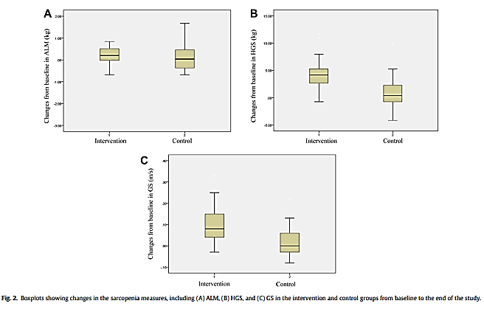
Abstract
Statement of the problem: Sarcopenia is defined as a geriatric syndrome characterized by progressive loss of skeletal muscle mass, strength, and physical function. Our previous study showed that the prevalence of sarcopenia is 20.8% among the Iranian community-dwelling older adults. Our findings underlined that sarcopenia might develop in older adults with impaired nutritional status and high body fat mass (1). Regarding the high prevalence of sarcopenia, and the importance of nutrition interventions in sarcopenia, efficient strategies are required for its management. The recent study conducted to evaluate the efficacy of daily consumption of fortified yogurt with 3g beta-Hydroxy beta-Methyl Butyrate (HMB), 1000IU vitamin D, and 500mg vitamin C on measures of sarcopenia and quality of life in sarcopenic older adults. Methods: Body composition, muscle strength, and functionality were measured using Dual-energy-X-ray Absorptiometry (DXA), hydraulic handgrip dynamometer, and usual gait speed, respectively. Findings: The results demonstrated that the increased muscle mass in the intervention group was mostly apparent in appendicular lean mass (ALM) (approximately 1% increase). Moreover, consumption of fortified yogurt enhanced handgrip strength and gait speed in the intervention group compared to the control group (P<0.001). The results also revealed a significant increase in vitamin D and IGF-1 levels in the intervention group (P < 0.001). The nutritional intervention significantly prevented any increase in the serum concentration of hs-CRP compared with the control group (P= 0.033). Moreover, there were significant differences between the 2 groups regarding physical aspects of quality of life (P= 0.035). Conclusion: A novel dairy product fortified with HMB, vitamin D, and vitamin C not only could enhance muscle strength and functionality, but also modulate anabolic and inflammatory conditions as well as quality of life. This study suggested that specific nutritional interventions alone could be beneficial, especially for those who are unable to exercise (2).

Image
Recent Publications

1. Nasimi N, Dabbaghmanesh MH, Sohrabi Z. Nutritional status and body fat mass: Determinants of sarcopenia in community-dwelling older adults. Experimental gerontology. 2019;122:67-73.
2. Nasimi N, Sohrabi Z, Dabbaghmanesh MH, Eskandari MH, Bedeltavana A, Famouri M, et al. A novel fortified dairy product and sarcopenia measures in sarcopenic older adults: A double-blind randomized controlled trial. Journal of the American Medical Directors Association. 2021;22(4):809-15.
3. Montazeri-Najafabady N, Nasimi N, Sohrabi Z, Chatrabnous N, Dabbaghmanesh MH. The Association between TP53 rs1625895 Polymorphism and the Risk of Sarcopenic Obesity in Iranian Older Adults: A Case-control Study. BMC Musculoskeletal Disorders. 2021; 22(1):1-9.
4. Courel-Ibáñez J, Vetrovsky T, Dadova K, et al. Health benefits of b-hydroxy-bmethylbutyrate (HMB) supplementation in addition to physical exercise in older adults: A systematic review with meta-analysis. Nutrients 2019; 11:2082.
5. Garcia M, Seelaender M, Sotiropoulos A, et al. Vitamin D, muscle recovery, sarcopenia, cachexia and muscle atrophy. Nutrition 2019; 60:66e69.

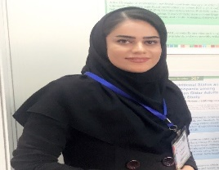Biography
Nasrin Nasimi has completed her Master from Shiraz University of Medical Sciences (SUMS- School of Nutrition and Food Sciences) and she is working in the community nutrition department of SUMS as teaching and research assistance. As a young researcher, she mainly worked on sarcopenia, muscle wasting, and nutrition supports in older adults. She has some publications in the aforementioned research areas and some submitted articles in this regard. She has also given four international presentations in Iran, Italy, Switzerland, and Austria. As a young researcher, she focuses on nutrition in different life stages and public health.
Email: nasrin_nasimi1992@yahoo.com

Notes/Comments:
Presenting author details
Full name: Nasrin Nasimi
Contact number: 0098 9177083414
Category: (Oral presentation/ Poster presentation)

