Title: Potential Health Benefits of Black Pepper. A focus on Human Studies
Hafsa Kamran, Assistant Professor, University Institute of Diet and Nutritional Sciences,
The University of Lahore, Lahore, Pakistan

Abstract (300 word limit)
Black pepper, also known as Piper nigrum is related to the family Piperaceae and is most commonly consumed spice worldwide. Among the several different kinds of spices Piper nigrum L. holds a dominant position due to its distinct pungency and flavor and is thus, recognized as “King of Spices”. The pungent aroma and flavor of black pepper is because of naturally occurring alkaloid piperine, volatile oils and oleoresins present in it. Piperine, pellitorine, guineensine, pipnoohine, trichostachine and piperonal are active components in black pepper. In human studies, piperine, the major active component of black pepper has been found to possess direct effect on various cancers, gastrointestinal motility, inflammation, oxidation, genotoxicity, asthma, diabetes, hyperlipidemias, obesity and metabolic syndrome. Piperine has also shown to increase bioavailability of certain drugs thus showing its indirect effect on cognitive performance, hepatic health, urticaria, allergy and ulcerative colitis. The focus of current review is to provide a brief overview of research regarding potential benefits of black pepper on human health.

Image

Fig 3: Role of Piperine in reduction of cancer metastasis in A549 cells in dose-dependent manner
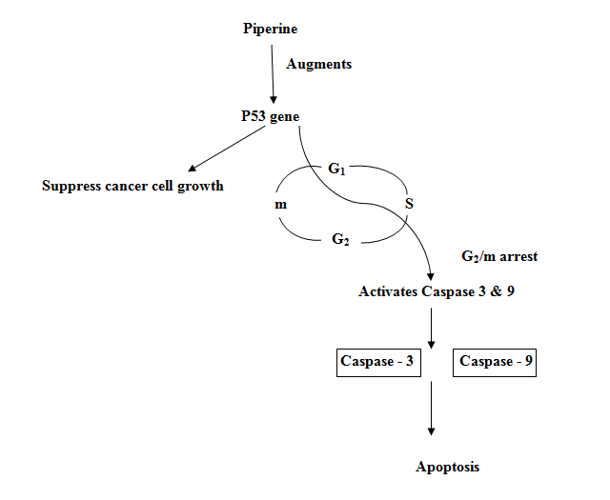
Recent Publications (minimum 5)
- 1. H. Kamran, A. Afreen, Z. Ahmed, “Effect of Internet Addiction on Dietary Behavior and Lifestyle Characteristics among University Students,” Annals of King Edward Medical University, 24(S), (2018), P.836.
- H. Kamran, Z. Ahmad, M. Aslam, and S. Jabeen, “Dietary Options in Polycystic Ovary Syndrome (PCOS),” Annals of King Edward Medical University, 23(2), (2017), P.236.
- M. Aslam, S.Khalid, and H. Kamran. " Effective Processing Methods for Fruits And Vegetables." Phytochemistry. Apple Academic Press, (2018), P.253.
- Roles of Phytomolecules in the Treatment and Management of Diabetes Mellitus." Phytochemistry. Apple Academic Press, (2018), P.387
- M. Aslam, S. Hamid, S. Khalid, H. Kamran, and S. Azhar, “Determination of Preservative Sodium Benzoate in Selected Samples of Fruit Juices and Squashes,” Asian Journal Of Allied Health Sciences, 2(1), (2017)


Biography

Hafsa Kamran has completed her M Phil degree in Community Health and Nutrition and has been serving as Assistant professor at University institute of diet and Nutritional Sciences for last seven years. She has great interest in nutraceuticals and functional foods. She has nine publications in renowned journals.

Email: Hafsa.kamran@rsmi.uol.edu.pk
- Full Name: Hafsa Kamran
- Personal Email: hafsakamran7@gmail.com
- Mobile Number: +92 323 4814202
- Linked In: linkedin.com/hafsa-kamran-02627a65
- Facebook: Hafsa Kamran
- Session Name/ number: Track 24 Nutraceuticals
- Category: (Oral presentation/ Poster presentation)
- Date of Birth: Jan 20th, 1980
- Postal Address: 205 A Nasheman e Iqbal Society Phase 2, Lahore, Pakistan
Notes or Comments:
NIL

