Fizza Batool, student, research officer in civil society association of- Pakistan, volunteer (seminars/workshop), marketing managing
, ISLAMABAD, PAKISTAN
Abstract:
Health is the ability of a biological system to acquire, convert, allocate, distribute, and utilize energy sustainably. His health management system (HMS) is an evolutionary medicine regulative process proposed by Nicholas in which actuarial assessment of fitness and economic-type cost–benefit analysis determines the body’s regulation of its physiology and health. This incorporation of cost–benefit calculations into body regulation provides a science grounded approach to mind–body phenomena such as placebos that are otherwise not explainable by low level, noneconomic, and purely feedback based homeostatic or allosteric theories. Many medical symptoms such as inflammation, fever, pain, sickness behavior, or morning sickness have an evolutionary medicine function of enabling the body to protect, heal or restore itself from injury, infection or other physiological disruption. The deployments of self-treatments have costs as well as benefits with the result that evolution has selected management processes in the brain such that self-treatments are used only when they provide an overall cost–benefit advantage. The brain controls such physiological process through top–down regulation. External treatment and the availability of support are factored into the health management system’s cost–benefit assessment as to whether to deploy or not an evolved self-treatment. Physical fitness is a state of health and well-being and, more specifically, the ability to perform aspects of sports, occupations and daily activities. Before the industrial revolution, fitness was defined as the capacity to carry out the day’s activities without undue fatigue. However, with automation and changes in lifestyles physical fitness is now considered a measure of the body's ability to function efficiently and effectively in work and leisure activities, to be healthy, to resist hypokinetic diseases, and to meet emergency situations. Nutrition is the science that interprets the interaction of nutrients and other substances in food in relation to maintenance, growth, reproduction, health and disease of an organism. It includes food intake, absorption, assimilation, biosynthesis, catabolism, and excretion. Nutrition is the science that interprets the interaction of nutrients and other substances in food in relation to maintenance, growth, reproduction, health and disease of an organism. It includes food intake, absorption, assimilation, biosynthesis, catabolism, and excretion.The diet of an organism is what it eats, which is largely determined by the availability and palatability of foods. For humans, a healthy diet includes preparation of food and storage methods that preserve nutrients from oxidation, heat or leaching, and that reduce risk of foodborne illnesses.
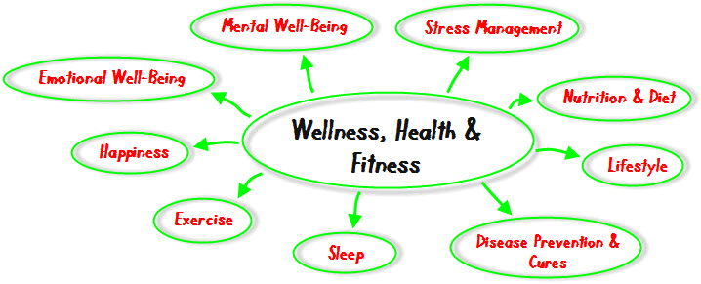
Figure 1: Fitness chart
Reference: minimum 5
1: Simandan, D., 2018. Rethinking the health consequences of social class and social mobility. Social Science & Medicine.
2: Campbell KL, McTiernan A (January 2007). "Exercise and biomarkers for cancer prevention studies". The Journal of Nutrition. 137.
3: Westerlind KC (November 2003). "Physical activity and cancer prevention--mechanisms". Medicine and Science in Sports and Exercise. 35 (11): 1834–40.
4: Wisløff U, Ellingsen Ø, Kemi OJ (July 2009). "High-intensity interval training to maximize cardiac benefits of exercise training?” Exercise and Sport Sciences Reviews. 139–46.
5: Tremblay MS, Colley RC, Saunders TJ, Healy GN, Owen N (December 2010). "Physiological and health implications of a sedentary lifestyle". Applied Physiology, Nutrition, and Metabolism = Physiologie Appliquee, Nutrition et Metabolisme.
Biography:


Fizza Batool has completed pre-medical. She is a student, research officer CSAP and volunteer with organizations also doing marketing managing.she her expertise in evaluation and passion in improving the health and wellbeing with an opportunity to gain experience and knowledge. She has built this model after years of experience in research, evaluation; workshops, seminars and administration all are in organizations and educational institutions. She has a good talent in this pathway and has a different way of focusing she has a very goood experience to show.
Email:fizzabatool90@yahoo.com
• Full Name: Fizza Batool
• Personal Email:fizzabatool90@yahoo.com
• Mobile Number: +923475018695
• Linked In: https://www.linkedin.com/in/model-fiza-b534a5a2
• Facebook: fizzabatool90@yahoo.com
• Session Name/ number: Nutrition, Physical Fitness (state of health & well-being) & Health Management (the ability of biological system to acquire, convert, & utilize energy sustainably).
• Category: (Oral presentation/ Poster presentation)
• Date of Birth: june-25-1998
• Postal Address: Imran Ali house, street no 12 near shahid general store koral Islamabad, Pakistan
Notes or Comments:
None..

