ABOUT ROY REDD
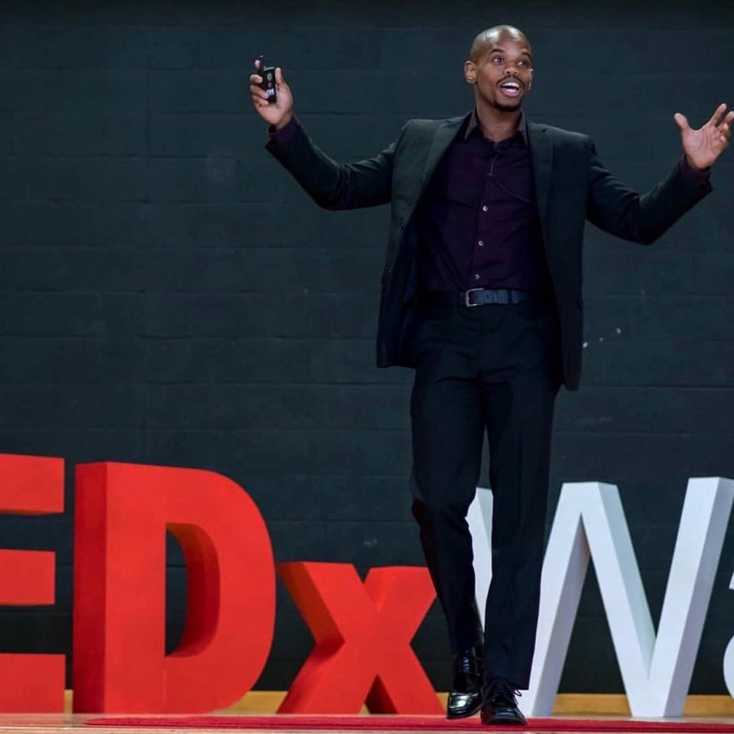

Roy is a Best-selling author of the book The Unnoticed Advantage and The Success Magnet: Cultivate the 5 values that attract success. Roy also Is a performance coach who works with pro, college, and high school athletes. He works with the athletes to dramatically increase, tangible, measurable, and physical results. He also does this with companies, organizations and anyone who has a purpose.

At the age of 25, Roy realized he was not the person he wanted to become. That’s when he decided to make a change in his life. Since that startling realization, he went from broke to making six-figures, homeless to buying his first home, and depressed to feeling fulfilled.

Roy Found that his distinctions dramatically increased what he calls workability. Workability simply means the ability to get the job done. When we look at the workability of an object we judge the object on its ability to do what the object was made for. With this knowledge, Roy realized that the workability of a human comes down to the human’s ability to achieve its purpose. This makes performance the most important thing in life because to perform means to do what it takes to achieve a purpose. Roy became a performance coach for Pro, collegiate, and high school athletes. With a new distinction, Roy calls UnBounded Performance Roy is coaching people to dramatically increases tangible, measurable and physical results.

Roy has spoken at Ted, National Head Start Conference, International Health and Wealth conference, La Sierra University, Unbounded Basketball Camp, Chaffey College, Inland Empire One Love Christmas Party For Orphans, and Multiple High School, College, and NBA Teams. I have been featured on shows like Hollywood Unlocked, The daily Grind, Convos with Cole, and multiple radio shows and podcast.

Check out Roy's Ted Talk here: https://youtu.be/_9kQFw-Mcnw

www.RoyRedd.com
ROY’S AV REQUIRENMENTS

- Lavalieremicrophone.

- Hand-heldmicrophone.

- PowerPoint will be used. Roy will need a projector and screen to fit the audience.

- Roy needs a means to leave the stage and be with the audience.

- Roy will like to be able to see the room prior to the talk if possible.

