Evaluation of Anti-Melanogenic Activities of Combined Extract of Persimmon fruit and Citrus unshiu peel in vitro and in vivo
Su Hyun Kim, Ah Reum Lee, Seong-Soo Roh, Daegu Haany University. South Korea

Abstract :
We conducted experiments about immunopotentiating with powder of silkworm as food and immunity promoting materials (Angelica Gigas Root, Eucommiae cortex, turmeric, cinnamon, Alpinia oxyphylla Miquel , Achyranthes bidentata Blume, liriope radix, Japanese lady bell, chives, ulmoides ).
In order to measure the effect of enhancing the immune function, a sample of silkworm powder and composite materials were orally treatment for 2 weeks and T lymphocyte proliferation and IL-2, IL-4, and IFN-gamma secreted by T lymphocyte activation, degree of nitric oxide uptake and total spleen, lymphocyte, and peritoneal macrophage counts were measured in macrophages.
That is, in vitro cytotoxicity was observed when the cells were co-cultured in silkworm powder and immunoprecipitation candidate treatment for 24 hours. As a result among 10 kinds of immunopotentiating material, 100 ug/ml Eucommia ulmoides, 400 ug/ml, 200 ug/ml cinnamon, 100 ug/ml liriope radix, 100 ug/ml chives, and Acanthopanax 100 ug/ml were chosen based on the results of spleen cell proliferation ability. The control group treated with Concanavalin A (Con-A) for activating splenocyte T cells and the control group treated with Con-A and candidate material samples were simultaneously treated to determine whether synergic effect of T cell proliferation occurred. As a result, group treated with each combination extract of Silkworm and Liriope radix, Cinamori cortex and Eucommiae cortex showed a synergistic effect on splenic T cell proliferation compared to group only treated with Silkworm. In addition, the expression levels of cytokines were increased in the silkworm cinnamon, silkworm liriope radix , and silkworm Eucommia ulmoides treated groups compared with silkworm alone group.
In conclusion, it can be concluded that an equal amount of silkworms and mosquitoes can be obtained to enhance the immunity-enhancing effect.

Image:
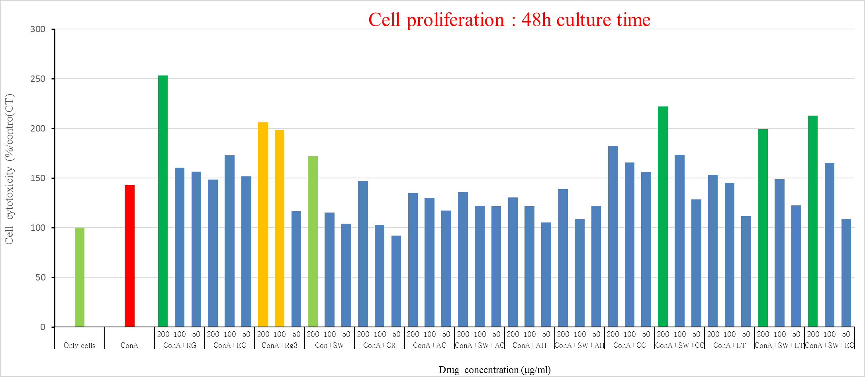
Figure1. Synergic effects of silkworm powder and candidate material complex of Con-A on the cell proliferation of spleen cells
Recent publications:
- Kwon OJ, Choo BK, Lee JY, Kim MY, Shin SH, Seo BI, Seo YB, Rhee MH, Shin MR, Kim GN, Park CH, Roh SS (2016) Protective effect of Rhei rhizome on reflux esophagitis in rats via Nrf2-mediated inhibition of NF-Kb signaling pathway, BMC complementary and alternative medicine 16: 1-12
- Kim GN, Shin MR, Shin SH, Lee AR, Lee JY, Seo BI, Kim MY, Kim TH, Noh JS, Rhee MH, Roh SS (2016) Study of antiobesity effect through inhibition of pancreatic lipase activity of Diospyros kaki fruit and Citrus unshiu peel, BioMed Research International 2016: 1-7
- Kwon OJ, Kim MY, Shin SH, Lee AR, Lee JY, Seo BI, Shin MR, Choi HG, Kim JA, Min BS, Kim GN, Noh JS, Rhee MH, Roh SS (2016) Antioxidant and anti-Inflammatory effects of Rhei Rhizoma and Coptidis Rhizoma mxture on reflux esophagitis in rats, Evidence-Based Complementary and Alternative Medicine 2016:1-13


Biography
His major is traditional Korean medicine, and he has lectured and studied pharmacology and toxicity in Korean medicine at Daeguhaany university. In addition to natural drug research, he is also focusing on research on functional food ingredients and natural cosmetic materials. Now he is the editor-in-chief of The Korea Association of Herbology and serves as an academic member and editor of internationally renowned journals. He has built this model after years of experience in research, evaluation, teaching and administration both in hospital and education institutions.
Email: ddede@dhu.ac.kr

Speaker Mobile Number: 82-10-9686-7975

Speaker Facebook Profile URL: https://www.facebook.com/profile.php?id=100001573796992

Note: Please add the Program Director of the conference to your Facebook with below link, So that he can contact you regarding acceptance of your abstract at the earliest.

Program Director
Krishnam Raju
Email: nutritionasia@nutritionconferences.org
Facebook: https://www.facebook.com/nutritionfoodpublichealthevents
LinkedIn: https://www.linkedin.com/in/publichealth-conference?trk=nav_responsive_tab_profile

