Adrian ColomerWinter1, Ibai Aldebaran de Villasante Llaquet2*

1International University of Valencia (Spain)

Keywords: Risk communication, Cognitive deficit model, Harmlessness

Introduction
The present research work is entitled "Relationship between information deprivation on food security and health risks during food consumption in the population of Piura (2018)." The report has been made due to the growing statistics of coronary metabolic diseases that are registered in Peru, and especially Piura, due to the deficient patterns of food consumption. It is for this reason that the perception of the risk that consumers have about food and the knowledge associated with the potential danger of developing diseases was analyzed.

Another of the justifying reasons for the development of this report is the scarce coverage of the media on food security, considering that more than fifty percent of the causes of death in Peru are due to diabetes and cardiovascular afflictions.

This thesis should take into account some fundamental principles such as innocuity, consumer trends, theories about cognitive deficit, risk communication, the rate of scientific literacy, the manipulation of neurointelligence in the labeling of food packaging as a means of confusion to the consumer for the adequate nutritional information interpretation of the food; coinciding with the proposal of the "Public Understanding of Science" the need of citizenship to have a wide range of understanding of terms and constructs sufficient to understand a significant number of events in daily life, including reading and understanding the label of a food package.

The methodology applied was observation; To take a close look at the most common and frequent eating habits of the Piura population during their visits to the main supermarkets in the city. Correlatively, a questionnaire was executed by means of a "survey" file to contrast the similarity between what was observed and what was answered in the interviews. Finally, in order to demonstrate the omissions on nutritional information in food labels, a metabolic analysis has been applied by high efficiency liquid chromatography to quantify the metabolites with genotoxic potential not declared in the foods sold by the companies.

The results shows that 39.7% and 14.7% of the asked participants
answer that the frequent consume of high carbohydrates (rice, yucca, potatoes) do not constituted a cardio metabolic (diabetes) risk for the health. The first one percentage answer with a categorical denial and the second one affirms that it is a myth. Correlatively, this result is related to the 4442 kilocalories average consumed per day of piuran population, specifically the low physical activity index, in numbers,
270.39 kcal per day burning average plus 1572.74 kcal of basal metabolism give a daily spend of 1843.13 kcal. The present quantity associated with the daily 4442 kcal consumption manifest an excess of 2578, 87 non- burned kcal that is going to be transformed in fats and glucose in the blood; which is a cardiovascular risk factor for piuran people. Finally, it was found 9mg/kg of hydroxymethylfurfural (carcinogenic substance) in chocolate bars samples which are not declared as a quality and innocuous standard at the nutrition facts.

The main conclusions of the study show that the relationship between information deprivation on food security and health risks during food consumption in the Piura population is deficient, mainly due to the little or no perception of the risk of the population surveyed during the feeding. Sequentially, it has been concluded that the excess of kilocalories consumed by the abundant intake of foods rich in carbohydrates, starch, sugar, lack of knowledge about the development of metabolic diseases due to the repetitive consumption of rice, cassava coincides with the scarce and confusing nutritional information in food labels and the high death rate from diabetes and other coronary diseases.

Question No: 1
Do you know what the nutritional table is?

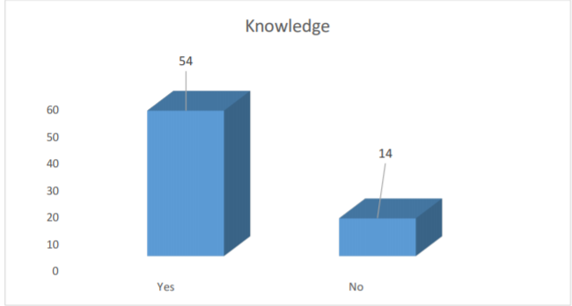

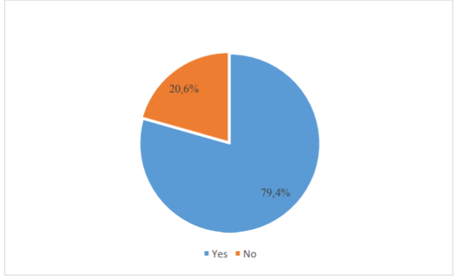
Question No: 3
In case Your answer is some, mention what you know?
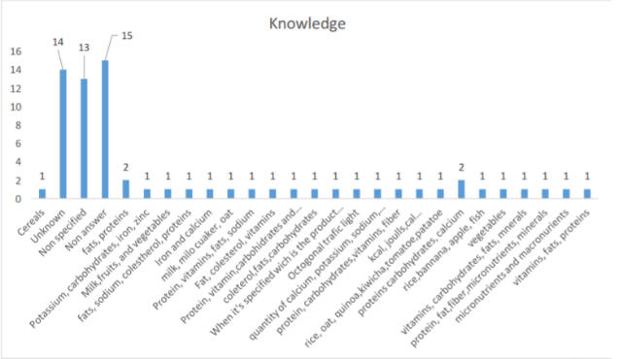

Source: Own Elaboration

Interpretation
In question No. 01, in its dimension of lack of information protection, it is observed that 79.4% of the 68 people surveyed; in numbers, equivalent to 54 users of the studied population, knows the nutritional table. In contrast, only 20.6% (14 people surveyed) of the users reported not knowing about the nutritional labels in the food.

Question No: 2
Do you know what the nutritional table is?
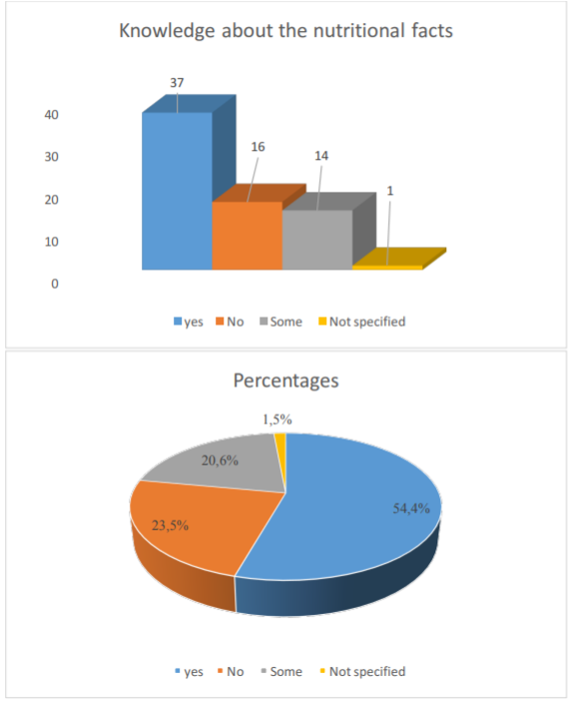

Interpretation
Regarding the detailed question about the knowledge of some nutritional substances, it is observed that 15 people did not respond properly to the question, followed by 14 and 13 respondents who do not know or do not specify despite having answered affirmatively to the question "some " Correlatively, in hierarchical order you have 2 people who know the groups "carbohydrates, proteins, calcium", two others who have cognition about fats and proteins. Finally, the rest of the participants present dissimilar responses to the conventionally accepted group of nutrients: proteins, carbohydrates, fats and minerals.

Question No: 4
Do you think that by the repetitive consumption of rice, potato cassava, sweet potato, foods rich in carbohydrates can develop metabolic diseases such as diabetes?

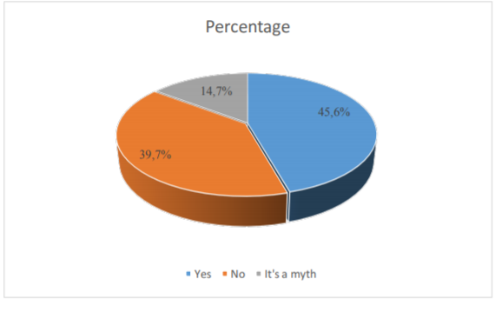

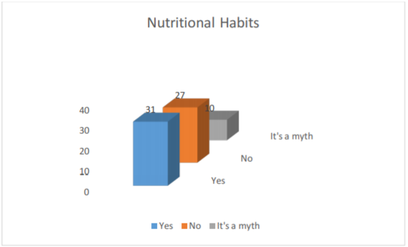

Source: Own Elaboration

Interpretation

In question no 2, with respect to the general knowledge about the nutritional elements present in food packaging, there are 37 interviewees who claim to know most of the nutrients that the food contains in its composition. In percentage terms, it represents 54.4% of the simple surveyed; compared to 23.5% (16) that doesnot know any ingredient at all, followed by 20.6% (14) that shows knowledge

on some and finally 1.5% (1) of the survey edpopulation that does not specify, doesnot comment.

Source: Own Elaboration

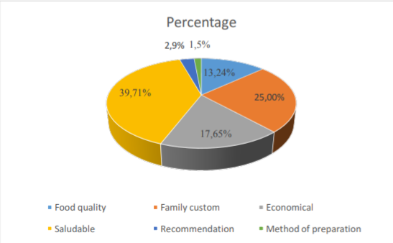
Interpretation
In question no 4, in its dimensión risks to health, there are 31 participant sequivalent to 45.6% who are convinced that the reiterative consumption of foods rich in sugars, starch, carbohydrates constitutes a risk in the development of metabolic diseases such as diabetes. In contrast, we have 39. 7% equivalent to 27 participants who affirm the opposite; finally it is observed that 10 people, whose percentage value represents 14.7% who believe that it is a myth.

Question No: 5
Do you think that low fat food (eg Yogurt Light) prevents coronary heart disease?
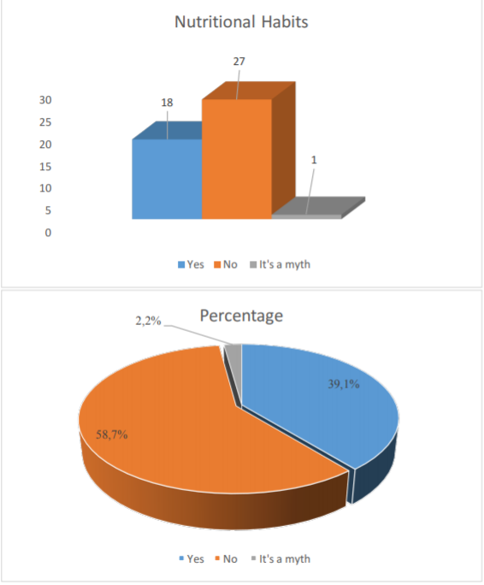
Referring to patterns of food consumption, it is observed that the main purchasing criteria are based on the healthy aspect with 39.71%, followed by a 25.00% "family custom", 17.65% for economic reasons, correlatively 13.24% "quality of the food", 2.9% by recommendation and finally 1.5% due to the ease of preparation.

Question No: 7
In case you have chosen the first option, what data is set to know that the food is healthy?
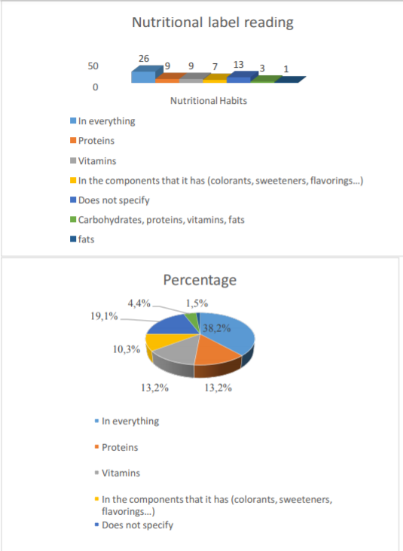

Source: Own Elaboration

Interpretation
In which concerns the question about the low fat foods as a preventive measure of coronary heart disease; it is observed that 27 of the people surveyed think that it doesnot prevent cardiovascular diseases in front of 18 participants that is a prophylactic measure. Finally 1 interviewee thinks it is a myth. In percentage terms it is distributed in a negative 58.7%, an affirmative 39.1% and a 2.2% rejection.

Question No: 6
What are your criteria for the selection of the food you eat?
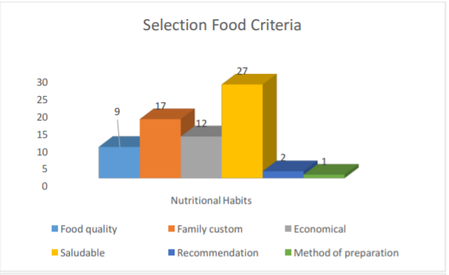

Source: Own Elaboration

Interpretation
Regarding the reading of the nutritional labels in the "food consumption" dimension, it is observed that to determine the healthy criterion, 38.2% of the participants look at everything in general, 19.1% do not specify reasons, 13.2% in vitamins and proteins respectively, 10.3% is fixed in the components it has (sweeteners, flavorings, raw materials), 4.4% in carbohydrates, proteins, vitamins and minerals; while 1.5% is fixed in the lipids.

Question No: 8
How much time do you spend for reading the nutritional label of the product before the purchase decision?
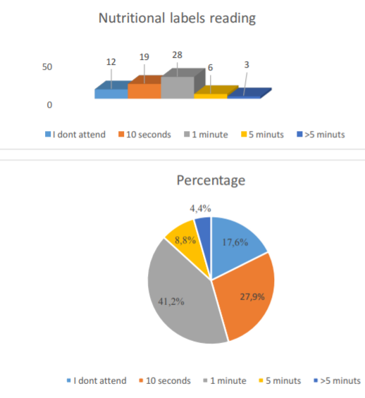

Interpretation
In the field of eating habits of the target sample, it is appreciated that the vast majority of participants have the habit of varying between rice and noodles to accompany the daily lunch. Sequentially, in percentage and numerical figures it represents 52.9% and 36 consumers, all followed by 36.8% (25) of the population interviewed who always consume rice, 5.9% (4) eat aguadito or soup , 2.9% (2) marks the option "none of the above: salad with grilled chicken and vegetables, fish and chicken". Finally, 1.5% (1) always consumes noodles.

Question No: 10
With what food do you usually accompany for dinner?

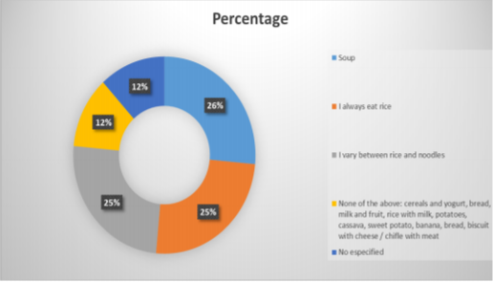

Source: Own Elaboration

Interpretation
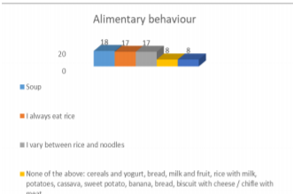
Regarding the time devoted to reading the nutritional labels, it is envisaged that 41.2%, in numerical figures, 28 participants take 1 minute of time to interpret the nutrients and ingredients of the nutritional table, a 27.9 % (19 users) only 10 seconds, followed by 17.6% (12) not looking at the labeling of the container, 8.8% (6) 5 minutes and finally 3 consumers (4.4%) who stop more of five minutes to analyze it.

Question No: 9
With what food do you usually accompany lunch?

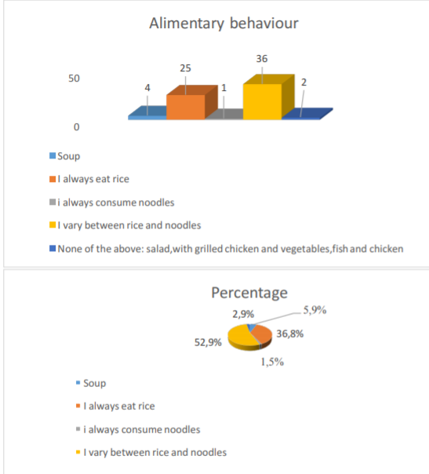

SoSource: Own Elaboration

Interpretation
Continuing with the dimension "alimentarycustom", it is known that most of there spond entsrepe atthesame accompaniment of the lunch during the dinner; 26% equivalent to 18 participant seat aguadito or soup, followedby 25% (17) repeated that always ingests rice and varies between rice and noodles, finally a repeated 12% (8) doesnot specify ordoes no teatany of the above : cereals with yogurt, bread, milk and fruit, rice with milk, potatoes, yucca, sweet potato, banana, bread, biscuit with cheese / chifle withmeat.

Source: Own Elaboration

Question No: 11
How often do you make exercise?
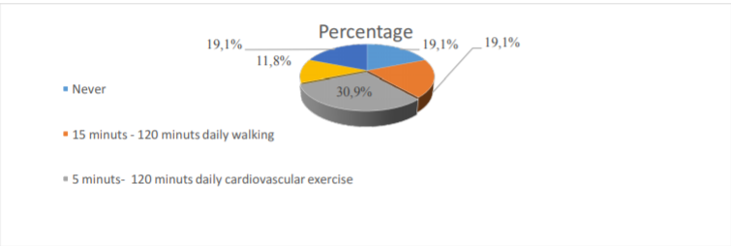
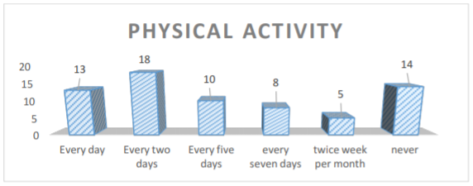

Source: Own elaboration

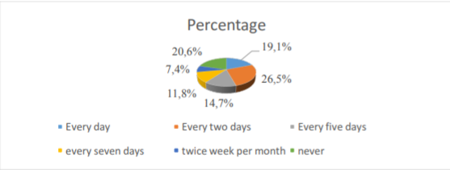
Interpretation

Interpretation

Source: Own Elaboration
Referring to the physical activity, it is identified that the frequency with which participants perform physical exercise is very variable, establishing very long time ranges that start from a minimum of 5 minutes to every 15 days. Percentage and numerically are ordered as follows: 30.9% (21) performed between 5 to 120 minutes of cardio and strength on a daily basis, followed by a triple 19.1% (13) that never exercised, which allocates 15 minutes to 120 minutes of daily walking, and others that perform 5 hours a week, bike every 5 days, volleyball every 3 days, 40 minutes of soccer every 3 days and finally running every 15 days.

Question No: 13
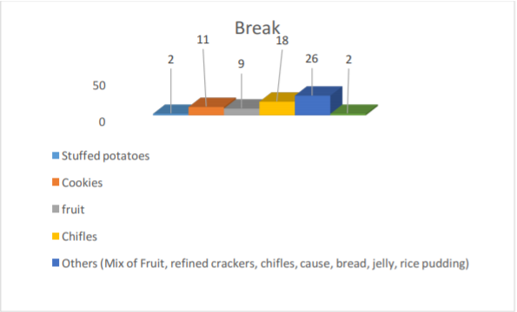
What food do you consume during the break?

In reference to the "healthrisks" dimension related to physical activity, of the total of 68 respondents, it is identified that 18 participants (26.5%) perform physical exercise every two days a week, followedby 14 users (20.6 %) that have a sedentary behavior, 19.1% (13) that practices portsdaily, 14, 7% (10) every five days,
11.8% (8) performed every 7 days and lastly7 , 4% (5) every two
weeks

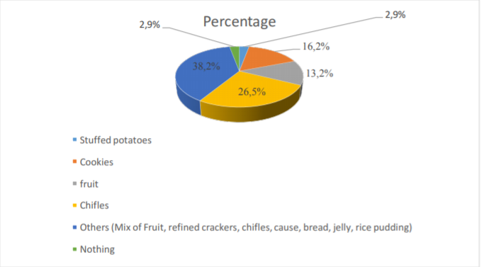
Question No: 12
How many minutes do you exercise? What exercises do you do?
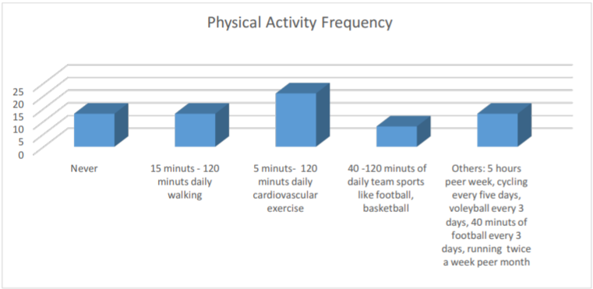
Source: Own elaboration

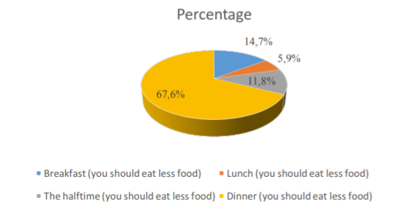
Interpretation
Regarding the foods that consumers frequently ingest during the snack time, under the dimension of the alimentary habits, they are ordered hierarchically in the following way: 27.9% consume a mix of fruits, refined crackers, chifles, cause, bread , gelatin, rice pudding, preceded by 27.9% who eat simple fruit or fruit salads, 16.2% eat biscuits, 11.8% chifles, and 2.9% repeat that they eat nothing at all during the halftime.

Question No. 14
How often do you consume the snacks during the break time?

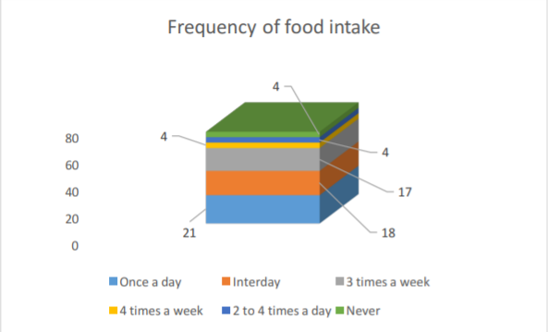
Source: Own Elaboration

Interpretation
Regarding the question about the hierarchical categorization of diets, the major participants considered the dinner as the most critical time to eat (you must consume less). In order, 67.6% (46) preceded by 14.7% (10) indicating the breakfast option, 11.8% (8) indicates the halftime as the most important. Finally a 5.9% (4) opts for the lunch option.

Metabolicanalysis of chocolate, chifle and carobsyrup
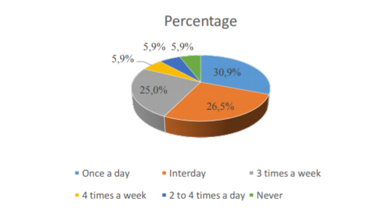
Analysis of acrilamyde in carobsyrup Figure No: 1

Source: Own Elaboration
 | Maximum daily intake recommended for adults, when carob syrup is con- sumed with acrylamide
 | Male | Recommendeddaily Maximumintake
 |  | Moisture gr | 42 | 42 | 42 | 42
 |  | mg/kg | 0.303 | 0.25 | 0.083 | 0.02
 |  | mg | 0.012726 | 0.0105 | 0.003486 | 0.00084
*Age | *Weight | IDA | MaximumAmmount to consume daily
Years | Kg | mg
23 | 45 | 0.225 | 17.68 | 21.43 | 64.54 | 267.86
24 | 45 | 0.225 | 17.68 | 21.43 | 64.54 | 267.86
65 | 47 | 0.235 | 18.47 | 22.38 | 67.41 | 279.76
28 | 48 | 0.24 | 18.86 | 22.86 | 68.85 | 285.71
24 | 48 | 0.24 | 18.86 | 22.86 | 68.85 | 285.71
55 | 50 | 0.25 | 19.64 | 23.81 | 71.72 | 297.62
23 | 50 | 0.25 | 19.64 | 23.81 | 71.72 | 297.62
56 | 50 | 0.25 | 19.64 | 23.81 | 71.72 | 297.62
64 | 50 | 0.25 | 19.64 | 23.81 | 71.72 | 297.62
27 | 50 | 0.25 | 19.64 | 23.81 | 71.72 | 297.62
51 | 50 | 0.25 | 19.64 | 23.81 | 71.72 | 297.62
23 | 51 | 0.255 | 20.04 | 24.29 | 73.15 | 303.57
23 | 55 | 0.275 | 21.61 | 26.19 | 78.89 | 327.38
28 | 55 | 0.275 | 21.61 | 26.19 | 78.89 | 327.38
28 | 55 | 0.275 | 21.61 | 26.19 | 78.89 | 327.38
22 | 55 | 0.275 | 21.61 | 26.19 | 78.89 | 327.38
24 | 55 | 0.275 | 21.61 | 26.19 | 78.89 | 327.38
20 | 56 | 0.28 | 22.00 | 26.67 | 80.32 | 333.33
22 | 57 | 0.285 | 22.40 | 27.14 | 81.76 | 339.29
21 | 58 | 0.29 | 22.79 | 27.62 | 83.19 | 345.24
21 | 58 | 0.29 | 22.79 | 27.62 | 83.19 | 345.24
20 | 59 | 0.295 | 23.18 | 28.10 | 84.62 | 351.19

Interpretation
In the figure no 14 shows that the frequency of consumption is very varied, whose periodicity ranges from once a day, Interlay, 3 times a week, 4 times a week, 2 to 4 times a day and never. Perceptually, it can be seen that 26.5% consume food interdiarily during the break, 30.9% eat daily, 25.0% 3 times a week and finally a repeated 5.9% eat snacks 4 times a day. Week, 2 to 4 times a day and never.

Question No. 15
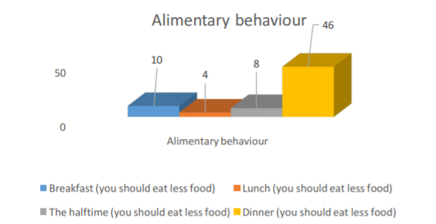
What time do you think is most critical when it comes to consuming food?

19 | 82 | 0.41 | 32.22 | 39.05 | 117.61 | 488.10
0 | 82 | 0.41 | 32.22 | 39.05 | 117.61 | 488.10
24 | 82 | 0.41 | 32.22 | 39.05 | 117.61 | 488.10
23 | 83 | 0.415 | 32.61 | 39.52 | 119.05 | 494.05
22 | 90 | 0.45 | 35.36 | 42.86 | 129.09 | 535.71
23 | 90 | 0.45 | 35.36 | 42.86 | 129.09 | 535.71
28 | 95 | 0.475 | 37.33 | 45.24 | 136.26 | 565.48
33 | 100 | 0.5 | 39.29 | 47.62 | 143.43 | 595.24

Source: Own Elaboration
43 | 60 | 0.3 | 23.57 | 28.57 | 86.06 | 357.14
22 | 60 | 0.3 | 23.57 | 28.57 | 86.06 | 357.14
31 | 60 | 0.3 | 23.57 | 28.57 | 86.06 | 357.14
20 | 60 | 0.3 | 23.57 | 28.57 | 86.06 | 357.14
24 | 62.5 | 0.3125 | 24.56 | 29.76 | 89.64 | 372.02
21 | 63 | 0.315 | 24.75 | 30.00 | 90.36 | 375.00
25 | 64 | 0.32 | 25.15 | 30.48 | 91.80 | 380.95
15 | 64 | 0.32 | 25.15 | 30.48 | 91.80 | 380.95
20 | 64 | 0.32 | 25.15 | 30.48 | 91.80 | 380.95
35 | 65 | 0.325 | 25.54 | 30.95 | 93.23 | 386.90
29 | 65 | 0.325 | 25.54 | 30.95 | 93.23 | 386.90
25 | 65 | 0.325 | 25.54 | 30.95 | 93.23 | 386.90
19 | 65 | 0.325 | 25.54 | 30.95 | 93.23 | 386.90
22 | 65 | 0.325 | 25.54 | 30.95 | 93.23 | 386.90
26 | 66 | 0.33 | 25.93 | 31.43 | 94.66 | 392.86
20 | 67 | 0.335 | 26.32 | 31.90 | 96.10 | 398.81
23 | 68 | 0.34 | 26.72 | 32.38 | 97.53 | 404.76
23 | 69 | 0.345 | 27.11 | 32.86 | 98.97 | 410.71
21 | 69 | 0.345 | 27.11 | 32.86 | 98.97 | 410.71
21 | 70 | 0.35 | 27.50 | 33.33 | 100.40 | 416.67
21 | 70 | 0.35 | 27.50 | 33.33 | 100.40 | 416.67
23 | 70 | 0.35 | 27.50 | 33.33 | 100.40 | 416.67
21 | 70 | 0.35 | 27.50 | 33.33 | 100.40 | 416.67
20 | 72 | 0.36 | 28.29 | 34.29 | 103.27 | 428.57
21 | 73 | 0.365 | 28.68 | 34.76 | 104.70 | 434.52
21 | 73 | 0.365 | 28.68 | 34.76 | 104.70 | 434.52
27 | 74 | 0.37 | 29.07 | 35.24 | 106.14 | 440.48
21 | 74 | 0.37 | 29.07 | 35.24 | 106.14 | 440.48
21 | 74 | 0.37 | 29.07 | 35.24 | 106.14 | 440.48
19 | 75 | 0.375 | 29.47 | 35.71 | 107.57 | 446.43
26 | 75 | 0.375 | 29.47 | 35.71 | 107.57 | 446.43
22 | 75 | 0.375 | 29.47 | 35.71 | 107.57 | 446.43
22 | 76 | 0.38 | 29.86 | 36.19 | 109.01 | 452.38
19 | 77.8 | 0.389 | 30.57 | 37.05 | 111.59 | 463.10
18 | 80 | 0.4 | 31.43 | 38.10 | 114.74 | 476.19
43 | 80 | 0.4 | 31.43 | 38.10 | 114.74 | 476.19
19 | 80 | 0.4 | 31.43 | 38.10 | 114.74 | 476.19
19 | 80 | 0.4 | 31.43 | 38.10 | 114.74 | 476.19

Used Formula: COAA=CAA (ug/Kg)*KgCA/Kg * person * day

Interpretation
Table 1 shows the 42 gram portions of carob syrup, which indicates that the greater portions of carob syrup to be consumed the lower the amount of acrylamide found in the carob; Indicating that its manufacturing processes are the best favored by the company with greater purchase because the information that companies hide in Peru is due to their poor manufacturing practices. As the weight of the consumer increases, the portions to be consumed of carob syrup are increasing, which is why the quantification of acrylamide should be reported on the label as a quality parameter for the consumer's food safety guarantee. No company in Peru shows on its labels or labeling the acrylamide content nor is it present in Peruvian Technical Standard 209.600.

Chocolate and Chifle Analysis
Figure No: 2 Chemical Essay Chifle
Essay | Results
Hidroximetilfurfural(mg/kg) | 0.2
Picture No: 03 Chocolate Chemical Essay
Essay | Results
Hidroximetilfurfural(mg/kg) | 9.10

Interpretation
In the sample of chocolate milk with peanutsonits label does not mention any quantifiable content of substances that are presumed to be toxic. According to Table 02, it is shown that milk chocolate with peanuts has a hydroxymethylfurfural content of 9.10 mg / kg (See Annex 01). Similarly, in the sample of chifles (fried plantains)

Average daily Intake
STANDARD BREAKFAST | CHOS | kcal | SATURED FATS | POLIN FATS | MONOSAT FATS | COLEST | Na | K | FATS | PROT | IDR
100 OAT GRAMS | 66.27 | 389 | 1.217 | 2.535 | 2.178 | 0 | 2 | 429 | 6.9 | 16.89 | 19
2 FRIED EGGS | 0.86 | 180 | 3.6 | 2.4 | 5.4 | 420 | 476 | 134 | 12.5 | 12.48 | 8
1 MILK CUP | 11 | 146 | 4.5 | 0.5 | 2 | 24 | 98 | 359 | 7.93 | 7.86 | 7
STANDARD LUNCH | CHOS | kcal | SATURED FATS | POLIN FATS | MONOSAT FATS | COLEST | Na | K | FATS | PROT | IDR
250 RICE GRAMS | 200 | 912.5 | 0.45 | 0.4425 | 0.515 | 0 | 12.5 | 287.5 | 1.65 | 15.3295 | 45
113 FRIED CHICKEN GRAMS | 0 | 220 | 2.5 | 1.86 | 3.4 | 94 | 444 | 275 | 8.72 | 33.39 | 11
1 FRIED PLANTAIN | 80.44 | 562 | 4 | 14 | 9.8 | 0 | 11 | 1133 | 29.6 | 3.3 | 28
3 INKA COLA GLASS | 105 | 400 | 0 | 0 | 0 | 0 | 45 | 21 | 0.21 | 0.75 | 21
STANDARD DINNER | CHOS | kcal | SATURED FATS | POLIN FATS | MONOSAT FATS | COLEST | Na | K | FATS | PROT | IDR
250 RICE GRAMS | 200 | 912.5 | 0.45 | 0.4425 | 0.515 | 0 | 12.5 | 287.5 | 1.65 | 15.3295 | 45
100 SWEETBREAD GRAMS | 0.6 | 116 | 0.7 | 1 | 1.7 | 239 | 157 | 214 | 4.2 | 18.2 | 6
1 FRIED PLANTAIN | 80.44 | 562 | 4 | 14 | 9.8 | 0 | 11 | 1133 | 29.6 | 3.3 | 28
50 MENESTRA GRAMS | 3.6 | 22 | 0.07 | 0.07 | 0.2 | 0.5 | 70 | 85 | 0.38 | 1.13 | 1
TOTAL | 748.21 | 4422 | 21.487 | 37.25 | 35.508 | 777.5 | 1339 | 4358 | 103.34 | 127.959 | 219

Source: Data obtained from standard mutritional surveys and tables

Interpretation
In the present table Nr 03 it is observed that the amount of grams of carbohydrates consumed daily is 648 of the total 979,509 contemplated in the sum of the macromolecules (proteins, fats, carbohydrates). Also the WHO is considered to be consumed 55 at 75% average daily carbohydrates; in the Piuran community, this recommendation is exceeded since the percentage consumed is 76.38%, which affects the health of the population, causing possible chronic diseases such as diabetes. Mainly the causative factors are the high intake of rice during all the diets of the day. On the other hand, it is recommended that the percentage of proteins with respect to calories be between 10-15% according to WHO. Similarly, 11.55% of the established range has been obtained. As for fats, it is between 15% and 30%, specifically at a value of 10.55%, well below the percentage set by the World Health Organization. The average kilocalories ingested by the surveyed population is 4422 kilocalories per day, however WHO establishes a range of 2250 to 3800 kilocalories per day according to the TMB factor (average energy needs according to physical activity).

Relationship between metabolic index activity and average daily intake
Picture Number 1

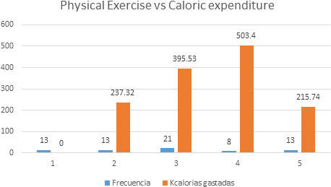
Picture No: 05 Question about frequency and type of physicalactivity

Options | Frequen- cy | Percentage | Mets | Kcalories consumed
Never | 13 | 19.1% | 0 | 0
15 minutes – 120 minutes walking (daily) | 13 | 19.1% | 3.3 | 237.32
5 minutes- 120 minutes de cardio and strength (daily) | 21 | 30.9% | 5.5 | 395.53
40 -120 minutes of collective (vóley, footballl, basketball)(daily) | 8 | 11.8% | 7 | 503.4
Others: 5 Hours per week, bycicle every 5 days, voleyball every 3 days, 40 minutes of football every 3 days, running every 15 days., | 13 | 19.1% | 3 | 215.74
Total | 68 | 100.0% | 3.76 | 270.39
Source: Data obtainedfromthe WHO and OwnElaboraiton
Formula Used: Kcal/min = MET x 0,0175 x weight (kg)

Interpretation
Referring the graph the frequency and type of physical activity it is observed that the majority of respondents spend 395.53 kcal per day. However, the total average of the whole population consumes
270.39 kcal during theday. If to these 270.39 kcal (average) isadded 1572.74 kcal of basal metabolism (SeeTable 05) results in 1843.13 kcal of daily expenditure. Correlatively, the present figure correlated with the 4422 kcal (seetablenr 03) ingested daily, manifestanexcess of 2578.87 kcal unspent which will be transform edintofats and bloodglucose. This factor will produce a highpercentage of people at risk of suffering from metabolicdiseases.

Figure No 6: Metabolic Basal Tax

Sexo | Tamaño (cm) | Peso(kg) | Edad (años) | TMB
Man | 179 | 64 | 23 | 1648.75
Woeman | 160 | 65 | 24 | 1535
Man | 166 | 90 | 65 | 1617.5
Man | 168 | 73 | 28 | 1645
Man | 165 | 70 | 24 | 1616.25
Man | 167 | 66 | 55 | 1433.75
Man | 174 | 90 | 23 | 1877.5
Woeman | 168 | 60 | 56 | 1375
Man | 170 | 80 | 64 | 1547.5
Woeman | 163 | 58 | 27 | 1468.75
Man | 182 | 82 | 51 | 1707.5
Man | 160 | 50 | 23 | 1390
Man | 165 | 45 | 23 | 1371.25
Man | 180 | 70 | 28 | 1690
Woeman | 175 | 75 | 28 | 1708.75
Woeman | 162 | 67 | 22 | 1577.5
Woeman | 170 | 64 | 24 | 1587.5
Woeman | 146 | 47 | 20 | 1287.5
Woeman | 165 | 69 | 22 | 1616.25
Man | 167 | 80 | 21 | 1743.75
Woeman | 160 | 55 | 21 | 1450
Man | 172 | 69 | 20 | 1670
Woeman | 160 | 75 | 43 | 1540
Man | 168 | 95 | 22 | 1895
Woeman | 175 | 59 | 31 | 1533.75
Woeman | 153 | 55 | 20 | 1411.25
Man | 170 | 60 | 24 | 1547.5
Woeman | 168 | 55 | 21 | 1500
Man | 164 | 65 | 25 | 1555
Woeman | 162 | 57 | 15 | 1512.5
Man | 170 | 60 | 20 | 1567.5
Man | 174 | 80 | 35 | 1717.5
Woeman | 164 | 82 | 29 | 1705
Man | 171 | 74 | 25 | 1688.75
Woeman | 150 | 48 | 19 | 1327.5
Woeman | 154 | 56 | 22 | 1417.5
Man | 162 | 80 | 26 | 1687.5
Man | 183 | 72 | 20 | 1768.75
Man | 168 | 65 | 23 | 1590
Man | 190 | 65 | 23 | 1727.5
Woeman | 145 | 55 | 21 | 1356.25
Man | 156 | 55 | 21 | 1425
Woeman | 160 | 60 | 21 | 1500
Woeman | 162 | 64 | 23 | 1542.5

Woeman | 150 | 50 | 21 | 1337.5
Woeman | 147 | 45 | 20 | 1273.75
Man | 163 | 73 | 21 | 1648.75
Woeman | 188 | 75 | 21 | 1825
Man | 178 | 83 | 27 | 1812.5
Man | 185 | 70 | 21 | 1756.25
Man | 170 | 65 | 21 | 1612.5
Woeman | 152 | 50 | 19 | 1360
Man | 172 | 76 | 26 | 1710
Man | 169 | 63 | 22 | 1581.25
Woeman | 162 | 74 | 22 | 1647.5
Man | 155 | 50 | 0 | 1473.75
Man | 169 | 70 | 0 | 1761.25
Man | 168 | 77.8 | 43 | 1618
Woeman | 150 | 48 | 19 | 1327.5
Woeman | 151 | 50 | 19 | 1353.75
Woeman | 152 | 51 | 19 | 1370
Woeman | 157 | 74 | 0 | 1726.25
Woeman | 153 | 62.5 | 24 | 1466.25
Woeman | 167 | 58 | 23 | 1513.75
Man | 162 | 55 | 22 | 1457.5
Man | 173 | 82 | 23 | 1791.25
Woeman | 160 | 68 | 28 | 1545
Man | 169 | 100 | 33 | 1896.25
AverageTax of basal Metabolism (TMB) |  |  |  | 1572.74
Source: Own Elaboration
Used Formula: Mifflin y StJeor TMB= (10 x Weight in Kg) + (6,25 x Heightin cm) – (5 x agein years) + 5

Conclusions
Conclusion 01: The relationship between information deprivation on food security and health risks during the consumption of food in the Piura population is deficient, while the consumer perceives the food habit as a nonexistent risk to his health, even though there are statistical data of high rates of metabolic diseases associated with the traditional diet.

Conclusion 02: The population of Piura manifests a deficient scientific literacy rate in terms of the adequate interpretation of the nutritional table and therefore does not know the handling and treatment of the foods that it selects for its consumption. The consumer is based more on a family habit for food purchase and therefore does not present a technical criterion according to what is required by the basal metabolism.

Conclusion 03: The most common dietary diet in Piurans is based on a high-calorie diet with a high glycemic value that is caused by the high percentage of population from the mountains whose diet was based on twelve hours of heavy agricultural workday. This custom has been maintained in a sedentary society that is only able to burn a daily average of 220 kcal caused by the low exercise activity. This diet rich in carbohydrates is the cause of several metabolic diseases associated with a deficient diet, in this case in excess. No

behavior of rejection to this food habit is perceived despite the existence of studies that demonstrate the presence of metabolites harmful to health.

Conclusion 04: It is identified an carbohydrates excess and kilocalories consumption by the person due to cultural factors such as sedentary lifestyle, overweight, excessive alcohol, tobacco and poor diet; and a high concentration of carcinogenic metabolites with genotoxic potential such as hydroxymethylfurfural and acrylamide found in products of the Piuran family basic basket such as chifle, carob and sublime chocolate. In figures, the excess of carbohydrates of 423.21 grams, of 4422 kilocalories and the presence of one thousand six hundred times more of acrylamide (83-303 ug / kg) over the maximum limit established by the WHO (0.004ug / kg-0.05 ug / kg), not officially declared by the companies in their nutritional labels, are due to the use of the low level of popular cognition about the nutritional technical language present in the food information for the concealment of these potentially harmful substances in public health. Consequently, nutritional labeling is obviating the acceptable daily intake of these foods considering the presence of the aforementioned metabolites [1-7].

Future directions
Recommendation 01: Implement education and food security campaigns that provide citizens with the necessary tools to differentiate between a harmful food and a healthy one. The proposal is aimed at an "upstream engagement" of the layman with participation in public policies related to food safety.

Recommendation 02: Develop a virtual labeling attached to the food packaging that reports the potential damage of an excessive consumption of nutrients as well as the benefits that this provides. Implement a section that stipulates the exact grams by weight, age, height, sex, metabolic activity recommended for each food as well as the maximum daily allowable intake for the purpose of an agreement between the basal metabolism and daily caloric expenditure. Likewise, deploy a three-dimensional pentagon on the labeling, pointing out the excesses of each product in a very visual and clear way (See Annex 1).

Recommendation 03: Establish healthy eating campaigns that encourage the incursion into a new diet adapted to the cosmopolitan

quality adopted by the Piuran citizen of the sierra; so that the consumption is in order to its daily activity.

Recommendation 04: Establish a new legislation in Indecopi (National Institute for the Defense of Competition and Protection of Intellectual Property) that requires food companies to quantify carcinogenic metabolites with genotoxic potential as a quality parameter in the Peruvian Technical Standard as a warning and precaution for the protection of the citizen. Likewise, indicate the ways of conservation, preparation and storage of the food that is appropriate to its stability and safety so that it does not cause health problems for the consumer. In addition to declare mandatory that nutrients are in large proportions in that food so that the consumer can have informed food consumption.

References
- Ludeña Gutiérrez A L (2012) Acrylamide in the consumption of algarrobine for standardization purposes in a technified process. Thesis. Universidad Nacional de Perú- Piura. Perú.
- Colomer Winter, A. e VillasanteLlaquet I (2017) Diagnosis on the production of algarrobine for the European Union market; Case Caserío de Sáncor, District of Chulucanas, Piura, Peru. Thesis. World Economic Health and patient safety Congres. Ámsterdam
- Schuler L (2018) The new way to lose fat. Men´s Health 45-47.
- Fernandez, B. y Gorman, J. The great lies of health. Men´sHealth. 53-55
- Anon (2018) Peru: levels of overweight and obesity are already a public health problem. Recuperado en: https://larepublica.pe/ sociedad/1053729-peru-niveles-de-sobrepeso-y-obesidad-ya- son-un-problea-de-salud-publica.
- Cristina Torres-Mallma, Claudia Trujillo-Valencia, Ana Lucía Urquiza-Díaz, Ronald Salazar-Rojas, Alvaro Taype-Rondán (2016) Food habits in first and sixth year medical students from a private university in Lima, Peru. University San Martín de Porres. Perú Rev Chil Nutr 43: 1-9
- Lanas F (2017) Association between the consumption of fats and carbohydrates with cardiovascular disease and mortality in 18 countries on 5 continents. University of the Frontier Temuco, Chile.

ANNEXED
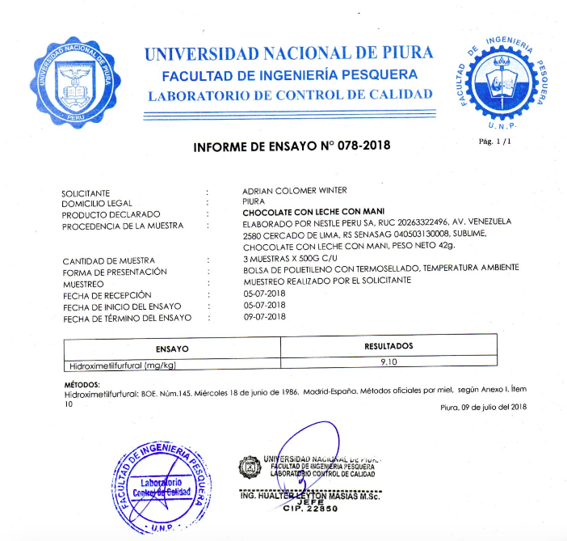
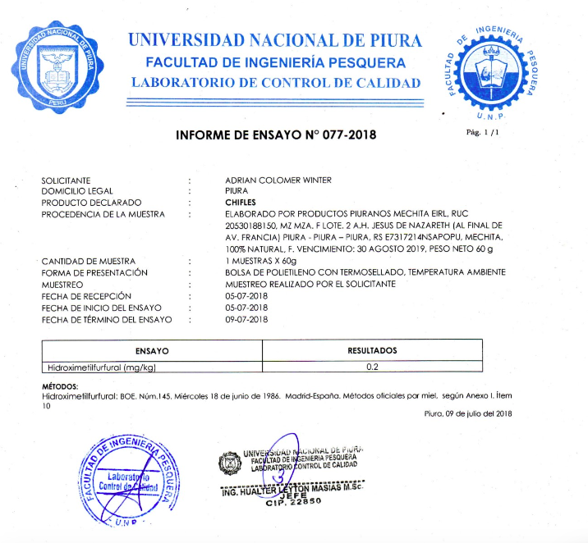 ANEXO 1: Encuesta sobre consumo alimenticio poblacional

Proyecto de Tesis
“Relación entre la desprotección informativa sobre seguridad alimentaria y los riesgos a la salud durante el consumo alimenticio en la población piurana”.

Cuestionario dirigido a los consumidores aleatorios de los diferentes supermercados de la región(Piura).

Objetivo. Recoger información sobre nivel de vida, calidad de vida, nivel de ingreso, nivel educativo, esperanza de vida, sedentarismo, actividad física, tipo de dieta, Antecedentes familiares( enfermedades metabólicas) ,frecuencia de compra, grado y tipo-repetitividad de escogencia alimentaria en la compra, numero de minutos destinados a la lectura de la etiqueta, tasa de alfabetismo interpretativo de nutrientes, composición nutricional( ml/g*kg), porcentaje de ingesta calórica diaria por día- persona, índice de actividad metabólica e índice de masa corporal.
Indicaciones. Lea cuidadosamente cada pregunta y marque con una aspa(X) la respuesta que considere correcta.
Indicar cantidad en cada caso
Ejemplo: b) Oreo Consumo un paquete aproximado de 8 galletas (1 paquete, 2 paquetes…)
- Arroz Una porción de aprox 100 gr
En cada pregunta se puede marcar más de una opción

Edad_ Sexo_ F_M Altura:
Peso
- Que consume usted durante su desayuno ? (Puede marcar más de una opción)
- Avena-__ tazas
- Frutas__ piezas
- Sandwich__
- Cereales con leche __tazas
- Pan con embutido queso o mermelada__ Piezas
- Leche__ Vasos
- Otros:

- Que consume usted durante el almuerzo (acompañamiento)?
- Siempre consumo arroz
- Siempre consumo fideos
- Vario entre arroz y fideos
- Aguadito
- Ninguna de las anteriores: Especifique cuales:

- Que consume durante el almuerzo (plato de fondo)?
- Verduras con una porción de carne/pollo/pescado
- Papa con carne/pollo/pescado
- Menestra con carne/pollo/pescado
- Ensalada con carne/pollo/pescado
- Ensalada, menestra o papa

- Que consume usted durante el almuerzo (postre)?
- Fruta
- Gelatina
- Yogurt
- Helado
- Pastel
- Otros…____________________________
- No como postre

- Que bebidas consume durante el almuerzo?
- Gaseosa-__ Vasos
- Cerveza-__ Vasos
- Agua-__ Vasos
- Refresco (limonada,Chicha morada, Cebada)…-__ Vasos
- Otros_____________________vasos

- Que alimentos consume en el entretiempo (break)
- Galletas de Soda
- Oreo
- Papa rellena
- Arroz con leche
- Causa
- Cañonazo y otras galletas refinadas
- Ensalada de frutas
- Frutos Secos
- Papas fritas
- Chifles
- Otros__

- Con que frecuencia consume usted los alimentos del break?

- Interdiario
- 3 veces a la semana
- 4 veces a la semana
- 1 vez al dia
- De 2 a 4 veces al dia
- Mayor de 4 veces al dia
- Nunca
- Que consume usted durante la Cena (acompañamiento)?

- Siempre consumo arroz
- Siempre consumo fideos
- Vario entre arroz y fideos
- Aguadito
- No consumo ninguno de los anteriores_ Especifique cuales :

- Que consume durante la Cena? (plato de fondo)

- Verduras con una porción de carne/pollo/pescado
- Papa con carne/pollo/pescado
- Menestra con carne/pollo/pescado
- Ensalada con carne/pollo/pescado
- Ensalada, menestra o papa
- Papa Rellena
- Mollejitas
- Pollo broaster
- Hamburguesa
- Salchipapas
- No consumo ninguno de los anteriores

- Que consume usted durante la Cena (postre)?
- Fruta
- Gelatina
- Yogurt
- Helado
- Pastel
- Otros…____________________________
- No como postre

- Que bebidas consume durante la Cena?

- Gaseosa-__ Vasos
- Cerveza-__ Vasos
- Agua-__ Vasos
- Refresco (limonada,Chicha morada, Cebada)…-__ Vasos
- Leche__ Vasos
- Otros_____________________vasos

- Indique que alimentos son los esenciales a diario en su canasta básica para el consumo familiar: Importante indicar cantidad

- Galletas
- Frutas
- Verduras
- Gaseosa
- Cerveza
- Arroz
- Menestra
- Fideos
- Azúcar
- Sal
- Aceite
- Vinagre
- Especies (Romero, pimienta, comino)
- Yuca, camote, papa
- Vegetales integrales; arroz integral…
- Chifles, papa frita (lays)
- Leche (diferenciar entre Entera, semidesnatada, desnatada)
- Leche Evaporada
- Otros

- Cada cuanto tiempo realiza usted la compra de la canasta alimenticia para su vivienda?

- Cada dia
- Interdiario
- Semanalmente
- Cada 15 dias
- Mensualmente

- Conoce usted que es la tabla nutricional?
- Sí
- No

- Conoce usted todos los elementos(nutrientes) que se mencionan en la tabla nutricional?
- Sí
- No
- Algunos__________
En caso de que su respuesta sea algunos mencione cuales conoce
- Cree usted que por el consumo reiterativo de (arroz, papa, yuca, camote, alimentos generales ricos en carbohidratos) se pueden desarrollar enfermedades metabólicas tales como diabetes?

- Sí
- No
- Es un mito

- Crees que la comida baja en grasas ( Ej. yogurt light) previene enfermedades coronarias?
- Sí
- No

- Cuáles son sus criterios para la selección de los alimentos que consume:

- Económica
- Saludable
- Modo de elaboración (facilidad de cocción)
- Recomendación social
- Costumbre familiar
- Calidad del alimento
- En caso que haya escogido la segunda opción, en que datos se fija para saber que el alimento es saludable?

- Carbohidratos
- Lípidos
- Proteínas
- En todo en general
- En los componentes que tiene (Edulcorantes, saborizantes, materias primas…)
- Vitaminas
- Minerales

- Cuanto tiempo destina usted para la lectura de la etiqueta nutricional del producto antes de la decisión de la compra?

- No lo miro
- 10 segundos
- 1 minutos
- 5 minutos
- >5 minutos

- Con que frecuencia realiza usted ejercicio físico? Puntualizar actividad que se realiza

- Todos los días____ minutos; ejercicios de:_________________________________
- Cada 2 días____ minutos; ejercicios de:___________________________________
- Cada 5 días____ minutos; ejercicios de:___________________________________
- Cada 7 días____ minutos; ejercicios de:___________________________________
- Cada 2 semanas____ minutos; ejercicios de:________________________________
- Nunca

- Qué momento considera que es más crítico a la hora de consumir alimentos?

- El desayuno (se debe consumir en menor cantidad)
- El almuerzo (se debe consumir en menor cantidad)
- El entretiempo (se debe consumir en menor cantidad)
- La cena (se debe consumir en menor cantidad)
Especificar motivo por el cual se escoge la opción____________________________________________________________________________________________________________________________________________

Gracias por su participación

ANEXO 02: Picture of Rice without nutritional label
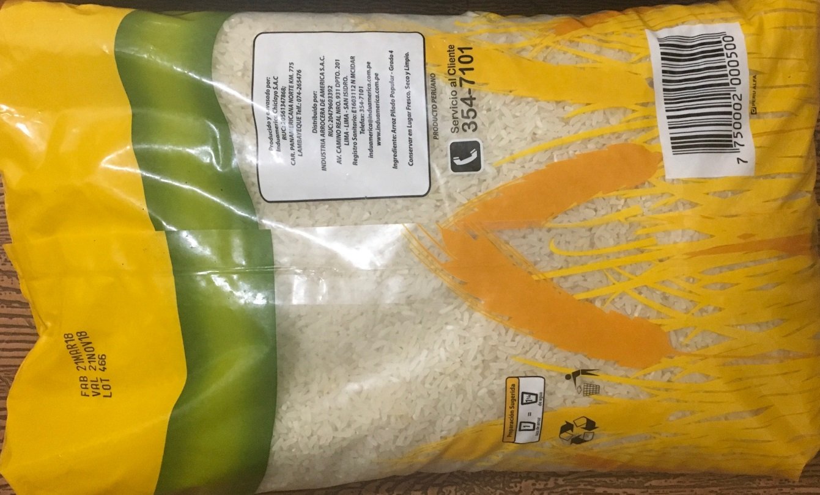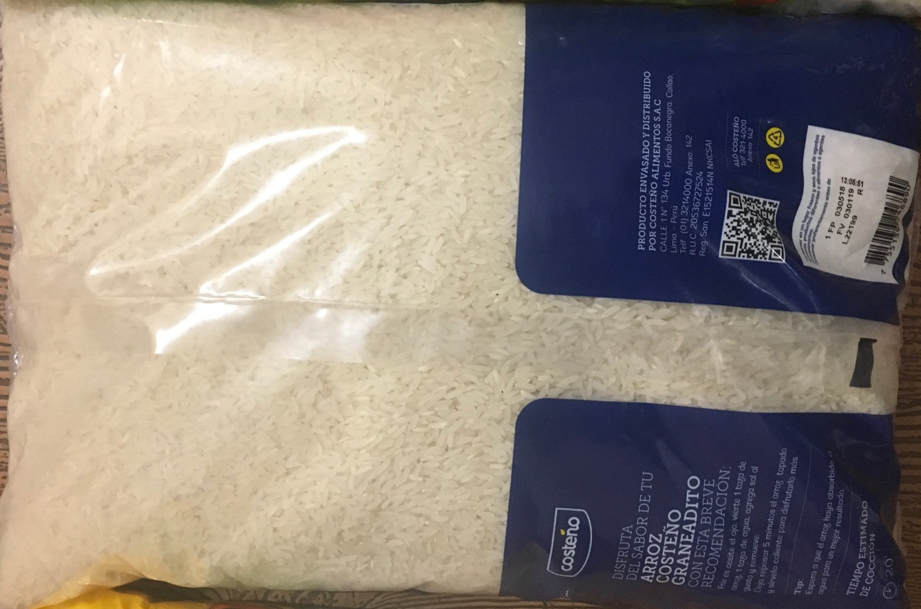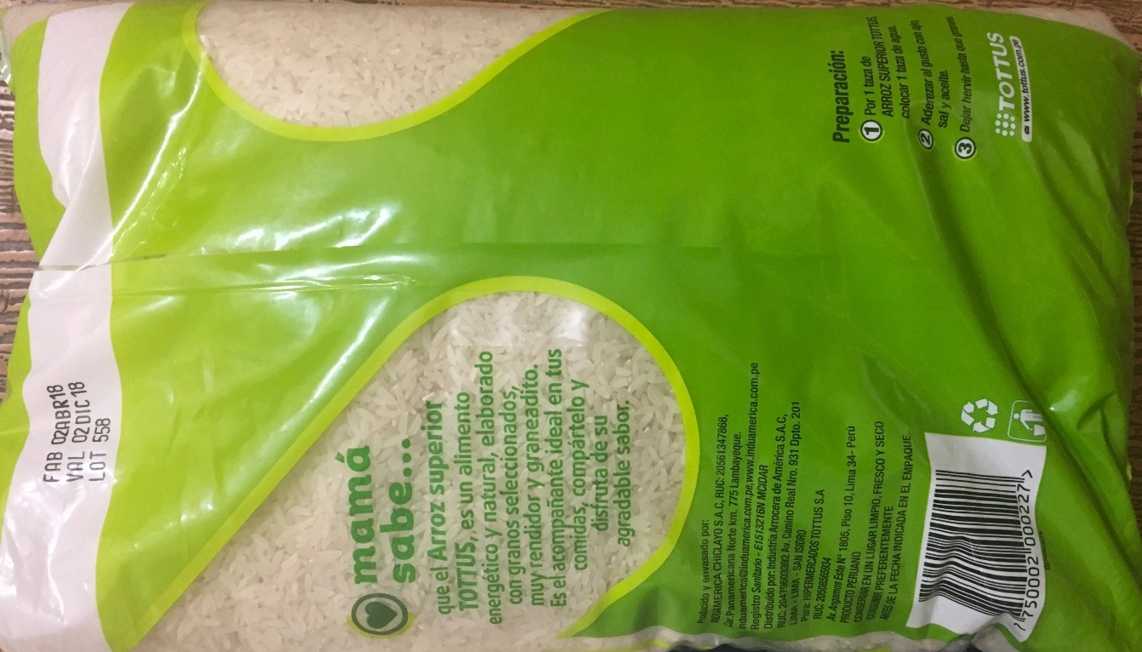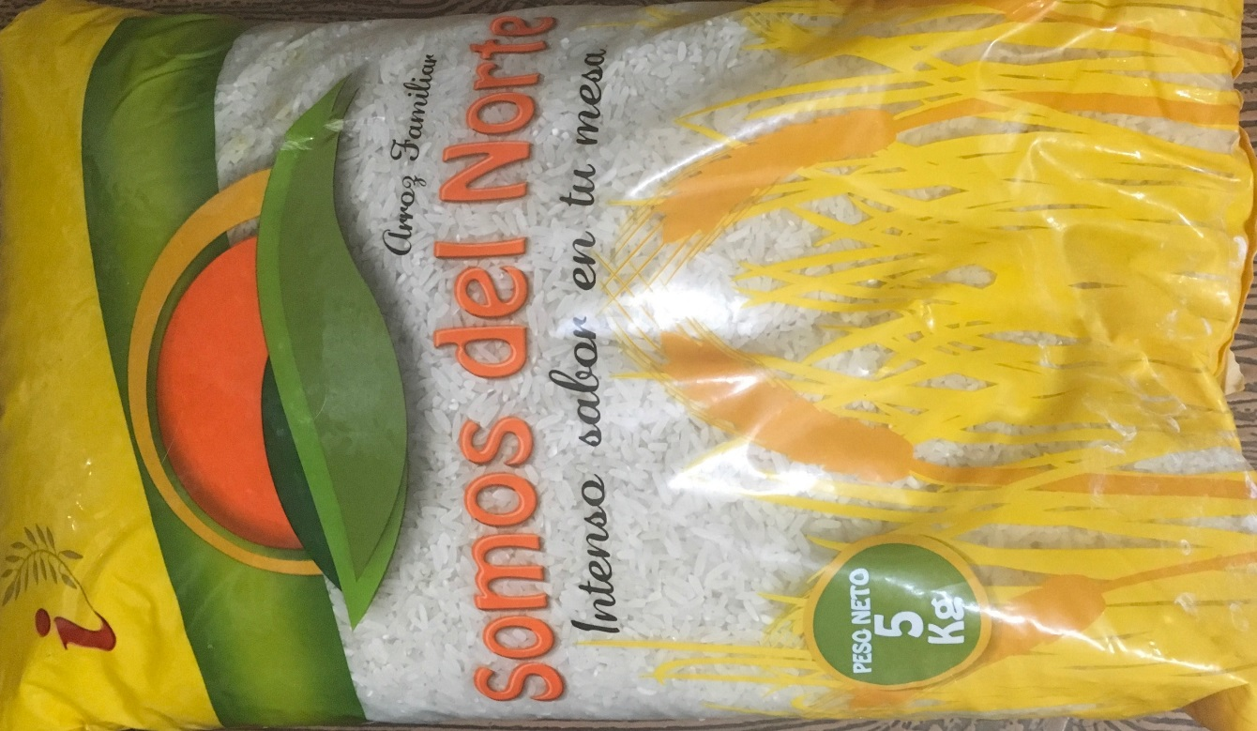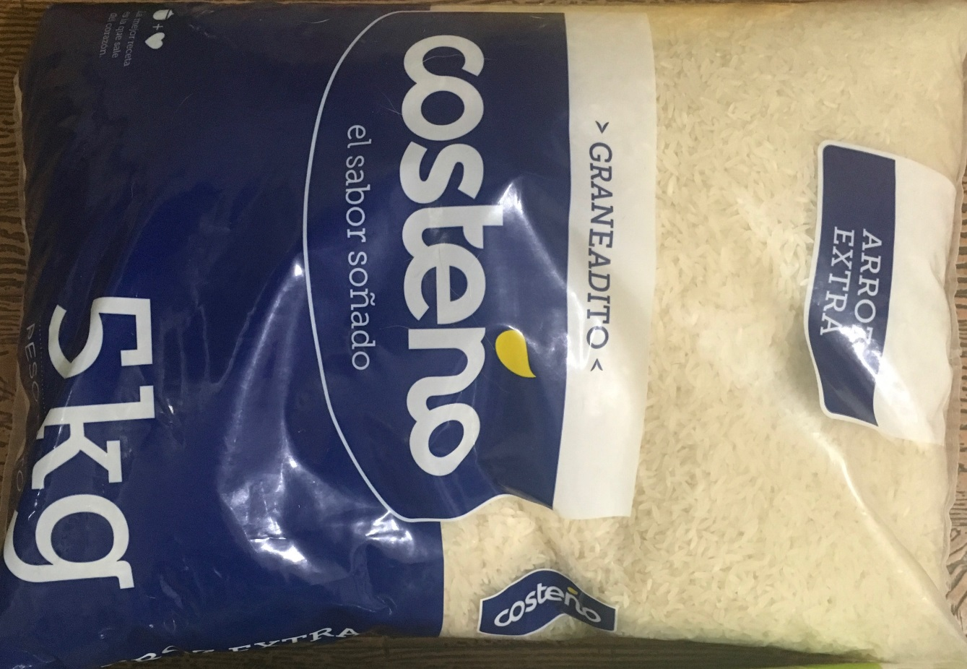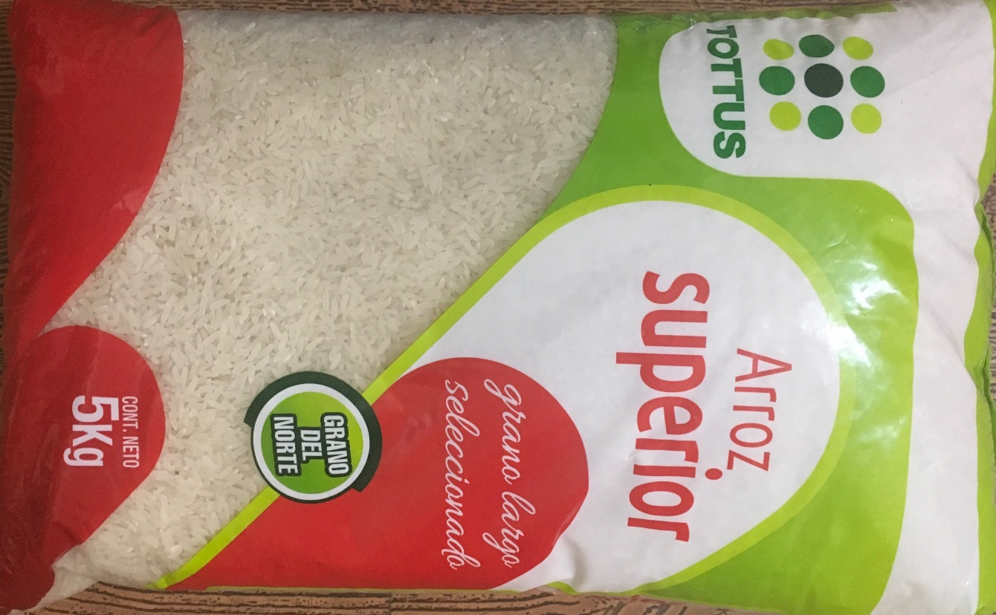

ANEXO 03: Sublime Chocolate NESTLE without HMF prescence in it’s label 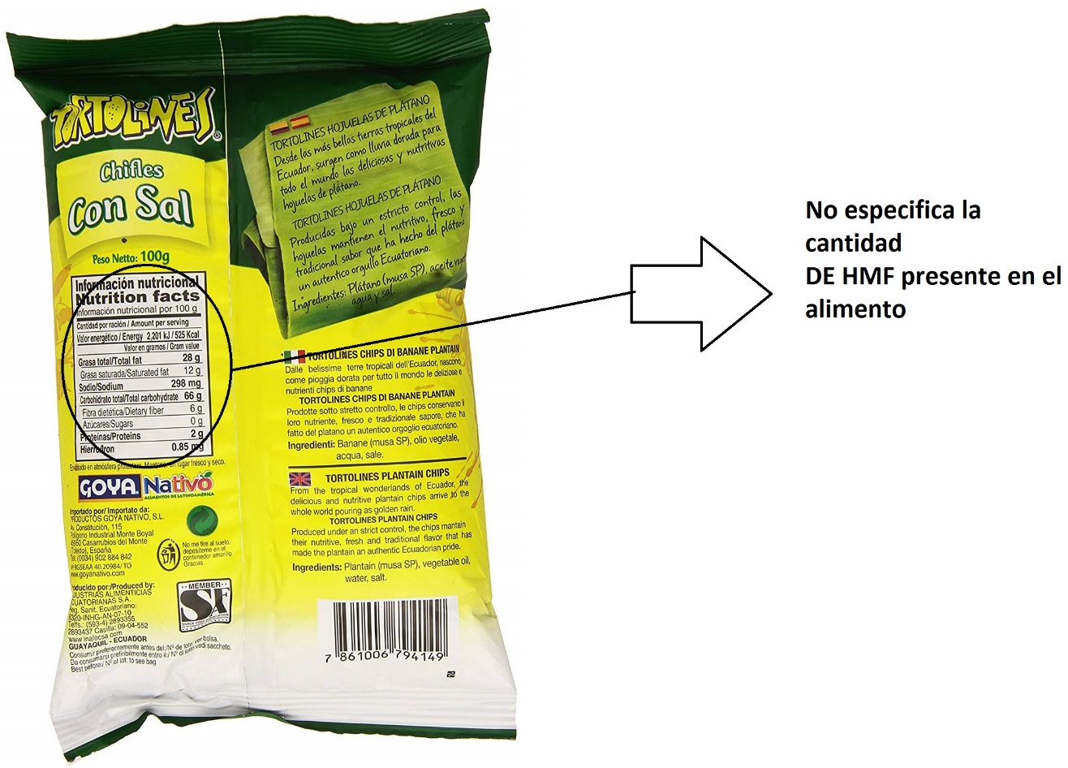
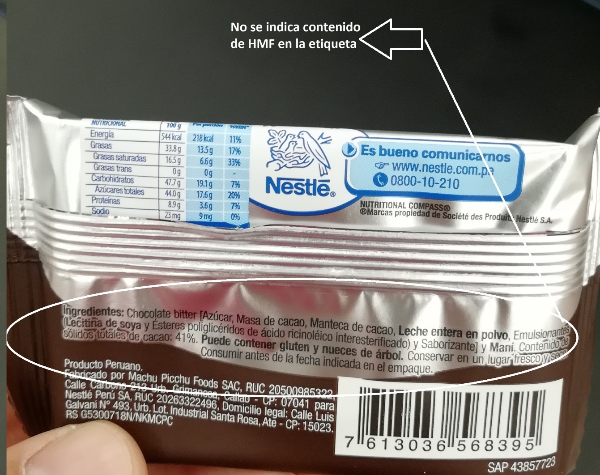

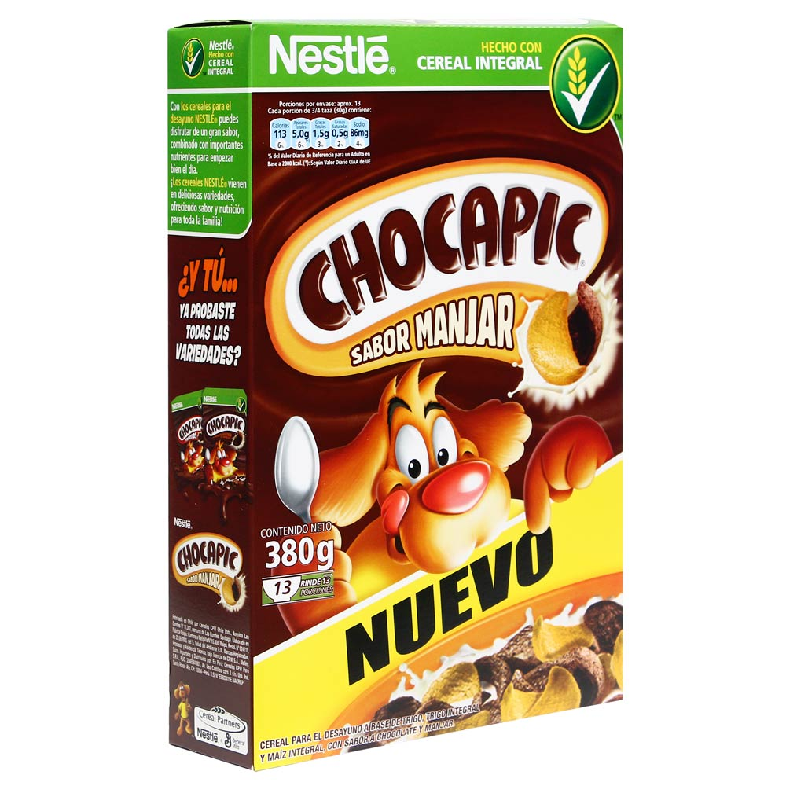
Anexo 04: Chocapic comparison between peruvian and Chile advertise.
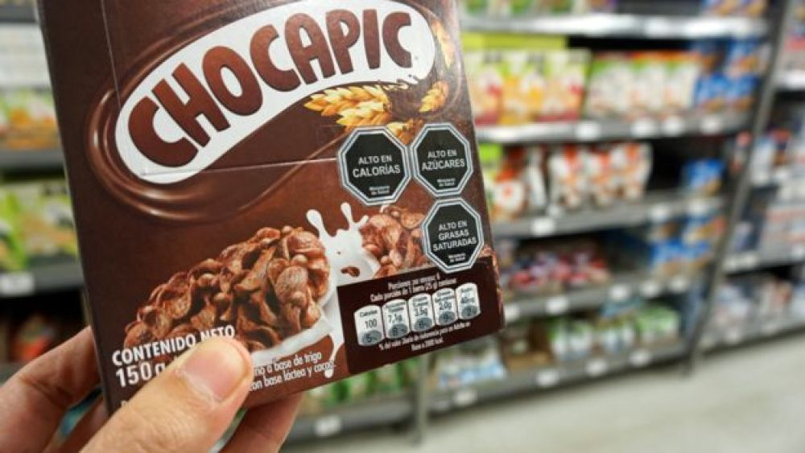

Techniques and instruments for data collection, validity and reliability
Observation is a phenomenological exploration technique. It is used when the researcher must visually record the phenomena that constitute the problem. Observation marks the beginning of an investigation.

Survey
The survey is a descriptive technique aimed at collecting primary and specific information from the interview to a large number of people. For this purpose, pre-designed and structured questionnaires with specialized questions of a specific topic to be investigated are applied.

Instruments

Two instruments have been constructed that will serve to evaluate the variables "lack of information protection, food consumption, health risks and food safety". The first instrument is a questionnaire divided into the dimensions "consumer trends, health, sociocultural stratum and socio-economic stratum" same that break down the items "level of life, quality of life, level of income, educational level, life expectancy, sedentary lifestyle, physical activity, type of diet, family history (metabolic diseases), frequency of purchase, grade and type-repetitiveness of food choice in the purchase, number of minutes devoted to reading the label and interpretive nutrient literacy rate.
A second instrument is the observation form, composed of the items nutritional composition (ml / g * kg), percentage of daily caloric intake per person-day, metabolic activity index and body mass index. The present tools are framed in the Likert scale based on qualitative-quantitative ranges.

Questionnaire
The basic instrument used in research by survey is the questionnaire, which is a document that collects in an organized way the indicators of the variables involved in the objective of the survey (Casas, et al 2003: 528). The basis for the elaboration of this file are the hypotheses, the sociodemographic, anthropometric, socio-economic, psychographic, age, cultural level data; dimensions of utmost relevance for determining the length and nature of the questions, the language record used and the response format.

Observation sheet
Observation forms are instruments of field research. They are used when the researcher must record data provided by other sources such as people, social groups or places where the problem is presented. They are the complement of the field diary, of the interview and are the first approach of the researcher to his universe of work. These instruments are very important, avoid forgetting data, people or situations, so the researcher should always have at hand his cards to complete the visual record of the situation (Maya, 2014).

Data Analysis Methods

In this research, descriptive statistics will be used to analyze the data. Specifically, we will work with the data obtained in the surveys and in the case of the observation form it will be with primary data generated by the study itself, which will be processed and presented in statistical tables.

Ethical aspects

In the present study, the following ethical considerations must be maintained:
a) The strict anonymity of the participants will be maintained, taking care that the use of the information is exclusively to prepare the investigation.
b) In the present work there was no plagiarism and it was carried out under the principles of honesty and objectivity.
c) The data generated in this study will have the permission and consent of the surveyed population.
d) The work will be carried out with scrupulous thoroughness following the steps of scientific research.

