Olive waste derived nutraceuticals: sustainable formulation and biological characterization
Kristina Radić, University of Zagreb, Faculty of Pharmacy and Biochemistry, Zagreb, Croatia
Dubravka Vitali Čepo, University of Zagreb, Faculty of Pharmacy and Biochemistry, Zagreb, Croatia

Abstract
Statement of the Problem: Olive pomace, remaining in large amounts after the production of olive oil represents serious ecological problem in olive-oil producing countries. At the same time, it is a valuable source of bioactive polyphenolic substances, also present in olive oil, with proven health benefits. Due to the lack of efficient and sustainable methods of formulation and data on its biological activity and particular possible areas of application, the use of olive pomace extract as nutraceutical/functional food ingredient is still limited. Therefore, the aim of our research was to develop sustainable formulation process and evaluate biological activity (in vitro bioavailability and antioxidant activity) of dry polyphenol rich olive pomace extracts. Methodology: Green extraction methods (ultrasound- and microwave- assisted extraction with food grade solvents) were optimized for the extraction of polyphenols from olive pomace. Spray-drying was combined with cyclodextrin encapsulation (different types) for the formulation of stabile dry products with acceptable technological properties. In vitro bioavailability of polyphenols from obtained formulations was evaluated in Caco-2 cell model. Antioxidant activity was evaluated in different chemical-, food- and biological model systems. Findings: Microwave-assisted extraction with 60% ethanol resulted with the highest yields of bioactive polyphenols in obtained extracts. Cyclodextrin encapsulation was combined with spray-drying to obtain dry extracts that were organoleptically acceptable and it significantly affected biological activity of obtained formulations. Hydroxypropyl-β-cyclodextrin and randomly methylated β-cyclodextrin encapsulated extracts showed excellent antioxidant activity in food- and biological models. Gastrointestinal stability of polyphenols in obtained extracts was good, with significant conversion of different polyphenols into hydroxytyrosol. Cyclodextrins significantly increased the content of bioactive polyphenols in obtained formulations and reduced transepithelial transfer of polyphenols across Caco-2 cell monolayer, but to a lesser extent. Conclusion & Significance: Olive pomace extracts obtained by novel sustainable process possess significant biological activity and can be used as nutraceuticals/functional food ingredients.

Image

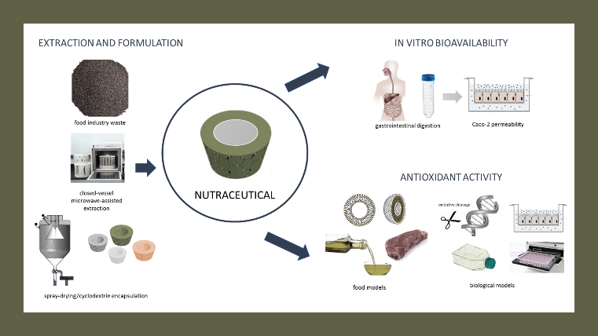
Recent Publications
- López de las Hazas MC et. al (2016) Differential absorption and metabolism of hydroxytyrosol and its precursors oleuropein and secoiridoids. Journal of Functional Foods 22:52-63.
- Braithwaite M et. al (2014) Nutraceutical-based therapeutics and formulation strategies augmenting their efficiency to complement modern medicine: An overview. Journal of Functional Foods 6(1):82-99.
- García-Padial M et. al (2013) The Role of Cyclodextrins in ORAC-Fluorescence Assays. Antioxidant Capacity of Tyrosol and Caffeic Acid with Hydroxypropyl-β-Cyclodextrin. Journal of Agricultural and Food Chemistry 61(50).
- Herrero M et. al (2005) New possibilities for the valorization of olive oil by-products. Journal of Chromatography A 1218(42):7511-20.
- Albahari et. al (2018) Characterization of olive pomace extract obtained by cyclodextrin-enhanced pulsed ultrasound assisted extraction. LWT- Food Science and Technology 92.

 Biography
Kristina Radić currently works at the Department of Food Chemistry at the Faculty of Pharmacy and Biochemistry, University of Zagreb. Kristina does research in Phytochemistry, Biochemistry, and Cell Biology. She is a collaborator at the project named 'Valorization of olive waste in sustainable food innovation (NutriOliWa).
Email: kradic@pharma.hr

Notes/Comments:

