Effects of chitosan oligosaccharides on microbiota composition of silver carp (Hypophthalmichthys molitrix) determined by culture-dependent and independent methods during chilled storage
Shiliang Jia, PhD, College of Food Science and Nutritional Engineering, China Agricultural University, Beijing 100083, China

Abstract (300 word limit)

Background: Silver carp is an important species for commercial production due to its high nutritional value, rapid growth rate, high yield, low feed demand. However, aquatic products are highly perishable because of microbial growth, which is due to high moisture content, abundant nutrients and higher pH. Previous studies demonstrated that composition of fish microbiota could affect the generation of TVB-N, the degradation of ATP-related compounds, and the production of biogenic amines during storage. Therefore, characterizing the composition of microbiota and evaluating the relationship between changes in quality and composition of microbiota during fish storage are important for quality control. This study evaluated the effects of chitosan oligosaccharides (COS) on the changes in quality and microbiota of silver carp fillets stored at 4 °C. Methods: Sensory scores, ATP-related compounds (inosine monophosphate, hypoxanthine ribonucleotide, hypoxanthine), total volatile basic nitrogen (TVB-N), biogenic amines were evaluated and presence of spoilage microbiota was detected by culture-dependent and culture-independent 16S rRNA gene sequencing methods. Results: During storage, COS treated samples maintained good quality, as evidenced by retarding sensory deterioration, inhibiting microbial growth, attenuating the production of TVB-N, putrescine, cadaverine and hypoxanthine, and delaying degradation of inosine monophosphate and hypoxanthine ribonucleotide. Variability in the predominant microbiota in different samples during chilled storage was observed. As storage time increased, the control and 1% (w/v) COS treated samples were rejected by sensory panelists at day 6 and 8, respectively. At the time of sensory rejection, Pseudomonas, followed by Aeromonas, Acinetobacter, and Shewanella became the main spoilers in the control samples. However, COS inhibited the growth of Pseudomonas, Aeromonas, and Shewanella significantly. Consequently, Acinetobacter followed by Pseudomonas became the predominant microbiota in 1% (w/v) COS treated samples. Conclusions: Therefore, COS improved the quality of fillets during chilled storage, which was mainly due to their modulating effects on microbiota.
Image
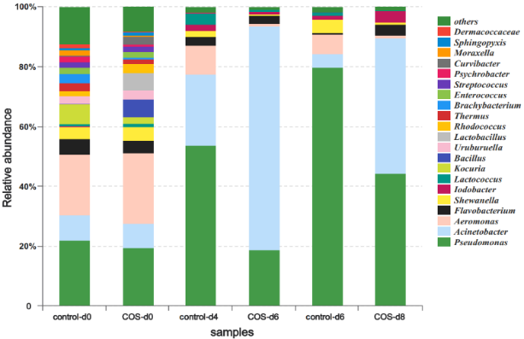
Fig. 1. Relative abundance of the bacteria of microbiota from control and COS treated silver carp fillets during storage at 4 ± 1 °C. Only the bacteria whose relative abundances were > 1% at the genus level obtained in this study were specifically indicated. The category “others” denotes genera represented by a proportion < 1%. (control-d0: control samples at day 0; control-d4: control samples at day 4; control-d6: control samples at day 6; COS-d0: 1% COS treated samples at day 0; COS-d6: 1% COS treated samples at day 6; COS-d8: 1% COS treated samples at day 8.)
Recent Publications (minimum 5)
- Shiliang Jia, Zhan Huang, Yutian Lei, et al. (2018). Application of Illumina-MiSeq high throughput sequencing and culture-dependent techniques for the identification of microbiota of silver carp (Hypophthalmichthys molitrix) treated by tea polyphenols. Food Microbiology, 76, 52-61.
- Xiaochang Liu, Zhan Huang, Shiliang Jia, et al. (2018). The roles of bacteria in the biochemical changes of chill-stored bighead carp (Aristichthys nobilis): Proteins degradation, biogenic amines accumulation, volatiles production, and nucleotides catabolism. Food Chemistry, 255, 174-181.
- Shiliang Jia, Zheng Lu, Zhaolan Gao, et al. (2016). Chitosan oligosaccharides alleviate cognitive deficits in an amyloid-β1–42-induced rat model of Alzheimer's disease. International Journal of Biological Macromolecules, 83, 416-425.
- Shiliang Jia, Xueling Wu, XiaoXiao Li, et al. (2016). Neuroprotective effects of liquiritin on cognitive deficits induced by soluble amyloid-β1–42 oligomers injected into the hippocampus. Journal of Asian natural products research, 18(12), 1186-1199.
- Dapeng Li, Shiliang Jia, Longteng Zhang, et al. (2017). Effect of using a high voltage electrostatic field on microbial communities, degradation of adenosine triphosphate, and water loss when thawing lightly-salted, frozen common carp (Cyprinus carpio). Journal of Food Engineering, 212, 226-233.


Biography (150 word limit)
Shiliang Jia has his expertise in the processing and storage of aquatic products. And he has characterized the microbial community in silver carp fillets stored at 4 °C and evaluated the spoilage potential of bacteria isolated from silver carp fillets. Recently, his research mainly focuses on Interactions of the specific spoilage organisms ,especially, the quorum sensing system in specific spoilage organisms.
Email: jiashiliang2011@163.com

Notes/Comments:

