40 YEARS of INNOVATED industrial base Agri/Nutri technology in sustainability for zero Nutri food waste
LIAQAT CORP (PVT) LTD.
ATAWA KAMRAN TOWN GUJRANWALA PAKISTAN
Cell# 0092-321-4854343

Abstract
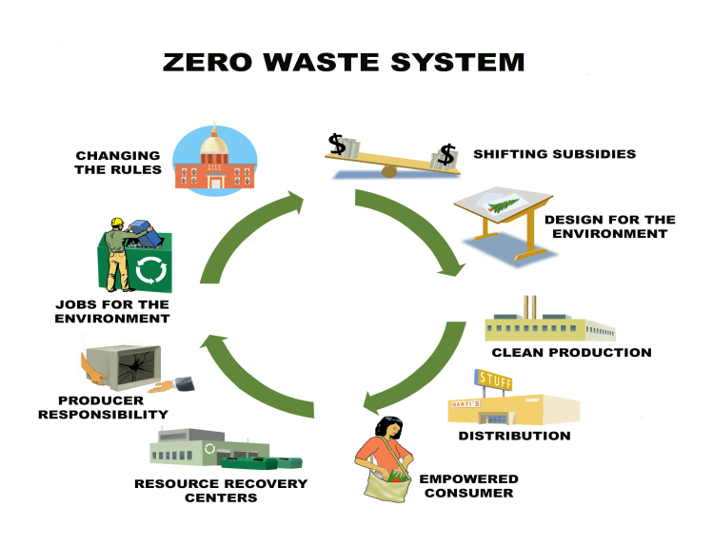
Being seed/food industry funder to farmers since 1975, were distributor of EU/USA seed companies, funding is at buy-back, agriculture losses forced us to INNOVATED KITCHEN based nutri- research in drying of food sourcing sites, factories/infrastructure/seasonal stations. By 1975, we used to save nutrition losses by manual sun-drying, developed multiple value added manual to mechanized processing sheets to eradicate spoilage. This type of NUTRITECH resulted. Wide range of Agri/nutri tech was developed. Innovated Kitchen drying trials achieved positivity; manual lines converted to mechanized, partial drying eliminated perishabilty by mobile drying units, challenges were resolved scientifically, Food/ agriculture Nutritional losses reshaped by value added multiple intermediate drying technologies. Spoilage removed by technical drying solutions leading sustainability, developed partnerships in nutritional security. Innovated Tech applied in sustainability. Environmental issues resolved technically, industrial Tech applied at sourcing for Nutri-positivity, future research balanced nutritional values. Due to instant check on spoilage by female clusters, losses instantly stopped. Qualitative/Quantitative INNOVATED drying impacted nutrition/improved lost, NUTRI delivered field farming productivity. Pre/postharvest LOSSES improved, by value added technologies, focused at sourcing. Game changing NUTRI technologies facilitated partnerships, clusters enhanced in surrounding largely, with industrial/future based technologies. Practical researched network shared. 40 years of innovated industrial based nutri/ tech is ready to save nutritional values by 2017-18, instead of 2050 @NFC. Low income women are integral part of nutritional security as , domestically trained in processing .SDGs converted to our in-house INNOVATED tech, reshaped EU/USA processing/production lines at less cost of 15 times, with equal outputs, consumer/oriented tech followed by smallholders.

Recent Publications
- Our Publication has been made published through Journal of life sciences USA in The First International Congress on Postharvest Loss Prevention2015 with the subject of “THE MOST FEASIBLE, LEAST COST AND PRAGMATIC APPROACH TO GRAPPLE WITH POST HARVEST LOSSES.”
Our following abstract has been accepted/Published by the organization
- IFAMA World Conference For zero food waste
3. ADM ILLINOIS
4. IUFOST 18th World Congress of Food Science and Technology.
5. ISGC 2017
6. WPC Congress Nominated us one of the nomine from all over the World.

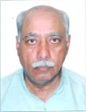Biography
Being Seed/Food Processing Industrialist, we were nominated exclusive sole Distributor of EU/US Seed Industries during 1970-75. As a Private Funder to Small Scale Farmers, all annual agricultural produce are under Buy-back disposal at our end. Initially suffered PHL losses in agriculture. Ultimately dried processing multiple technologies innovated-Scientific Technological Processing Sheets Research was conducted for our Buy-back financial Survival, innovated dried processing lines fabricated locally.
The losses are at farming/domestic/fruit-veg-grain market/processing factories. Initially partial scientific applications were researched to kill moisture/weight/volume. So produce was converted technically into scientific dried form partially, moisture was reduced up to 12% to 15% for safe limitation. The major hurdle in Drying Processing was high-cost Machinery of EU/USA so fabricated sustainable Drying Processing Plant by only at a cost of $0.10 M approximately, by conversion of 40 Ft FCL Container into tunnel type dryers which is available by US Manufacturers at cost of $2.5 M.
Email: phlaid@liaqatcorp.com

Notes/Comments:

We are the founder Technologist, innovative in-house Scientific PHL Technology innovator in AGRICULTURE Since 1975, DEVELOPED innovated dried cost effective processing lines/innovative sheets, as per the sourcing sites, with ZERO WASTE for small scale farmers, killed hunger / poverty practically to our funding areas.

Being private funders of seed/food industry, to small-scale farmers, all our funding are under buy-back agreements, so we have created technological drying value- added SOLUTIONS of innovations for our survival, on the other hands, we were the exclusive sole-distributors of the EU/USA VEGETABLE SEEDS companies in PAKISTAN and entire VEGETABLE SEED RANGE, was being shipped to us on CREDIT BASIS OF 90 DAYS TO 180 days , so for our financial survival ,we have to develop/innovated dried processing solutions with MULTIPLE VALUE ADDED agri-drying technologies .

However our 40 years scientific/technological saving/drying INNOVATIONS solutions are in a position to save the HUNGRY WORLD practically, as we are not writers but are practical processing/saving fighters against PHL in the farming to foods converting sites and faced/fought challenges for the killing of hunger/poverty. However vision of AGRICULTURE saving upto 2030, may be converted into 2/3 years at your approachable targeted sites , our entire MISSION/VISION are quite at guarantee/warranted basis under agreements and technological solutions have been acknowledged by WAGGENEN UNIVERSITY NL/ILLINOIS UNIVERSITY /6 EU scientific FOUNDATIONS/STAKE HOLDERS etc have accepted our SCIENTIFIC/TECHNOLOGICAL PHL ABSTRACTS FOR ZERO WASTE.
WUR NL have requested us for becoming the, member of their CLUSTER TEAM for PHL technology, , we have accepted the membership of cluster/ WUR team.

We have survived practically in the last 40 years against PHL developed scientific SOLUTIOS with our COST EFFECTIVE INNOVATED CHALLANGING PROCESSING TECHNOLOGY LINES, to kill hunger.
Being private funder, to small scale farmers since 1975,have developed each technical/practical challenges SOLUTIONS for zero waste in agriculture ,our entire RESEARCH is neither homemade nor University made but it is all ,industrial based fighting solutions and we are the future of sustainable AGRICULTURE in the hungry/poverty world.
Having technical capacity to provide a perfect ROAD MAP for sustainability in agriculture and vision of 2030 may be achieved within 2/3 years perfectly under PROFIT/LOSS BASIS partnership also.
Our future based dried processing value added multiple technologies are the perfect solutions in AGRICULTURE for your mission, may be transferred at TURN KEY BASIS agreements in any part of LOSS/HUNGRY WORLD ,to any crop for your SOLUTIONS FINDINGS.

