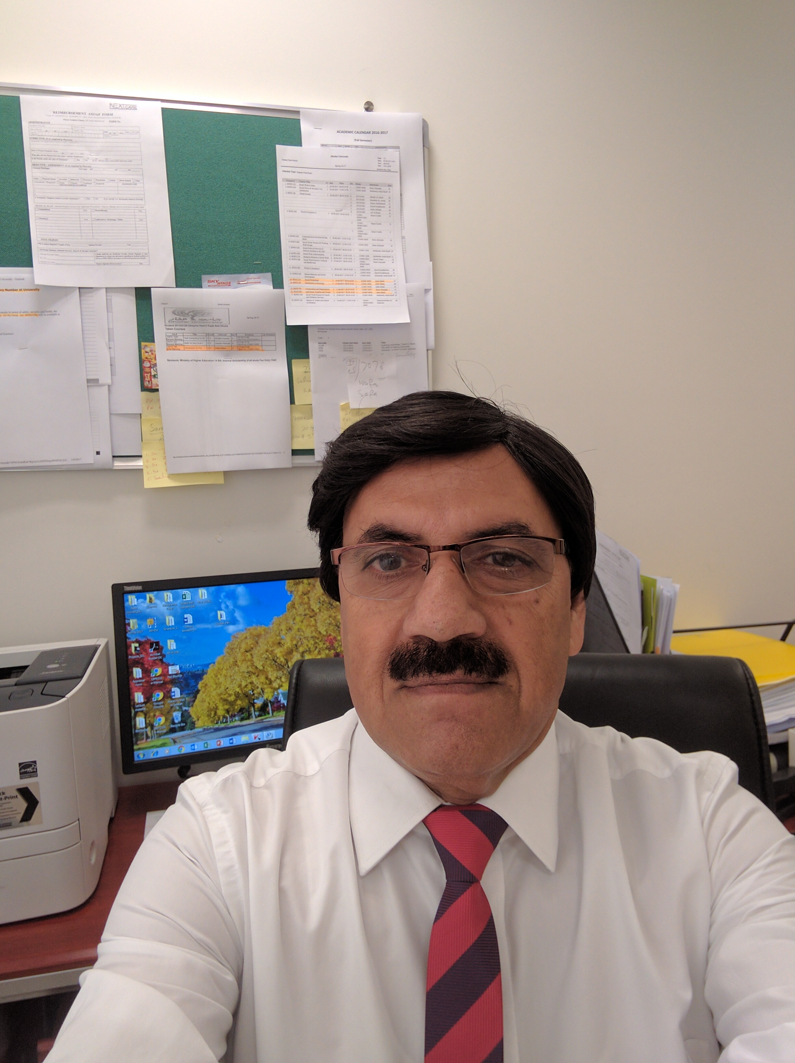
Further Training and Staffing and its Relation to Quality of Patient Care in Canada, Medication Errors, Fall Injury, Infection and Complaints.
Zafar Mehdi¹ , Ramzi Nasser¹, Hildegard Theobald², Klaus Schoemann³
¹Dhofar University Oman
²University of Vechta, Germany
³Jacobs University Bremen, Germany

There are mandatory and volunteer further training programs in health care and long-term care sectors in Canada. The relations between further training of care workers and quality of patient care in hospitals, home care settings and residential care facilities are unclear. The study investigates the association between further training and care workers staffing (nurses, elderly carers and care assistants) on the elderly health situation, work situation, and quality of patient care in Canada. Cross-sectional data were drawn from 2010, Canadian Survey of Labour and Income Dynamics (SLID) 2010, and Canadian National Survey of the Work and Health of Nurses (2005) for the analysis. Findings reveal that additional training of care workers has a positive association with work situation and quality of patient care as in reduction of injury, infection, medication error, and satisfaction. Likewise, staffing level among elderly health workers has a strong relation with lower injuries, lower medication errors, lower Nosocomial infection and increased satisfaction. The implication of the study suggests a greater role and staffing of health workers and professional development programs to improve the quality of life of elderly.

Biography of Presenter

Zafar Mehdi has completed his PhD in 2015 from the Department of Gerontology, University of Vechta, Germany, Masters’ in sociology, university of the Punjab, Lahore, Pakistan and Masters’ in Demography from ANU Australia and diploma in Public Health from University of Saskatchewan, Canada. He has been teaching social sciences in Pakistan and Canada for many years. At present, Mr. Mehdi is working as an assistant professor of social sciences at Dhofar University Oman (Middle East). He has published several papers at reputed National and International Journals.
Presenting author details
Full name: Zafar Mehdi
Contact number: +968 9176 3805, +968 23237256
Twitter account@zafarmehdi14
Linked In account: https://www.linkedin.com/in/dr-zafar-mehdi-1a0054140
Session name/ number:
Category: (Oral presentation)

