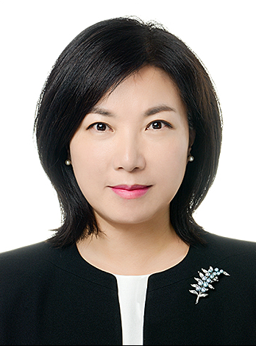
Title: Latent class analysis of gambling activities among Korean out-of-school adolescents
Name: Hwal Lan Bang

Andong National University Department of Nursing, Republic of Korea

This study aimed to identify different patterns of gambling activities of adolescents out-of-school in Korea, and to compare important factors related to gambling behaviors and gambling problem severity. The secondary data from Survey on 2015 Youth Gambling Problems were used. Thirteen distinct gambling activities of 1,200 adolescents who dropped out of school were analyzed using latent class analysis (LCA). Differences in gambling experience and self-report score of problem gambling among classes were tested. Five subgroups of gambling activities were identified: 12.9% of the sample in occasional gambling, 4.5% in extensive gambling, 9.8% in rapid gambling, 4.1% in reclusive gambling and 68.7% in rare gambling group. Extensive and reclusive gambling adolescents started gambling right after quitting school, around the age of 15.4 years. Extensive gambling group engaged in almost every form of gambling activities, regulated and unregulated, and reclusive gambling group played mainly illegal online sports betting. Extensive and reclusive gambling groups spent more time and money on gambling. The problem gambling severity level measured by Canadian Adolescent Gambling Inventory (CAGI) was the highest among extensive gambling adolescents, followed by reclusive gambling and rapid gambling group. In conclusion, gambling was occurring frequently in youths out-of-school, and the problem gambling severity was of concern. Out-of-school adolescents are left out of public assistance and most gambling interventions and policies are school-based, concentrating on prevention. It is required to expand the role of addiction nursing in community setting to manage gambling related problems among out-of-school adolescents.

(Up to 250 words)

Biography

HL Bang has completed her PhD at the age of 49 years from Seoul National University. She is an assistant professor at Andong National University Department of Nursing.

(Up to 100 words)

Presenting author details
Full name: Hwal Lan Bang
Contact number:(82)-054-820-5686
Session name/ number:
Category: (Poster presentation)
Addiction Nursing, Pediatric Nursing

