Telenursing and Travels

Name: Dr. Raphael Akangbe (DBA, PhD, FCIML)
Lagos State Ministry of Health, Nigeria.

Abstract (300 word limit)
Statement of the Problem: Technology in healthcare has contributed immensely to the way healthcare givers approaches diagnosis and treatments. “Modern technology to promptly deliver nursing care administration and conduct nursing practice remotely”, is referred to as Telenursing.
The American Nurses Association defined telenursing as a subset of telehealth in which the focus is on the specific profession’s practice (i.e., nursing).
Despite the fact that, the adoption of technology has been used to change the delivery pattern of nursing care and may require expatriate related to its use for effective delivery in nursing care administration, the process and scope of nursing practice is not different from telenursing. Technologically inclined nurses that engages in telenursing practice proceeds to the assessment, planning, intervention, and evaluation of the outcomes of nursing care administration, this is done through the use of modern technologies such as the IoT, IoMT, mobile-health (mHealth), digital health tools, and telemonitoring technology. There is a need to consider that modern health services are now been provided through technologies which have increased, the use of telehealth to capture the scopes of services.
For the purpose of this study, I will define telehealth as “the conscious efforts in the use of information and telecommunications technologies which supports wide-distance of clinical health care assessment, client and healthcare professional education, public health and health information exchange administration.”
While, telemedicine, in the original term, is described as the practice of health care delivery, diagnosis, consultation, treatment, transfer of medical data, and education using VR, interactive audio-visual, and data/information communications.

Recent Publications (minimum 5)
- Current Trends in Health Information Management (2018) https://www.amazon.com/Current-Trends-Health-Information-Management/dp/0359166105/ref=sr_1_4?crid=1NNDSWGILGH7A&keywords=Dr.+Raphael+Akangbe&qid=1640800325&sprefix=dr.+raphael+akangbe%2Caps%2C450&sr=8-4
- Health Informatics: An Interdisciplinary Approach in Healthcare Management
https://www.amazon.com/Health-Informatics-Interdisciplinary-Approach-Management/dp/0359954146/ref=sr_1_3?crid=1NNDSWGILGH7A&keywords=Dr.+Raphael+Akangbe&qid=1640800419&sprefix=dr.+raphael+akangbe%2Caps%2C450&sr=8-3
- E-Health Technology: Concepts, Strategy, Exchange and Security.
https://www.amazon.com/Health-Technology-Concepts-Strategy-Exchange/dp/1716391768/ref=sr_1_2?crid=1NNDSWGILGH7A&keywords=Dr.+Raphael+Akangbe&qid=1640800419&sprefix=dr.+raphael+akangbe%2Caps%2C450&sr=8-2

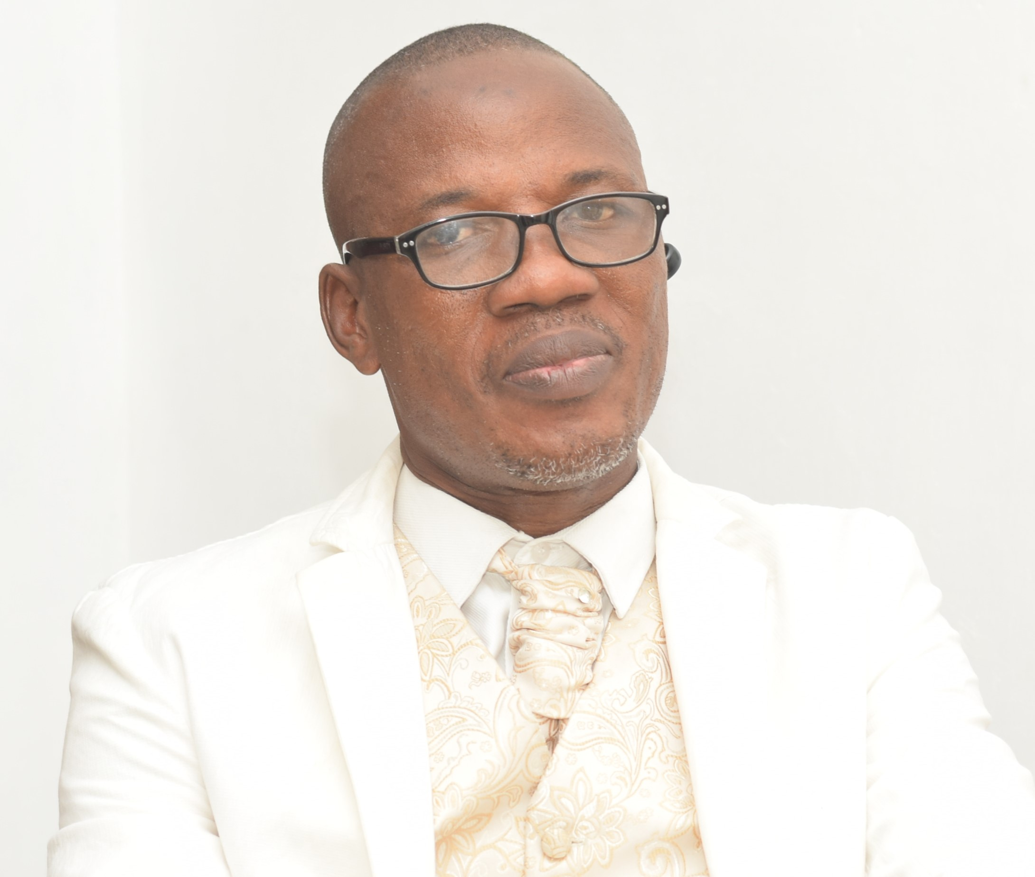

Biography
Dr. Raphael Akangbe is an accomplished Digital Health/Health Informatics, consultant and a lecturer with over 18 years of experience.
Dr. Raphael earned his MSc. In Health Informatics and Information Management, DBA and PhD in Health Information Management and Health Management Information System respectively. Through his course, he developed a passionate interest in Digital Health.
Dr. Raphael is a prominent local and international conference speaker and has authored 3 books, that are on sale on amazon.com and other globally recognized online book stores. They are:
- Current Trends in Health Information Management
- Health Informatics: An Interdisciplinary Approach in Healthcare Management
- E-Health Technology: Concepts, Strategy, Exchange and Security.
He is presently working as Lagos State Ministry of Health Data Protection Officer, E-Health Unit. Raphael is a Treasurer and a board member at Society for Telemedicine and e-Health in Nigeria (SfTeHiN).
Email: rphelgloria@gmail.com

Notes/Comments:
Presenting author details
Full-name:Dr.RaphaelAkangbe
Contact-number:+2348028668951
Linked In account: Raphael Akangbe
Session name/ number: Telenursing and Travel
Category: (Oral presentation)

