[Title page]

Remission of Post Polio Syndrome following by spinal manipulation

Eric Chun Pu Chu,^{1*} Fa-Sain Lo,² Amiya Bhaumik ³

^{1, 2}New York Chiropractic & Physiotherapy Centre, New York Medical Group, Hong Kong, China
³Faculty of Sciences, Lincoln University College, Kelantan, Malaysia.

*Correspondence:
Eric Chun Pu Chu, BSc, DC, MHA, ICCSP, FRCC;
New York Chiropractic and Physiotherapy Centre,
41/F Langham Place Office Tower, 8 Argyle Street, Hong Kong, China.
Tel: +852-3594-7844; Fax +852-3594-6193; E-mail: eric@nymg.com.hk

Author name and affiliation
- Eric Chun Pu Chu, BSc, DC, MHA, ICCSP, FRCC;
E-mail: eric@nymg.com.hk
New York Chiropractic and Physiotherapy Centre,
41/F Langham Place Office Tower, 8 Argyle Street, Mongkok,
Hong Kong, China. Tel: +852-3594-7844; Fax +852-3594-6193.
- Fa-Sain Lo, PhD; E-mail: fslonymg@gmail.com
New York Chiropractic and Physiotherapy Centre,
41/F Langham Place Office Tower, 8 Argyle Street, Mongkok,
Hong Kong, China. Tel: +852-3594-7844; Fax +852-3594-6193.
- Amiya Bhaumik, PhD; E-mail: irismwm@hotmail.com
Lincoln University College, Jalan Kota Bharu - Pengkalan Kubor, 15050 Kota Bharu, Kelantan, Malaysia. Tel: +60 3-7886 7315

Financial support and sponsorship: None

Conflicts of interest: The authors declare no potential conflict of interests.

Remission of Post Polio Syndrome following by spinal manipulation

Abstract
After the introduction of effective vaccines in the 1960s, paralytic poliomyelitis (polio)was almost eliminated as a public health problem in most countries. After recovery from the acute attack of poliomyelitis virus, it was believed that the survivors would remain stable in their health conditions. However, the eradication of the disease does not end healthcare management of polio victims. Many survivors are at risk of developing a disorder that affects survivor years after recovery from an initial polio attack, post-polio syndrome (PPS). We report a case of PPS who seek chiropractic therapy for the complaints of recently developed weakness and neuro-musculoskeletal symptoms 60 years after polio recovery. Understanding the pathophysiology of PPS will help clinicians to provide accurate diagnosis and management of improvement of quality of life (QOL).
Keywords: late effects of polio, paralytic poliomyelitis, polio survivor, post-polio syndrome
Running title: Post-polio syndrome

Introduction
Poliovirus has high resistance to the environment. It is a type of human enterovirus species, and mainly affects children under 5 years of age. ¹ It is highly contagious and spreads through the fecal-oral route. The severity of the disease relies heavily on the site of viral target. The polio virus diverts the translation machinery and inhibits cellular protein synthesis.¹ As majority of poliovirus is confined in the gastrointestinal tract of human system, poliovirus infection is mostly subclinical with minimum or no symptoms. However, less than 1% of poliovirus translates to polio, which attacks the motor neurons in the brain stem and anterior horn of spinal cord, and lead to muscle weakness and flaccid paralysis.² In 1955, the polio vaccine was first introduced and global strategy was enforced. Most countries have now eradicated the polio.

In the 1970s, many polio survivors had noticed gradual new wasting and pain in muscles that were previously affected.³ The term “post-polio syndrome “was introduced in the 1980s,⁴ describing the condition that affects polio victims’ years after recovery from the initial episode. The cause of PPS remains unclear but experts have offered several theories to explain the pathophysiology.⁵ The theories include degeneration of individual nerve terminals in motor units, fatigue of overworked nerve cells, the general ageing neuromuscular functions, and inflammatory changes in the central nervous system.⁶ The result of biomechanical defect may mimic PPS including muscle fatigue and tendonitis, degenerative arthritis, osteoporosis, and fracture. Therefore, conservative method shall be considered for the management of polio survivors.

Case report
A 63-year-old man presented with chief complaints of low back pain, and progressive left lower limb weakness. He had a history of polio attack at the age of², which left him with permanent deformity in the right lower extremity. After decades, weakness, fatigue, and cramps were newly developed in the muscle groups of the left (strong)leg, progressively over one year. A gradual decrease in the size of muscles on left leg was reported and he was unable to remain daily social activities. After review by the family physician and psychologist, he was treated with non-steroidal anti-inflammatory drug and exercise, which did not help with his conditions.

The patient walked with crutches and presented with a waddling gait. His had muscle atrophy of the right lower extremity, which is indicative of previous paralytic polio infection. During his neurological examinations, his motor strength was graded as 0/5 at right L1-S1,4/5 at left L1-2, and 3-5 at left L3-S1. The orthopedic examinations were positive at Adam's test and spinal palpation revealed segmental dysfunction at T7-10, L1-2, L4-5. His radiological findings were indicative of lumbar scoliosis and osteoarthritis at L2-5. Needle electromyography revealed denervation of muscles on right lower extremity. Surface electromyography (MyoVision®) reported hyperactivity of bilateral paraspinal muscles. His conditions are consistent of the diagnosis3 for post-polio syndrome.

To regain function and reduce stiffness of the musculoskeletal system, manual myofascial technique, therapeutic ultrasound therapy, and motorized intersegmental traction (Spine Decompression Device, MID 4M Series, WIZ Medical, Korea) were applied 3 times a week in the first 4-weeks. The patient reported immediate reduction of intensity and duration of lower leg pain and cramp. To realign the posture and biomechanics of body, chiropractic spinal manipulation was added two times a week in the following 2 months. During the course of treatments, he noticed the progressive improvement in motor strength, leg length inequity, and mental stress. Intervertebral segmental dysfunctions have reduced with increased mobility. At the 3rd months reassessment, his surface EMG has reported a reduction in hyperactivity, which implied significant improvement in neuromuscular dysfunction (Figure 1). He continued the treatment once a month for further 6 months. At the 9th month, his QOL, which is evaluated by WHOQOL-BREF 7, has improved at 50% (from 30%) in physical health,90% (from 40%) in psychological health,80% (from 45%) in social health, and 90% (from 40%) environmental health.

Discussion
In 1955, polio vaccine was introduced. Its utilization has eradicated polio from most countries. 92% of the World Health Organization (WHO)members conducts acute flaccid paralysis surveillance plan on the weekly basis to monitor the global eradication of polio. The surveillance includes strategy in certification, containment, integration and eradication. The polio cases have decreased by more than 99 percent since 1988. Only Nigeria, Afghanistan, and Pakistan remain endemic and report 23 wild PV cases and 34 vaccine-derived PV cases (Nigeria)in 2018. The plan to achieving a polio-free world has been mapped in the Global Polio Eradication Initiative (GPEI)Strategic Plan 2019–2023 [WHO].⁸

Post-polio syndrome (PPS)is a neurologic disorder that affects polio survivors’ years after recovery from the initial attack. It is characterized by new weakening in muscles, progressive muscle fatigue, gradual decrease in muscle size, degenerative joint pain, and skeletal deformities in polio survivors.⁵ The risk factors of developing PPS are directly related to the severity, age, recovery, and excessive physical activity after recovery from polio. Individuals who had minimal symptoms from the original illness are more likely to experience only mild signs and symptoms of PPS. A person who suffered from polio as an adult rather than as a child, may experience more severe signs of PPS. In addition, the greater the recovery of polio attack, the more likely PPS will develop due to the more recovery places additional stress on motor neurons. Excessive physical activity leads to exhausted motor neurons with more severe fatigue and greater loss of muscle function.⁹

The cause of PPS is unknown but the pathophysiology of new weakness appears to be related to the exhaustion of neurons in the spinal cord and brain stem after the polio attack. To compensate for the resulting neuron shortage, the surviving neurons sprout new fibers and connect with surviving muscle fibers, and results in enlargement of motor units and gradual gain in strength of affected limbs.^{1,10} Years of overwork of extended motor units, the remaining neurons deteriorate and loss motor strength.² Restoration of nerve function may occur a second time, but eventually causes permanent weakness and pain in the compensated muscles³ Muscle atrophy, joint immobility, compromised movement pattern, leg length inequality, and degenerative joints may lead to compromised neurophysiology. The neuroplastic alteration change prefrontal cortex and amplify chronic pain, motor behavior, and emotional processes.¹¹

The diagnosis of PPS relies on clinical history and presentation as there is no specific laboratory tests and symptoms vary greatly among individuals. The diagnosis is concluded by eliminations of other diseases that could explain the conditions. The EFNS (European Federation of Neurological Societies) criteria³ is the universal accepted model of PPS for physicians to follow: 1) prior history of acute paralytic illness with positive signs of neuromuscular examination and electromyography. 2) 15 years of partial or complete recovery of neuromuscular functions after acute paralytic poliomyelitis. 3)gradual or sudden onset of progressive and persistent new muscle weakness or abnormal muscle fatiguability. 4) symptoms that persist for at least 12 months. 5)exclusion of other medical, neuromuscular, and orthopedic abnormalities as origins of syndrome.³

The perceptions of QOL were related to physical condition, social relationships, psychological conditions.⁷ and most of the PPS therapy have focused on finding safe treatments that reduces symptoms. After progressive tissue damage of PPS, neuroplastic change affect the prefrontal cortex and intensify the development of chronic disability, dysfunctional pain, motor behavior, and emotional processes.¹¹ Conservative therapy is the corner stone for PPS¹⁰ ,and chiropractic spinal manipulation alters processing in the prefrontal cortex,¹² which critically changes pain process,¹³ emotional regulation, and mental health.¹⁴ Moreover, spinal manipulation can help PPS patients stretch the muscles and tendons, regain joint function, and prevent muscle atrophy¹⁰. The therapeutic goal of PPS is to maintain function and increase QOL. The limitation of the report is that it is a single case. Further research on how manual therapy affect QOL in PPS is needed to clarify these issues.

Conclusion
Post-polio syndrome is caused by the exhaustion of the motor unit years after recovery from an initial acute attack of the poliomyelitis. This case report indicates the effectiveness of chiropractic therapy on a polio survivor in improving neuromuscular dysfunction and rehabilitating physical, social and mental health. Due to the limitation of a single case report, further study in comparing therapeutic regimens should be investigated to clarify these issues.

Ethics, consent and permissions
Written informed consent has been provided by the patient to have the case details published. Ethics approval is not required for a retrospective chart review of anonymous patient data. No institution approval was required to publish the case details.
Author contributions
Both authors contributed to data analysis, drafting or revising the article, gave final approval of the version to be published, and agree to be accountable for all aspects of the work.
Conflicts of interest
There are no conflicts of interest.
References
- Baj A, Colombo M, Headley JL, et al. Post-poliomyelitis syndrome as a possible viral disease. Int J Infect Dis. 2015; 35:e107-e116.
- Groce NE, Banks LM, Stein MA. Surviving polio in a post-polio word. Social Sci Med. 2014;107:171-8. https://doi.org/10.1016/j.socscimed.2014.02.024.
- Farbu E, Gilhus NE, Barnes MP, et al. EFNS guideline on diagnosis and management of post-polio syndrome. Report of an EFNS task force. Eur J Neurol. 2006;13(8):795-801. doi: 10.1111/j.1468-1331.2006.01385.x.
- Halstead LS, Rossi CD. New problems in old polio patients: results of a survey of 539 polio survivors. Orthopedics. 1985;8(7):845-50.
- Trojan DA, Cashman NR. Post-poliomyelitis syndrome. Muscle Nerve. 2005; 31(1):6-19. doi:10.1002/mus.20259.
- Farbu E, Gilhus NE, Barnes MP, et al. Post-polio syndrome. In: Gilhus NE, Barnes MP, Brainin M, eds. European Handbook of Neurological Management, Volume 1, 2nd edn. Oxford: Blackwell Publishing; 2011. pp. 311-9.
- Almeida-Brasi CC, Silveira MR, Silva KR, et al. Quality of life and associated characteristics: application of WHOQOL-BREF in the context of primary health care. Ciênc Saúde Coletiva. 2017;22(5):1705-16. doi: 10.1590/1413-81232017225.20362015.
- World Health Organization. The GPEI Polio Endgame Strategy 2019-2023. Geneva: WHO; 2019. Available from: http://polioeradication.org/wp-content/uploads/2019/06/english-polio-endgame-strategy.pdf.
- National Institute of Neurological Disorders and Stroke. The Polio Fact Sheet. USA: Available from: https://www.ninds.nih.gov/Disorders/Patient-Caregiver-Education/Fact-Sheets/Post-Polio-Syndrome-Fact-Sheet. Accessed October 31,2019.
- Chu ECP, Lam K. Post-poliomyelitis syndrome. Int Med Case Rep J. 2019;12:261-4.
- Pelletier R,Higgins J, Bourbonnais D. Is neuroplasticity in the central nervous system the missing link to our understanding of chronic musculoskeletal disorders? BMC Musculoskeletal Disorders. 2015;16(25).
- Haavik-Taylor & Murphy (2007)Cervical spine manipulation alters sensorimotor integration: A somatosensory evoked potential study. Clinical Neurophysiology;118(2): p. 391-402.
- Lorenz J,Minoshima S,Casey KL. Keeping pain out of mind: the role of the dorsolateral prefrontal cortex in pain modulation. Brain. May 2003;126(Pt 5):1079-1091.
- Arnsten et al. (2015). The effects of stress exposure on prefrontal cortex: Translating basic research into successful treatments for post-traumatic stress disorder. Neurobiology of Stress,1,89-99.

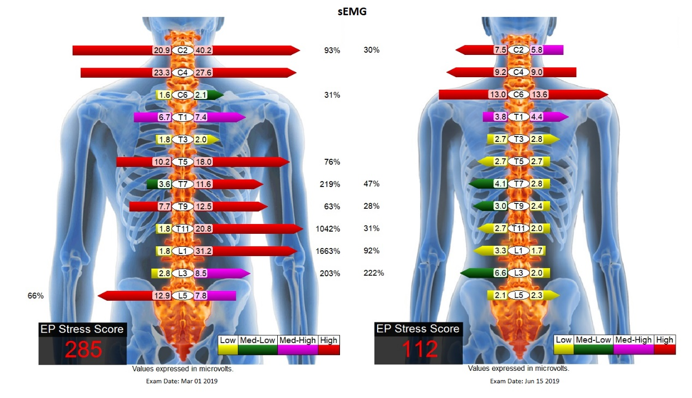

Figure 1: The initial surface electromyography (left) revealed muscle spasm at multiple levels of paraspinal muscle. The post-treatment surface electromyography (right) indicated improvement of the paraspinal spam.

