Skin Failure: Diagnosis and Treatment of Wound and Skin
Disorders in the Terminally Ill Patient

Traci Brackin, Blount Senior Care Partners, Maryville, TN, United States 37804

Healthcare providers commonly treat and educate patients and family members regarding multiple types of organ failure. The intensive care nurse cares for an intubated patient and teaches the wife about mechanical ventilation for respiratory failure. The cardiologist prescribes a diuretic and explains a low sodium diet for the man with heart failure. However, many providers are not as comfortable diagnosing, treating, and educating patients and family about skin failure. This educational session will provide nurses with the information needed to understand the concept of skin failure. Similarly, the learning objectives will include key concepts for treatment with a palliative focus. This treatment includes symptom management, such as controlling pain, odor, drainage, bleeding, and bioburden. The lecture will include topics regarding the economic impact of wounds and wound care, and some cultural and societal factors associated with wound treatment. We will also discuss the factors associated with wound healing or non-healing.

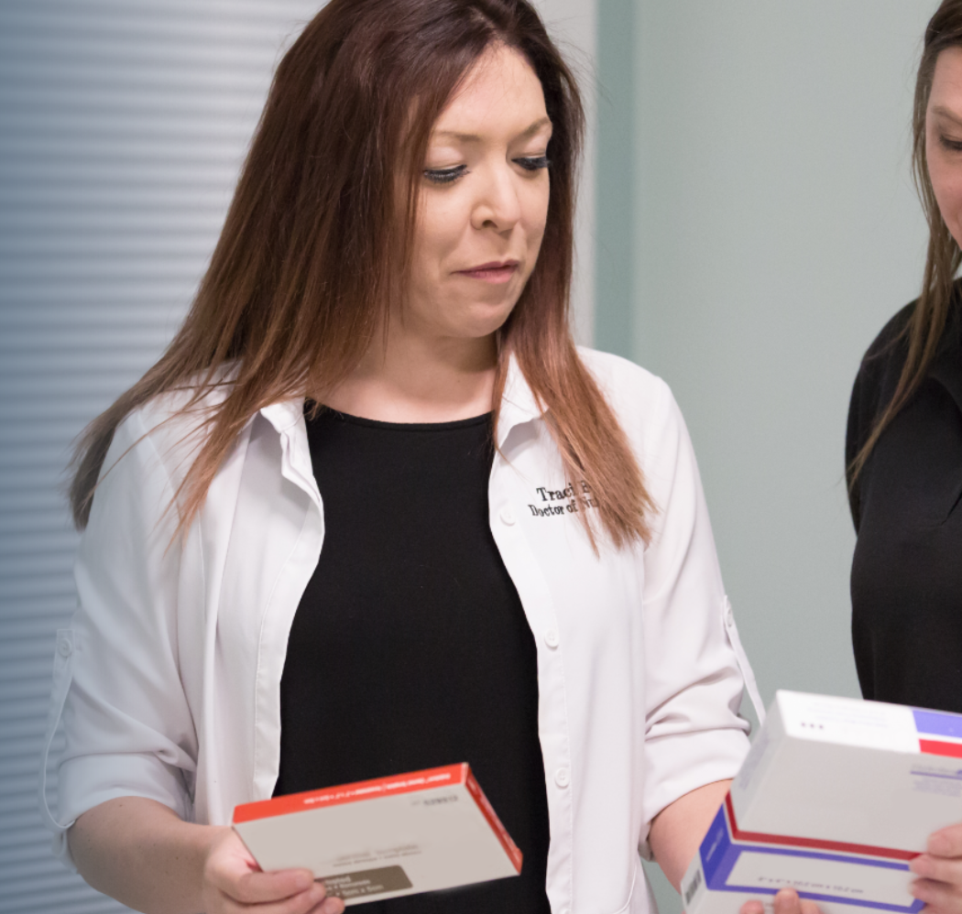 Traci Brackin is a family nurse practitioner with advanced training in wound, ostomy, urinary & fecal continence & foot care. She practices in the hospital, nursing homes, assisted living, clinic, and even home visits. Her doctoral thesis was developing a palliative wound care protocol in order to assist nurses in the management of terminal wound manifestations, such as pain, odor, drainage, bleeding, & bioburden. Dr. Brackin educates nurses and physicians throughout the United States about wound care, and has been priviledged to lecture at many national conventions within the US. Her passion for wound care is contagious, and her education program regarding skin failure is certain to better equip nurses to handle difficult situations.

Presenting author details
Full name: Traci Brackin, DNP, APRN, FNP-BC, APCWCN, CFCN
Contact number: +1 865-387-1180
Twitter account:
Linked In account:
Session name/ number:
Category: (Oral presentation/ Poster presentation) Oral Presentation/Lecture

