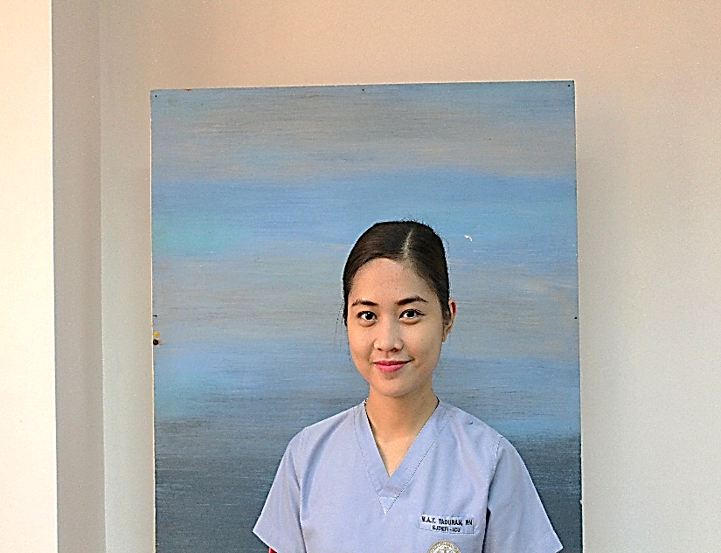
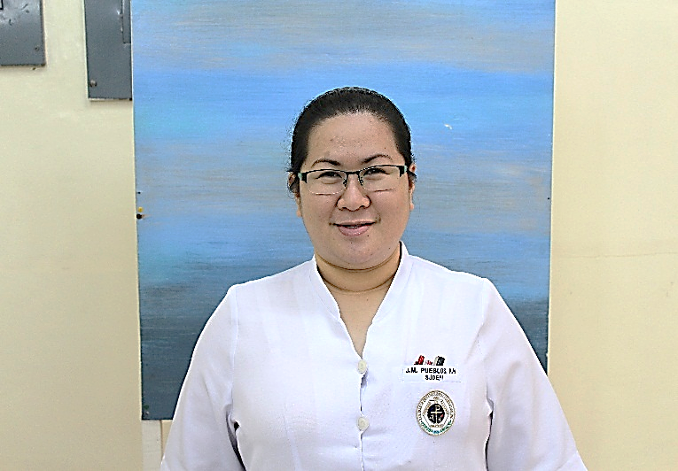

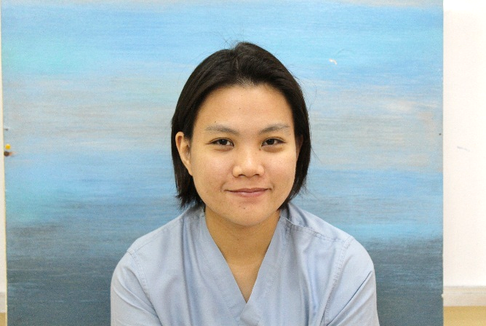

Title: Assessment of Medication and Treatment Administration Barriers: Leading to Monthly
MARY ANGELA T. TADURAN, RN
JANE M. PUEBLOS, RN, MSN
VINCENT JAMES G. BASAS II, RN
MICHELLE JORDANNE D. DE JESUS, RN
RAYMOND G. CERVANTES, RN
Medication Administration and Treatment Safety Huddle
(M.A.T.S.H)
Investigators’ Name: Jane M. Pueblos, RN, MSN.
Raymond G. Cervantes, RN.
James Vincent G. Basas II, RN.
Michelle Jordanne D. de Jesus, RN.
Mary Angela T. Taduran, RN.
San Juan De Dios Educational Foundation Inc. (Hospital), 2772 Roxas Boulevard, Pasay City, Manila
The increasing incidence of medication variance is one of the most pressing concerns in the context of medication and treatment administration in the Critical Care Unit of San Juan De Dios Educational Foundation Inc. (Hospital). To help the critical care nurses increase safety parameters, an appropriate medication variance analyses must be proactively designed to address these concerns. The purpose of this study is to develop guidelines on Monthly Medication Administration and Treatment Safety Huddle (M.A.T.S.H.) after the identification of the criticality and impact of medication and treatment barriers. This study utilized the quantitative-descriptive-correlational research design. Purposive sampling was utilized and all 25 staff nurses participated in the survey. The respondents evaluated the criticality of the 14 statements that describe the different medication administration and treatment barriers in the Critical Care Unit. They have also determined the potential impact of these barriers as: P= wrong patient, T=wrong time or extra time, R= wrong route, M=wrong medication or drug and D= wrong dose. Findings revealed that there is a significant relationship (p= 0.003) between the perceived criticality of the medication administration and treatment barriers and the perceived potential impact of the respondents. This means that the higher the perceived criticality on the medication administration and treatment barriers, the higher its potential impact, or the criticality of the barriers influence its impact. Currently, the M.A.T.S.H. is being utilized in the Critical Care Unit of the hospital and it has leveraged the awareness on the medication and treatment barriers among the staff nurses.

Biography

Jane M. Pueblos completed her Bachelor of Science in Nursing from University of Eastern Philippines and also finished her Master’s of Science in Nursing Major in Nursing Administration at Concordia College- Manila. She is also the Section Manager of the Critical Care Unit of San Juan De Dios Educational Foundation Inc. (Hospital). She is a member of the Association of Nursing Service Administrators of le Philippines( ANSAP) and a lifetime member of the Philippine Nurses Association (PNA), Operating Room Nurses Association of the Phillipines (ORNAP) and one of the founding member of the Philippine Society of Orthopeadic Nurses (PSON).

Raymond G. Cervantes completed his Bachelor of Science in Nursing from Catanduanes State University and is currently taking his Master’s of Science in Nursing Major in Nursing Administration at Concordia College- Manila. He is also the Unit Manager of the Critical Care Unit of San Juan De Dios Educational Foundation Inc. (Hospital). He is the Committee Chairman of the Proactive Review of Opportunity-Based Enhancements (P.R.O.B.E) Team, previously the Research Team of San Juan De Dios Educational Foundation Inc. (Hospital). He presented a study about the Assessment of Medication and Treatment Administration Barriers: Leading to Monthly
Medication Administration and Treatment Safety Huddle at the Association of Nursing Service Administrators of the Philippines (ANSAP). He has also one poster presentation about the CAMP- ME (Collaborative Assembly of Managers Proactively Moved by Engagement) as an Effective Strategy in Raising Delegation, Teamwork and Collaboration at ANSAP.

Michelle Jordanne D. De Jesus completed her Bachelor of Science in Nursing from Pamantasan ng Lungsod ng Maynila and she is currently her Master’s of Science in Nursing Major in Nursing Administration at St. Paul University in Manila. She is also the Unit Manager of the Critical Care Unit of San Juan De Dios Educational Foundation Inc. (Hospital). She is a member of the Philippine Nurses Association (PNA).

Vincent James G. Basas II completed his Bachelor of Science in Nursing from Our Lady of Fatima University in Valenzuela City and he is currently taking Master’s of Science in Nursing Major in Nursing Administration at Concordia College- Manila. He is also currently the Unit Manager of the Emergency Services Unit of San Juan De Dios Educational Foundation Inc. (Hospital).

Mary Angela Taduran completed her Bachelor of Science in Nursing from Rizal Technological University in Manila and is currently taking her Master’s of Science in Nursing Major in Nursing Administration at Concordia College- Manila. She is also a former Charge Nurse of the Critical Care Unit and the former Research Chairman of the San Juan De Dios Educational Foundation Inc. (Hospital).
Presenting author details
Full name: RAYMOND G. CERVANTES
Contact number: +639274514870
Twitter account: n/a
Linked In account: cervantesraymond92@gmail.com
Session name/ number: Critical Care Nursing
Category: Oral presentation or Poster presentation

