Cancer Patient’s Perception of Nursing Presence during Chemotherapy Protocol

Introduction

Undergoing chemotherapy for cancer patient to get rid of disease is the essential part of the treatment of many cancer conditions. The most common and effective treatment modality to manage cancer is chemotherapy. According to Zhou et al. (2011), this modality has some severe effects on body, mind, spirit, social life and family life as well. Some physical effects are e.g. myelosuppression, gastrointestinal toxicity, cardiotoxicity, hepatotoxicity, neurotoxicity, ototoxicity etc. Sometimes the chemotherapy treatment to manage these side effects is discontinued. Apart from the physical problems, patients also face sleep disruption and other symptoms of depression and anxiety. Patients may also have trouble concentrating or paying attention and mood change (National Comprehensive Cancer Network, 2019).

Any person, who is diagnosed with cancer, has many types of reaction, concerns and worries. If not all, maximum patients get shocked and reluctant with disbelief; they feel feared of the consequences of treatment, prognosis of disease and get anxious. They become angry, guilty and blame their God. As a result, most of the time people feel sad, face loneliness, and some of them lose control on their emotions and get emotional that decreases their quality of life. For these kinds of situations, there should be a person to attend them all the time during their tenure of chemotherapy treatment, to prepare patients at home and empower them in managing their worries with courage (Cancer Council of Australia, 2019).

Lynch. E (2014) greatly supports this great idea of living for someone else. Normally, if one lives for someone, one is most likely to care for the person who lacks professionals in developing countries and this idea is nursing presence. Nursing presence is a skill that fosters strong relationship between nurses and patients. To get positive effects as result, nurses can utilize this relationship to prepare patients to overcome the potential side effects of chemotherapy.

This literature defines nursing presence in such a way “to be with patient” that, rather than being physically close, the presence is felt between nurses and patients. According to Yesilot S.B. (2014) presence as a nursing action consists of “being with the other person physically, psychologically and spiritually as long as that person needs.” In oncology set-up , nursing can be defined as nurses devoted to cancer patients keeping mutual relationship. Furthermore, nursing-patient communication is a relationship which opens the lines of communication to involve patient in education.

Boeck, P (2015) identifies the attributes that are essential to the concept of presence and clarifies its nursing usage. It is important to reflect on various ways of providing presence in the clinical setting. By exploring the spiritual, literary, psychological and nursing literature, there is a diverse, yet similar interconnectivity of what presence may represent. Observations and experiences of a range of sensatory and kinesthetic perceptions are revealed to ascertain the attributes discerning commonalities and themes of presence. Nursing presence is an essential state of holistic nursing as well as a core competency in contemporary nursing.

In order to satisfy the patient, it is necessary not only to fulfill physical needs of patients during administration of chemotherapy, but it is important too to address psychological needs and all other dimensions of holistic care e.g. psychological, social, and spiritual, gain patient’s confidence, financial management, emotional disturbances and near future management of disease and treatment complications.

As Fredericks. S (2009) examines the relationship of patient demographics and learning needs in the patient who has gone under coronary artery bypass and found statistically significant relationships in the patients' age, gender, and cultural background and learning needs. In the same way, knowledge of the relationship of nursing presence with patient demographic is important. These preliminary data of patients highlight the importance of addressing the learning needs of patients with different backgrounds in order to improve self-management needs to focus the patient for self-management at home.

This research aims at exploring patient’s perception of nursing presence and will be examine the relationship of patient demographics to feeling the nursing presence and satisfaction with care provided when they are in Inpatient Department admitted for chemotherapy. The quality of care can be measured with an indicator which is called patient satisfaction. In the hospital business, patient satisfaction is a growing factor which communicates the effectiveness of nursing care.

The dictionary definition of patient satisfaction is “a pleasant feeling that you get when you receive something you wanted, or when you have done something you wanted to do” (Cambridge Dictionary) but the operational definition of this concept described by exploring and measuring the patient satisfaction during their treatment of cancer e.g. receiving chemotherapy during the course of illness. This satisfaction can be enhanced by being around patient when they are receiving chemotherapy treatment.

Chemotherapy is the use of antineoplastic drugs to treat many cancer conditions. Patients need to closely be monitored and prepared for prevention of infection and management of complications at home. To improve and provide high quality care to cancer patients, Lock, K.K, (2004) identifies that cancer patient’s need individualized discussion prior to and during administration of chemotherapy so nursing presence becomes necessary to provide preferred care (2004).

If a nurse stays present around the patient while administering chemotherapy and discusses the preventive strategies for home, a life can be saved by reducing chemotherapy side effects after treatment. Nursing presence is such a methodology, in which a nurse wins patient’s confidence by addressing his or her concerns in holistic way. This therapeutic value occurs when nurse establishes good communication with patient and family. Now its patient’s ability to put forward the presence of nurse and take full advantage of nurse being around his or her in living with cancer and after chemotherapy administration treatment. However, there are demographic variables which may improve nursing presence such as age, gender, patient education, disease progression and patient family members. The more the patient is educated, young, lives with an educated family will be able to feel nursing presence in which a nurse educates patient to live after chemotherapy.

A study conducted by YEŞİLOT, S.B (2017) in Turkey explored “Cancer Patient’s Perception of Nursing Presence” found a significant positive correlation in between satisfaction with nursing care and nursing presence scale. The study recommended that the positive perception of nursing presence increased the satisfaction with nursing care. The results indicate that training on the relationship building between providing presence and patient satisfaction should further be studied in detail. So this study will be replicated here. The only difference is that YEŞİLOT, S.B (2017) explored overall perception of cancer patients of nursing presence, but this study will explore cancer patient’s perception of nursing presence when they are in chemotherapy receiving phase and a relationship of patient demographic with nursing presence.

The above mentioned study which was conducted by YEŞİLOT, S.B (2017) in which the researcher has used Carol Kostovich’s Nursing Presence Scale (NPS) in Turkish translated language whereas in the current study the same Nursing Presence Scale tool will be used in Urdu translated language. An electronic permission is taken from Dr. Saliha Bozdogan YEŞİLOT to use her idea in this research which was related to topic of the research. If we talk about the cultural differences in Turkish population and Pakistani population, there is not much difference e.g. both countries have shared history, both are Islamic state, having common faiths, have cultural similarities, a common education system adopting and both countries call each other sister country.

To the best of my knowledge, this concern unfortunately is not studied in my country. This study is a unique in its nature because this is first time I am conducting this kind of research in Lahore, Pakistan. This research is theory driven which addresses holistic nursing practices, and this study will benefit patients who are in chemotherapy treatment phase and the same patients in the other units of chemotherapy will be benefited. Furthermore, this embraced concept can be added to the current curriculum in nursing training.

This is sole nurse’s responsibility to administer chemotherapy to the cancer patient. Nurses do their job very well (Pass I/V cannula, do dressing of central line, perform dipstick of urine, maintain intake & output, do documentation, educate patient to overcome the expected side effects of chemotherapy), but there is some lacking that most of the nurses only address patient’s physical concerns not the psychological, social, emotional, social and spiritual concerns which lead this study to be conducted.

An overall personal experience shows that nurses make sure that chemotherapy has arrived. H/She goes to patient, gives chemotherapy, and asks patient to inform if chemotherapy infusion bag finishes. Although he or she discusses the expected side effects of chemotherapy, its management and other physical expected complications but do not stay around patient as the nursing presence expects. Staying around patient improves patient satisfaction with care and treatment. The competency of nursing presence includes: to be sensitive with patient concerns, teaching to patients about their needs, asking patient even though they do not have any problem just to show that we are sensitive about your concerns.

The height of nursing presence achieves to gain patient’s trust, understand patient’s feelings, patient have trouble free days in hospital, nurse creates a healing atmosphere around patient, he or she helps patient feel safe in the treatment phase, patients have their own control over health, now this is nurse’s responsibility to make a bond between them and patients.

The nursing presence includes making the patient relax emotionally, understands the feelings of patient, patients may feel safe during chemotherapy, win their trust, to build a strong bond among nurse and patient and satisfy the patient with care delivered during chemotherapy. Nurses should use many of their functional skills, perform different actions, and have strong interpersonal communication skills and humanistic qualifications.

In a study conducted by Radwin et al., n cancer patients, nursing care was defined as a significant and valuable contribution; nurses were reported to be significant, critical, supportive, relaxing, concerned, thoughtful, sensitive, helpful, and emphatic; and care was defined to be compassionate, interesting, and polite. Patients stated that they realized the care, were relaxed, and felt safe with less anxiety when they received a nursing service including these characteristics. In a study by Sainio et al., it was easier for patients to respond to the care when nurses displayed a positive, friendly, and realistic attitude while providing care. Study results indicated that nurses’ attitudes during the period of providing care affected patients’ emotions related to the care.

Research has shown that cancer patients and family’s worries are countless. Researchers, scientists and clinicians are actively trying to identify effective interventional methods to overcome the feeling of patient loneliness during chemotherapy treatment. Considerable evidence suggests that cancer patients and their families suffer from psychological distress associated with cancer treatment as elaborated by Rashid. Y. A (2012). Another study conducted in Taiwan explored the psychological process of patients while receiving chemotherapy. Four stages of the process examined, which revealed that patients usually feel fear of getting separated from family, moreover, they experience physical hardship, furthermore, and they find adjustment methods and finally achieve relaxation and accept change in their life. (Yen-Chieh, C. 2016)

The overall aim of this study is to evaluate cancer patient’s perception of nursing presence when they are in chemotherapy receiving phase and suggest nursing interventions to enhance nursing presence.

Specific objectives are:

To determine the patients’ perception of nursing presence during chemotherapy.

To determine the relationship between demographic profile of the patients receiving chemotherapy and perceived nursing presence

Research Question:

How do cancer patients perceive the nursing presence in the period that they are receiving chemotherapy from nurses in in-patient department?

What is the relationship between perceived nursing presence and the demographic profile (gender, age, marital status, educational status) of the patients receiving chemotherapy in in-patient department?

Hypothesis: There is a significant relationship between the perceived nursing presence and the demographic profile (gender, age, marital status, educational status) of patients receiving chemotherapy.

Scope and Limitation of this study

This study will only determine the perception of cancer patients undergoing chemotherapy so is Limited to the nursing presence in correlation to patient demographics as perceived by the patient undergoing chemotherapy. This study will be carried out in oncology center in Lahore, Pakistan. If nurses lack the above-mentioned skills, there are so many educational programs which enhance nurse’s knowledge, attitude and practice by education. Ferrell. B.R (2003) requires educating oncology nurses because “Oncology nurses are central to all aspects of survivorship for patient care and family support and patient satisfaction”.

The patients admitted in In-Patient Department for chemotherapy treatment for their cancer will be benefited from this research. The patients and their families will be able to come to know the significance of patient/nurse/family interaction during chemotherapy. The families of cancer patients will be able to take care of their loved ones at home by getting education from nurses for the potential side effects at home and hospital visits will be reduced.

When nurses are principally responsible to play their role in provision of safe surrounding to patient and teach him to settle physically, emotionally, psychologically and spiritually to fight with disease, disturbances arise as a result of treatment by maintaining good therapeutic relationship with patient. So, nurses cannot get success in his or her goal unless patient is able to adopt the behavior nurse want to teach.

According to Jennings K.M (2017) the primary goal of nursing is to enhance life processes to promote adaptation, with adaptation being the process and outcome of thinking and feeling individuals who use conscious awareness and choice to create human and environmental integration” that’s why we will gather patient’s demographic date to come to know the ability of patient to understand.

Nurses will come to know the better way to take care of patients undergoing chemotherapy by adding all dimensions of holistic care especially psychological concerns nurses have to take care when administering chemotherapy to patients in In-Patient Department. The hospital administration will modify their policy adding psychological, social, spiritual, physical and emotional care of a patient undergoing chemotherapy to enable its nurses to the better provision of all ideal things in this regard. There will be better and improved nursing care delivery system for patients. Nurses will be able to better utilize their time rather than wasting their time in other time taking activities and spend their time with patients and their families. According to Rossele. B, (2016), unplanned activities and inability to say “No” are the major time wasters for all of us. This time can be better utilized for patients to satisfy them being present around them.

Literature Review

The previous studies and current local practices have shown that nurses do not give holistic care whereas holistic care is considered and believed to be the heart, complete and comprehensive method of care in nursing. This method recognizes a person. According to Zamanzadeh. V (2015), holistic care includes a wide range of approaches, including medication, education, communication, self-help, and complementary treatment. In holistic nursing, all aspects of patients and their effects on the treatment process are considered, and the patients’ thoughts, emotions, cultures, opinions, and attitudes are helpful in as contributing to recovery, happiness, and satisfaction. In many hospitals, nurses are being educated and asked to deliver holistic care but unfortunately, they are not being monitored about their actions.
The American Holistic Nurses Association (ANA) defines holistic nursing as “all nursing practice that has healing the whole person as its goal.” There are many easy ways to improve relationships with patients and promote a healthy psychological, emotional, and spiritual environment so nursing presence is one of them. ANA suggests some of the strategies to promote holistic care e.g. learn the patients name and use it, make good, strong eye contact, ask how a patient is feeling and sincerely care, smiling and laughing when appropriate, use therapeutic touch, assist the patient to see themselves as someone that deserves dignity, as for their needs and concerns even if they do not share.
This is the patient’s right to preserve their dignity, educate patients on the importance of self-care, ask the patient how you can reduce their anxiety or pain, use non-pharmacological methods of pain control such as imagery, relaxation techniques, and more. Encourage patients and assist as needed with alternative treatment modalities; never underestimate the benefit of a massage, aromatherapy, or music, ask if patients have certain religious, cultural, or spiritual beliefs; be sensitive and accepting if they do have and this all can be addressed when nurse is around the patient while administering chemotherapy.

Nursing presence is the new concept in which a nurse remains present all the times around the patient to manage patient’s physical concerns along with psychological. Furthermore, he or she addresses patient’s social, spiritual and emotional concerns. Along with the physical complications, nurses need to address patient’s psycho-social issues also in terms of holistic care, nurse visits the patient many times because many times patient is on continuous chemotherapy and nurse visits patient again and again but do not ask patient needs, concerns and patient’s level of satisfaction to the nursing services. In a visit to the patient’s room, a nurse monitors vital signs of the patient, takes care of intravenous line and current infusion which is going on and plans for next bottle to hang on.

Nursing presence recognized by thoughtful performance, verbal confirmation, good listening & non-verbal skills, clinical capability, spiritual care, actions beyond usual physical care, unrestricted availability of the assigned nurse, sympathy shown by nurses in the time of crisis, valuing personhood and giving a sense of presence has been found beneficial in patients taking treatment for cancer. Furthermore, the nurse explains that one has to measure your urine, give for test, eat well balanced diet which hospital provides but do not address her feeling, their spiritual needs in this crucial condition, management of children at home, or the management of financial issues during chemotherapy.

Pakistan is a developing country and is having lack of treatment facilities and committed nursing staff which put our patients on less satisfied state of mind and nursing presence does not cost any money to practice which can create a huge difference in patient’s satisfaction and improve quality of life. So, there is need to look on patient’s satisfaction related to nursing presence when they are receiving chemotherapy in Inpatient Department while they are admitted. Where there are so much number of cancer patients and facilities are low, they will face much greater number of problems because health care system will experience shortage of nurses because of increases burden.

As the person gets diagnosed with cancer, patient faces a situation of uncertain future and fear of death around him or her and the symptoms interfere with daily living and the treatment starts hoping to get well soon, but the hopelessness and helplessness does not allow patient to get adjusted with disease as soon he comes in hospital for chemotherapy.

Oncology Staff Nurse’s role is to provide direct care to patient and family members. Roy. D (2019) opines that the bedside nurse is responsible to provide education to patient and family. Khan N (2012) identifies the role of an oncology nurse is to administer chemotherapy, and he or she is responsible from the start of the chemotherapy till the discharge from hospital and prepare the patient for home. This is possible when the primary nurse starts chemotherapy, educates patient about prevention and management of side effects, and handovers to next shift for continuity of care in the form of complete and comprehensive hand over. Now the patient believes that along with good communication skills and technical skills a nurse can demonstrate positive attitude to help cancer patients in their psychological issues caused by disease and its treatment.

Many studies concentrated on which age and gender causes more anxiety and depression and revealed that women and patient in young age are more likely to get worried from disease more (H. Faller, J. Weis (2016)) reveals that younger age, female sex, and higher education were associated with more needs, being married and living with a partner with fewer needs, respectively.

The more the advanced disease is, the more adjustment to cancer and its treatment will be. It is logical to expect that more advanced patients experience higher levels of anxiety, depression, and hopelessness (C. D. Bergerot, K. L. Clark 2013). In other study, Laurel. R (2003) examines relationships between patients' demographic characteristics and patients' reports of patient-centered care (which is known as nursing presence) and found that people with low socioeconomic status, women elderly, less educated and fragile cancer patients are victim of lower quality of nursing care.

Erin S. Costanzo (2009) suggests increasing the nursing presence to take care of oneself, providing perceptible help, or addressing fears and concerns about the disease, treatment, family, friends and significant others make an essential contribution to adjust with disease and treatment.

Goldberg R.J (1985) “Studies of the relation of adaptation and the patient's psychological situation such as degree of pessimism or anxiety, personality characteristics, prior experience with the death of a close friend or relative or religious beliefs have been inconclusive”. According to Ursula M. Sansom-Daly (2013) having the low socio-economic status and lower educational attainment results in distress and need to be addressed.

Nursing presence in nursing is understood to have trust-worthy therapeutic relationship, have closeness, relational interchange while working together. A good aspect for good nursing care is to know each other. A satisfactory feature of a good nurse is to be expert, demonstrating sensitivity, holism, and spirituality, ability to give of self and accessibility, active listening & hearing, fully encouragement with patient concerns and simplification of teaching process. In the technical skills of a good nurse is be able to monitor progress, responsiveness to patient cues, full attention/attentiveness, maintenance of psychological presence, ability to adapt to unique situations, advocacy, instills confidence and teaching intentionality versus instinctual four behavioral levels e.g. physical, therapeutic, holistic and spiritual. Demonstrates depth levels e.g. being present, and available there, partial presence, to full presence based on patient indications (Turpin. R.L 2014.)

According to Khan N (2012), where there are technical expertise for ensuring safe treatment of cancer patients, there is need to demonstrate a high level of positive attitude cancer nurses to help and treat cancer patient’s physiological side effects of treatment and psychological issues as well caused by disease and its treatment which include social, spiritual, emotional and familial.

Nursing presence in patient care is becoming a fashionable concept and is being recognized by patients and families an advantage because it involves patient and family, allows a companionship and promotes connection experience (Hessel JA 2009). Furthermore, the concept of presence around patient has been studied by Boeck. P.R (2014) and has been stimulated the therapeutic relationship which enhances wholeness and healing in patients who are receiving chemotherapy (Antineoplastic) drugs as the treatment of disease (Cancer). It is important to find various ways and should not miss any chance of being around with patient during chemotherapy administration.

Turpin, R (2014) describes nursing presence in such a way in which the author comments that when a nurse and patient both are mutually open in their discussion on a specific topic and nurse spends his/her time for nursing presence to meet patient needs. This researcher claims that nursing presence capability is declining in today’s communication.

Mohammadipour. F. (2017) reveals that nursing presence is not well known and claims that nursing presence is the foundation of patient satisfaction for quick recovery and positive outcome. According to Muhammadipur F. (2017), nursing presence is an underdeveloped concept and there is need to educate nurses about this attribute of this new concept because nursing presence is an integral part of caring with humanistic and patient-centered approach.

The effects of nursing presence can be seen in Lai H (2011) research. The investigator found that by offering music interventions to both patient and care giver we can overcome the feelings of loneliness. “The music intervention (a 30 minutes prerecorded music was provided, and participants listened for thirty minutes) with nursing presence provided a more friendly music experience to the listeners” in this recorded music session.

Holistic nursing practice is cost effective and is efficient when nursing care with enacting caring presence is recommended. Therefore, it is necessary to measure nurse’s capacity to monitor and develop in nurses according to patient’s needs. Previously! This concept has been studied by many researchers since Florence Nightingale who is called the mother of modern nursing. After Florence nightingale, Pettigrew (1988) explored patient families after the death of victim and found that when nurses evolve around patient and in the time of family crisis, they feel stimulated.
Nursing presence has shown positive outcome on patient recovery during treatment and patient gets satisfied when he or she is in admitted in hospital. According to Mohammadipour F (2017) the integral component of nursing care is to be present around patient and patient’s family to adopt patient centered approach. Anderson, J.H (2007) reveals that nurse-patient relationship improves clinical decision making and ultimately patient outcomes. The author proposes some of the attributes of nursing presence that the nurse should be able to listen, understand, and touch, share any experiences, respect and coach patient which allows patient to ventilate their feelings, threats, and promote healing.
Sue Penque & Gina Kearney (2015) examines the effects of nursing presence on patient satisfaction and found that for the purposes of this research study, the authors defined nursing presence as an intentional communion tool with which the patient leads to more knowing, awareness, and a meaningful connection. Ignoring the nursing presence, we ignore Florence Nightingale’s theory that when a nurse is not present around a patient, we ignore emotional care of patients (Nightingle, F 1860/1969). In the present literature, first time the nursing presence was defined by Florence Nightingale as an infrequent healing presence which is denoted by Dossey (2000).

A phenomenological study conducted by Davis (2005) as a purposive and conceptually driven sequential interview in adult patients and found that nursing presence was the defining characteristic as a good nursing care. If the presence was absent, Doona has identified six of the features of nursing presence e.g. uniqueness, connecting with the patient experience, sensing, going beyond the scientific date, knowing and being with the patient in critical care and perinatal and psychiatric care setting (Doona et al. 1999).

In 2009, a transformative nursing presence model was introduced by Iseminger et al. in which the researcher has identified actual and perceived barriers to nursing practice. To improve nursing presence there should be transcendent practices, which can be implemented on patient for nursing presence enhancement. Transcendent practices consist of awareness about ward where the patient must spend time during chemotherapy, empathic appreciation and listening, perfect and skilled communication, availability of daily necessities and alignment with organization.

Theoretical Framework

Florence Nightingale (1820-1910) is the first theorist believed in the concept holistic nursing care and practiced focusing on unity, wellness, and the interrelationship of human being and their environment (American Holistic Nurses Association, 1998). McMahon. M.A & Christopher. K.A (2011) guides that Kim's nurse‐client domain provided the mid-range theory of presence contributes to our understanding of the relational aspects of nursing practice within the contemporary healthcare environment.
Brown (1986) revealed that in the period of inpatient care, presence by the nurse was most important quality in the area of medical surgical area of hospital in the experience of care. On the other hand, Busch et al. (2012) conducted a comparative, quantitative two group study. In this study, the research found that there was no difference in anxiety in burn patient despite giving therapeutic touch and nursing presence. Rather there was no pain after giving nursing presence after procedure in burn patients.

A theory of nursing presence studied by a student of Ph.D. in Nursing Program College of Nursing McMahon M.A et.al (2011) discloses the importance of including of humanistic aspects of patient care in the curricula in Bachelor of Science in Nursing (BSN) which will ensure the essential value of relational engagement with client.

Holistic nursing is a rehearsal of nursing that focuses on healing the whole person. This practice recognizes that a person is not simply his or her illness. Holistic healing addresses the interconnectedness of the mind, body, spirit, social/cultural, emotions, relationships, context, and environment. All of these aspects combine to create the person, so in order to heal the person, the holistic nurse looks at all aspects and how they can affect the patient’s health.

Watson’s Theory of Caring, nursing is “concerned with promoting health, preventing illness, caring for the sick and restoring health.” Watson believes that holistic health care is central to the practice of nursing, and defines nursing as “a human science of persons and human health-illness experiences that are mediated by professional, personal, scientific, esthetic, and ethical human transactions.” Watson’s model contains seven assumptions about care and caring, as well as ten primary carative factors. It places the patient in the
context of the family, community, and culture, and the focus of the practice is on the patient rather than the technology.

Adventist Hinsdale Hospital (2013) recognizes the role of the nurse in Watson’s Caring Theory that can be applied by: creating a caring relationship with patient, displaying unconditional acceptance, applying a holistic treatment approach which includes treating the mind, soul, and spirit as well as the body, taking time to have uninterrupted moments with the patients Watson refers to this as caring moments and using knowledge and intervention to promote health and healing.
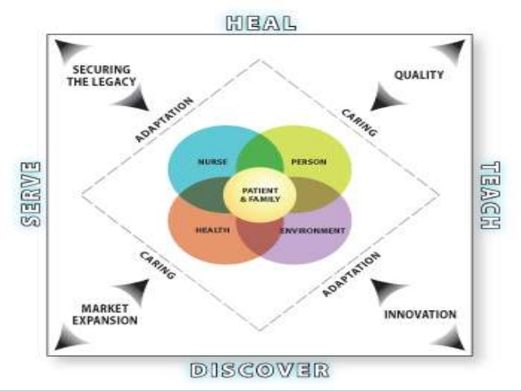

Five phases involved in this theory are to preparation of the nurse knower for coming to know. The nurse knows the patient intuitively. The nurse gains knowledge of the patient through intuitive impression and learns about the patient’s expressions. Then the nurse gains scientific knowledge of patient by pondering, analyzing, sorting, comparing, contrasting, relating, interpreting, naming and categorizing data according to nursing process. Then the nurse combines the subjective and objective information to gain perspective on situation in light of her education and experience to conclude the problem. Then the nurse makes a conclusion about the best way to improve the patient well-being.

Key trainings and characteristics of nursing presence e.g. nursing sensitivity, nursing belief, nursing care, and nursing knowledge are linked with positive patient outcomes, and these concepts together define the amount of health value effectiveness. Now this is the nurse’s responsibility to what extent they make this possible to achieve this milestone of effectiveness. According to McMahon & Christopher (2011) presents nurse qualities, patient characteristics and compatibility factor within the nurse-patient relationship plays an important role in promoting nursing presence.

Humanistic Nursing Theory by Dr. Jean Watson based on the idea that nursing is an inter-subject transactional relationship between a patient and nurse. Existentialism is the only conceptual framework of this theory. This theory’s main focus is the essence of daily experience. The implicit assumption of this theory is that nurses acts influence the quality of a person’s life. Theoretical assertions explain that by the humanistic theory a nurse connects with patient and struggle to understand the patient to face his or her current situation.

Humanistic theory explains that the practice of nursing is rooted from existentialism. The purpose of the nurse-patient relationship is to nourish the wellbeing of person in need. According to this theory, there are three concepts which provide humanistic theory creative and these are meeting, presence, response and relating. Presence is the quality of being open, receptive, ready and available to another person. In call and response, nurse and patient call and respond to each other both verbally and nonverbally. Call and response is where the patient calls for help and the nurse hears and responds with knowledge, life experience, and skill to help the patient with health related needs.

According to Humanistic nursing theory, there is an inherent obligation of nurses to one another and to the family and community of nurses, that which enhances one of us, enhances all of us. Nursing metaparadigm of this theory is nursing, health, man and environment.

Phenomenological neurology includes the methodology for understanding and describing nursing situation. The nurse assumes a perceived health need by the individual who is involved in an interaction with a health care provider and these concerned with the nature of the facts and what they mean to individuals.

This concept will facilitate nurses working in chemotherapy unit to understand the presence and guide nurse educators to teach nursing presence skills. The building blocks of professional nursing presence theory is constructed on the different variables e.g. “individual nurse characteristics, individual client characteristics, shared characteristics within the nurse‐client dyad, an environment conducive to relational work, and the nurse's intentional decisions within the practice domain”.

Applicability of Jean Watson’s theory of human caring to this research.

As this study is exploring nursing presence in patients during chemotherapy, nurses should work according to the core concept of Jean Watson’s theory of human caring which are to practice of loving-kindness and equanimity. Authentic presence by enabling deep belief of others (patient and family). Being the caring-healing environment and allowing miracles. All of the above mentioned principles of practice will be explored to measure the nursing presence.

The basic concept of this theory is “to do for others” which will by directly or indirectly explored in cancer patients with chemotherapy followed by connecting human to human by authentic presence. According to Wagner (2010) one of ten guidelines for putting Love/Heart-Centered Caring practice into action is to engage in genuine teaching-learning experience that attends to wholeness and meaning, attempting to say within other’s frame of reference that is called true teaching while being present around patient during chemotherapy.

Assisting with basic needs, with an intentional caring consciousness, administering ‘human care essentials,’ which potentiate alignment of mind-body-spirit, wholeness in all aspects of care are the true nursing presence essences (Wagner, 2010) are been explored during chemotherapy. Instillation of faith-hope to be self-caring by being available to meet the needs of cancer patients will be explored in this study. Weather chemotherapy nurses developed helping and trusting relationship of patients and families during chemotherapy which is the core concept of Jean Watson’s theory.

Methodology

As this is the descriptive correlational design of study and this method is the most relevant and suitable for this type of studies because already tried and tested in many researches. This study has two variables, dependent variable is patient satisfaction and independent variable is nursing presence which is asked in one of the questions in NPS to express how satisfied they (Patients) are with the care provided by these nurses. As we increase nursing presence as the patient satisfaction will be increased. So dependent variable is directly influenced by our independent variable.

The research setting will be the In-Patient Department of Shaukat Khanum Memorial Cancer Hospital, Lahore, Pakistan where cancer patients are admitted for their treatment of chemotherapy and nurses give them chemotherapy as the curative purpose.

Shaukat Khanum Memorial Cancer Hospital is a tertiary setting, consists of 190 beds for cancer treatment in Lahore, Pakistan. Purely cancer patients are treated here. This hospital has approximately 400 nurses working in the entire hospital, whereas around 50 nurses work with admitted cancer patients who are admitted for chemotherapy.

Data collection tool consists of, section 1. Demographics date (Gender, age, marital status, language, and educational status), some supporting data includes income status, residential area, occupational status, the person participant lived with, metastasis, and presence of comorbid disease, history of receiving services, and satisfaction with the previous nursing services will be collected.

Section 2. Consists of Nursing Presence Scale (NPS) developed by Carol Kostovich (2012). Questionnaire items include attached appendix 2 which mainly explore about nurse’s were sensitiveness of patient concerns, giving a plenty of time, asking for any problem/needs, patient comfort physically, psychologically, emotionally and helped extended by nurses. The last item generally explores the satisfaction on the services the nurses provided. These questions will be formulated in a Likert scale. The scoring of each item is determined as never (1 point), rarely (2 points), sometimes (3 points), frequently (4 points) and always (5 points).

Inclusion Criteria:

All adult patients admitted for chemotherapy in inpatient unit and are been admitted at least for 24 hours and has received Day-1 chemotherapy of any regimen of cancer and understand Urdu (National Language) well will be included in this study. The patients who are conscious and well oriented to time, person and place will included.

Exclusion Criteria:

All Outpatient Departments (OPD), Chemotherapy Bay patients, pediatric (0-18 years) and patients who are not admitted will not be eligible to take part in this study. Patients who are admitted for chemotherapy in in-patient unit but have not started their chemotherapy will not be included. Patients with brain disease (any metastatic disease), suffering from mental retardation and or psychologically ill will not are included. Even if the patient is Pakistani but do not understand Urdu will not be included.

Sampling Technique

The formula to measure the sample size.

To determine the sample size, two steps need to go through. First, calculate the sample size for infinite population; second, the sample size to the required population needs to be adjusted. The formula is (S: Z² *p* (1-p)/M²)

Compute:

S= Sample size for infinitive population

Z= Z score

P= Population proportion (assumed to be 50% = 0.5)

M= Margin of error

Z score is determined based on confidence level, and confidence level is the probability that the value of a parameter falls within a specified range of values.
Confidence Level | Z-Value
90% | 1.645
95% | 1.960
99% | 2.576

We will consider 95% confidence level so Z-value will be 1.960. Margin of error is a small amount that is allowed for in case of miscalculation or change of circumstances. So the margin of error as 5% (m=0.05) will be considered

Z-score=1.96

p=0.5

m=0.05

s= (z-score)²*p*(1-p)/(margin of error)²

s= (1.96)² *0.5*(1-0.5)/(0.05)²

s=3.8416*0.25/0.0025

s=384.16

So sample size for infinitive population is 384.16

Now we need to adjust the sample size to the required population. Our sample size is 250

Adjusted sample size= (s)/1+ [(s-1)/population]

s=384.16/1+[(384.16-1/100000]

s=384016/1.0038316

s=382.69=>383

Cochrane, W.G. (1977)

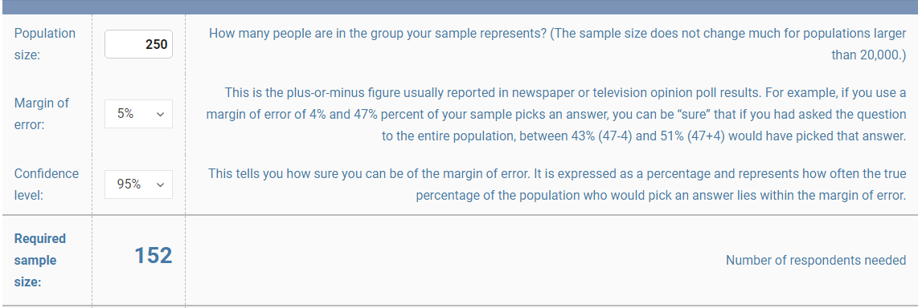

Data gathering Procedure

As this is the human involvement of hospital environment so this is necessary to get permission from hospital research committee. So hospital Institutional Review Board will be contacted for this study once permission to collect data from hospital will be granted. An Urdu translated questionnaire will be filled with patient in the presence of family. This questionnaire is in Likert scale scoring 1-5 describing 1 as Never, 2 as Seldom, 3 as occasionally, 4 as frequently and 5 as Always.

The data collection procedure: A well reliable and valid in research is data collection tool. After getting written informed consent, this questionnaire will be filled sitting on bedside of patient. If patient can read and write and understands questions well which are in local (Urdu) language will be given to patient for one-two hours. Data forms will be collected after two hours. In this way, using descriptive information followed by 24 item questionnaires will be collected.

Data Analysis

As the objective of this study is to measure the level of perceived nursing presence and correlation between the nursing presence and demographic profile of patients will be computed.
Data analysis: correlation and regression analysis in SPSS 20 package program (SPSS, IL, USA) will be used. For The Pearson’s correlation analysis (age, duration of diagnosis, duration and number of hospitalization, and the relationship between the satisfaction with nurses and NPS score) will be used.
To evaluate the linear relationship between two continuous variables, the T-test (gender, marital status, occupational status, educational status and mean NPS score) will be used to assess the significance between two variables.

In ethical consideration, informed consent from patient will be taken prior to data collection. Data collection too translated in Urdu will be filled sitting on patient bed side. To test the validity of data collection tool a pilot testing will be done.



Appendix-1: Evidence of permission to use NPS in research.

English version of Presence of Nursing Scale in Patients with Cancer, developed by Carol Kostovich (Kostovich 2012)

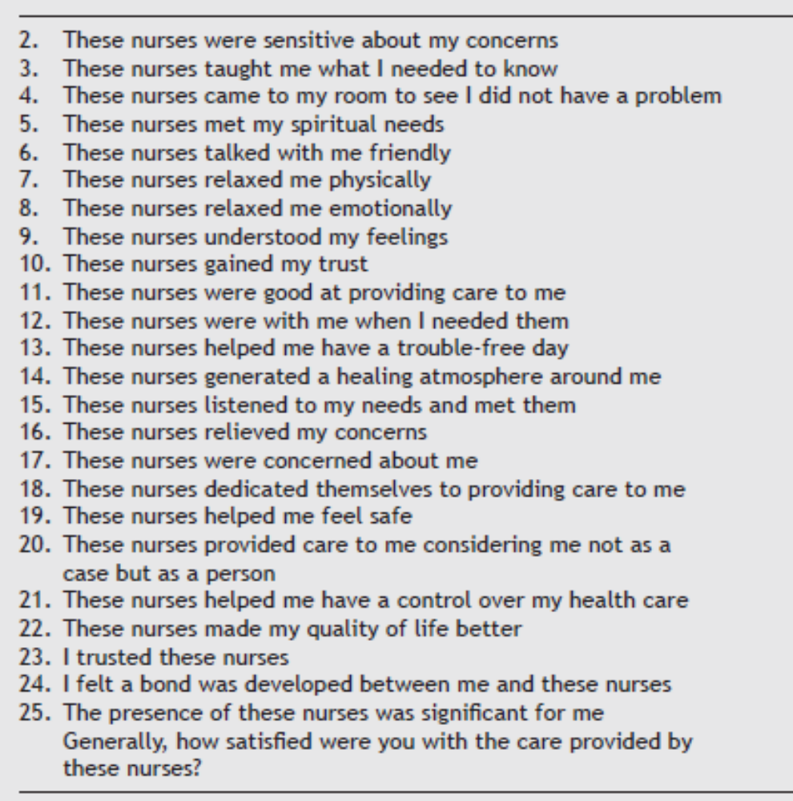

Appendix.2 Nursing Presence Scale:

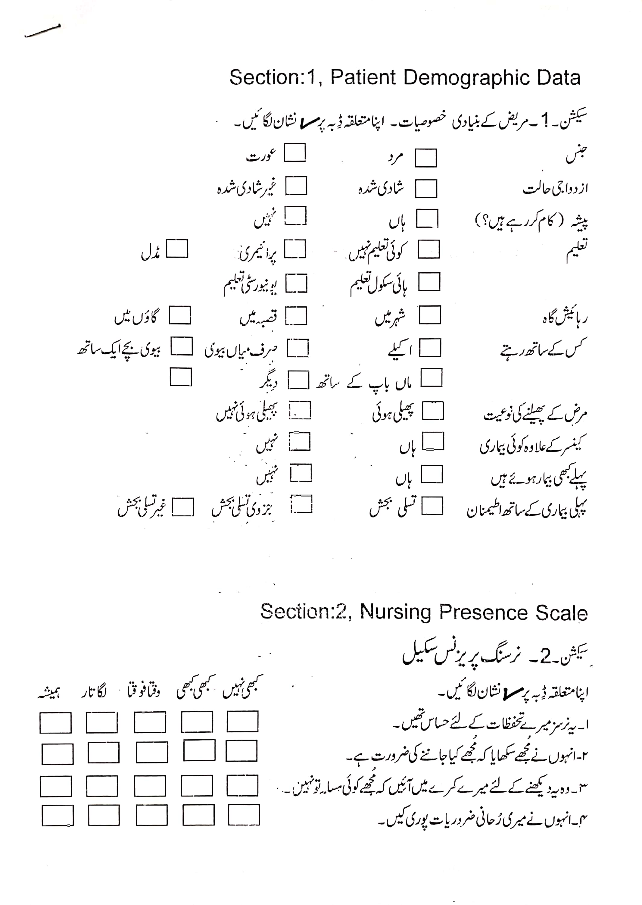
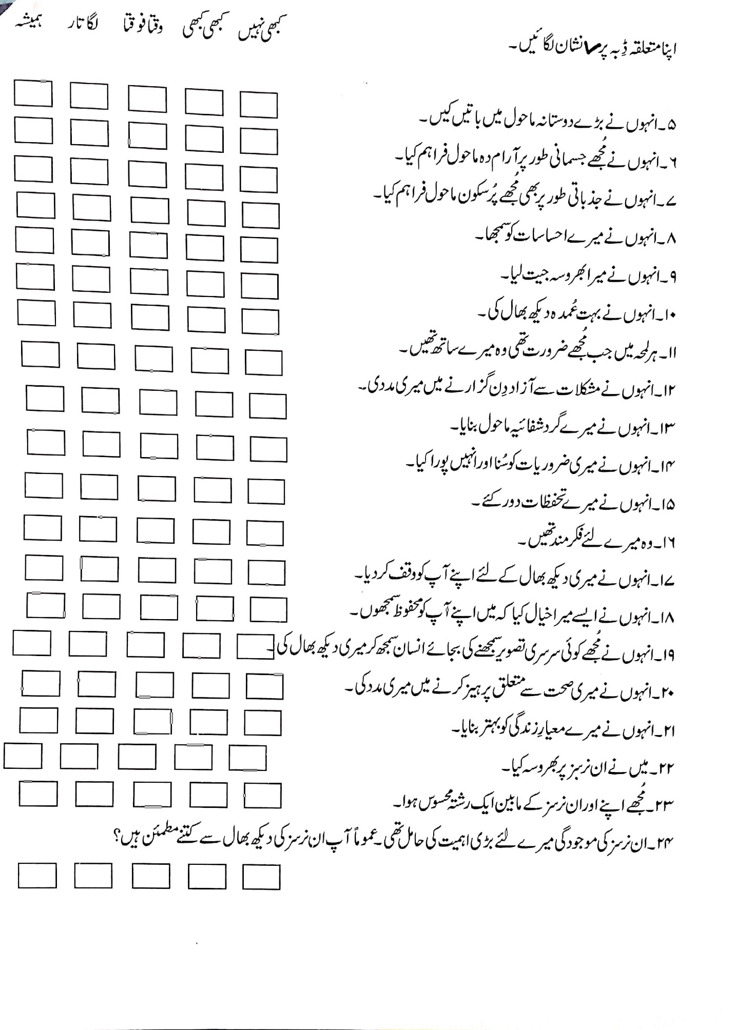
Appendix.3 Patient demographics:

Results: will be discussed on approval

References List:

National Cancer Institute (2018) Your Feelings during Chemotherapy Available [Online] on the URL: https://www.navigatingcare.com/library/cancer-treatment-articles/your-feelings-during-chemotherapy
Tanimukai H (2015) Cancer-related Cognitive Impairment: Current Knowledge and Future Challenges Seishin Shinkeigaku Zasshi = Psychiatria Et Neurologia Japonica [Seishin Shinkeigaku Zasshi] 2015; Vol. 117 (8), pp. 585-600 Last accessed 10/01/2019
https://www.macmillandictionary.com/dictionary/british/presence Last accessed 10/01/2019
https://www.dictionary.com/browse/presence Last accessed 10/01/2019
Mohammadipour. F (2017) Concept Development of “Nursing Presence”: Application of Schwartz-Barcott and Kim's Hybrid Model Asian Nursing Research 11 (2017) 19e29 [Online] Available at URL: https://www.sciencedirect.com/science/article/pii/S1976131717300749 Last accessed 10/01/2019
Anderson. J.H (2007). The Impact of Using Nursing Presence in a Community Heart Failure Program. Vol. 22, No. 2, pp 89Y94 x Copyright B 2007 Wolters Kluwer Health | Lippincott Williams & Wilkins

Cecil. P (2015). An exploration of emotional protection and regulation in nurse—patient interactions: The role of the professional face and the emotional mirror [Online] Available at URL: https://www.collegianjournal.com/article/S1322-7696(14)00064-X/pdf Last accessed 10/01/2019

Godkin. J (2001) Healing Presence [Online] Available at URL:
https://journals.sagepub.com/doi/abs/10.1177/089801010101900102

Zyblock. D.M (2010) Nursing Presence in Contemporary Nursing Practice [Online] Available at URL: https://onlinelibrary.wiley.com/doi/abs/10.1111/j.1744-6198.2010.00173.x

McMahon. M.A & Christopher. K.A (2011) Toward a Mid‐Range Theory of Nursing Presence
Available at URL: https://onlinelibrary.wiley.com/doi/full/10.1111/j.1744-6198.2011.00215.x

Yen-Chieh, C (2016). The Psychological Process of Breast Cancer Patients Receiving Initial Chemotherapy: Rising From the Ashes
Cancer Nursing: November/December 2016 - Volume 39 - Issue 6 - p E36–E44

Lock, K.K (2004). Information needs of cancer patients receiving chemotherapy in an ambulatory-care setting [Online] Available at URL: https://www.ncbi.nlm.nih.gov/pubmed/12619480

Rossole, B (2016).S The Top 5 time wasters (and how to eliminate them)
[Online] Available at URL: https://www.bizjournals.com/bizjournals/how-to/growth-strategies/2016/12/the-top-5-time-wasters-and-how-to-eliminate-them.html
Yesilot. S. B (2017) Cancer Patient’s Perception of Nursing Presence [Online] Available at URL: https://www.journalagent.com/phd/pdfs/PHD-92005-RESEARCH_ARTICLE-BOZDOGAN_YESILOT%5BA%5D.pdf

Grassi.L (2017) Advancing psychosocial care in cancer patients [Online] Available at URL: https://www.ncbi.nlm.nih.gov/pmc/articles/PMC5717468/
Turpin, R.L (2014). State of the Science of Nursing Presence Revisited: Knowledge For Preserving Nursing Presence Capability. International Journal for Human Caring, 2014; 18(4): 14-29. (16p).

Hessel JA (2009) Presence in nursing practice: a concept analysis. Holist Nurs Pract. 2009 Sep-Oct; 23(5):276-81. doi: 10.1097/HNP.0b013e3181b66cb5. [Online] Available at URL: https://www.ncbi.nlm.nih.gov/pubmed/19713785
Boeck. PR (2014) Presence: A Concept Analysis [Online] Available at URL: https://journals.sagepub.com/doi/pdf/10.1177/2158244014527990
Mohammadipour, F (2017). Concept Development of“Nursing Presence”: Application ofSchwartz-Barcott and Kim's Hybrid Model [Online] Available at URL:
https://reader.elsevier.com/reader/sd/pii/S1976131717300749?token=E5D3C147FBA0EFFFA773BA730C3B5C86B2193093119B8DE876359D34E81D91A316F09608AC3DB1118721D3AFBD4AA9FD Asian Nursing Research 11 (2017) 19e29

McMahon. M. A (2011) Toward a Mid‐Range Theory of Nursing Presence [Online] Available at URL: https://onlinelibrary.wiley.com/doi/abs/10.1111/j.1744-6198.2011.00215.x Volume46, Issue 2 April‐June 2011Pages 71-82

Lai H (2011) Effects of music intervention with nursing presence and recorded music on psycho‐physiological indices of cancer patient caregivers. [Online] Available at URL: https://onlinelibrary.wiley.com/doi/pdf/10.1111/j.1365-2702.2011.03916.x
Yagaskai K (2013) The Need for a Nursing Presence in Oral Chemotherapy [Online] Available at URL: https://www.researchgate.net/profile/Kaori_Yagasaki/publication/257248499_The_Need_for_a_Nursing_Presence_in_Oral_Chemotherapy/links/568f8add08aef987e569ccab/The-Need-for-a-Nursing-Presence-in-Oral-Chemotherapy.pdf
Turpin, R. (2014). "State of the Science of Nursing Presence Revisited: Knowledge for Preserving Nursing Presence Capability." International Journal for Human Caring (INT J HUM CARING), 2014; 18(4): 14-29. (16p). Version of record avaiulable at: https://login.proxy006.nclive.org/login?url=http://search.ebscohost.com/ login.aspx?direct=true&db=ccm&AN=103869614&site=eds-live&scope=site
Dossey, B. (2000). Florence Nightingale: Mystic, visionary, healer. Philadelphia, PA: Lippincott Williams & Wilkins.
Roy. D (2019) Duties and responsibilities of the nursing personnel [Online] Available at URL:
https://www.slideshare.net/KittuRoy/duties-and-responsibilities-of-the-nursing-personnel
Cohen, M., Hausner, J., & Johnson, M. (1994). Knowledge and presence: Accountability as described by nurses and surgical patients. Journal of Professional Nursing, 10, 177-185.
Zhou, Q. M., Wang, X. F., Liu, X. J., Zhang, H., Lu, Y. Y., Huang, S., et al. (2011). Curcumin improves MMC-based chemotherapy by simultaneously sensitising cancer cells to MMC and reducing MMC-associated side-effects. Eur. J. Cancer 47, 2240–2247. doi: 10.1016/j.ejca.2011.04.032
H. Faller, J. Weis, U. Koch et al., “Perceived need for psychosocial support depending on emotional distress and mental comorbidity in men and women with cancer,” Journal of Psychosomatic Research, vol. 81, pp. 24–30, 2016.
Radwin, Laurel. (2003) Cancer Patients' Demographic Characteristics and Ratings of Patient-Centered Nursing Care. Journal of Nursing Scholarship Volume: 35 Issue 4 (2003) ISSN: 1527-6546 Online ISSN: 1547-5069

Lynch. Emily (2014). What does it feel like to live for someone else? [Online] Available at URL: https://www.quora.com/What-does-it-feel-like-to-live-for-someone-else

YEŞİLOT. Saliha BOZDOĞAN (2016) Nursing Presence: A Theoretical Overview [Online] Available at URL: https://www.journalagent.com/phd/pdfs/PHD_7_2_94_99%5BA%5D.pdf Journal of Psychiatric Nursing 2016;7(2):94–99

Fredericks S; (2009) Patient demographics and learning needs: examination of relationship.
Retrieved July 15, 2009 from http://web.b.ebscohost.com/ehost/detail/detail?vid=5&sid=1eb0c5d1-7385-42f6-b918-7508ad22b71e%40pdc-v-sessmgr05&bdata=JkF1dGhUeXBlPWlwLHNzbyZzaXRlPWVob3N0LWxpdmU%3d#AN=19605606&db=cmedm.
Olumodeji, A. A. (2015, October 3). Influence of socio demographic variables on patient’s satisfaction with quality of nursing care in teaching hospitals in northern Nigeria. Retrieved November 24, 2019, from http://www.medicalsjournals.com/.
Radwin LE, Farquhar SL, Knowles MN, Virchick BG. Cancer patients’ descriptions of their nursing care. J Adv Nurs 2005;50:162–9.
Sainio C, Lauri S, Eriksson E. Cancer patients’ views and experiences of participation in care and decision making. Nurs Ethics 2001;8:97–113.

Zamanzadeh. V. et.al (2015) Effective Factors in Providing Holistic Care: A Qualitative Study
Retrieved November 24, 2019, from https://www.ncbi.nlm.nih.gov/pmc/articles/PMC4441185/
Khan. N et.al (2012) Assessment of knowledge, skill and attitude of oncology nurses in chemotherapy administration in tertiary hospital Pakistan. Open Journal of Nursing, 2012, 2, 97-103.
Adventist Hinsdale Hospital (2013) Dr. Watson Caring Theory. [Online] Available at URL: https://sites.google.com/site/watsonscaringtheory/watson-s-theory-applying-to-nursing-care

