The Zika Virus and the Eye
Rolly Coronica, DNP, ARNP, FNP-C, CRNO
The intrauterine Zika virus (ZIKV) infection produces human neurologic abnormalities
and retinal lesions (De Paula Freitas et al., 2016; Jampol & Goldstein, 2016; Ventura, Maia, Dias, Ventura, & Belfort, 2016). It is important to understand the full impact of the effects of ZIKV infection on pregnancy outcomes. Aside from the neurologic and retinal diseases, there are other neurophysiologic effects, such as decreased hearing and motor function abnormalities, that hinder neurodevelopment and alter developmental milestones of affected children (Spong, 2016). Characterizing and understanding the degree of the impact of the ZIKV infection on fetal development can guide in the development of tools and algorithms to assess, diagnose, treat, and monitor affected children.
The Zika Virus
The Zika virus belongs to the Flaviviridae family and is related to the Japanese encephalitis, yellow fever, West Nile, and dengue viruses. The ZIKV is primarily transmitted by the female Aedes aegypti mosquito in the mosquito–human–mosquito cycle, but reports suggest that it can also spread through blood transfusion or sexual contact (Ahmad & Ustianowski, 2016; Jampol & Goldstein, 2016). There are also reports of breastmilk and perinatal transmission of ZIKV (De Paula Freitas et al., 2016). The RNA of the Zika virus has now been detected in blood, urine, semen, saliva, female genital tract secretions, cerebrospinal fluid, amniotic fluid, and breastmilk (Falcao et al., 2016). Two ZIKV strains, the African and the Asian, have been identified. Since the ZIKV outbreaks in French Polynesia, in Cape Verde, and then in Brazil and Colombia, a rapid geographical spread of ZIKV infection has been observed (see Figure 1) (Falcao et al., 2016).
Figure 1. Countries and Territories Where ZIKV Has Been Reported (CDC, 2016).
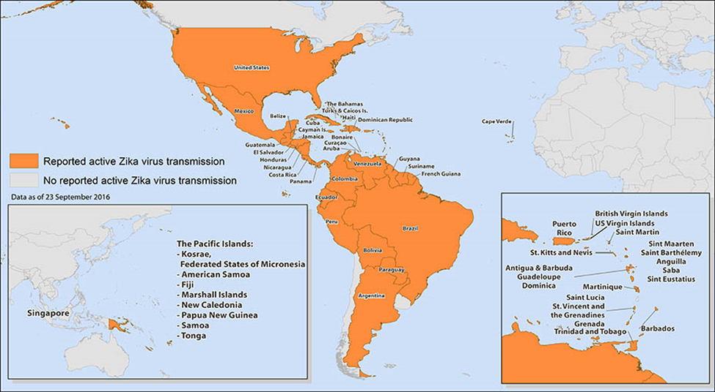
Signs and Symptoms of ZIKV Infection
About 80% of patients with ZIKV infection, also known as Zika virus disease or ZIKV fever, are asymptomatic or oligosymptomatic (De Paula Freitas et al., 2016). The symptomatic patients manifest dengue fever-like symptoms. These short-lived signs and symptoms include fever, conjunctivitis, headache, maculopapular rash, and joint pain (see Table 1) (De Paula Freitas et al., 2016; Jampol & Goldstein, 2016). ZIKV infection in adults has been linked to Guillain-Barré syndrome (GBS). Infection during pregnancy increases the prevalence of microcephaly in newborns, and vision-threatening findings among these infants are likely associated with the ZIKV infection (De Paula Freitas et al., 2016; Jampol & Goldstein, 2016). Zika virus infection in pregnancy has been linked to adverse complications, including miscarriage, stillbirth, fetal brain anomalies, and eye disorders (Spong, 2016).

Table 1. Signs and Symptoms of Zika Viral Infection (De Paula Freitas et al., 2016; Falcao et al., 2016)
Signs and symptoms | Specifics
Fever | No fever or low fever < 38.5°C (1–2 days)
Skin rash | Frequent
Myalgia | Moderately frequent
Arthralgia | Moderately frequent; in wrists and hands, with complete regression
Non-purulent conjunctivitis | 50%–90% of cases
Headache | Frequent; moderate intensity
Pruritus | Moderate to severe
Lymphadenopathy | Moderately frequent
Neurological complications among adults | Guillain-Barré syndrome
Neurological complications among adults | Encephalitis (rare)
Neurological complications among newborns | Microcephaly
Neurological complications among newborns | Chorioretina and optic nerve abnormalities
The ZIKV and Microcephaly
In April 2016, the Centers for Diseases Control and Prevention (2016) pointed out the causal relationship between prenatal ZIKV infection and fetal microcephaly and other cerebral abnormalities. The head circumference criteria for microcephaly were established to less than two standard deviations below the average, or 33 centimeters or less. Table 2 describes the microcephaly criteria based on fetal ultrasonography (CDC, 2016; De Paula Freitas et al., 2016; Falcao et al., 2016;Ventura, Maia, Bravo-Filho, Góis, & Belfort, 2016).
Table 2. Microcephaly Criteria for Prenatal ZIKV Infection
Fetal Ultrasound Examination
At least one of the following criteria:
- Cerebral calcifications and/or
- Ventricular abnormalities and/or
- At least two of the following:
- hypoplasia of the cerebellum
- hypoplasia of the cerebellar vermis
- widening of the posterior fossa greater than 10 mm
- agenesis/hypoplasia of the corpus callosum

These ultrasound findings can be detected as early as the 18th week of pregnancy. Other ultrasound findings may include intrauterine growth retardation, arthrogryposis, oligohydramnios or anhydramnios, and cerebral or umbilical artery flow abnormalities (CDC, 2016; De Paula Freitas et al., 2016; Falcao et al., 2016; Ventura, Maia, Bravo-Filho, Góis, & Belfort, 2016).
The ZIKV and the Eye
De Paula Freitas and colleagues (2016) conducted a descriptive study of infants born with microcephaly after a ZIKV infection outbreak in Brazil. Investigators found that ophthalmic defects were primarily located in the chorioretina and optic nerve and developed during the first or second trimester of pregnancy. The study included infants with head circumference of 32 cm or less born to mothers who had presumed ZIKV infection during pregnancy. Excluded from the study were microcephalic infants whose mothers had drug or alcohol use during pregnancy or familial history of microcephaly. Infants with congenital infections such as syphilis, cytomegalovirus, herpes simplex virus, rubella, HIV, or toxoplasmosis were also excluded. Table 3 lists ocular findings from infants with presumed congenital Zika virus infection (De Paula Freitas et al., 2006; McCarthy, 2016).
Table 3. Ocular Findings in Infants with Presumed Congenital Zika Virus Infection
Ocular findings | N = 17 | Incidence (%)
Focal pigment mottling | 11 | 64.7%
Chorioretinal atrophy | 11 | 64.7%
Optic nerve abnormalities | 8 | 47.1%
Iris coloboma | 2 | 11.8%
Lens subluxation | 1 | 5.9%
Signs of active uveitis | 0 | 0
Vasculitis | 0 | 0

The fundus photographs in Figures 2–6 show ocular findings in infants with presumed intrauterine ZIKV infection (De Paula Freitas et al., 2016).
Figure 2. Macular Pigmentary Mottling and Chorioretinal Atrophic Lesion
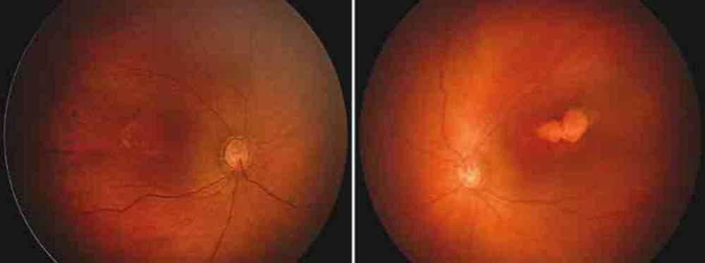
Left: Right eye shows granular and pigmentary mottling in the macula. Right: Left eye has chorioretinal lobulated atrophic lesion and pigmentary mottling.
Figure 3. Chorioretinal Atrophy and Hyperpigmented Mottling
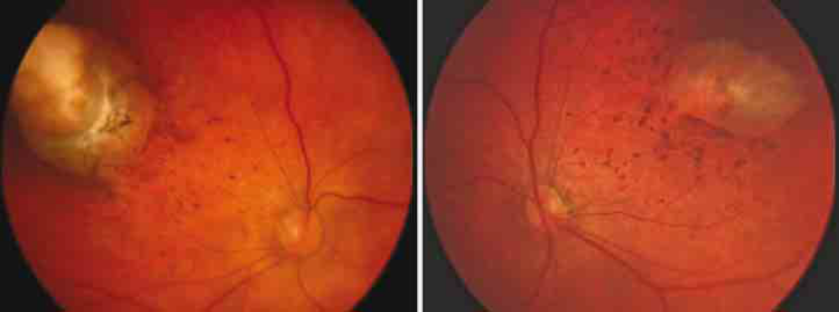
Both eyes show round paramacular superotemporal chorioretinal atrophy surrounded by hyperpigmented halo and mottling.

Figure 4. Optic Nerve Abnormalities, Pigment Mottling, and Chorioretinal Atrophy
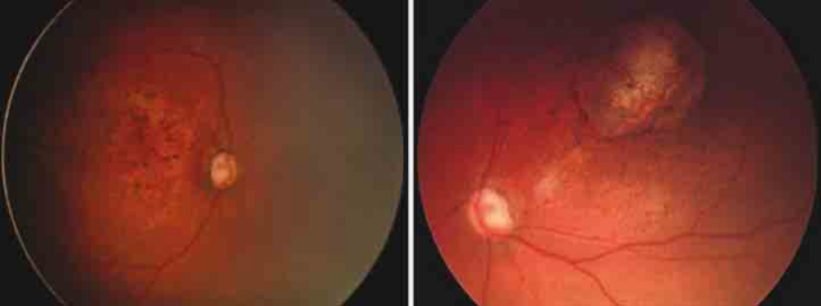
Left: Right eye has enlarged cup-to-disc ratio and macular pigmentary mottling. Right: Left eye has macular chorioretinal atrophic lesion with hyperpigmented halo and pigmentary mottling and enlarged cup-to-disc ratio.
Figure 5. Chorioretinal Scar and Pigment Mottling
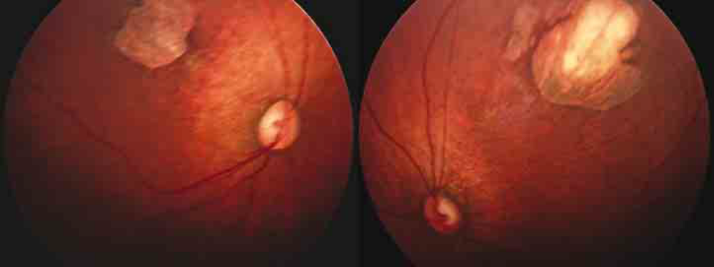 Both eyes have a superotemporal perimacular chorioretinal scar with perilesional pigmentary mottling.
Figure 6. Optic Nerve Abnormalities, Pigment Mottling, and Chorioretinal Atrophy
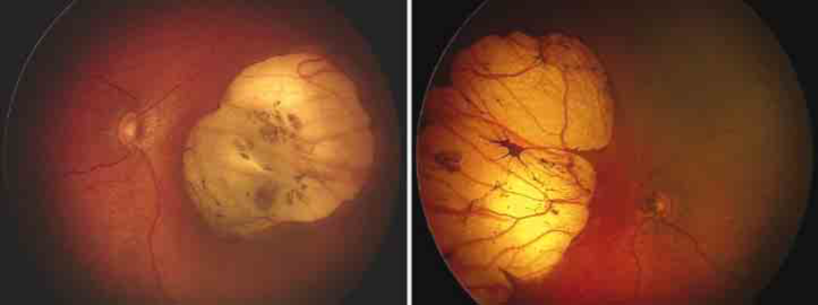
Left: Right eye has optic disc hypoplasia, peripapillary nasal atrophy, and a round excavated nasal lesion with hyperpigmented halo and a colobomatous-like defect. Right: Left eye has optic disc hypoplasia, peripapillary nasal atrophy, and a retinal nasal lesion with a similar pattern.
Adults infected with ZIKV who present with conjunctivitis may have uveitis. Some patients with the diagnosis of ZIKV-related conjunctivitis can have intraocular inflammation, which may be a potential manifestation of ZIKV infection (Furtado, Espósito, Klein, Teixeira-Pinto, & Da Fonseca, 2016).
ZIKV Infection Diagnosis
Positive real-time reverse transcription polymerase chain reaction (rRT-PCR), immunoglobulin M (IgM) antibody, and neutralizing antibody are the molecular and serologic tests available to confirm ZIKV infection (CDC, 2016; Rabe, Staples, & Villanueva, 2016; Falcao et al., 2016). Each of these tests has its strengths and limitations.
The rRT-PCR is useful for detecting the ZIKV on the first few days of acute infection but is not helpful to confirm infection in infants. A positive rRT-PCR confirms ZIKV infection, but a negative rRT-PCR result does not exclude infection. Following rRT-PCR, the next step in diagnosis is to utilize IgM and neutralizing antibody testing, which can identify additional recent ZIKV infections. However, ZIKV antibody test results can be misleading because of cross-reactivity with other flaviviruses or in individuals previously infected with or vaccinated against related flaviviruses (CDC, 2016; Rabe, Staples, & Villanueva, 2016; Falcao et al., 2016).
ZIKV RNA can be detected in blood samples within one to five days after the start of symptoms. Keep in mind that a negative result does not rule out ZIKV infection because the sensitivity of rRT-PCR is estimated to be 40%. Because the virus persists in the urine, rRT-PCR should be performed on a urine sample between the fifth and the 15th day after the start of symptoms. Serological tests can detect IgM from the fourth day; and IgG, from the 12th day (CDC, 2016; Rabe, Staples, & Villanueva, 2016; Falcao et al., 2016).
ZIKV Infection Treatment
No specific antiviral treatment is available for ZIKV infections. The management of acute ZIKV illness consists of oral hydration; medications for symptomatic relief of pain, fever, and itching; and rest. Dengue fever is considered as the primary diagnosis until ruled out because it has acute severe complications (CDC, 2016; Falcao et al., 2016). Until dengue fever has been ruled out, affected persons should avoid nonsteroidal anti-inflammatory drugs (NSAIDs). Pregnant women beyond the 32nd week of gestation should also avoid NSAIDs because of the risk of early closure of the arterial duct. Additionally, avoid using aspirin in children under the age of 12 years because of the risk of Reye syndrome (CDC, 2016; Falcao et al., 2016).
The following are recommendations for pregnant women (CDC, 2016; Falcao et al., 2016):
- If the laboratory test is positive for ZIKV or inconclusive, serial ultrasound examinations are recommended.
- If the fetus has a confirmed diagnosis of microcephaly, evaluate for amniocentesis from the 15th week of pregnancy onward.
- Women who live in a transmission area, should undergo blood tests for ZIKV at the beginning of their prenatal visits.
- Women who have history of travel to transmission areas should be offered serologic tests 2–12 weeks after traveling.
Implications for the Nurse Practitioners
Health providers might interact with patients who may have plans to travel or have already travelled to areas of reported active Zika transmission (see Figure 1). Education on prevention is critical and should be provided by physicians, nurses, and infection prevention specialists. Presently, there is no vaccine or medication that can prevent ZIKV infection. The best way to prevent ZIKV infection is to avoid mosquito bites by wearing appropriate clothing, using insect repellant, and staying indoors when traveling to known ZIKV transmission areas. The CDC (2016) advises pregnant women not to travel to transmission countries. Men who have traveled to a ZIKV area are advised to practice abstinence or use condoms. How long after infection the ZIKV can be sexually transmitted is still unknown. Non-pregnant women of childbearing age who have travelled in these areas are advised to delay pregnancy for at least eight weeks (CDC, 2016; Scully & Robinson, 2016). The CDC has printed materials including this information for education purposes (see Figure 7.)
Figure 7. Pamphlet on ZIKV Infection (CDC, 2016)
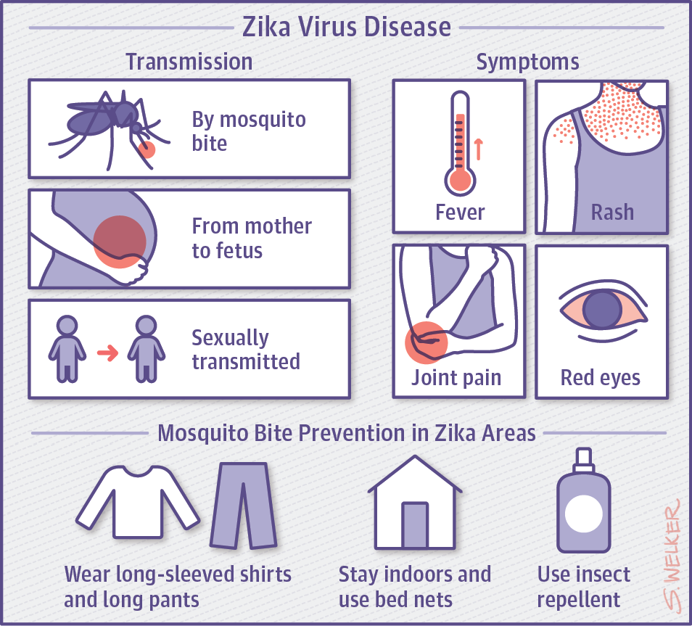
Pregnant patients should be encouraged to seek medical attention for possible diagnosis and treatment as outlined earlier in the article. Infants with ocular findings associated with presumed intrauterine ZIKV infection and their families will need support and follow-up from the providers.
Conclusion
A better understanding of the full impact of the effects of ZIKV infection on pregnancy outcomes is needed. The CDC has established clinical cases that may indicate the causal relationship between prenatal ZIKV infection and fetal microcephaly and other cerebral abnormalities. The presence of ocular findings such as focal pigment mottling, chorioretinal atrophy, and optic disc abnormalities contribute to timely diagnosis of ZIKV congenital infection in infants born with microcephaly. Experts strongly recommend that infants with microcephaly undergo routine ophthalmologic evaluation to identify chorioretinal and optic disc lesions especially in transmission areas of South and Central America and the Caribbean. However, it has been suggested that microcephaly should not be a required criterion for a congenital ZIKV infection diagnosis because there could be infants without microcephaly who have been infected by ZIKV during the gestational period. Fundus screening for all infants with suspected congenital ZIKV infection should be conducted because ocular findings might be missed if microcephaly remains an inclusion criterion in the screening process. There has been no report of infants diagnosed with congenital ZIKV infection who did not have microcephaly but did have ocular findings.
References
Ahmad, S., & Ustianowski, A. (2016). Zika virus: Management of infection and risk. BMJ, 352, 1062. doi:10.1136/bmj.i1062
Centers for Disease Control and Prevention (CDC). (2016). Preventing Zika. Retrieved from https://www.cdc.gov/zika/
De Paula Freitas, B., De Oliveira Dias, J., Prazeres, J., Sacramento, G., Ko, A., Maia, M., & Belfort, R. (2016). Ocular findings in infants with microcephaly associated with presumed Zika virus congenital infection in Salvador, Brazil. JAMA Ophthalmology, 134(5), 529–535. doi:10.1001/jamaophthalmol.2016.0267
Falcao, M., Cimerman, S., Luz, K., Chebabo, A., Brigido, H., Lobo, I., . . . & Bandeira, A. (2016). Management of infection by the Zika virus. Annals of Clinical Microbiology and Antimicrobials, 15, 57. doi:10.1186/s12941-016-0172-y
Furtado, J., Espósito, D., Klein, T., Teixeira-Pinto, T., & Da Fonseca, B. (2016). Uveitis associated with Zika virus infection. New England Journal of Medicine, 375(4), 394–396. doi:10.1056/NEJMc1603618
Jampol, L., & Goldstein, D. (2016). Zika virus infection and the eye. JAMA Ophthalmology, 134(5), 535–536. doi:10.1001/jamaophthalmol.2016.0284
McCarthy, M. (2016). Severe eye damage in infants with microcephaly is presumed to be due to Zika virus. BMJ, 352.
Rabe, L., Staples, J., & Villanueva, J. (2016). Interim guidance for interpretation of Zika virus antibody test results. Morbidity and Mortality Weekly Report, 65. doi:10.15585/mmwr.mm6521e1
Scully, C., & Robinson, A. (2016). Check before you travel: Zika virus – another emerging global health threat. British Dental Journal, 220, 265–267. doi:10.1038/sj.bdj.2016.182
Spong, C. (2016). Understanding Zika virus pathogenesis: An interview with Catherine Spong. BIOMed Central. 14, 84. doi:10.1186/s12916-016-0628-0
Ventura, C., Maia, M., Bravo-Filho, V., Góis, A., & Belfort, R. (2016). Zika virus in Brazil and macular atrophy in a child with microcephaly. Lancet, 387(10015), 228. doi:10.1016/S0140-6736(16)00006-4
Ventura, C., Maia, M., Dias, N., Ventura, L., & Belfort, R. (2016). Zika: Neurological and ocular findings in infant without microcephaly. Lancet, 387(10037), 25055. doi:10.1016/S0140-6736(16)30776-0

Rolly Coronica, DNP, ARNP, FNP, CRNO, is affiliated with South University and Boston VA Ophthalmology Department as assistant professor and ophthalmic NP Supervisor, respectively.

