DOMESTIC VIOLENCE AGAINST MARRIED WOMEN
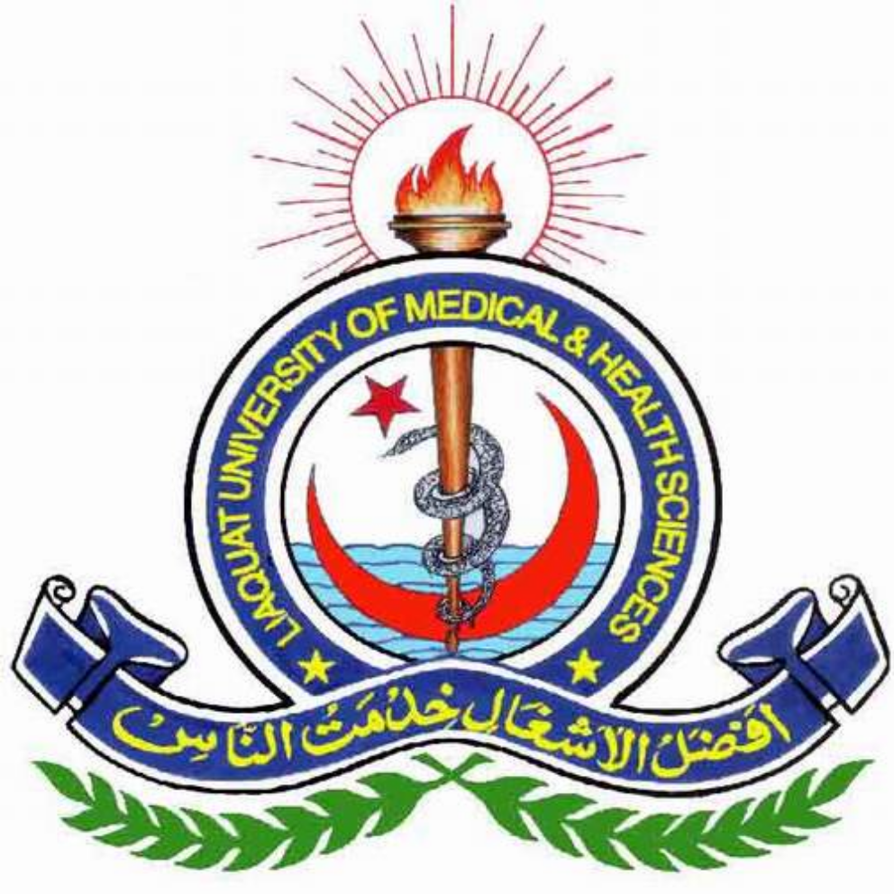

BY
MS. RUBINA JOHN
MS Nursing
Director
People’s Nursing School
Liaquat University
of Medical & Health Sciences, Jamshoro

ABSTRACT

Background:
Domestic Abuse as physical violence or assault on a partner is a very common phenomena not in our country but throughout the world irrespective of age, races, developing or developed countries.
Domestic violence is the summary of physically, sexually and psychologically abusive behaviors directed by one partner against another irrespective of their marital status or gender. Domestic violence has no borders, it occurs in all sphere of life.
Generally it is very hard to accept or feel domestic abuse, since someone notice first time in her life and unaware of such kind of abuses it will take some time to feel or observed such abusive behavior of the partner
Domestic abuse usually seems absence of the relationship between the partners and the majority of victims feel that they have found their perfect life partner or soul mate, but gradually partner feels abusive behavior increases
Rational:
The purpose of this research study is to explore women feelings who were suffering from violence by their husbands. It is a very common perception in our society that most of the cases married women considered like a servant or inferior as compared with her husband.
It has been observed in our society that married women consistently discriminated and brutally abused by her husband.
Our newspapers have been flashed with stories of rape victims, honor killings, bride burning and domestic violence for a long time.
The women are killed in the name of honor and religion, customs and traditions and mostly because of man’s arrogance and ego. Therefore, I will make an effort to research on this highly important issue.

Study Objectives
General objective:
To documents’ the perspectives and responses of married women undergoing domestic violence

Specific objective:
To determine factors for compromise on situation among married women suffered from domestic violence.
To determine reason for physical violence against women

The study objectives are:
To explore of lived experience of the women and analysis on violence against women in Pakistan
Explore what strategies women use to end violence or to reduce its consequences.

Gain insights into women’s perceptions about what behaviors are abusive in what circumstances;
To build consensus on recommendations

Methodology
In-depth qualitative interviews were undertaken in person with 180women victims of domestic violence living in Karachi who are suffering violence by their husbands. The study involved collecting Qualitative data through structured Questionnaire.

The sampling aim was to locate women from diverse social backgrounds and with different demographic characteristics. The interview guide included a series of broad, open-ended questions about women’s experiences of abuse.
The analysis of the interviews followed the technique of thematic decomposition, guided. The interviews have taken from women included items on socio-economic details and domestic violence experience.

To assess domestic violence exposure, women were asked several questions on various behaviors of violence by phenomenological and discourse analysis. The spss:20 package computer software was used to manage code and explore the data.

Data collection tools and Techniques
Sampling Method.
Target Population: Married women Suffering from Domestic Violence
tudy design: Qualitative Cross-Sectional Study.
Study setting: Karachi City
Inclusion criteria: Women who married 5 to 10 years ago
Exclusion criteria: Women who disagree to give consent?

Sampling technique.
A Convenience sampling Design is used in this study

Data Analysis
Data collection tool: Face to face interviews taken in Urdu from the respondents
Statistical analysis : Descriptive Analysis is conducted by SPSS version 20 is used to analysed the data
Results
There were total 180 participants were taken into this research study, it is a descriptive study conducted in the city of Karachi. Table1 shows the level of education among the subjects and this will represented in Figure1. Table2 shows the education level of participants husbands which graphically represented in Figure2.
Results

It was observed that most of the subjects were belonging to housewife 81.67% showed in table3. The distribution of their children showed inTtable4, which showed that distribution of children were equally distributed. Table5 and Table6 showing the distributions of sons and daughters which were also equally distributed.

CONCLUSIONS
The distribution of different types of the abuses shown in the Table11, it was observed that 30.6% of the women were brutally abused physically, 28.3% were abused sexually, 25% financially and 16.1% of the women were verbally abused by their husbands. These findings also showed that the morally, ethically and religiously society is totally collapsed.

It also indicates that there is no difference between a broken family and a family in which mother is suffering from such brutal abused by her husband. Naturally when someone especially women were suffering from such terrible condition sought some unnatural solution as in this research 37.2% of the victim women were deciding to suicide in order to rid off this horrible life.

28.4% thought to escape from the home but didn’t escape Finally mother has taken only one possible decision in order to save the life of her innocent children from this evil world to scarify her life for her children see Table12.

DISCUSSION
This research study reflects the picture or face of the society that behaves brutally with her family members and an innocent mother. People forget the meaning of a good moral and ethical society in which children were suffering from such domestic violence.
Discussion
This will put a long lasting impact on their minds and psychological they were in depressing state of living that untimely disturbs their education as well health. It was observed that one in four women has a victim of brutal domestic violence.

Family member were also affected by such kind of situation in the family. Children were also on at high risk in these families which ultimately causes negative impacts on the development on the children.

The thoughtless attitude of the abusers husbands distressed women “Instead of being ashamed, they seemed proud when they talked about abusing their wives”

For queries please contact at
Email: surgicalnursing@nursingconference.com
Fax: +1-650-618-1414
Phone: +1-650-268-9744
Toll Free: +1-800-216-6499

