Unraveling the puzzles of human DNA replication
Tahir H. Tahirov, Eppley Institute for Research in Cancer and Allied Diseases, Fred & Pamela Buffett Cancer Center University of Nebraska Medical Center, USA

Abstract
All eukaryotes possess four paralogous B family DNA polymerases: Polα, Polδ, Polε and Polζ. Polα functions in initiation and early elongation steps of replication. Polα is tightly associated with a primase and hence is the only DNA polymerase that can initiate the synthesis of DNA by extending RNA primers laid by primase. Polδ plays a central role in DNA replication and DNA repair in eukaryotic cells. Polε is involved in the initiation of replication at origins and in leading-strand synthesis in the vicinity of the origins, whereas Polζ is involved in translesion DNA synthesis. When Polδ encounters replication-blocking lesions, it switches from replication to translesion synthesis by recruiting damage bypass polymerases, including Polζ. Polζ is responsible for nearly all mutations induced by DNA damaging agents in human cells and model organisms. Accumulation of mutations in cellular genetic material causes various diseases, including cancer.
In spite of key role of B family DNA polymerases in replication and genome maintenance, only limited data are available regarding mechanisms of their functions. Our aim is to explore the structural features beyond the polymerase catalytic core and reveal how the intersubunit interactions and conformational changes regulate the function of these polymerases. We started with crystal structure-based characterization of the role of the second B-subunits in human B-family DNA polymerases. In particular, we determined the crystal structures of B-subunit complexes for all four DNA polymerases and discovered that Polδ and Polζ are sharing the same second and third subunits. We will briefly review our recent achievements and focus our presentation on novel crystal structure of entire human primase-Polα complex. The structure reveals how the primase and Polα are acting in a highly coordinated fashion during the initiation of RNA primer synthesis, extension and counting by primase and transfer of primer-template duplex for further extension by Polα.

Image
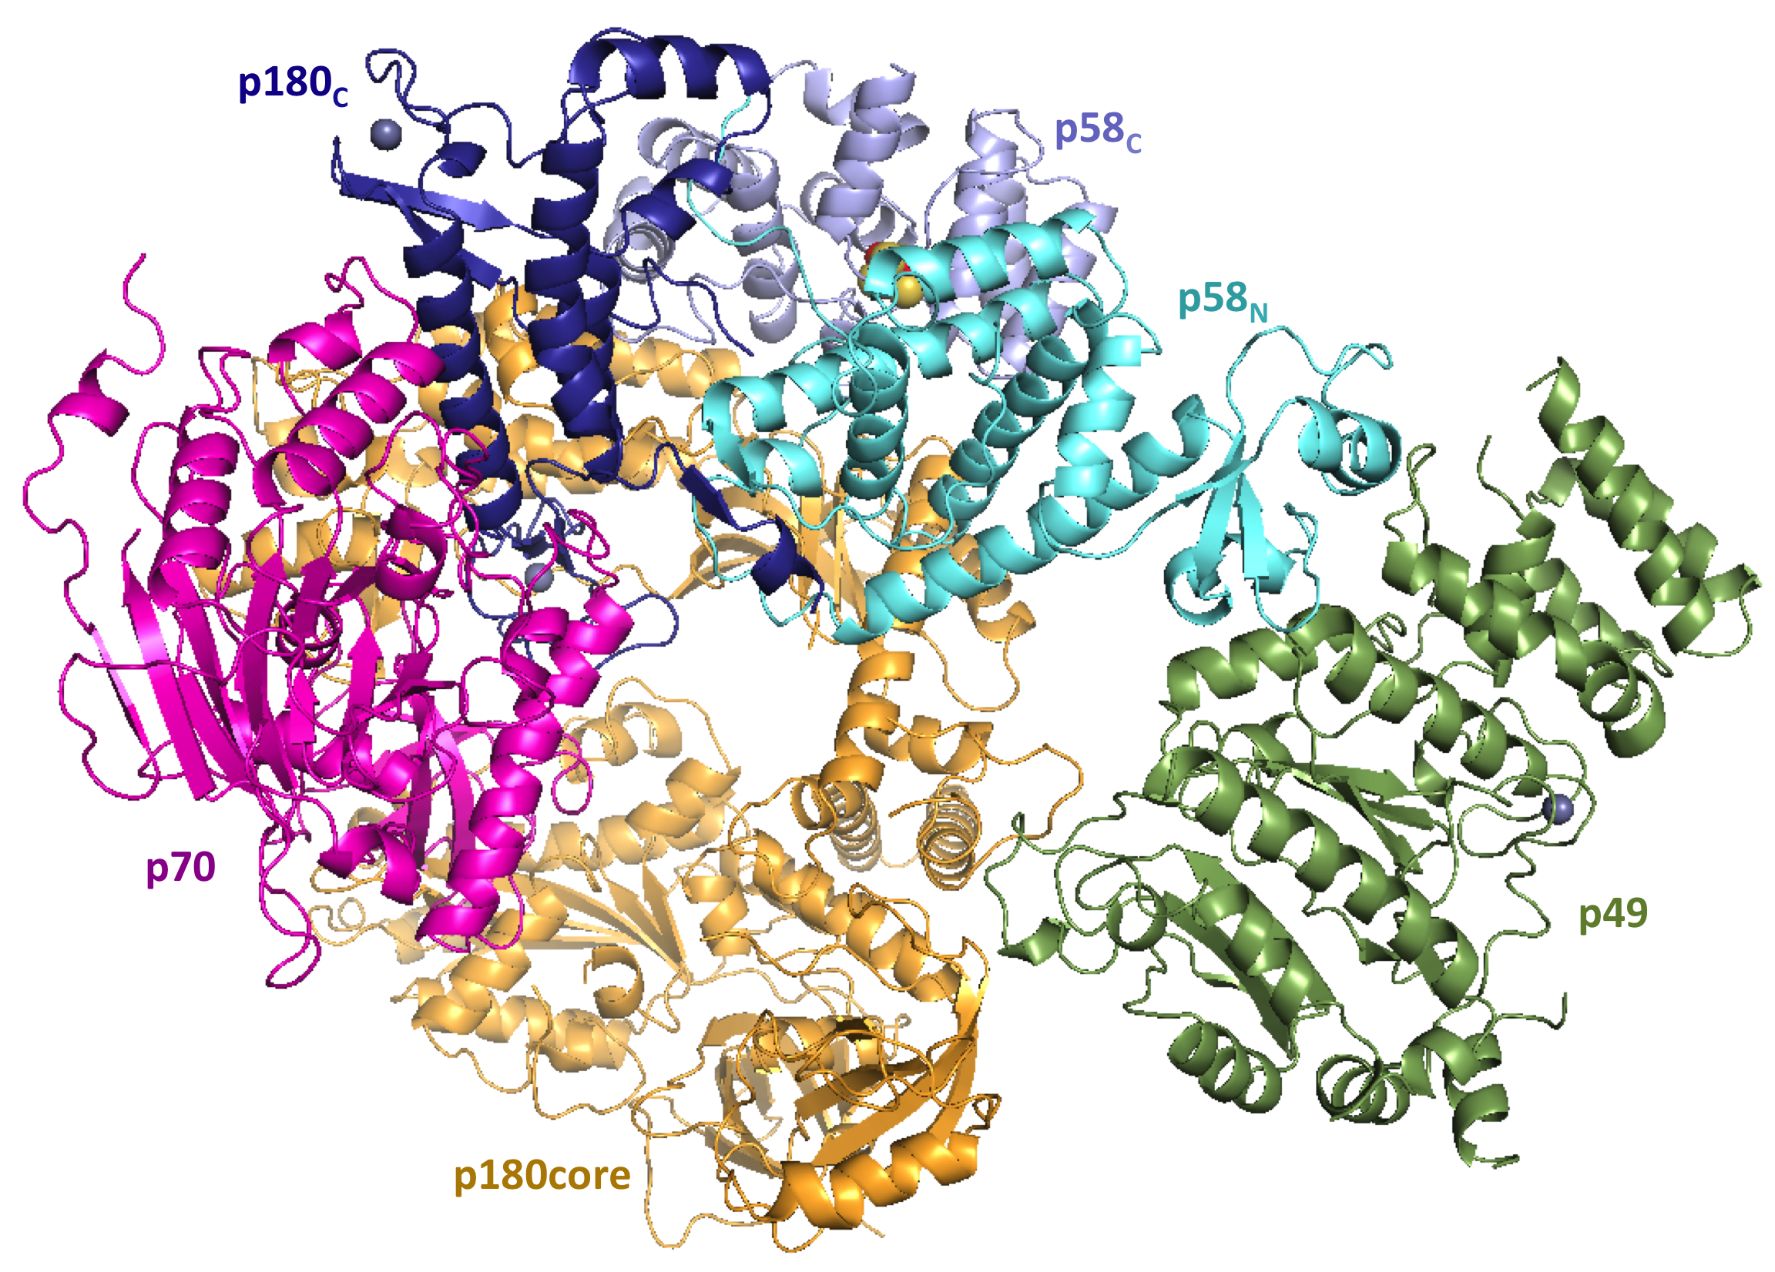
Figure 1: Overall view of human primase-Polα complex.
Recent Publications
- Baranovskiy AG, Babayeva ND, Zhang Y, Gu J, Suwa Y, Pavlov YI, Tahirov TH (2016) Mechanism of concerted RNA-DNA primer synthesis by the human primosome. J. Biol. Chem. 291: 10006-10020.
- Baranovskiy AG, Zhang Y, Suwa Y, Babayeva ND, Gu J, Pavlov YI, Tahirov TH (2016) Insight into the human DNA primase interaction with template-primer. J. Biol. Chem. 291: 4793-4802.
- Suwa Y, Gu J, Baranovskiy AG, Babayeva ND, Pavlov YI, Tahirov TH. Crystal structure of the human Pol α B-subunit in complex with the C-terminal domain of the catalytic subunit. J. Biol. Chem. 290: 14328-14337 (2015).
- Baranovskiy AG, Zhang Y, Suwa Y, Babayeva ND, Gu J, Pavlov YI, Tahirov TH (2015) Crystal structure of the human primase. J. Biol. Chem. 290: 5635-5646.
- Baranovskiy AG, Babayeva ND, Suwa Y, Gu J, Pavlov YI, Tahirov TH (2014) Structural basis for inhibition of DNA replication by aphidicolin. Nucleic Acids Research 42: 14013-14021.
- Baranovskiy AG, Lada AG, Siebler H, Zhang Y, Pavlov YI, Tahirov TH (2012) DNA polymerases δ and ζ switch by sharing the accessory subunits of DNA polymerase δ. J. Biol. Chem. 287, 17281-17287.

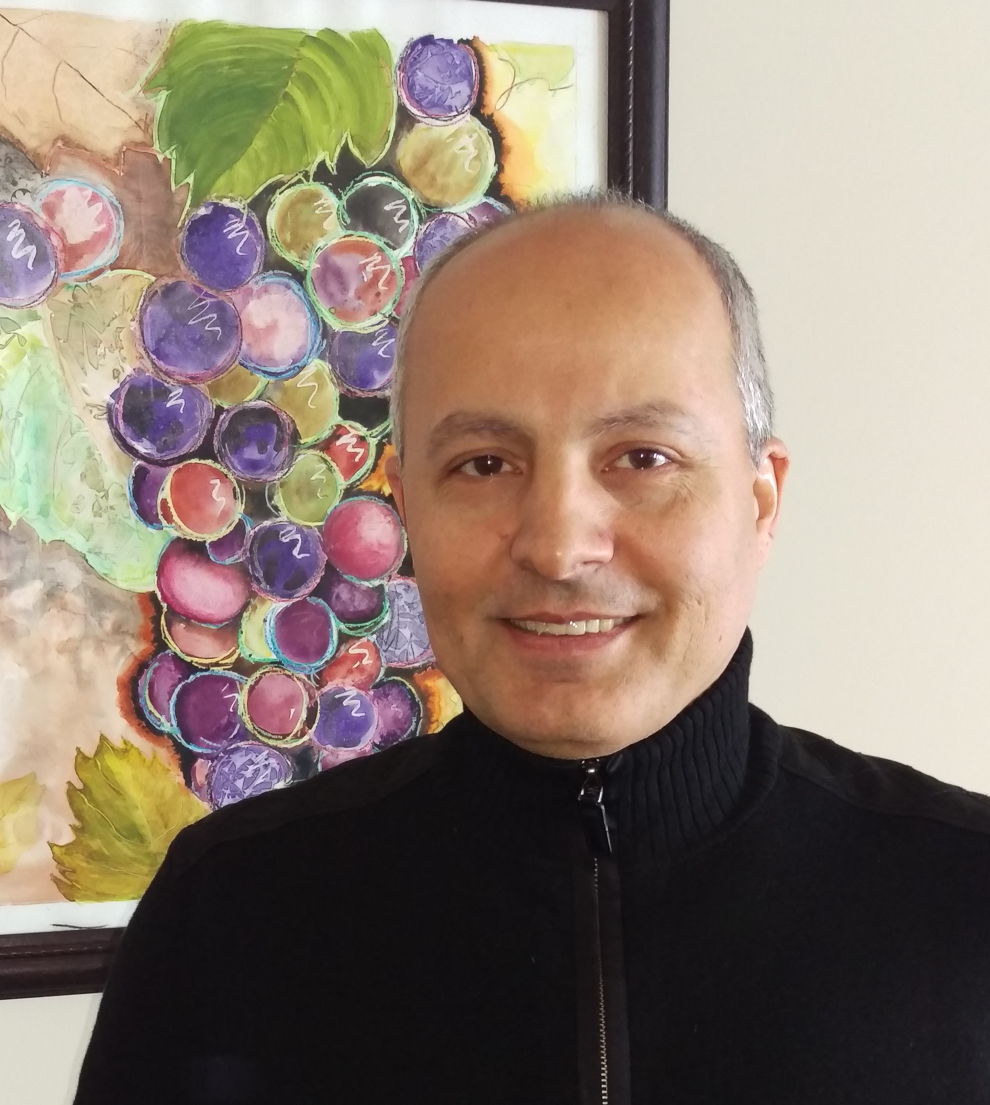 Biography
Tahir Tahirov has received his Master of Science degree in metallophysics from Kiev Polytechnic Institute (Ukraine). During doctoral training in crystallochemistry in the Chernogolovka branch of the Semenov Institute of Chemical Physics (Russia) he discovered a new class of organic superconductors with two incommensurate crystal lattices. His career in structural biology has started during postdoctoral training in Tsing Hua University (Taiwan) where he solved the first crystal structure of protein. He continued his studies as a researcher at the Himeji Institute of Technology, Osaka University and the Yokohama City University School of Medicine, and then as a team leader at the RIKEN Harima Institute. At the age of 43 Dr. Tahirov became a Full Professor at the Eppley Institute for Research in Cancer and Allied Diseases, University of Nebraska Medical Center. He has published over 120 research articles (50 in physics and chemistry and the rest in structural biology). He is one of the leading experts in structural studies of human DNA replication machinery.
Email: ttahirov@unmc.edu
Phone: +1-402-359-7607

Notes/Comments:

