Safety work organization of mining on the Semipalatinsk test site
Vitaliy V. Romanenko, Branch "Institute of radiation safety and ecology", RSE NNC RK, Kurchatov, Republic of Kazakhstan
Sergey B. Subbotin, PhD, Branch "Institute of radiation safety and ecology", RSE NNC RK, Kurchatov, Republic of Kazakhstan
Vladislav I. Suprunov, Branch "Institute of radiation safety and ecology", RSE NNC RK, Kurchatov, Republic of Kazakhstan
Konstantin L. Zelenskiy, Branch "Institute of radiation safety and ecology", RSE NNC RK, Kurchatov, Republic of Kazakhstan
Rustem A. Sadykov, Branch "Institute of radiation safety and ecology", RSE NNC RK, Kurchatov, Republic of Kazakhstan

Abstract
Statement of the Problem: Semipalatinsk test site (STS), where 459 nuclear tests were tested, according to geological studies is a territory rich in mineral deposits. Exploration studies discovered tungsten, beryllium, iron, coal and fluorite at the territory of Semipalatinsk test site (STS). Ensuring radiation safety in mining quarries on STS is radically different from traditional methods associated with controlling the levels of gamma, alpha and beta-emitting radionuclides. The purpose of this study is to ensuring radiation safe mining of minerals in conditions of close location of underground nuclear test sites. Methodology & Theoretical Orientation: Radiation monitoring of underground and drainage water, atmospheric air, production of the deposit, workplaces, machinery and equipment. Control of personnel dose loads. Findings: The content of radionuclides in the air does not exceed the permissible values. Doses of quarry workers do not exceed acceptable levels. Radioactive contamination of production does not present. Increase content of radionuclides was observed in the groundwater in connection with the growth of the depression funnel. The flow of contaminated water from UNE sites has been identified. Corrective actions were developed. Conclusion & Significance: The situation is predicted to be successful within existing quarries for all parameters of radiation monitoring at present, while observing radiation safety measures and a number of measures to prevent the movement of polluted groundwater to the quarry. Recommendations: Since the deposits in the territory of the STS are located not far from the places of UNE, their further development is possible if the requirements and recommendations of state bodies that control the protection of public health and environmental protection are fulfilled. First, it is necessary to control the content of ⁹⁰Sr and tritium in drainage waters, and to control the tritium content in the air of working areas.

Image
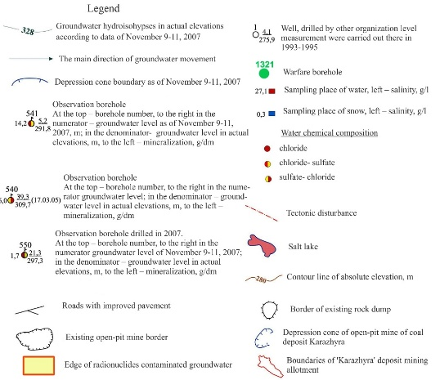
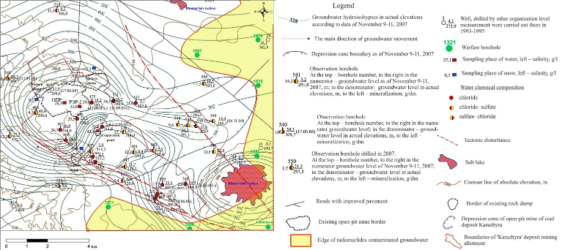
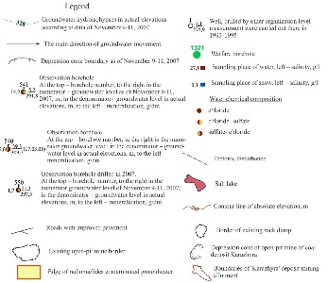
Recent Publications
1. S.B. Subbotin, E.A. Novikova, V.V. Romanenko// Assessment of
«Karazhyra» deposit development influence on underground water condition at «Balapan» test site of former STS // NNC RK Bulletin. -2012. - Issue 3.- p.92-100
2. S.B. Subbotin, V.V. Romanenko, E.A. Novikova, //The study of pollution by artificial radionuclides groundwater of the test site “Balapan” // Problems of biogeochemistry and geochemical ecology.- 2010. - №3 (14). – p.95-123.
3. S.B. Subbotin, S.N. Lukashenko, V.V. Romanenko. Identification of ways of migration of technogenic radionuclides beyond the test site "Balapan". Topical issues of radioecology of Kazakhstan [Collection of Proceedings of the NNC RK for 2010]– Vol.2 – Issue 3 – Pavlodar: Publishing house, 2011. – p. 161-232.
4. S.B. Subbotin, S.N. Lukashenko, K.L. Zelensky, V.V. Romanenko // Development of mineral deposits on the territory of the Semipalatinsk test site on the example of the Karazhira coal field // International Scientific Forum NUCLEAR SCIENCE AND TECHNOLOGIES, ABSTRACTS, September 12-15, 2017, Almaty, Republic of Kazakhstan
5. S.B. Subbotin, S.N. Lukashenko, K.L. Zelensky, V.V. Romanenko // Possibility Assessment of Determination of the Place of the Underground Nuclear Tests by Means of Artificial Radionuclides Presence in Groundwater with STS // CTBT: Science and Technology 2017 // Vienna, Austria, 26-30 June 2017.
6. Fadeeva I.I., Ayunov D.E., Romanenko V.V. Estimation the up-to-date thermal effect from underground nuclear explosion in the Semipalatinsk test site // Subsoil use problems. - №2, 2017. ISSN 2313-1586

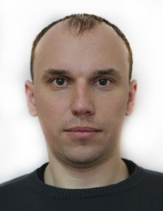Biography
Vitaliy V. Romanenko works at branch "Institute of radiation safety and ecology", RSE NNC RK since 2010. He has master degree on specialty "Technical physics". He holds the post of head of research team for field studies in laboratory of studies of hazardous natural-technogenic processes. During the work, he participated in development and implementation of radiation monitoring programs, environmental research etc. He has experience as manager of scientific projects. His basic direction of activity is the study of ecology in Semipalatinsk Test Site and rural areas.
Email: Romanenko@nnc.kz

Notes/Comments:

