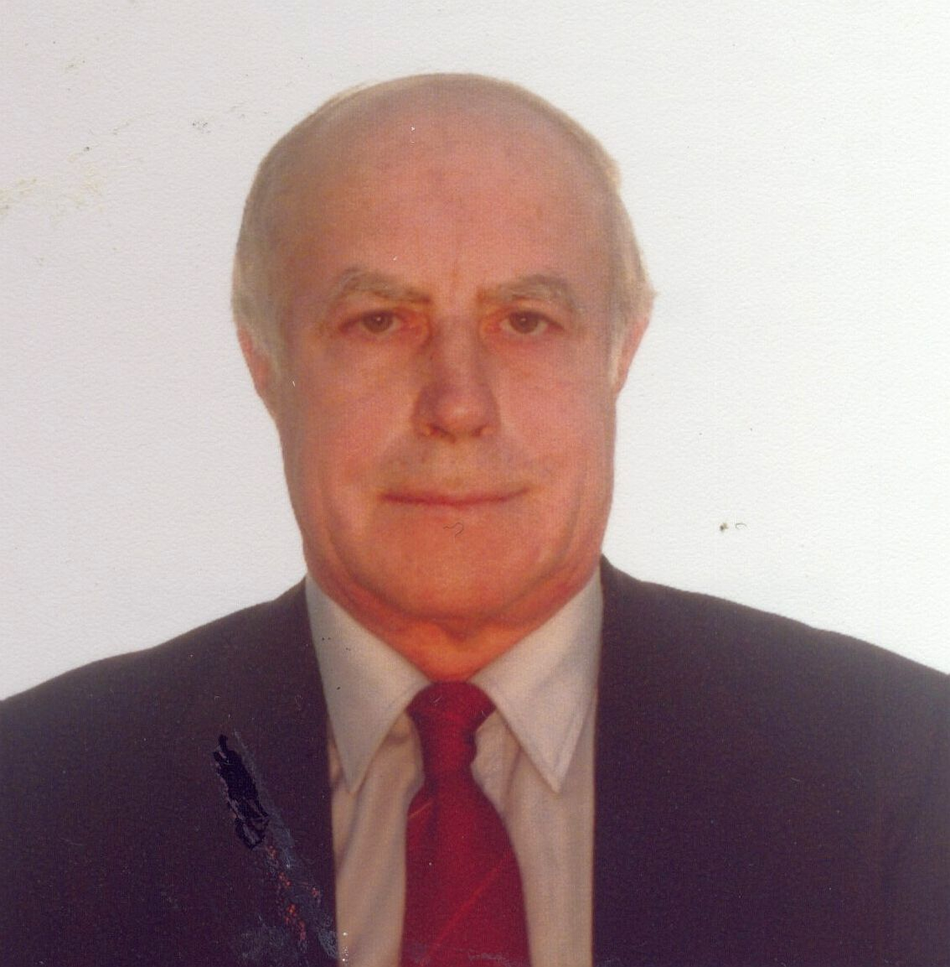
Title: Tracer-Scale Chemistry of Volatile Oxygen-Bearing Compounds Formed by U, Pu and Cm
Name: Vladimir Domanov
Joint Institute for Nuclear Research, Dubna, Moscow reg., 141980, Russia

Tracer-scale chemistry has some distinguishing characteristics which differ it from common (macro) chemistry. For example, the common redox reaction 2Pu(IV) + U(IV) → 2Pu(III) + U(VI) does not occur in extremely diluted solutions as collisions between microcomponents are practically excluded. Considerable differences in the chemical behavior micro- and macroquantities of some actinides in the gase phase had also been observed. The initial sample containd a tracer quantity of the actinide under study that was adsorbed on the surface of quartz powder. The experiments were carried out using open quartz thermochromatographic columns (i.d. = 3 mm); oxygen served as a reagent and helium was a carrier gas; the flow rate of the gas mixture was 20 cm³ min^{–1}; the initial sample was heated in a gas stream at 700-750˚C; the final part of the thermal-gradient section was cooled to –165˚C; the temperature gradient was –18˚C cm⁻¹; the duration of each experiment was 30 min. It was found that uranium formed volatile dioxide and troioxide that were adsorbed at 450±25 and 250±25˚C. Two plutonium radioisotopes ^{238,239}Pu were used in similar experiments. Contrary to the prevous results, plutonium formed three oxides. The centeres of their depozition zones were registered at 450±30˚C(PuO₂), 250±30˚C(PuO₃) and at –105±25˚C(PuO₄). In similar conditions, Cm formed also three oxides: CmO₂, CmO₃ and CmO₄. They were adsorbed at 550±25, 390±25 and –80±50˚C respectively. The values of adsorption enthalpy for these oxides on quartz and their chemical yields were determined.

Biography

Domanov completed Moscow Chemical-Technological Mendeleev Institute at the age of 25 years.
On graduation this Institute, he began to work in JINR on the post of a probationer-investigator. After 2 years, he got the post of a junior research worker. He defended a thesis in the year 1985. He got the post of senior scientific researcher in the year 1990. He has published about 100 papers in reputed journals and in scientific issues. Domanov has 13 author’s certificates (Soviet Patents) and 3 Patents of RF.
Presenting author details
Full name: Vladimir Panteleimonovich Domanov
Contact number: +7 (09621) 63431
Twitter account: ---
Linked In account: ---
Session name/ number: Radiochemistry
Category: Oral presentation

