Title: EXTRA SKELETAL EWING’S SARCOMA PRESENTED WITH FOCAL SEIZURE AND HEMORRHAGIC STROKE-LIKE TABLE: A CASE REPORT
Erman Altunisik
Department of Neurology, Adiyaman University Faculty of Medicine, Adiyaman, Turkey
Extra skeletal Ewing's sarcoma (EES) is a rare tumor originating from non-bone tissues and consisting of small round cells with a fragment or lobular distribution. What is known about the central nervous system (CNS) metastases of EES is extremely limited. Our case, which was not diagnosed before and initially presented with neurological symptoms and CNS involvement, is the first case in the literature. We aimed to contribute to the literature through this case. A 26-year-old male patient was admitted to the emergency department with sudden headache, weakness on the right side and involuntary fast clonic contractions localized in the right arm and leg. Computed tomography (CT) revealed hemorrhagic appearance in the left frontoparietal region (figüre 1a), upon which the patient was hospitalized with a preliminary diagnosis of hemorrhagic stroke. The patient had complete clinical recovery and his focal seizure was under control. After two weeks, the patient presented to the emergency department again with a complaint of headache. CT revealed hemorrhage consistent appearance in the right parietal region (figüre 1b). Mass lesions accompanied by edema sites and intravenous contrast enhancement were detected around hemorrhagic lesions in both hemispheres in magnetic resonance imaging (MRI) (figüre 1c-d). In the following days MRI examination of the left leg was performed due to pain and swelling in the left thigh. A mass lesion was detected in the left thigh (figure 2a-b). The patient was diagnosed with ES as a result of the histopathological examination and evaluated as having EES. Neurological findings can be seen in many malignant diseases as a result of both solid involvement and paraneoplastic processes. It should be kept in mind that even in patients who have not yet been diagnosed, neurological findings can be observed, which can facilitate the primary diagnosis

Biography
Erman Altunisik has completed his PhD at the age of 24 years from Cukurova University and postdoctoral studies from Gaziantep University School of Medicine. He has published more than 20 papers in reputed journals. He is still working as an assistant professor at Adıyaman University, Faculty of Medicine, Department of Neurology.

Presenting author details
Full name: Erman Altunisik
Contact number: +905054674669
Category: e-Poster presentation

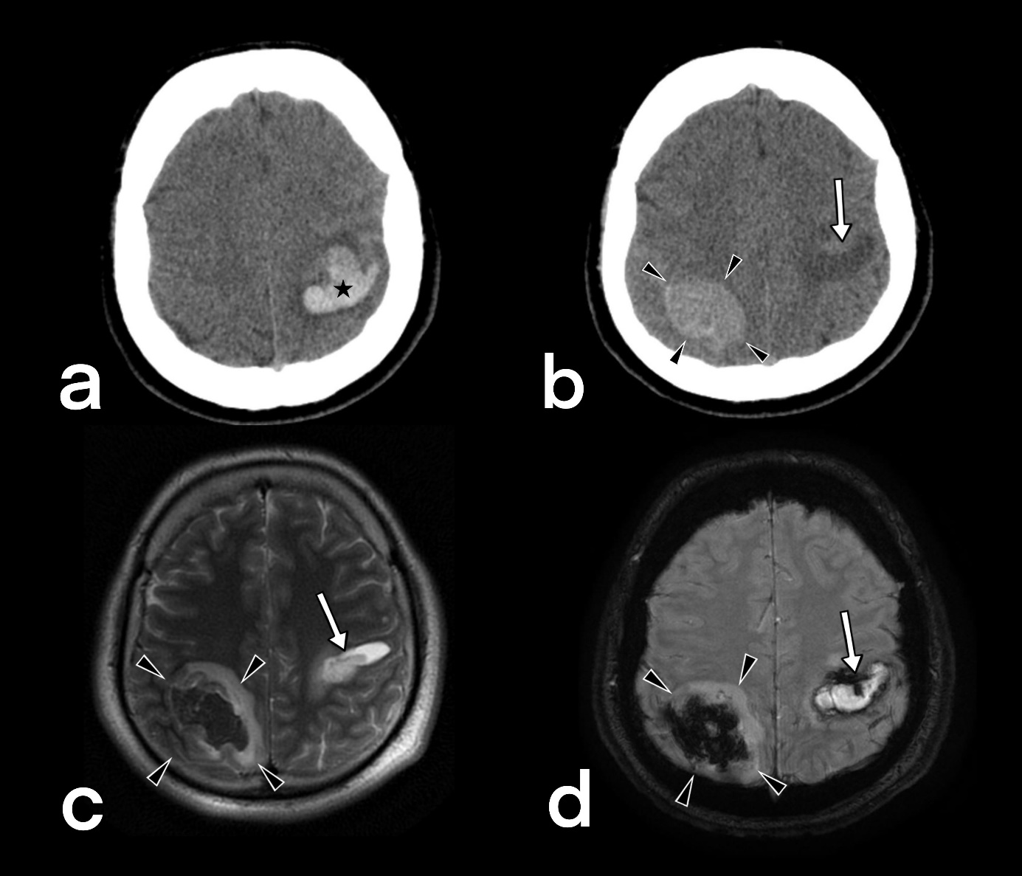

Figure 1: Cranial axial CT and T2 weighted axial and SWAN MRI examination of the patient.
Cranial axial CT examination of the patient performed at the time of his presentation to the emergency department (a). On the left, the bleeding area (asterisk) is observed as hyperdense in the frontoparietal region. The cranial CT of the patients after 15 days (b), T2 weighted axial MRI (c) and SWAN MRI (d) examination show a new bleeding area (arrowheads) in the parietal region on the right. The bleeding area is hyperdense on CT and has mixed intensity on MRI. The initial bleeding area is indicated by an arrow.
CT: Computed tomography, MRI: Magnetic resonance imaging, SWAN: Susceptibility-weighted angiography MRI

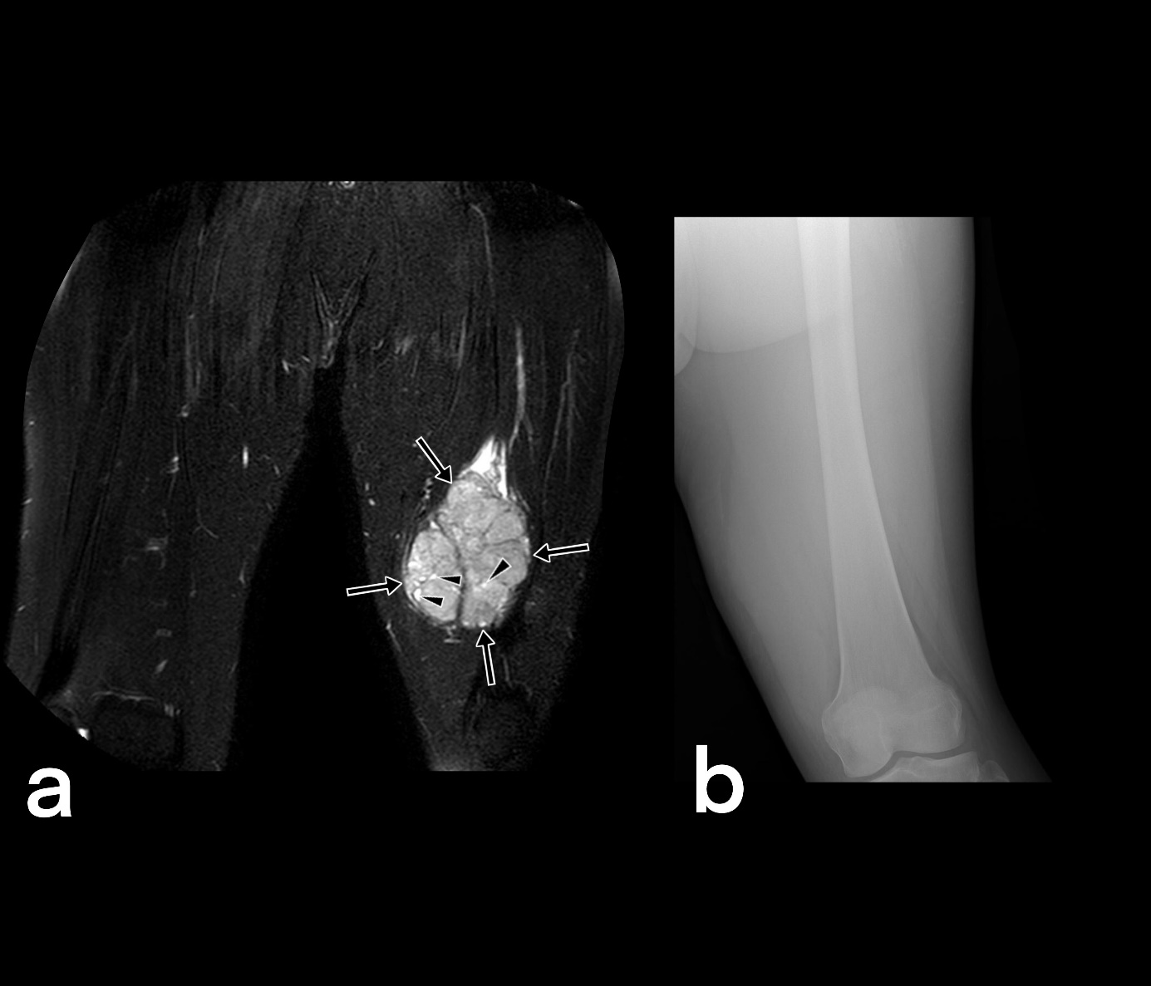

Figure 2: T2-weighted fat-suppressed MRI and X-Ray image of left thigh
In T2-weighted fat-suppressed MRI (a), a well-defined mass of approximately 6 cm in diameter is observed in the soft tissue on the left thigh (arrows). Areas with higher signals (arrowheads) represent small bleeding areas within the mass. Note that the bone structure is preserved in the X-Ray image taken simultaneously (b), and there is no irregularity in the bone cortex. Extra-skeletal Ewing’s sarcoma can be very aggressive and metastatic without damaging the integrity of the bone structure (except in advanced stages).
MRI: Magnetic resonance imaging

