Tau Protein in the Retina

Umur Kayabasi , MD
Assistant Professor
Department of Neuroophthalmology,
Bahcesehir University- Istanbul / Turkey
*Corresponding author: Umur A Kayabasi, Department of Neuroophthalmology, Istanbul, Turkey, E-mail: kayabasi@yahoo.com
Abstract
Introduction: Tau protein plays a crucial role in many neurodegenerative diseases including Alzheimer's disease (AD). Tau inclusions and amyloid beta (AB) depositions have been described in the post-mortem retina exams of AD patients. Cryo- electron microscopy (Cryo- EM) was recently used to detect the detailed structure of Tau filaments.
Methods and Result: We examined the retinas of PET-proven live AD patients by spectral domain optical scanning tomography (SD- OCT) and fundus auto fluoresce in (FAF). The hyper or hypo- fluorescent lesions in the retina were scanned by OCT and images that completely corresponded with the histopathological and Cryo- EM shapes of Tau filaments were observed.
Conclusion: Retinal Tau is a very promising target to detect early changes in AD and retinal imaging may be an exciting and trustable technique to predict and monitor the disease.
Keywords: Tau; OCT; Retina; Alzheimer's
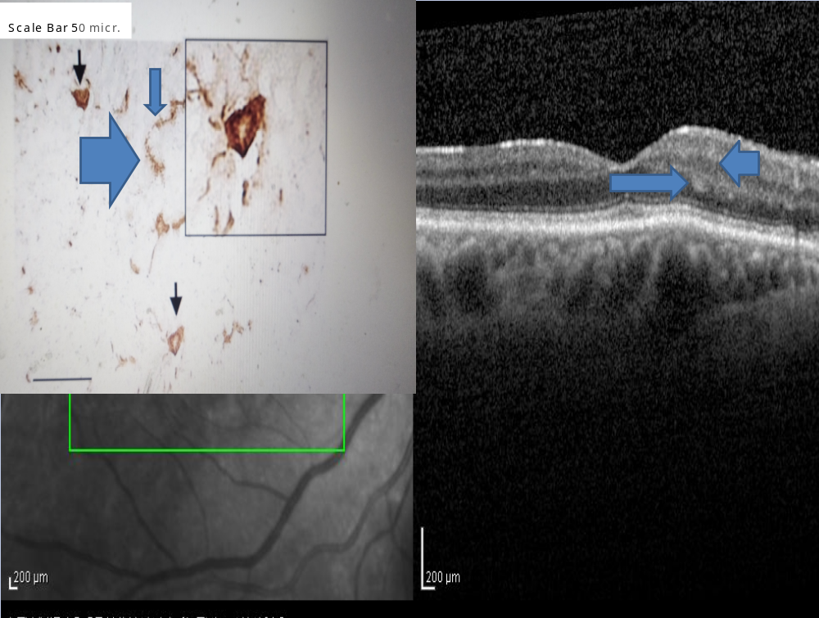
Figure : Tau in the retina

